CH3041 Tutorial 8 Answers Air Pollution

1. Relative warming potentials are used to assess the importance of the various greenhouse gases
that are introduced into the atmosphere in large quantities through human activity.
- List three greenhouse gases and explain how they operate to enhance the greenhouse effect.
- List the RWPs for the gases you have chosen and explain why they differ for each gas.
The Earth's lower atmosphere traps and re-radiates to the surface much of the energy that has been emitted from the Earth's surface. The energy emitted from the surface is blackbody radiation resulting from the warming of the surface by solar radiation (the Earth behaves as a blackbody radiator with a temperature of –23ºC), this is emitted in the IR region of the electromagnetic spectrum.
This natural greenhouse effect results in the Earth's surface having a mean temperature of +15ºC rather than -18ºC.

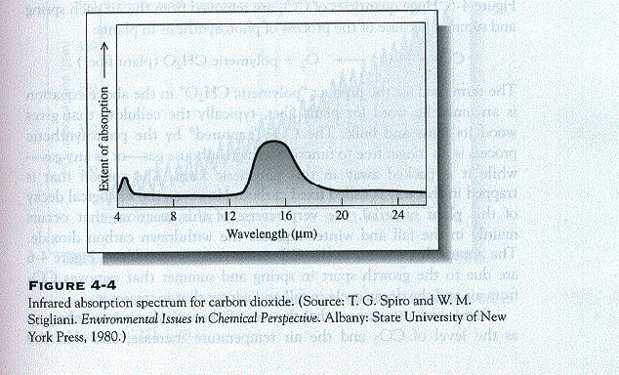
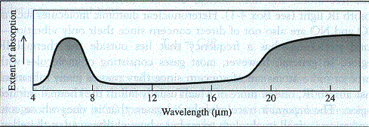
CO₂
H₂O

The natural greenhouse gases which trap IR energy are H₂O, CO₂, CH₄ and N₂O. The enhanced greenhouse effect comes about as a result of enhancement of the trapping mechanism in the atmosphere and this is then due to increased levels of the greenhouse gases CO₂, CH₄ and N₂O and to the addition of anthropogenic gases such as the Chlorofluorocarbons.
The greenhouse gases each have a characteristic window of absorption in the IR region. For CO₂ the absorption of radiation in the IR wavelengths (13 - 15μm) is quite significant with the current concentration of this gas in the troposphere (360 ppm) as it is a minor gas in the atmosphere. A doubling of the current CO₂ concentration will result in a significant increase in the amount of radiation absorbed, a positive radiative forcing will produce a warming effect at the Earth's surface - Greenhouse Warming. CO₂ is produced in enormous quantities, natural emissions are augmented by production from fossil fuel combustion, cement manufacture, land-use changes, and the concentration now is +25% compared with pre-industrial values.
The other gases CH₄ and N₂O are trace gases and they have shown substantial increases in concentration (+100%, +9%, resp.) since industrialisation. They absorb radiation in a window (8 - 12 μm) that shows very little absorption and so increases in the concentrations of these gases result in significant warming.
The CFCs (and HCFCs) have been produced in large quantities by man, have long half lives in the atmosphere and absorb in the same region as CH₄ and N₂O. O₃ is another greenhouse gas. They result in tropospheric warming but stratospheric cooling.
A Relative Warming Potential for a greenhouse gas takes the Global Warming Potential GWP for a gas and includes the emission data to estimate the relative effect of a gas in influencing the global climate. Due to the extremely large emissions of CO₂ it will contribute to 50% of the RWP over the next 200 years.
The Global Warming Potentials of greenhouse gases express the relative ability of a greenhouse gas to increase the mean Earth surface temperature over a certain time period and it includes the IR characteristics of the gas (λ, ε), the lifetime of the gas in the atmosphere and any indirect effects it produces. CO₂ has a reference value of 1, CH₄ 11, CFCs 1000's.
The RWP for CO₂ 50%. CFCs(HCFCs,HFCs) 20%, CH₄ 20%and N₂O 5% over the next 200 years.

2. Describe the major chemical processes which result in the formation of a "London" smog,
include the key compounds and the physical conditions required for such a smog to form.
- What measurements would you expect to carry out to declare a smog event?

Classic “London smog” is a product of coal combustion under oxygen poor conditions which form soot + CO + SO₂.
4’CH’ + 3O₂→ 4CO + 2H₂O insufficient O₂
4’CH’ + O₂→ 4C + 2H₂O insufficient O₂
Further reduction in O₂ levels results in the formation of carcinogenic PAHs.
Coal also contains significant quantities of FeS₂ 4FeS₂ + 11O₂→ 8SO₂ + 2Fe₂O₃
SO₂ reacts to form an H₂SO₄ aerosol mist. 2SO₂ + 2H₂O + O₂→ 2H₂SO₄ (Mn cat.)
The London smog is therefore a result of the emission of large quantities of primary pollutants especially particulate matter.
The other factor that is necessary to form the SMoke fOG is very static air. In London
temperature inversions are common where the ground air is cooler than the upper air trapping the emitted pollutants above ground level. The smoke particles act a condensation nuclei for fog formation.
The water present in the fog is highly acidic due to reaction in the fog drops.
The air particle load reduces light intensity to visibility < 30m,

To declare such a smog you would monitor particulate levels using a HighVol sampler in particular looking at the PM2.5 level, when this exceeds 65 mg / m3 and if the SO₂ and CO levels are high (UV and IR spectrometers, resp.) while O₃ and VOC are low then a London smog is present.

3. Explain the function of a three-way catalytic converter in reducing photochemical smog.

The progress of smog formation follows the inputs of pollutants (primarily from mobile sources (cars)) and the increase in solar radiation. In the early morning cars add NO, VOCs and CO.
The catalytic converter functions to remove NO, VOCs and CO.

The three-way converter converts all three pollutants CO, NO and hydrocarbons (VOCs) into the non-toxic gases N₂, CO₂ and H₂O.
2NO + 2CO → N₂ + CO₂ 2CO + O₂ → 2CO₂
‘VOC’ + xO₂ → yCO₂ + zH₂O greenhouse gas!
The catalysts are supported Pt & Rh which reduce NO_{x} and oxidise the CO & VOCs.
Rh/Pt microcrystal are supported on an Al₂O₃ microporous support allowing the exhaust gases to be converted in the 300 ms contact time while they are passing through the converter.

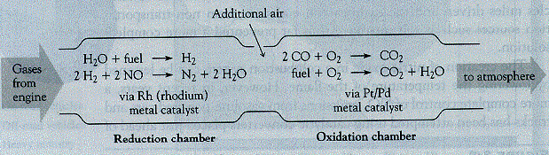
Addition of 3-way catalytic converters to cars has reduced the levels of emitted NO_{x} (by 75%),CO, & VOCs (95%).

4. The Barron Catchment has been shown to carry phosphate and nitrate pollutants on occasion at
levels above the ANZ freshwater guidelines. Explain the origin of enhanced levels of these
pollutants in the Barron catchment, what the limits are and how these nutrient levels are
normally measured.

The levels measured in the DPI study (Natural Resources of the Barron River Catchment 2. Water Quality, Land Use & Land Managment Interactions”. A.L. Cogle. (DPI, Queensland Government, 2000) were for total-P, total-N, PO₄³⁻ and NO₃⁻.
ANZ Guidelines for Queensalnd Tropical Lowland Rivers trigger levels are: total-P 10 ppb, total-N 300ppb.
The origin of these nutrients in the waterways are through elevated levels of N and P in the runoff/groundwater from agricultural land that is being fertilised with man-made fertilisers.
NPK fertilisers such as ammonium nitrate NH₄NO₃, superphospate: CaSO₄ / Ca(H₂PO₄)_{2,} NH₄H₂PO₄, - elevate P and N levels.
Pollution from sewerage outlets was either from rural septic tank systems and prior to 2002 to the Atherton sewerage treatment plant effluent being disposed of into the Barron river system. The Cairns sewerage treatment plant has a significant effect on the levels of P and N at the Barron mouth for the same reason. STPP Sodium TriPolyphosphate Na₅P₃O₁₀ is the major source of soluble P in sewerage, it is the builder added to detergents to remove hardness and for detergent function. STPP can comprise up to 50% by mass of some detergents (typical dishwasher formulations). Sewerage sludge is around 4%N by weight and this is after the soluble NO₃⁻ component has been removed to the effluent water.

5. Detail the chemistry involved in the formation of actual acid sulphate soil.
- How would you determine the presence of an ASS soil on a site.

The formation of actual acid sulphate soils on the Eastern Coast of Australia is a perturbation of the natural environment that results in the formation of new environmental conditions and the liberation of free mineral acidity. Acid sulphate soils are laid down in marine situation where there is a iron rich sediments where there is significant vegetation and sulphate, commonly found in mangrove swamps. Many soil types on the Eastern Coast are in the category of potential acid-sulphate soil while others are actual acid-sulphate soils. The latter contain high concentrations of pyrite that have been exposed to oxic conditions where the pyritic material generates large quantities of H₂SO₄ (eg. >2 kg / tonne).

4FeS₂ + 15O₂ + 14H₂O → 4Fe(OH)₃ + 8H₂SO₄

The presence of an actual ASS would be determined by first observing the minerals present : jarosite and goethite are indicator minerals, swamp tolerant vegetation and milky green or extremely clear surface water. A pH < 4 of the soil (or paste) and a test with peroxide pH < 3 would be good indicators of an actual acid sulphate soil. This would be confirmed by a POCAS test where there was a positive value for the Total Actual Acidity in conjunction with a positive value for the POCAS test itself.

