CH3041 Tutorial 6 Analytical B Answers

1. Indicate the typical features of a chemiluminescence spectrometer and how it functions.
- What chemicals would you analyse for using chemiluminescence and give some typical IDLs for these chemicals.
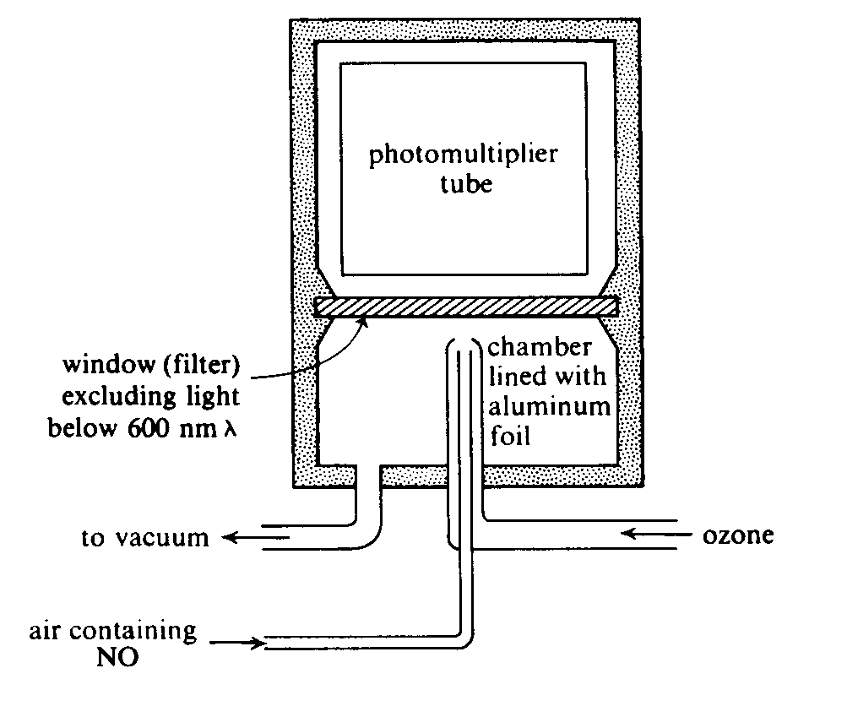
O₃, NO, NO₂

The analysis of NOx involves the reaction of NO with ozone. This
chemical reaction generates an excited species of NO* which
the decays back to the ground state generating light.
In practice the NO2 in NOx is converted to NO and then this is pumped into an evacuated chamber into which ozone is fed. The emission of light is then passed through a filter window, the light is is detected with a standard photomultiplier in the UV range (λ = 600 - 875 nm.)
The detection limit is around 10 ppb.
O₃ is detected in a similar manner except that C₂H₄ is used
as the reacting gas.
NO + O₃ → NO₂* + O₂
NO₂* → NO₂ + hν
I = k[i]

- How does chemiluminescence differ from fluorescence?
Chemiluminescence relies on a chemical reaction between the analyte of interest and a reactant species to generate an excited state species. This then decays to generate the characteristic wavelength that is used in the analytical method (generally in the UV).
Fluorescence involves passing a high power beam of light into the analyte solution (or gas) and the species absorbs some of this radiation (in particular if it contains aromatic systems) as it passes into an excited state. The excited state then decays to a lower energy state with the same spin quantum numbers. S₁ → S₀ + hν generating the characteristic wavelength that is used in the analytical method (generally in the UV).
The difference then is in the way that the excited state species is created Chemiluminescence it is by reaction, Fluorescence it is by light activation.

2. How does ion chromatography separate the ions contained in a water sample, use phosphate and nitrate
as analytes to illustrate your answer.

Ion chromatography is an example of ion-exchange chromatography which uses an ion exchange resin as the stationary phase. A resin is a porous, amorphous, organic material; cross linked styrene-divinylbenzene copolymer is a common stationary phase. The styrene substituents are -NR₃⁺ (ammonium) for anion exchange. Ion exchangers loaded with one type of ion (eg. CO₃²⁻) will bind small amounts of a different ion almost quantitatively. (eg. PO₄³⁻). Taking the anionic case, at the substituent ion-exchange sites are found the CO₃²⁻ ions, these ions are simply swapped for the introduced anions as CO₃²⁻ is the most easily replaced anion.
Selectivity is higher for: higher charge ions, smaller hydration radius, high polarizability.
eg. PO₄³⁻ >NO₃⁻ ie. PO₄³⁻ binds more strongly than NO₃⁻
A small amount of the water sample is swept onto the carbonate form of the column and then a HPLC type system is used to force the mobile phase which is typically MeOH,H₂O containing Na₂CO₃ through the column. The eluent which contains CO₃²⁻ in huge excess sweeps the introduced analyte ions from the exchange sites into the mobile phase. The ions such as phosphate and nitrate are separated based on their relative selectivity for the site.

3. There are many solid state electrodes on the market that are used in environmental chemical applications.
electrolyte
Inorganic crystal
LaF₃
V
Ag/AgCl
- Provide details of one of these electrodes including a sketch of the electrode and the basic physical principle of operation
- Indicate the analyte detection limit and what interferences are possible.
Solid State electrode : F⁻ electrode
The electrolyte in the inner cell is 0.1M NaF, 0.1M NaCl
Crystalline LaF₃ is a conductor. The crystal at the base of the electrode
is placed in contact with the external water solution (containing some F⁻ ions).
LaF_{3(s)}  LaF²⁺_{(s)} + F⁻_{(aq)}
The equilibrium is disturbed as a result of the excess F⁻ ions in the
external solution, and the new potential on the inside of the crystal is sensed
with respect to the Ag/AgCl reference electrode which is in contact with the
electrolyte. After the instrument is calibrated the voltage response
converted to the mM [F⁻] units which are displayed.
Range: [F⁻] 10⁻⁶ - 1 M .
Selectivity coefficient: k_{F-,OH-} = 0.1
(k = response OH⁻ / response F⁻)

In a neutral water the interference with OH⁻ will not be great as the [OH⁻] is 10⁻⁷ M but in basic
waters this interference will be a problem. Under acidic conditions there is also a problem as the fluoride ion is protonated to HF and this is not detected by the electrode.

4. Sketch the basic features of a typical gas chromatographic (GC) instrument that you would use to
analyse fragrant organic molecules such as geraniol and farnesol.
- Include details of the stationary phase, mobile phase, detector and the type of output that would be expect.
- How would you calibrate this instrument for a particular terpene?

column
oven
FID-detector
integrator/PC
carrier
gas(He)

Mobile phase : He
Terpenes above contain OH therefore use a column with a polar mobile phase.
Column:, capillary column 30m, Capillary open tubular 0.32mm,
Stationary phase : fused silica with Carbowax film on the
surface for polar oganics
Detector: The FID detector is a Flame Ionisation Detector which analyse for all organic compounds,
alternatively a MS detector may be used.
Output: there would be a number of peaks each with a characteristic t'_{r}.
D R
e e
t s
e p
c o
t n
o s
r e
Typical Gas Chromatogram
time
Input
time
t_{m}
Air
geraniol
t_{r}’
t_{r}
Analyte
farnesol
Typical Gas Chromatogram

The GC would be calibrated by passing a calibration standard through the instrument at the start of the day to check that the instrument is working OK. The Calibration Verification Standard (CVS) a commercial QC standard run at the beginning and end of analysis.

Next a Continuing Calibration Standard (CCS) is run at the beginning and end of analysis and
every 10 samples in between. This contains the terpene of interest made up from calibration standards of known concentration.
Calibration curve: the instrument response is plotted versus concentration of analyte, each instrument needs a least a 5 point calibration to ensure linearity of response.

