CH3041 Tutorial 5 Analytical A Answers

1. A monitoring program is to be put in place in the following catchment which empties into a small freshwater lake. A spillage of a toxic organochlorine pesticide is indicated at the mark.
Plan a sampling protocol for the site indicating what information you will need before you start sampling and what information you need to obtain from the sampling.
0 1km
Samples are indicated at the X.
Information needed before the sampling includes:
1) What is the quantity of the pesticide introduced into
the environment and how long did it take for this material
to get into the creek.
2) What is the flow rate through the tributary and the
main creek, how deep is the lake and the total surface area (for the lake volume), these are to calculate the dilution factors in the creek and lake.
3) What are the properties of the organochlorine pesticide. H₂O-solubility, K_{OW}, mp, bp, p_{vap}, LC₅₀
are there any secondary chemical which could act cooperatively.
4) Is the pesticide able to react in the environment with anything that will reduce the distance of transport or the degree of biomagnification (metabolic conversion).
5) What are the degradation products (metabolites) of the pesticide.
6) The geography(maps), are there any low lying areas in the catchment where the water will tend to pool, here sediment deposits are likely to be significant.
7) Have any toxicological studies been carried out, what are typical BCF values in an aquatic food chain.
8) Safety aspects of sampling estimated and access to the site.
9) Land use in the vicinity of the catchment.

What you need to get out:
1) The level of pesticide(+ metabolites) in the water column of the lake and any residuals in the creek,
including an estimate of the errors ie. the data quality.
2) The level of pesticide(+ metabolites) in the sediments of the creek having found the critical areas where contaminated sediments lie and in the sediments of the lake.
3) The level of pesticide(+ metabolites) in the food chain. Here an initial map at each level of the food chain is required and once the critical organism has been identified then this bioindicator will be used as the critical group for long term monitoring.
Long term monitoring will be put in place over the critical path where concentrations in the water and sediment are highest along with monitoring of the critical group. This will generate a set of data to aid in establishing when the site has recovered from the spill.

Sampling protocol:
Initial exploratory widespread monitoring to find out where the pollutant has migrated to. Physical measurements will be taken at each sampling point (T, DO, pH).
Sampling regime will be systematic down the creek from the spill every 200 metres with judgemental sampling taken at any point where it appears that water flow is low. In the lake a grid pattern will be used with samples at every 200 metres by 50 metres.
Water samples will be taken in midstream under the surface into amber glass storage jars. From there they will be stored in an Esky on ice and then taken back to a freezer in the laboratory.
Lake samples will be collected using a peristaltic pump and teflon tubing.
Sediment samples in the river can be collected either using a coliwasa or in the lake using a Ekman grab sampler. The sediment would be stored in amber glass jars, cooled and transported to the lab for freezing.
Biological samples will be collected in an approved manner (with appropriate authorisation) for animal and botanic samples.
Blanks: a control sample would be taken in the small side creek upstream of the confluence., an equipment blank would be taken at the end of each days sampling.
Duplicates: 1 per every 5 samples. Spike samples at least one per days sampling.
Analysis will be carried out using either GC-MS or GC-ECD for which only , the MDL will set the sample size based on the lower limit needed to class the site as recovered. This is likely to of the order of <1ppb.
Total number of samples will be based on the above x 5%. This will be costed and the time for the project estimated. Monitoring will involve only water and sediment sampling at the points on the critical path. The frequency will be initially high perhaps every week and after that at monthly intervals.
A safety protocol will be needed. A quality assurance plan will need to be detailed.

2. Explain the physical basis for the biomagnification of toxicants such as DDT and Hg in the food chain.

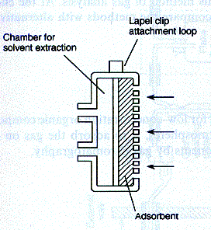
Biomagnification occurs when a chemical such as DDT which is found in the fatty tissue of one organism is consumed by another organism higher in the food chain. DDT is an organic molecule which has a high K_{OW} value which means it will partition into organic matter rather than water. When ingested if the rate of excretion / metabolism of the material is lower than the rate of ingestion the material will bioaccumulate.
Hg is acted on by microbes to form MeHg⁺ which is then an organometallic compounds that behaves in a similar manner to DDT. As both DDT and MeHg⁺ are taken into the food chain at the lowest levels and are then quite stable in their metabolised forms they simply concentrate as one organism consumes many times it's own weight of the lower organisms which have a lower concentration. A magnification factor can be as high as 2 x 106 over the concentration found in the contaminated water or sediments that the primary organisms are in contact with.

3. Provide examples of sampling devices and storage containers for:
(i) Indoor air : organic pollutants.
Passive diffusive sampler. Collected on Tenax resin.
Hi-Vol for organic aerosols. Collected on membrane filter.
Whole air sample: SUMMA cannister. (sampled & stored)

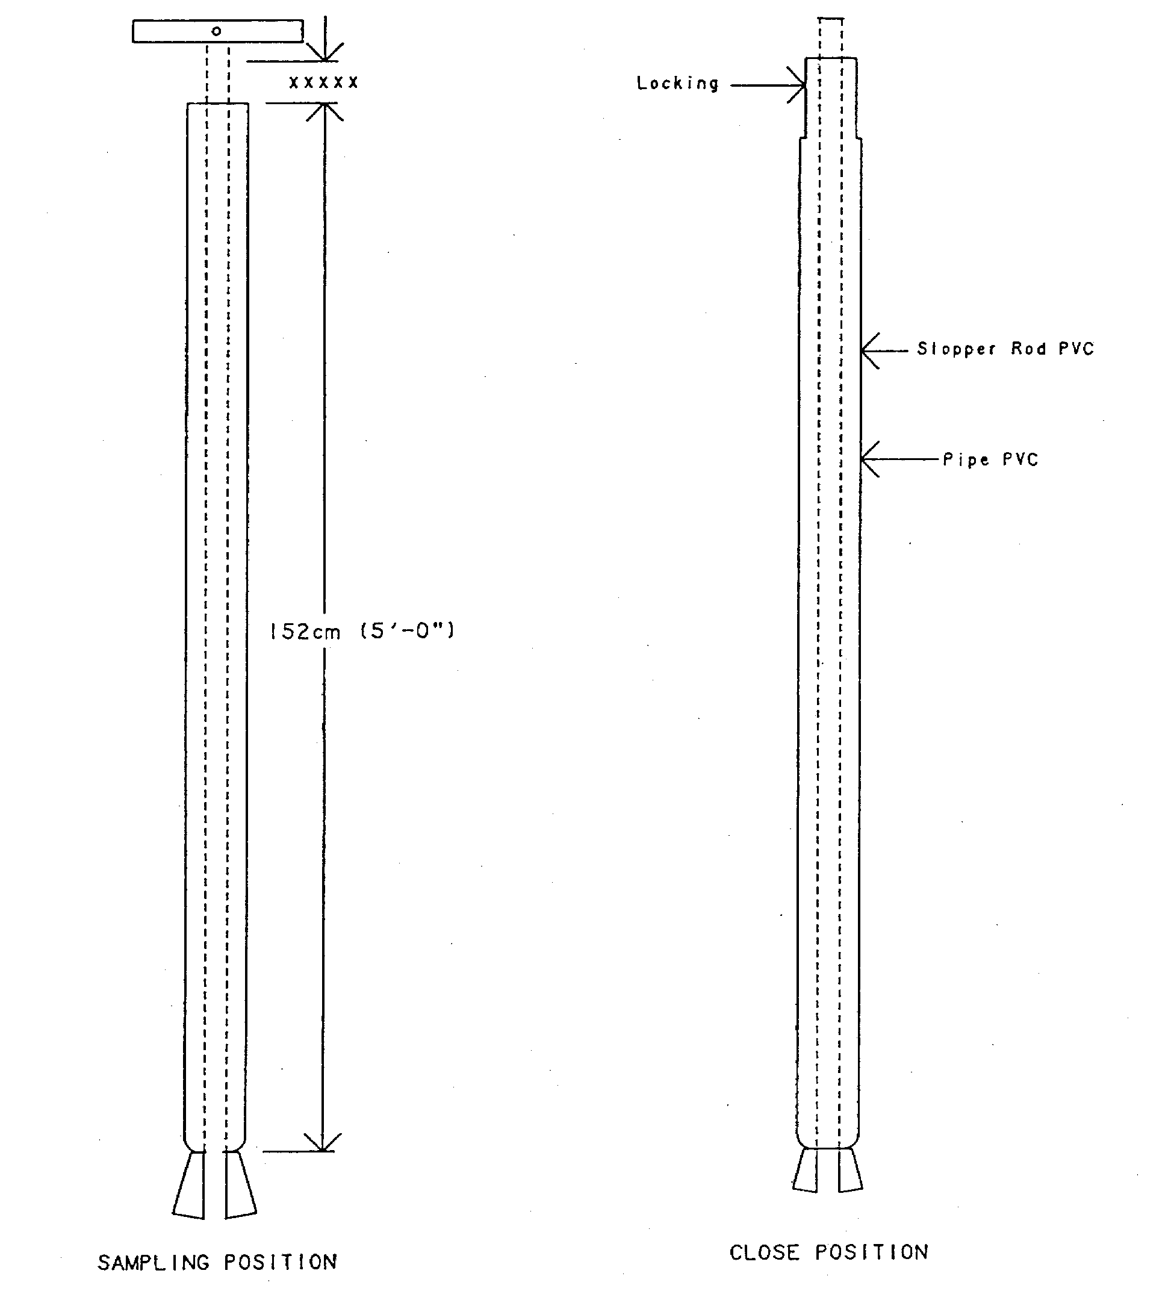
(ii) Soil : B horizon of a krasnozem soil containing Pb in a labile form.

PVC pipe.
Auger down to B horizon and then collect B horizon,
place into an acid treated glass container (storage).

(iii) Sediment sample: from estuarine muds near a marine defouling
operation, Sn contamination.

Coliwasa. Glass container with acid added (storage).

4. Describe the analytical protocol required to determine the phosphate content in a water that has been polluted with a hydrocarbon (petroleum oil).

Extraction:
Separating funnel. Remove organic layer. Wash 3 times with water and combine the extracts.
Note the original volume of water used.
Analysis:
Prepare a molybdenum blue series of standards of known PO₄³⁻ concentration. Run Visible spectrometry on these standards and prepare a calibration curve. Run the unknown and determine if it is within the range of the curve. If it is calculate the concentration in the sample and then work back to the undiluted sample volume to give PO₄³⁻ in ppm.
Results:
Report the unknown concentrations in ppm including the error bars associated with the analyses.

