CH3041 Tutorial 4 Terrestrial Chemistry Answers

1. Discuss the chemistry in a raindrop using the two-film model for the transfer of gases into the drop.
Water is a present in the troposphere at 0.5 - 4% by volume. When small aerosol particles such as Aitken
nuclei are present in air that is saturated with water vapour they act as Cloud Condensation Nuclei. Salt
lowers the vapour pressure in these very small cloud drops and rapid condensation occurs as p_{vap} exceeds
p_{sat} until the drops approach raindrop size (10⁻⁴ m).

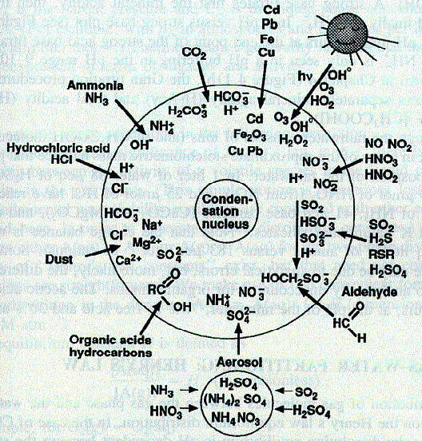
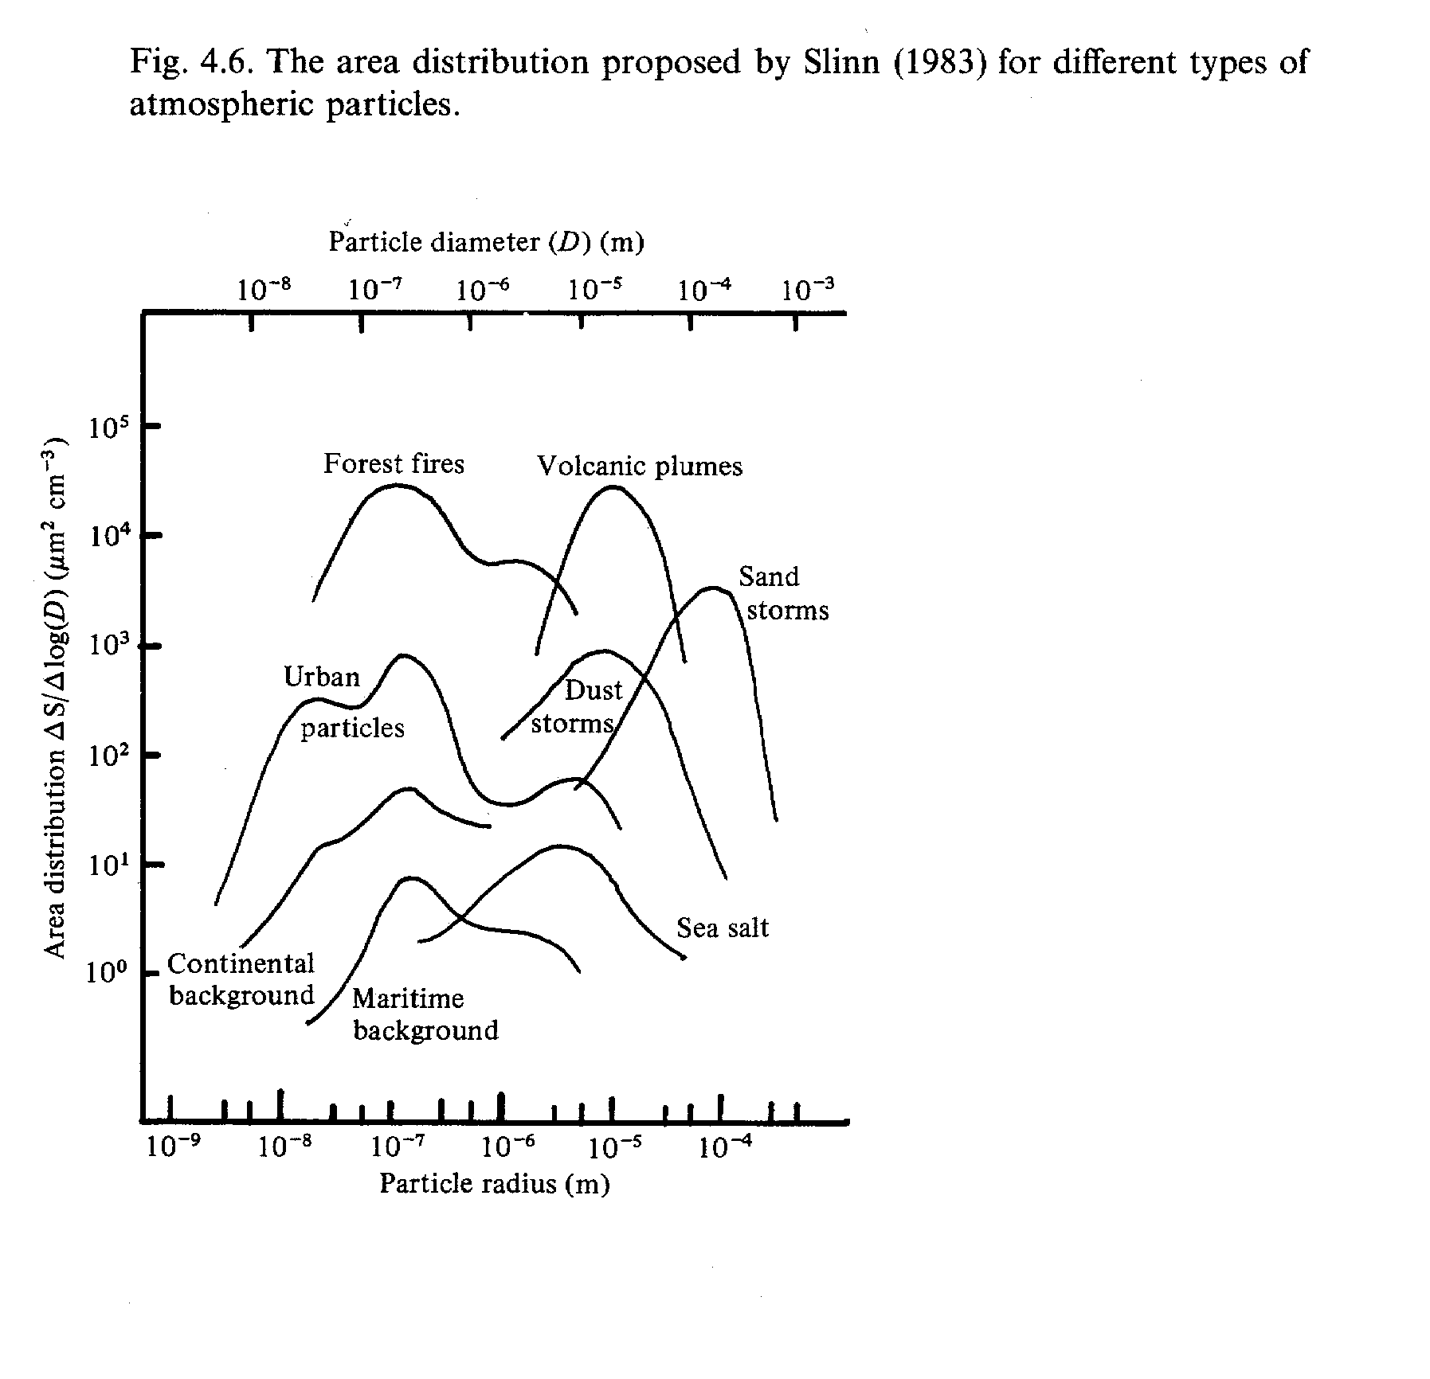
1) raindrop chemistry picture (Lecture 10),
2) aerosol size range picture (Lecture 3).
(10 MB FILE Stripped out pictures from lectures!)

In the raindrop there is the central aerosol particle which is generally dust, sea salt sulphate or organic matter. This is in contact with the aqueous solution the outer boundary of which is then an interface between the gas phase and the liquid phase. Material that is present in the atmosphere as aerosol particles will deposit onto the surface of the raindrop and become incorporated in the drop in the process of 'wet deposition'.
Gases with limited solubility and low volatility will precipitate on the surface of the drop eg. Pb vapour, PAH (polyaromatic hydrocarbons). These materials can reduce the ability of soluble gases to transfer across the surface.
Soluble gases will dissolve into the raindrop according to Henry's Law [i] = K_{H} p_{i}.
Further reaction in the raindrop will reduce the concentration of the substance in the raindrop and so further amounts will dissolve, this will result in larger amounts going into solution than those based simply on Henry's Law alone.
Dissolution of a gas involves a two step process (1) fast transfer to the liquid and (2) slow mixing within the liquid The transfer process across the surface of the
Boundary layers

Interface

Air

Water
drop may be described by a Two-Film Model.
On either side of the surface turbulent diffusion is
moving material by turbulent diffusion. At the surface
there is a liquid boundary layer and a gas boundary layer.
Slow transfer of material occurs across the boundary layers by diffusion.
The movement of material across a boundary layer is described by the flux expression F = 1/r Δ[i]
where 1/r is the resistance of the boundary layer to diffusion of the substance through the layer and
the difference in concentrations is the other term.
One of the resistance terms normally dominates, for instance diffusion of a high solubility gas will generally have the gas phase resistance dominating.
The soluble gases that transfer into the raindrop will include CO₂ which will make the pH of the drop slightly acid, H2S/DMS/SO₂/SO₃/H₂SO₄ , HCl and NO_{x}/HNO₃ all of which will increase the acidity. Ammonia which will be protonated to form NH₄⁺ in the raindrop. Organic gases which may either increase or decrease the pH.

2. Provide chemical formulae and structural diagrams for three common aluminosilicate minerals.

Feldspar KAlSi₃O₈ quartz structure, 3-D network covalent solid
aluminium substitutes every 4th Si site.
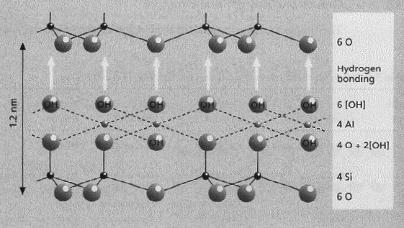
pictures from lecture 13
Kaolinite a 1 : 1 mineral
Si₄Al₄O₁₀(OH)₈

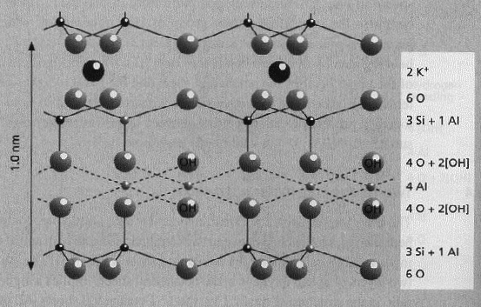 Muscovite [KAl₃Si₃O₁₀(OH)₂]₂

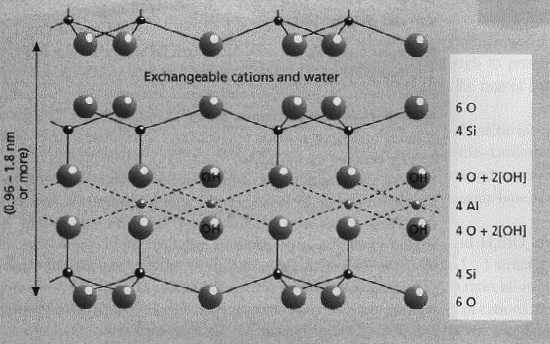
Smectite
[M₀(Al₂)(Si₄)O₁₀(OH)₂ ]₂

3. Discuss the mechanisms for weathering of primary minerals to form secondary minerals in soil.
Why is quartz found in high percentage in the sedimentary rocks?

A primary mineral is formed under conditions of high temperature and pressure, rock forming conditions. A secondary mineral is formed from primary minerals by alteration (either chemical or physical conditions) in the course of weathering.
As primary conditions are formed under anaerobic reducing conditions they are not thermodynamically stable under oxic conditions found at the Earth's surface.
Bowen's reaction series illustrates the relationship between the conditions of formation of a mineral and the propensity to weather, this then is an indication of the propensity of a primary mineral to weather based on the structural type of the mineral. A monomer silicate is formed under high temperature of crystallisation and as a result a thermodynamically less stable structure is formed under these conditions the lack of interconnection between monomer units allows ready weathering, the stability of quartz is due the converse.
The Felsic series is based on the aluminosilicate 3D framework silicate structure which contains internal cage structures. These cages are most stable when they contain K⁺ and least stable when they contain Ca²⁺ and this again relates to the ease of weathering.
Mechanisms of chemical weathering:
1) Dissolution: Mg₂SiO₄ + H₂O → Mg²⁺_{(aq)} + H₄SiO_{4(aq)}
2) Oxidation: 4FeS₂+15O₂+14H₂O→4Fe(OH)₃ +8H₂SO₄
3) Acid hydrolysis: 2NaAlSi₃O_{8(s)} + 2H₂CO₃ +9H₂O → 2Na⁺ + 2HCO₃⁻ + 4H₄SiO_{4(aq)} + Al₂Si₂O₅(OH)_{4(s)}
4) Complexation: muscovite + oxalate KAl₃Si₃O₁₀(OH)₂+3C₂O₄²⁻+10H⁺→ 3AlC₂O₄⁺ +3Si(OH)₄ + K⁺
Increasing
Temp.
mineral xyst
in
magma
Increasing
susceptibility
to
weathering
Ferromagnesian series
Olivine

Pyroxene

Amphibole

Biotite
Muscovite

Quartz
Felsic series
Ca-feldspar

Na-feldspar

K-feldspar

(monomer) ionic(framework)

(chain)
(framework)

(double chain)
(framework)
(sheet)

(sheet)

(framework)

The secondary minerals such as the clay minerals form from the primary minerals under conditions of low pressure and temperature and high oxygen partial pressure. The primary minerals are weathered at surface sites that possess defects or are broken by physical weathering. Once the surface area to particle size ratio becomes high then weathering proceeds at a rapid rate. The pits that form in the defect sites are eroded away by the weak organic acids from humic materials and the carbonic acid in the C horizon of the soil. The Al:Si ratio will increase with time as the Al(OH)₃ is quite insoluble under most pH regimes while the silicic acid may be removed as the framework of the primary silicate mineral is broken down. Reformation of a clay mineral occurs as the solublised silcate content and the available base cations recombine.
Quartz is a 3D-network covalently bonded silicate, which means that it has a particularly stable structure. As it is both thermodynamically & kinetically a stable mineral slow physical weathering is a major mechanism for the breakdown of quartz and this means it is usually found in this form in sedimentary rocks.

4. Illustrate the main features of the nitrogen cycle and explain the processes denitrification and nitrogen
fixation.
STABILITY (ΔG_{f}º )

N₂ (O)
nitrogen

NH₃ (-3)
ammonia

NO₂⁻ (+3)
nitrite

NO₃⁻ (+5)
nitrate
Reservoir x 10¹² kg N
Fluxes x 10⁹ kg N/a

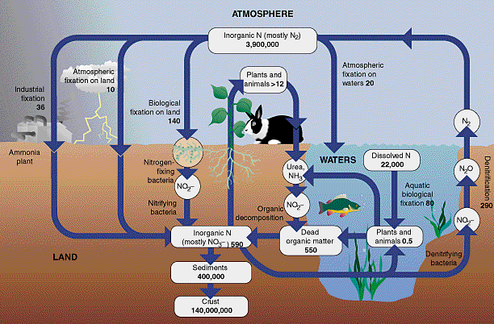
N₂O 1.4

Organic N
300

Rhizobium
Nitrosomonas
Nitrobacter
Rhizobium
nitrate
190

NO₃⁻
570

Dintrogen is the main reservoir of N and for organisms
to use this as a source of N (Redfield protoplasm has
the formula C₁₀₆H₂₆₃O₁₁₀N₁₆P₁ ) they must either use
this or a product derived from it. The entry point of N into the biological cycle is
the Nitrogen fixation reaction and the major return is denitriication.

Nitrogenase is a 2 protein enzyme that catalyses the reduction of N₂.
One of the proteins has 2 Mo atoms which coordinate to the N₂ molecule and help to break the triple bond which has a energy of activation of 950 kJ/mol.
Nitrogen fixation: In the case of the Rhizobium bacteria it is symbiotic relation-
ship the bacteria gets E from the plant (legume nodules → photosynthetically
produced sugars), the plant gets NH₄⁺⁺

Nitrogen fixation N₂ + 8H⁺ + 6e⁻ → 2NH₄⁺
ΔG -120 kJ/mol ‘CH₂O’+ H₂O → CO₂+ 4H⁺ + 4e⁻

3{‘CH₂O’}+ 3H₂O + 2N₂ + 4H⁺ → 3CO₂+ 4NH₄⁺
- this links the C cycle to the N cycle.

2) Denitrification: a major N₂ return pathway which Rhizobium will also use as
a source of metabolic energy.
NO₃⁻ + 5/4{‘CH₂O’} + H⁺ → ½N₂ + 7/4H₂O + 5/4CO₂

