CH3041 Tutorial 1 Answers

1. The exhaust of an automobile is found to contain 2 percent CO (20 000 ppmv) at a temperature of 80° C. Express the concentration of CO in the exhaust gas in μg/m³ which is another commonly used gas concentration unit. Assume ideal gas behaviour for the gas.

2% = 20,000 ppm eg. 20,000 L of CO /10⁶ L of exhaust

T = 273 + 80 = 353° K p = 1.013 x 10⁵ Pa R = 8.314 Pa m³ mol⁻¹ K⁻¹
molar mass of CO M_{CO} = 12 + 16 = 28 g/mole

From the ideal gas law
pV = nRT = (g_{CO}/M_{CO}) RT
rearranging:
g_{CO} = pV (M_{CO}) /RT

= (1.01315 x 10⁵ Pa)(20,000 x 10⁻³ m³) (28 g/mol)
(8.314 Pa m³ mol⁻¹ K⁻¹) (353 K)

= 1.93 x 10⁴ g in 20 000L
thus
20,000 L of CO/ 10⁶ L of exhaust = 1.93 x 10⁴ g/10⁶ L
convert L to m³ (factor x 10⁻³) = 1.93 x 10⁴ g/10³ m³
= 19.3 g / m³
convert g to μg (factor x 10⁶) = 1.93 x 10⁷ μg/m³

Another approach:
The conversion between μg/m³ and ppm may also be based on the fact that under standard conditions (25°C and 101.325 kPa), one mole of an ideal gas occupies 22.414 L. Thus, we may write an equation that converts the mass of the carbon monoxide g_{CO} in grams to its equivalent volume V_{CO} in litres:

V_{CO} = g_{CO /} M_{CO} x 22.414 L/mole

Since ppm is a volume ratio, we may write
ppm = V_{CO} = X L
V_{air} 10⁶ L
where V_{air} is the total volume of air being considered in cubic meters at the temperature and pressure of the reading. We then combine the above equations with temperature and pressure corrections to form:

ppm = g_{CO} x 22.414 x T₂ x 101.325 kPa
M_{CO} 273K P₂ (here P₂ = 101.325)
V_{air}
when g_{CO} is converted to μg and as V_{air} is in millions of L these factors cancel one another.
No pressure correction is needed.

20 000 ppm = (μg _{CO} / M_{CO} ) x 10⁶ x (22.414 x 10⁻³) x (353 / 273)
10⁶ L
conv to μg conv to m³
Rearrange:
μg _{CO} / m³ = 20 000 x M_{CO} x 273 / (22.414 x 10⁻³ x 353)
= 1.93 x 10⁷ μg / m³
2. Using the Barometric Law p_{z} = p_{o} e(-z / H) where the scale factor H is 8.4 km calculate the partial pressure of oxygen in Pa at 6.2 km given that the volume percentage of oxygen in air at sea level is 20.946%. Atmospheric pressure at sea level is 1.013 x 10⁵ Pa.

at STP 1mol of any gas occupies 22.41 L

VO₂ = nO₂ ⇒ pO₂ = nO₂ pO_{total}
VO_{total} nO_{total} nO_{total}

pO₂ = 0.20946 x 1.013 x 10⁵
= 21218.3 Pa

pO2 at 6.2 km = 21218.3 Pa exp( - 6.2 km / 8.4 km)
= 10142.8 Pa

3. CFCs are responsible for the depletion of stratospheric ozone in the polar regions. Explain the physico-chemical basis for this phenomenon.

CFCs are chlorofluorcarbons such as CFC-12 CF₂Cl₂. These chemicals were produced in large quantities (kt / y) for use as refrigerants, propellants and cleaning products. Once released into the atmosphere these halocarbons are quite inert in the troposphere and migrate upwards to the stratosphere over 3 - 10 years. The lifetime of the CFCs in the stratosphere is 110 yrs for CFC 12 which means that the removal rate here is also quite slow. The decay process is:
CF₂Cl₂ → CF₂Cl. + Cl.
This generates he reactive Cl radical which catalytically removes ozone, 100 000 ozone molecules are removed per Cl radical:
Cl. + O₃ → ClO. + O₂ (chlorine monoxide)
ClO. + O → Cl. + O₂ (net loss of O₃)
This then is a general mechanism for the removal of ozone in the stratosphere which occurs globally.
At the poles extreme weather conditions in the winter mean that the air circulates locally in a circumpolar pattern without extensive mixing with warmer higher latitude air. No light is present and so the ozone level will not be replenished. The very low temperatures (< -70 ºC)results in the formation of water ice / HNO₃ solid particles in the air called polar stratospheric clouds (PSC) HNO₃.3H₂O,HCl.
The chlorine nitrate available in the stratosphere may be catalytically broken down on the surface of the acidic ice crystals to form Cl₂ gas.
ClONO_{2(g)}+ HCl_{(s)}→ Cl_{2(g)}+ HNO_{3(s)}
In early spring the available light breaks down further CFC molecules and the usual sink for ClO. , NO_{x}, is at this stage tied up in the PSC ice. (ClO. + NO₂. → ClONO₂)
What occurs is a very rapid formation of chlorine radicals with the incoming photons able to break the Cl-Cl bond readily.
1Cl_{2(g)}+ hν →2Cl._{(g)}
The normal process for the removal of ozone involving the Cl. radical then proceeds rapidly on the fixed amount of ozone inside the polar vortex. As there is no interruption to the catalytic cycle for the destruction of ozone this reaction then runs unabated and this quickly consumes the available ozone until the column density of ozone drops significantly enough for it to be measured using remote sensing spectrometers on satellites.
4. Draw a figure illustrating the different regions of the atmosphere and the accompanying temperature profile. Explain the variation in temperature with altitude.

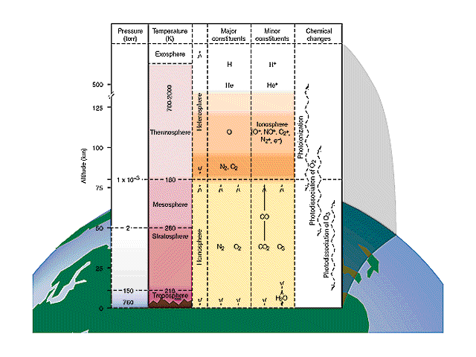
Convection, vertical mixing, surface heated, hot air rises 300K
5) O₃ → O₂ + O UV-B
6) O + O₃ → 2O₂
3) O₂ → 2O UV-C
4) O + O₂ → O₃
1) O₂ → 2O UV-C
2) O → O⁺ + e⁻ UV-C
Tropopause
Stratopause
Mesopause
Turbopause
200K
260K
180K
300K

