
Department of Chemistry
Cairns Edition

CH2041
LABORATORY NOTES
2006

Name:

DEPARTMENT OF CHEMISTRY

CH2041 PRACTICAL COURSE

Table of Contents

Assignment Subject

General Introduction
Notes on Environmental Chemistry Assignments

1 Errors of Observation
2 Air sampling and Analysis: NO_{x} and Particulate Matter
3 Measurement of Water Quality - I (pH, DO, BOD, Solids)
4 Measurement of Water Quality - II (Cond.,Hardness, BOD-II)
5 Measurement of Water Quality - III (PO₄)
6 Preparation of Laboratory Standards (NaOH, Tris Buffer)
& Ion Exchange Chromatography
7 Identification of Food Dyes and Preservatives.
8 Field trip: Stream Water Quality investigation.
9 Toxicological Chemistry
10 Field Trip: Water Quality Laboratory
11 Determination of Acid Levels in Acid Sulphate Soils
12 Field Trip: Water Treatment

GENERAL INTRODUCTION

1. INTRODUCTION

This course involves aspects of sampling and analysis as applied to problems in environmental science. Some of the analyses are qualitative in nature but most are quantitative. As far as possible the laboratory work is organised to correspond with the lectures but a perfect match is not always achievable. In this course the emphasis is on "wet chemistry" techniques that are in common use in environmental analysis rather than "instrumental techniques" which do not involve solution chemistry.

2. ORGANISATION

The practicals will start on the second week of semester and run for the next 10 weeks of the course. The order of practicals runs sequentially from the book. The laboratory session is held on Wednesday morning from 8.30 - 12am. Two field trips will be carried out during these Wednesday morning practical sessions.
ALL PRACTICALS ARE PERFORMED IN PAIRS.

3. WORK INVOLVED

a. Before you come into the laboratory, check the table of contents to find out which assignment you will be doing then read over, understand and prepare for that assignment. Sort out any queries before the lab class by use of text books and tutorial staff.

b. You should arrive on time for the session. Once in the laboratory, before beginning your lab work, you should collect last week's report. Often there will be a tutor-led discussion before the practical work begins. In the case of a field trip you should arrive at the departure point 10 minutes in advance of the official start time.

c. If you are late you must ask your demonstrator about any safety matters associated with the
experimental work before commencing the practical session.

d. When you have finished the lab work you should clean up your work space and return any borrowed apparatus to the preparative laboratory. Glassware and other apparatus are to be cleaned and placed on the large drying stand. Usually there will be a tutor-led discussion on treatment of results. If you have finished early you should begin (and often complete) your calculations and begin to write up your report. The class finishes at 12 am. All experimental work must be completed by 11.45am, anyone leaving before 11.45 am will be marked absent unless all of the lab work is completed AND a completed report is presented to your tutor.

e. After the practical session you should complete your report and prepare for the next session.

f. If you are absent for a medical reason you should present a medical certificate to your tutor in the next lab session and ensure that it is noted on your record. Absence for any other valid reason should be explained in writing or preferably by a certificate from the University student councillor and must be recorded with your tutor.
If you miss 3 or more practicals without a valid reason you will have failed the practical component and will have to repeat the course.

4. REPORTS

A "REPORTS" book must be obtained from the Faculty office and is to be used to write up your experimental results as you work. Your assessment will involve a combination of written and aural reports on the practical experiments you have carried out.
The written reports will need to be completed on a word processor and should follow the format description included at the end of this section. The marked reports should be stapled inside the report book for future reference. Make sure that your name is clearly recorded on the front of your "REPORTS" book and on your reports.
Reports are submitted by taking them to the Faculty Office in E1 for date/time stamping.
They are to be submitted by the following Tuesday at 8:30am.

Aural reports will involve a short (around 10 minute) presentation of your results to your
demonstrator who will ask you questions which test your comprehension of the concepts that were to
have been gained from the experiment. Times will be arranged in advance with your demonstrator.
For the aural presentation it is expected that you will have carried out the results, discussion,
conclusion part of the report but it will not need to be handed in and you should have answered any
questions that may have been posed in the experiment.

Late reports will be penalised unless the student has made a prior arrangement with the tutor responsible for marking the report. Normally, late reports will incur a penalty of 10% per day.

5. ASSESSMENT

The details are basically the same for all assignments. There is a Practical component out of 5 which is achieved given a satisfactory performance in the laboratory / field. The report is assessed out of 15. The two marks are combined to give a mark for the assignment out of 20. The written report mark is further subdivided into Structure (5), Results (5) and Discussion (5). Assignments 3 and 4 are combined and require only one report, the combined mark is 40 for this practical (breakdown as 2 x 20 marks). The aural reports are done in pairs and basically comprise the same treatment of results but you do not need to have a tidy written report just something that you can work from during the aural.
For the field trip to the water laboratory (Assignment 10) and the trip to the Mossman water treatment facilities no write ups are expected but the material covered is examined in Test 2, 20 marks are given for attendance and reasonable participation – these practicals are compulsory and you must remember shoes.

Assignment | Total
1 | Written Report
2 | Written Report
3 | -
4 | Aural Report
5 | Written Report
6 | Aural Report
7 | Aural Report
8 | Aural Report
9 | Aural Report
10 | -
11 | Aural Report
12 | -

6. ITEMS NEEDED

1. One copy of the "CH2041 REPORTS" book obtained from the Faculty Office.
2. One copy of "CH2041 CHEMISTRY LABORATORY NOTES" (this book!) obtained from the Faculty Office.
3. A breakage deposit must be paid to the Science Faculty Office and the receipt number entered on your card by the third week of the first semester. Deductions will be made from refunds for breakages.
4. A laboratory coat (provided), safety glasses (provided) and protective footwear (ordinary shoes but not thongs) must be worn at all times in the laboratory.

7. SAFETY

7.1 Accidents
Accidents do happen in chemical laboratories, usually through thoughtlessness. You are therefore recommended, for your own sake and that of your neighbours, to re-read the Safety Handbook from CH1011 and to THINK before you act.

7.2 Fire
Many organic solvents are highly flammable and require cautious handling. If a fire starts, turn out all adjacent burners and remove everything that may ignite. Water should not be used on fires involving organic chemicals. Smother fires by covering with any suitable object (e.g. bunsen mat or Fire Blanket) to exclude air. Fire extinguishers are available in all laboratories and should be used for larger fires.

7.3 Handling chemicals
Many chemicals are TOXIC and should be handled with caution. Chemicals spilt on the skin should be washed off immediately with plenty of water followed by soap and warm water. Gloves are provided for some experiments. Care should be taken not to leave chemicals where others may come into contact with them. Any liquid running down the side of a container should be wiped off with a piece of paper towel.
• All experiments involving the use or generation of irritating or corrosive substances e.g. Br₂,
HNO₃ etc., should be carried out in a fume cupboard.
• In many cases bottles are provided for waste chemicals and must be used for this purpose.
• If in doubt about any chemical always consult the MSDS book at the laboratory entrance.

7.4 Pregnant Women
Many chemicals are teratogenic and should not be handled by pregnant women. If any student is pregnant then they should inform their laboratory supervisor and they will be directed to perform only those practical experiments which it is safe for them to undertake.

8. DATA RECORDING

Measurements and observations must be recorded directly into your "REPORTS" book. You should note any changes from the standard experimental procedure as you go along so that this may be included in the experimental part of your report. The experimental section written in your own words should be written directly into your report book during the practical.
9. WORKING IN PAIRS
It is vital that on the same day as the practical both partners obtain identical copies of the raw data and familiarise themselves with any procedure they did no carry out themselves. That evening the practical experimental should be written up in a legible although not necessarily final form otherwise the final report will be significantly compromised.

10. WORD PROCESSING
All written reports must be word processed. In Chemistry extensive use is made of subscripts / superscripts. Fast entry of these Microsoft Word® involves:
Superscript press ctrl/shift/+ at the same time
Subscript press ctrl/= at the same time
Cancel just repeat the command you used to enter the subscript mode or superscript mode
For symbols such as Greek mu (μ) go to the Insert pull down in Word® and select Symbol. In the pull down select the Symbol font. Then click the symbol you are after and then push the Insert button.

NOTES ON ENVIRONMENTAL CHEMISTRY ASSIGNMENTS

In environmental chemistry extensive use is made of analytical techniques to characterise the chemical species present in the local environment being investigated. The assignments in this practical course reflect this direction with the majority being concerned with quantitative analytical measurements. Analytical measurements must often be made on site and so there will be field based assignments as well as laboratory assignments. If you are required to carry out environmental monitoring on completion of your degree then it will be based around the use of laboratory analytical methods. One of the field trips will therefore involve a visit to a modern NATA accredited analytical laboratory so you have some idea of the operation of a non-University laboratory.
Analytical techniques are broadly divided into qualitative and quantitative methods. You have already looked at qualitative analyses in CH1012 where you ascertained the identity of an organic unknown using chemical tests. In environmental testing qualitative tests are used to establish which chemical species are present before commencing the much more laborious and hence expensive quantitative analyses. You will carry out some qualitative testing for food dyes present in foods.

Quantitative analytical methods are usually subdivided into:
Examples from the experiments you will carry out
Classical Methods
(i) Volumetric analysis: titrations are used largely for water analysis (O₂, Ca²⁺..)
(ii) Gravimetric analysis: solids content in water and air use measurement of mass

Instrumental Methods
(i) Absorption spectrophotometry (colorimetric) PO₄ measurement
(ii) Electrochemical methods pH and O₂ measurements use analyte sensitive electrodes

Often environmental samples contain the analytes of interest in a background medium of little interest - the matrix. There are often several analytes present that must be separated from each other and from the matrix before the analysis can commence. This part of an analytical method is called the separation procedure and we will look at Ion Exchange Chromatography and Column Chromatography as examples of typical separation procedures.

The typical environmental classifications of matrix are:
(1) gas (2) liquid (3) solid.
In the first practical we will look at air analysis where we have a gas matrix. In the last practical we will look at the analysis of soil and rock samples which are typical solid matrices. The remainder of the practicals will focus on aqueous chemistry.

Aurals:
An aural assessment requires you to have effectively completed the results and discussion section of a typical report but you will not be required to submit it. Instead, you will be questioned for around 15 minutes with your partner (or individually) on various aspects of the practical (you must know in detail what you and your partner did experimentally) including your results and any conclusions you have drawn including comparison with literature results.
You will have to know the subject area in question well and so some additional revision from your lecture notes in addition will be well advised to get a good grade.

Reports:
(i) You are not expected to spend unreasonable amounts of time writing up the Assignments.
(ii) In the next section the details of a typical Report are covered.
REPORT WRITING

1. INTRODUCTION

In CH2041 half of the reports will be written up in full. This is not intended to be a time consuming exercise but rather to serve as good training. After you have finished your studies at James Cook University you may have to write reports for various reasons and this will help to make you more proficient in this scientific skill.

For instance, your report may be intended to do one of the following:

- To explain your work to other scientists, and to enable them to compare their work with yours (eg. a report to a scientific journal);

- To enable a manager in industry to make decisions of economic or marketing importance based on your work (eg. a report to your superior in industry);

- To help you remember and understand your own work, and plan further work (eg. a progress report).

These and other types of reports are required in the work of most professional scientists. In these notes we explain how to write a good report. In any report you set out to show what you have accomplished. It should give a clear, complete and readable account of what you have done. All of your work will be wasted effort if no one reads it and so the report is written for the convenience of the reader. The basic features of a well written report are its:

(a) Structure
(b) Content
(c) Style

Each of these will be considered in turn. In addition, where quantitative work is involved, correct use of units and experimental precision need to be considered.

2. STRUCTURE OF A REPORT

To cater for the reader's convenience and, at the same time, ease of writing for the author, reports are usually divided into sections as follows:

Heading
1. Introduction
2. Experimental
3. Results
4. Discussion
References
Appendices (optional)

In some cases the order may be different, in others two sections may be combined (eg. results and discussion) or one of these sections may be expanded (eg. introduction and theory). The one given here is probably the most common arrangement.

3. CONTENT OF A REPORT
In deciding the content of a report a good general guide is to include all information relevant to the report, as briefly as possible, and include nothing else. The aim should be, while including all essential information, to make the report as brief AND AS READABLE as possible. The content of each section is as follows.

3.1 Heading

This consists of the following:

1. The title of the report (taken from the lab notes),
2. The NAME of the AUTHOR (and NAME OF PARTNER),
3. The date on which the experiment was performed,
4. An abstract.

The first three require no explanation except that it is worthwhile stressing that the date of performance of the experiment (not date of writing report, for instance) is required, since some results may be affected by ambient conditions (eg. atmospheric pressure), which vary from day to day.

In the abstract should be a brief and clear account of what is accomplished by the work presented in your report. It should include:

1. The method used eg. "The Winkler titration method was used ...",
- The important results (in the case of numerical results this should include the "error" in those results).
- What samples the analyses were performed on “eg air samples from a 1986 Mitsubishi Magna”.
- Any conclusions drawn from the work.

It should not normally present what was hoped to be accomplished but what was accomplished.

3.2 Introductory Section

This serves to introduce the reader to the topic and content of the report. In doing this it should also present those equations or concepts which are needed in the subsequent sections. It should explain the relevance and importance of this work to chemistry. Equations should be numbered sequentially. Unlike the introductions in these notes, introductions for the reports should NOT include detailed derivations of equations. Instead a reference should be given in which the derivation may be found. Usually this will be your textbook. The introduction must be in your own words and should take no more than one typed page.

3.3 Experimental Section

The experimental details in the laboratory notebook are not to be simply copied out. Instead, you should detail the procedures you carried out which will be basically a synopsis of the detailed procedures from the notebook. The experimental section will be written in the past tense and must be in your own words. The focus of this section is on the equipment and techniques used. Whenever possible the manufacturer and model of any equipment should be quoted. Where volumetric glassware is used it is sufficient to give the grade (A or B) of apparatus used at the start of the introduction e.g. B grade glassware was used throughout.
For field trips a site description should be included at the start of this section with a code selected for each site where samples were taken. The site code is then used for the remainder of the report; the date and time when the trip occurred should also be indicated in your report. The start of the experimental should cover general types of equipment used, spectrometers etc, the samples being analysed and a site description of appropriate.

3.4 Results Section

Here you describe your observations and measurements. In some cases it is appropriate to combine this with another section eg. "Results and Discussion". We will follow the model of a separate results section and a separate discussion section.
In the results section you should:

(i) Describe your observations and measurements,
(ii) Present any (raw) experimental data,
(iii) Explain, where appropriate, how any data was treated to obtain numerical results (referring back to equations presented in the Introduction and to Appendices for details of the calculations),
(iv) Present any results calculated from experimental data, and
(v) Describe your results.

Where numerical data is involved (quantitative work), it should most often be presented in the form of a table. Note, however, that a table of data by itself is neither sufficient or satisfactory. You MUST WRITE a description of your results and refer to the table in which they are presented.

Tables and graphs must be numbered and carry an appropriate caption and must be clearly and correctly labelled.

In quantitative work, error estimates should be included with your values. The first practical involves a quick coverage of the standard treatment of errors in analytical chemistry.

Lengthy, detailed calculations have no place in the results section of a report; they belong in an appendix.

It is obvious that such calculations are needed before the results section can be completed and that the different sections, often, will not be written in the order in which they appear in the final report. It may be convenient therefore to begin each section on a new page, and later, to combine them together to complete the report.

In the report the primary data and results obtained from them will be presented in the results section. The methods by which the primary data and results were obtained will be given in the introduction or in a theory section and should be referred to when writing the results section. Any apparatus used to obtain the data is to be described in the experimental section.

3.5 Discussion section

Here you discuss the significance of your results. Since these are set experiments and not original research your scope is somewhat limited but there are certain (minimum) basic points you must cover.

Sometimes you will have a result which can be compared to a literature result. If that is possible it must be done. Where the result includes a numerical value the comparison MUST involve consideration of the experimental error. It is also necessary to comment on this comparison. There does not have to be a full analysis of errors but the major errors should be identified, a relative error calculated and the numeric answer must be rounded based on the calculated absolute.

Wherever possible try to interpret your results in terms of some physical, chemical or theoretical model.

In some cases it is difficult or inappropriate to separate the results and discussion. In such cases a "combined" section "Results and Discussion" is presented.

3.6 List of references

In the text, reference to other parts of the report should be made by section (or equation) number, not by page number. References to other works (e.g. papers) should be consecutively numbered in the text and should be listed by number in a list of references at the end of the article. Each reference to another work is given a superscript number directly after it is mentioned in the text. These references should be as complete as possible and presented as follows.
Note WEB references are a last resort not a first resort for peer reviewed scientific information.

(a) For a book give the following information, in the order shown, author(s) book title, volume, publisher, city, year, pages.
Example
1. S.E. Manahan, Environmental Chemistry, Sixth Edition, Lewis, Boca Raton, 1994, pp 102-120.

(b) For a paper in a journal the required information is author(s), journal, year, volume, page.
Example
2. H. Wu and L.S. Wang, J. Chem. Phys., 1997, 107, 8221.

(c) For a WEB reference the required information is Author (if available). Title of page as listed on the site. Address of page (date accessed).
Example
3. Hsu, D. Chemicool Periodical Table. http://www-tech.mit.edu/Chemicool/ (accessed Jan 1999).
3.7 Appendices

Generally any essential material which does not belong in the main body of the report is put in an Appendix. It is often detail whose omission will not present a good general understanding of the work but is essential for a detailed understanding.

For this course it is suggested that all lengthy calculations be presented in an appendix. Each appendix should have a title and be numbered. Also each appendix may be broken into sections.

4. STYLE

Style means simply how you or I write. In our approach to report-writing, we will divide style into two components: "English" and "Science". In the English component, we shall include aspects of vocabulary and grammar, sentence and paragraph structure, brevity, etc; by contrast, the Science component shall deal with items such as the correctness and clarity of results and their discussion.

In scientific reports, which tend to deal with "hard" facts and often numerical data, attention to style is important. Poor style can make a report confusing, boring, frustrating, or can even convey to the reader incorrect information. A general rule is "the 3 C's". A report should be: Correct, Clear and Concise
The above considerations of structure and content will help to eliminate problems. By breaking the report into sections you know clearly what sort of material should be included in each section. The content for each section is therefore made clear, given that it must be chosen to include everything which is relevant and nothing else. Your writing style then will be chosen so as to present this content as briefly and as clearly as possible.

Finally it is NEVER adequate to simply present a series of tables and graphs; you must WRITE about your results! Your report should give a complete and readable account of what you have done. It should be written for someone who is a competent chemist. It SHOULD NOT be written for someone who is already familiar with the experiment!

ABOUT THIS MANUAL
Many of the experiments described in this manual have their roots in Experiments detailed in Quantitative Analysis, (Harris, D.C., 4th edition, 1995, W.H. Freeman, N.Y.), the Acid Sulfate Soil Manual (NSW Acid Sulfate Soil Management Advisory Committee), Environmental Geochemistry International Test Procedures, Experiments in Environmental Chemistry, (Vowles, P.D., & Cornell, D.W., 1980, Pergumon) and in Laboratory Experiments in Environmental Chemistry (Ondrus, M.G., 1993, Wernz). Several of these in turn often attribute the original genesis of the experiments to works reported in the Journal of Chemical Education. Of the experiments that are derived from these sources none are carried across completely and all have been reworked for local conditions and instrumentation.
Using SPSS for plotting calibration graphs in CH2041

Data Entry in SPSS version 11

When you start up SPSS 10 you should be shown the following screen after you click the dialogue box Type In Data.

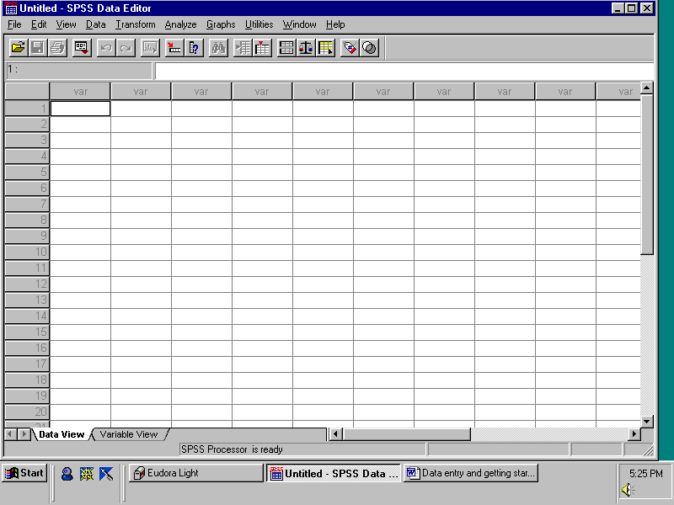

This is what is referred to as the data screen. SPSS has two main screens, the data screen and the output screen. We will talk more about the output screen later on. The data screen has variables across the horizontal axis and cases (data entry points) on the vertical axis. The data screen is where you enter your data and do all the transformations, statistical tests and graphics definitions.
Like Excel®, the data window also has work sheets, one for viewing your data, one for viewing the variables.

The first step in entering data is the naming of variables. To name variables you can either click on the Variable view tab on the bottom left or you can double click on the variable name. Using either method the following screen should be displayed
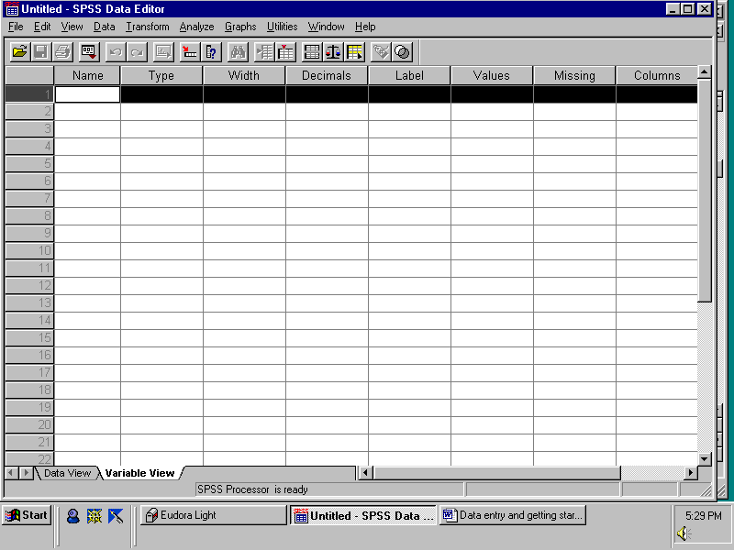

A series of columns will be highlighted and you can enter information into each of them. If we wished to create a variable named “ppm”, we would click on cell 1 under Name and type in ppm.
If you then move to a new cell, SPSS adds by default information into the rest of the cells, apart from the label cell. Variable names in SPSS are limited to eight characters and you should make them descriptive so you can recall what they are for later on.

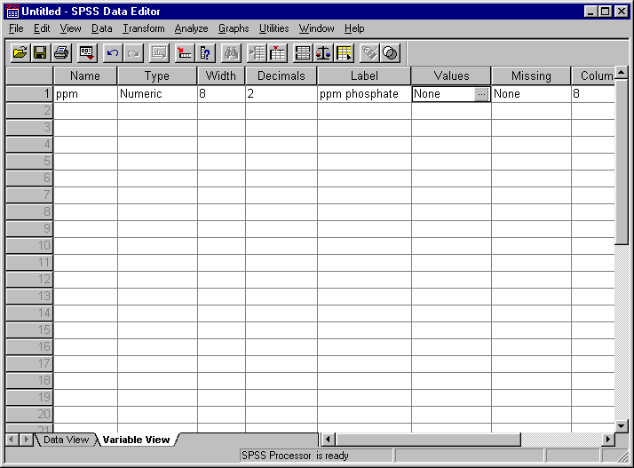
The next useful cell is the Label cell. This allows you to add a description to the name of your variables. It will not show up on the data sheet, but will turn up on the output you generate. In this case, we are going to add the description “ppm phosphate”. The label description is limited to 256 characters.

It is now time to add data into the data sheet.
Click on the Data view tab in the far left hand bottom corner.
Position the cursor in the first cell in the top left hand corner of the data view sheet under the name of the variable. Data entry is similar to a spreadsheet.
Enter the following values in the ppm column 15, 20, 25, 30, 35.
The screen should look as follows

Now double click on the second column heading Var to enter the y-variable (ie you go into Variable view).
We will enter data for Absorbance by clicking on cell 1 under Name and entering Abs and then add an appropriate Label Spectrometer absorbance.
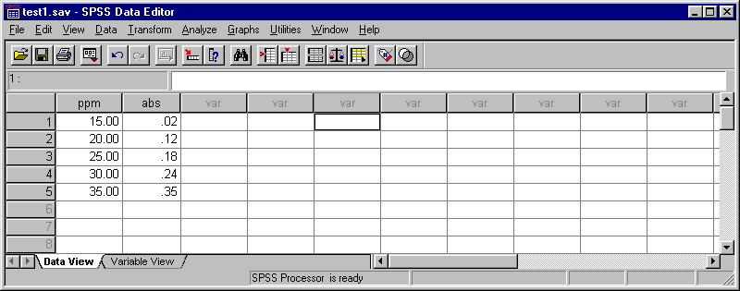
Click on the Data view tab in the far lower left hand corner to return to the Data entry page.
Enter the following values under Abs 0.02, 0.10, 0.18, 0.24, 0.35.
Regressions and Graphing in SPSS version 11

At this point you should save your data from the pull down menu File choose Save As and save the file "yourfilename" to the appropriate place (floppy disk, zip or CD-R). This places the SPSS file yourfilename.sav on the storage medium for later use.

We are now going to graph the calibration data and use SPSS to plot the 95% Confidence Limits on the graph. The calibration data is plotted and a line of best fit is determined using linear regression (the method is linear least squares). The degree of fit is indicated by the R-value which is drawn on the plot, the closer the value is to 1.00 the better the fit; 0.99 for instance is an excellent fit.

We are going to choose the easy way of making graphs called Interactive Graphs.
To plot the graph choose Graphs from the pull down menu and choose Interactive / Scatterplot.
In the Assign Variables tag click (hold down) and drag "ppm phosphate" into the 2nd box down on the right hand side (⎯ →) of the Assign Variables window and click (hold down) and drag "Spectrometer absorbance" into the top box (↑).
This assigns the ppm values to the x-axis and the absorbance values to the y-axis.

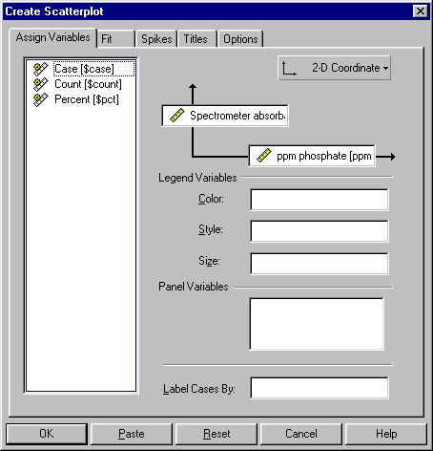

Remaining in the Create Scatterplot window choose the Fit tag.
Under the Fit tag use the Method pull down and enter "Regression".
Click "Include constant in equation" and for the Prediction lines click "Mean".
Leave the confidence interval set at 95%.

Click OK and the graphics processor will open Output Viewer and plot the graph.
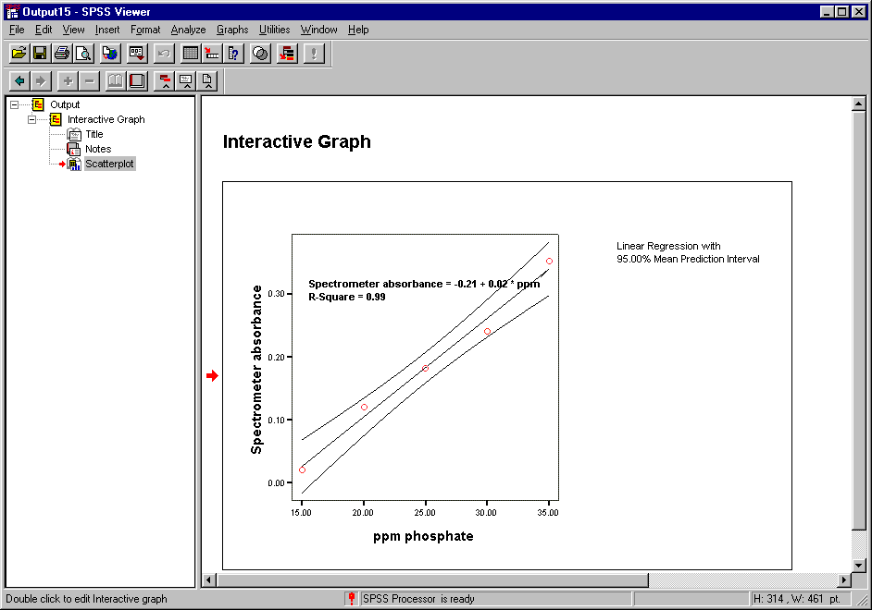

Now we need to do some editing of the graph to make it look useful.

First click on the centre of the graph to enter the graphics editor.
(you will see extra tool bars appear around the graph as in the following picture).
Double click on one of the numbers on the y-axis to enter the axis editor.
Under the Scale tag click the Ticks originate from zero.
Under the Appearance tag click the Minor ticks box.
To add Grid lines which will aid you when you need to draw lines on the graph click the Grid lines tab and then click the Grid lines box - at the outset just leave it set at major ticks as you will use these to aid in taking values off the graph. Click OK.
Double click on one of the numbers on the x-axis to enter the axis editor.
Under the Scale tag click the Ticks originate from zero.
Under the Appearance tag click the Minor ticks box.
To add Grid lines which will aid you when you need to draw lines on the graph click the Grid lines tab and then click the Grid lines box - at the outset just leave it set at major ticks as you will use these to aid in taking values off the graph. Click OK.
Double click on one of your data points on the graph to enter the Cloud editor.
Under the Symbols tag change the point Style to "+" . Click OK.
Click and drag on the label Linear Regression with 95% Mean Prediction Interval and place this in the lower right hand side of your graph (this will allow us to make the plot as large as possible in the Word processor document).

You should now have a graph that looks much like the one over the page.

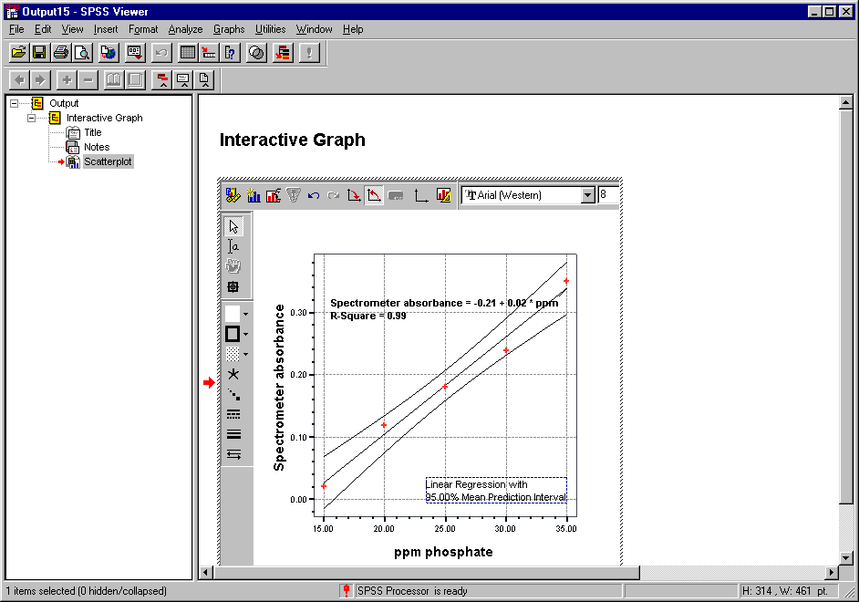

In the Output Viewer click on Scatterplot in the file listing in the small window on the left hand side of the graphics window. This selects the graph for copying (a box will appear around the outside of the graph if you have clicked correctly, if not just try again).
Now in the Edit pull down menu choose Copy.

Your graph is now ready to be pasted into your word processor document.
Next switch to your word processor.
The following instructions assume that you are using Microsoft Word®.
From the pull down Edit choose Paste and the graphic object (the graph) will appear somewhere near your insertion point. The graph may be too large and so with the picture highlighted (there will be little white boxes around the graphic) click on your right hand mouse button and select Format picture. In the Format picture window choose the Size tab and change the Scale / Height to 80% (you must leave the Lock aspect ratio and Relative to original picture size ticked), next go to the Wrapping tab and choose Tight. Click OK.

You are now able to resize the picture as you feel with either the same method or the expander at the corner of the highlighted region, the text will float around the picture.

Enter a title for the graph.

Next we work out the concentration for the unknown. In this case the unknown had a measured value absorbance of 0.15. This is drawn onto the calibration curve (either by hand or using the drawing pallet in Word®) and the ppm value is obtained by dropping a tie-line to the x-axis (N.B. the equation for the line is not sufficiently accurate to use), the value obtained is 22.7ppm.
The statistical error in this concentration arising from the calibration curve is worked out using the confidence limits. The x-axis values for the confidence limits that are at the same y-axis value as the unknown (0.15) are obtained by dropping tie-lines to the x-axis as indicated.
These are the error bars for your measured concentration, here 22.7 ± 1.7ppm (the error is 1.7ppm = (1.8 + 1.6) /2}. You recall that errors are reported to 1 and at most 2 significant figures.

You are now finished plotting your data.

DEMO REPORT

This demo report is for your use as a model of how to write up a practical report. It is not complete and is a mixture of several student reports from CH2041. The function of this report is to be illustrative of the format expected rather than rigorously correct in content.

CH2041 Author: Mike Liddell
Partner : Les Various
Date : 31 / 5 / 99

ASSIGNMENT 21

IDENTIFICATION OF GASES

ABSTRACT
The qualitative analysis of food dyes in jellybeans and the quantitative level of benzoic acid in the soft drink Sprite were obtained by spectrophotometry. The dyes found in the jellybeans (Red10, Blue10, Yellow10) and the benzoic acid concentration in the soft drink (10mg / L) were all within the Australian standards.

1.0 INTRODUCTION

1.1 Toxicology
Toxicology is the science of poisons or toxicants, as they are otherwise known. Toxicants are chemical substances that are harmful to living organisms through their effects on tissues, organs or the biological processes of the organism being studied. The physiological effect of the toxicant on an organism and the toxicant required to cause that effect are the two important aspects which are observed in toxicology. By observing these effects, we can establish the concentration of toxicant which causes the harmful effects (LC₅₀, lethal concentration), a concentration below which there are no harmful effects. This is otherwise known as a Dose-Response relationship.¹

1.2 Gaseous pollutants
Some of the major gaseous pollutants are the oxides of nitrogen, collectively called NO_{x}, these refer to NO and NO₂. These are produced in car exhaust and from subsequent reaction in the atmosphere.

N₂ + O₂  2NO (1)
2NO + O₂  2NO₂ (2)
The method of analysis used for NO_{x} was based on the fact that NO_{x} dissolves in aqueous solutions to form nitrite ions. The nitrite ion collected from cigarette smoke and diesel exhaust was analysed spectrophotometrically by the distinctly coloured azo dye that forms when NO_{x} reacts with sulfanilic acid and 1-napthylamine in acetic acid by the following reaction:
2NO₂ + H₂O  2H⁺ + NO₃⁻ + NO₂⁻ (3)

2.0 EXPERIMENTAL

2.1 pH Determination
Using a pH meter (Beckman 10H), which was calibrated in a pH = 7.0 buffer solution, then rinsed and placed in a pH = 4.01 buffer solution (and adjusted accordingly), we took pH readings from the four water samples obtained, as well as three other samples provided (vinegar, soft drink, washing powder). We placed the electrode into the sample, stirring it around gently and recording the pH meter reading once the meter had became static in it's measurement. The electrode was then rinsed thoroughly and placed in the next sample.

2.2 Hardness of water
50 mL of the two freshwater samples and sewage sample, and 5 mL of the seawater sample were each transferred via pipette into their respective 250 mL flasks. To these, 2 mL of buffer solution was added, and 3-4 drops of EBT indicator. This solution was then titrated with EDTA until the colour changed from wine red to blue. This gave us the total Ca²⁺ and Mg²⁺ concentration

3.0 RESULTS

3.1 Analysis of dyes in jellybeans

Table1 shows the correlation between the expected and observed spectra found in the jelly bean food dyes extracted from the violet and amber jellybeans.

Jellybean Name Expected Absorption Observed Absorption
Maxima (nm) Maxima (nm)
Violet Green10 625 625
Red10 530 531
Amber Yellow10 440 439
Red10 530 530

Table 1. Expected and Observed absorption spectra for food dyes in jellybeans.

The food dye experiment was only carried out on the violet and amber jellybeans as there was insufficient time to conduct the experiment on the purple jellybeans. The green and red dyes of the violet jellybeans were visibly separated on the SepPak cartridge. The red dye was the first to be released followed by the green. Comparison of the spectrophotometric absorbance maxima of the dyes (Figures 1 and 2) to those of known dyes (Appendix I) identified the dyes and red10 and green10 in the violet jellybeans.

3.2 Analysis of benzoic acid in soft drink
The data reported in Table 2 show the variation in absorbance of the standard solutions of benzoic acid at various concentrations. From the calibration curve (Figure 3) it was found that the soft drink (absorbance of 0.280) contained 50.1 mg / L in the diluted sample. This figure was multiplied by four to allow for the dilution (25 mL of sample was made up finally in 100 mL of solution) to give a final value of 198.8 mg / L of benzoic acid in the soft drink.

4.0 DISCUSSION

4.1 Standard NaOH
The actual titre values of the prepared NaOH solution were larger than the calculated values and the calculated concentrations of NaOH were larger than the actual values. This may be due to Na₂CO₃ being present. Standard deviations and relative standard deviations were small, indicating either superior analytical skills or more likely too few samples for the statistics to be significant.

4.2 'tris' buffer
The calculated volume of 0.188 M NaOH required to reach a pH of 7.60 (33.37 mL) was lower than the actual volume used (33.96 mL) due to human error (NaOH concentration) and the deficiencies in the calculation of the pH using the Henderson-Hasselbach equation.

REFERENCES
1. S.E. Manahan, Environmental Chemistry, 6th Edition, Lewis, Boca Raton, 1994, pp 102-120.

APPENDIX I

- Calculation for concentration of NaOH required for titration with KHP samples
Sample 1: c = n / V = 4.29e-3 mol / 24.95e-3 L = 0.1880 M

- Weight of 0.025 mol of trishydrochloride
m = n x M = 0.025 mol x 157.597 g/mol = 3.940 g

ASSIGNMENT 1
ERRORS OF OBSERVATION AND THEIR TREATMENT

AIMS
This assignment does not involve any experimental procedures but rather deals with the subject of error analysis which was only briefly mentioned in CH1011. The problems dealt with in the assignment relate principally to experiments carried out in first year Chemistry and will prepare you for carrying out error analysis in the subsequent assignments in CH2041 when it is required – which is nearly always!

1. INTRODUCTION

In taking a scientific measurement it is essential to know the accuracy and precision of the measurement. The accuracy is how close the value is to the true value while the precision is the magnitude of the error. The value 27.005± 0.005 has low accuracy and high precision with respect to the true value 30.0000, while the value 30.1± 0.7 has high accuracy and low precision.

In this assignment we are concerned with precision, that is how we deal we errors. For everyday use precision may not be of much importance but in scientific work it is of critical importance. Therefore, it is a waste of time to make a measurement without also determining its precision. This is then presented by quoting an "error" in that measurement. In the example above this is done by writing
a) distance = 30 ± 5 km or b) distance = 30.000 ± 0.001 km.

What this means should become clearer as we look at 'errors' in more detail.

1.1 Error in a single measured quantity

Let us begin by looking at the error in a single quantity such as the distance between two points. In measuring any particular property or quantity, x the observed value, x_{obs} is always slightly different from the true value x_{t} Although it may be impossible to know the true value it is possible to set limits within which the true value must lie and, in this case, to determine that x_{t}, lies between x_{obs} -E(x) and x_{obs} +E(x). The quantity E(x) which defines the region about x_{obs} is called the error in x. Since the true value lies within this region the value of x is written as
$x=x_{\text{obs}}±E(x)$
or, including the units, as $x=[x_{\text{obs}}±E(x)]\text{units}$

$e\text{.}g\text{.}T=(\text{245}\text{.}3±0\text{.}3)K$

1.2 Estimated error.

One way of determining E(x) is by estimation and this is frequently used. Take, for example, reading the liquid level in a burette. My best estimate of this reading (V) is 7.37 cm³ but I believe the value could be as low as 7.36 cm³ or as high as 7.38 cm³. Therefore
$V=(7\text{.}\text{37}±0\text{.}\text{01}){\text{cm}}^{3}$
Note that the value of the estimated error is half the difference between the extreme values!

Similarly, in reading a thermometer where the value lies between 34.5⁰C and 34.7⁰C the temperature is written as
T = (34.6 ± 0.1) ºC

$T=(\text{34}\text{.}6±0\text{.}\text{01})°C$

Again in reading the absorbance from a spectrophotometer if the value lies between 0.134 and 0.136 then:
$A=0\text{.}\text{135}±0\text{.}\text{001}$
reading = 0.135 ±0.001 (RE: 1/135, 0.7%)

1.3 Truncation error

In reading a digital display it should be kept in mind that the readings are truncated so that a value of 849.4 lies somewhere between 849.35 and 849.45 and should be written as 849.4±0.05. The error of +0.05 is called a truncation error. Often such displays will not give a steady value but show readings which vary over a small range e.g. between 849.3 and 849.5 so that the value lies between 849.25 and 849.55 giving 849.4 ± 0.15. Note that the error is not half the difference between the two extreme values indicated on the display but is equal to that difference plus 1 unit then divided by two due to the truncation error.
849.5
849.4
849.3

Values found from the literature are also normally truncated. Thus the value of the gas constant is given as R=8.314 J K⁻¹ and this should be interpreted as meaning R=(8.314±0.0005) J K⁻¹ mol⁻¹, note that the error contains one more decimal place than the value! Normally they should contain the same number of decimal places. Truncation errors are the ONLY exception to this rule.

1.4 Statistical evaluation of the error

Standard Deviation.
A better approach than estimation for error analysis is to repeat the measurement a large number of times. If the measurement is obtained N times (N is the number of samples) as honestly and as accurately as possible a number of different values will be obtained, a best estimate of the (true) value x_{t} is the mean (arithmetic mean, average) $(\bar{x})$of all of these measurements.

$$\bar{x}=\frac{S_{i=1}^{N}x_{i}}{N}$$

Instead of an estimated error it is now possible to calculate a well defined statistical error which indicates the spread of the values, the standard deviation σ is given by:

$$σ=\sqrt{\frac{Σ_{i=1}^{N}(x_{i}−\bar{x})^{2}}{\left(N−1\right)}}$$

This formula is for the standard deviation of the entire population of samples, where there are N samples in total. As an example if there are a set of samples 1345, 1301, 1368, 1322, 1310, 1370, 1318, 1350, 1303, 1299 then the mean of this set is 1328.6 and the standard deviation is 26.055 which, as it indicates the random error, is rounded to 26. The mean value for this set of samples would be 1329 ± 26 to 1 standard deviation.

When it is necessary to compare estimated errors and standard deviations a good rule is to take a deviation to be about half of an estimated error. You must, therefore, say if you are using estimated or standard deviations (statistically derived errors).

Sometimes, particularly where the error is a standard deviation, a measurement is written not as

$$T=(\text{245}\text{.}3±0\text{.}3)K\text{ or }p=(\text{101}\text{.}4±1\text{.}1)\text{kPa}$$

but, instead, as

$$T+\text{245}\text{.}3(3)K\text{ or }p=\text{101}\text{.}4(\text{11})\text{kPa}$$

NOTE the lack of decimal points in the later cases; the numbers in brackets refer to the standard deviation in the last figures in the value itself.

When a large number of measurements of a value are made the values will vary around the mean value in a characteristic distribution. In repeated analytical measurements of a quantity a Gaussian or normal sampling distribution is observed (at least approximately) where
68% of the samples lie within ±1σ of the mean.
95% of the samples lie within ±2σ of the mean.
99.7% of the samples lie within ±3σ of the mean.

Confidence Limits of the Mean.
Another way of expressing the error in a measurement is based on the characteristics of the normal distribution. In an analysis we are trying to specify the correct value for the analysis x_{t}. We can provide a range of values about the mean of our measured values where this correct value is to be found. This range is provided by calculation of the confidence limits which are given by:
$x= \overline{x} ± t\left(\frac{σ}{\sqrt{N}}\right)$
Where t is worked out from the degrees of freedom = N-1.

Values of t for confidence intervals.
Degrees of Freedom Values of t for confidence limit of
95% 99%
1 12.71 63.66
2 4.30 9.92
3 3.18 5.84
4 2.78 4.60
5 2.57 4.03
10 2.23 3.17
50 2.01 2.68

For instance if we have calculated a mean of a sample of 5 values to be 121.4mM with a standard deviation of 1.3mM then the 95% confidence limits are:
x = 121.4 ± 2.78(1.3 /√5)
x = 121.4±1.6mM

As you can see this is another way of expressing the error in a value obtained from a set of repeated measurements, the confidence limits of the mean – in analytical chemistry normally the 95% limits are used.

1.5 Significant figures in the error

In the examples above the errors are to one (e.g. 0.2 and 0.3) or two (e.g. 3.4) significant figures. This practice is universal.
Errors are approximate and are quoted to one, or AT MOST two, significant figures.

Usually two figures are used only when the first figure in the error is a 1 or a 2 or confidence limits are used.

1.6 Relative and percentage errors

Sometimes there is an advantage in considering the relative or fractional size of errors. The relative error is given by

$$\text{RE}(x)=\frac{E(x)}{x}$$

and gives the fraction of x which is uncertain. Often it is convenient to present the relative error as a percentage
$$\text{RE}(x)\text{\%}=\frac{E(x)}{x}\text{x }\text{100}\text{\%}$$

Relative errors are loosely related to significant figures. A 10% error (percentages are always relative errors) means about two significant figures. For example, 90±9 has two significant figures and a 10% error. Generally a 10% error means about two significant figures, a 1% error three, a 0.1% error four significant figures and so on. However, 100 ± 7 has three significant figures while 90 ± 6 has only two significant figures - both have a 7% error, so this is a rough and ready estimate.

If we are working with standard deviations then in a similar manner we can work with the relative standard deviations.

$\text{RE}\left(σ_{x}\right) = \frac{σ}{x}$

2. ORIGIN AND NATURE OF ERRORS

Errors are of two basic types random and systematic errors.
Random errors are revealed by repeated measurement and can be estimated, or evaluated, as described above.
Systematic errors are introduced by the measuring device and are not revealed by repeated measurement. They may be quite difficult to detect.

Take the measurement of a length using a ruler. As usual repeated measurement of the distance between points will give slightly different results; due to a 'random error' in measurement. However, if the ruler was marked at one temperature and used at another all the measurements will be in error due to thermal expansion or contraction of the ruler. This additional error is a systematic error. The ruler should be recalibrated at the new temperature.

(Of course any calibration is not perfect but the error involved in calibration is a measurable random not an unknown systematic error).

Systematic errors are best dealt with by calibration. Alternatively they may be estimated in some way (often from the manufacturer's specifications). Systematic errors for volumetric apparatus are called tolerances typical values are given in the Appendix. They do, however, vary somewhat and are often inscribed with other information, on the glassware. An example of this is shown for a pipette.

The total error is the sum of the systematic and random errors.

3. ERROR IN A CALCULATED QUANTITY
- THE PROPAGATION OF ERRORS

Now consider the error in a quantity calculated from other quantities in which the error is known for each quantity. Only the error in a particular measured quantity has been considered so far. There are a few simple rules which may be used to calculate the total error.
In using these rules it must be kept in mind that errors are only calculated to 1 (at most 2) significant figures. This means that any contribution which is less than one tenth of any other may be neglected! It also means that such calculations, being approximate, may, with practice, be carried out very quickly.
Random errors involved are always entered in the following calculations as positive numbers.
Systematic errors must be entered with the correct sign (frequently systematic errors can cancel out!).

RULE 1: It is never necessary to keep more than 2 significant figures in error calculations.

RULE 2: If any single contribution is less than one tenth of another contribution then it is neglected.
(N.B. with a computer rule 2 would not be used).

3.1 Sums and differences

If a quantity A is given by

$$A=B+C\text{ or }A=B−C$$

where the errors, E(B) in B and E(C) in C, are known. Then the absolute error E(A) in A is given by
$$E(A)=E(B)+E(C)$$
$E(A)=E(B)+E(C)$

This may be extended to any number of sums and differences as long as only sums and differences are involved.

Example:

In a titration the initial and final burette readings are

$\text{initial: }V_{i}=(5\text{.}\text{44}±0\text{.}\text{02}){\text{cm}}^{3}$ $\text{final: }V_{f}=(\text{23}\text{.}\text{68}±0\text{.}\text{02}){\text{cm}}^{3}$

The titre value V is the difference between them so that the error in the titre is the sum of the errors giving

$$V=V_{f}−V_{i}=(\text{18}\text{.}\text{24}±0\text{.}\text{04}){\text{cm}}^{3}$$

3.2 Products and quotients

If $A=\text{BxC}\text{, or if }A=\frac{B}{C}\text{, or if }\text{ A}=\frac{C}{B}$

Then we use relative errors RE(X):
$$\text{RE}(A)=\text{RE}(B)+\text{RE}(C)$$
$$\text{RE}(A)=\text{RE}(B)+\text{RE}(C)$$
or
$$\frac{E(A)}{A}=\frac{E(B)}{B}+\frac{E(C)}{C}$$

This may be extended to any number of products and quotients as long as only products and quotients are involved. Remember that relative errors may be given as percentages.

Example:
If a solution contains n = (0.135 ± 0.003) mol of solute X in a volume V = (1.104 ± 0.002) dm³ of solution then the concentration [X] is

$$[X]=\frac{n}{V}=0\text{.}\text{122282608}{\text{ mol dm}}^{−3}$$

To find the error in this value apply rule (2) to give

$$\text{RE}([X])=\frac{E([X])}{[X]}=\frac{E(n)}{n}+\frac{E(V)}{V}=\frac{3}{\text{135}}+\frac{2}{\text{1104}}=\frac{1}{\text{45}}+\frac{1}{\text{551}}$$

Since the denominator in the second term is more than ten times the denominator in the first term, then it should be neglected giving

$$\text{RE}([X])=\frac{E([X])}{[X]}=\frac{1}{\text{45}}$$

We now have the relative error RE([X]) in the final result which must be converted to an absolute error E([X]). To obtain E([X]), the error in [X], rearrange the expression for RE ([X])

$$E([X])=X\text{ x }\text{RE}([X])$$
so that
$$E([X])=0\text{.}\text{12228}\text{ x }1/{\text{45}}=0\text{.}\text{0027}=0\text{.}\text{003}$$

giving
$$[X]=(0\text{.}\text{122}±0\text{.}\text{003}) {\text{mol dm}}^{−3}$$

Alternatively, using percentage errors

$$\text{RE}([X])=\text{RE}(n)+\text{RE}(V)=\frac{3}{\text{135}}\text{x }\text{100}\text{\%}+\frac{2}{\text{1104}}\text{x }\text{100}\text{\%}=2\text{.}2\text{\%}+0\text{.}\text{18}\text{\%}=2\text{.}4\text{\%}$$

So the error is 2.4% of 0.12228 mol dm⁻³ = 0.003 mol dm⁻³ giving

$$[X]=(0\text{.}\text{122}±0\text{.}\text{003}){\text{ mol dm}}^{−3}$$

3.3 Natural logarithms

If
$$Y=\text{ln}(X)$$
then
$$E(Y)=\frac{E(X)}{X}\text{ or }E(\text{ln}X)=\frac{E(X)}{X}$$

so that the error in ln X equals the relative error in X!

Example:
If $x=0\text{.}\text{104}±0\text{.}\text{006}$ then $\text{ln}x=−2\text{.}\text{26}±0\text{.}\text{06}$ since $E(\text{ln}x)=\frac{E(x)}{x}=\frac{0\text{.}\text{006}}{0\text{.}\text{104}}=0\text{.}\text{06}$

4. SIGNIFICANT FIGURES

The way in which a value is quoted, the number of significant figures, is determined by its error.
The error (± value) is determined by estimated errors, truncation errors, standard deviation or confidence limits and if necessary using propagation of errors to build up a total error. The error is used to determine the significant figures in the value itself, the error determines the last significant digit in the value.

e.g. $T=(\text{259}\text{.}\text{28}±0\text{.}\text{03})K$
but not
$T=(\text{259}\text{.}\text{2834621}±0\text{.}\text{03})K$ (too many significant figures)
and not
$T=(\text{259}\text{.}3±0\text{.}\text{03})K$ (too few significant figures)

The temperature $T=(\text{259}\text{.}\text{28}±0\text{.}\text{03})K$
is known to five significant figures.

Although expressions such as:

$p=(\text{235},\text{000}±2,\text{000})\text{Pa}$ and $l=(0\text{.}\text{00334}±0\text{.}\text{00005})m$

are not incorrect, they are clumsy and forms should be used such as:

$p=(\text{235}±2)\text{kPa}$ or $p=(0\text{.}\text{235}±0\text{.}\text{002})\text{MPa}$ and $l=(3\text{.}\text{34}±0\text{.}\text{05})\text{mm}$

Finally forms such as

$p=(2\text{.}\text{35}x{\text{10}}^{5}±2x{\text{10}}^{3})\text{Pa}$ and $l=(3\text{.}\text{34}x{\text{10}}^{−3}±5x{\text{10}}^{−5})m$

in which different exponents are used for the quantity and error, should NOT be used.

DON’T ROUND EARLY IN PROPOGATION OF ERROR CALCULATIONS
Until the correct number of significant figures has been determined it is important to keep at least one more significant figure than the least accurate value used to obtain the final value.

6. ERRORS IN SLOPES AND INTERCEPTS FROM GRAPHS

Often measurements are made of the changing value of some property as another property is altered; the two properties are measured together. An example is measurement of the vapour pressure of a liquid at different temperatures. Usually the form of the dependence is known from theory and it is the parameters involved in the relationship which are extracted from such measurements.

In the example mentioned the variation of vapour pressure p with temperature T is given by

$$\text{ln}\frac{p}{p^{0}}=−\frac{{ΔH}_{υ}^{0}}{\text{RT}}+\frac{{ΔS}_{υ}^{0}}{R}$$

where p⁰ = 1 atmosphere,${DH}_{u}^{0}$ is the standard heat of vaporisation, ${DS}_{u}^{o}$ is the standard enthalpy of vaporisation and R is the gas constant.

Most usually the relationship is manipulated to that it corresponds to the equation for a straight line which is often written as
$$y=\text{mx}+c$$

where x is the independent variable, y is the dependant variable, m is the slope of the straight line and c is the "intercept" (the value of y at x = 0). In the example given the equation does have this form with

$y=\text{ln}\frac{P}{P^{0}},$ $x=\frac{1}{T},$ $m\text{=-}\frac{{DH}_{u}^{O}}{R}$ and $c=\frac{{ΔS}_{v}^{o}}{R}$
Therefore ${DH}_{u}^{0}$ and ${DS}_{u}^{o}$ may be found by
1) plotting (ln(p/p⁰) against 1/T
2) drawing a line of best fit through these points
3) using the slope m and intercept c in the equations above to obtain ${DH}_{u}^{0}$ and ${DS}_{u}^{o}$

Due to uncertainty in the experimental measurements the points will not lie exactly on a straight line but will be scattered about it. The problem, then, is how to determine the "best" possible line for the real data. This is done using the method of least squares (also called linear regression). In this method it is assumed that all of the experimental error is in the y values and that the values of x are known exactly. The line of best fit is then taken to be that line for which the sum of squares of the vertical distances of the points from the line of best fit is a minimum. These vertical distances are called residuals and the criterion is that the sum of squared residuals is a minimum. This condition can be used to obtain equations which allow the slope and intercept to be obtained from the data.

The calculations involved in obtaining slope and intercept in this way can be tedious and are normally done using a computer program. In the introductory section “Using SPSS for plotting calibration graphs in CH2041” you are introduced to how to use linear regression to fit data with the statistical package SPSS.

7. WRITE UP

You will find a series of problems in error analysis detailed in your report book. These you will work through at you own speed with assistance from the demonstrator as required. To be carried out individually.
APPENDIX

Table 1. Tolerances (systematic errors) and drainage times for pipettes

volume/cm³ | 2 | 5 | 10 | 20 | 25 | 50 | 100
discharge time/s | 7-15 | 10-20 | 15-25 | 25-30 | 20-35 | 25-40 | 30-50
tolerance/cm³ (Grade A) | 0.01 | 0.02 | 0.02 | 0.03 | 0.03 | 0.04 | 0.06
tolerance/cm³ (Grade B) | 0.02 | 0.03 | 0.04 | 0.05 | 0.06 | 0.08 | 0.12

Table 2. Tolerances (systematic errors) for burettes

volume/cm³ | 2 | 5 | 10 | 25 | 50 | 100
tolerance/cm³ (Grade A) | 0.01 | 0.02 | 0.02 | 0.04 | 0.06 | 0.10
tolerance/cm³ (Grade B) | 0.02 | 0.03 | 0.04 | 0.08 | 0.10 | 0.20

Table 3. Tolerances (systematic errors) for volumetric flasks

volume/cm³ | 5 | 10 | 25 | 50 | 100 | 250 | 500 | 1000 | 2000
tolerance/cm³ (Grade A) | 0.02 | 0.02 | 0.03 | 0.04 | 0.06 | 0.10 | 0.15 | 0.20 | 0.4
tolerance/cm³ (Grade B) | 0.03 | 0.03 | 0.04 | 0.06 | 0.10 | 0.20 | 0.30 | 0.40 | 0.

Table 4. Corrections for thermal expansion to be applied to volumetric apparatus.

Temperature/⁰C | 5 | 10 | 15 | 20 | 25 | 30
volume% (Glass*) | -0.039 | -0.026 | -0.013 | 0.000 | 0.013 | 0.026
Factor (Glass*) | 0.99961 | 0.99974 | 0.99987 | 1.00000 | 1.00013 | 1.00026
volume% (Water) | 0.137 | 0.124 | 0.077 | 0.000 | -0.103 | -0.230
Factor (Water) | 1.00137 | 1.00125 | 1.00077 | 1.00000 | 0.99897 | 0.99770
Factor (Overall) | 1.00098 | 1.00098 | 1.00064 | 1.00000 | 0.99910 | 0.99796

*the coefficient of thermal expansion for glass is taken as 2.6x10⁻⁵ K⁻¹. The volume of the apparatus is then multiplied by the Factor at a given temperature to correct for thermal expansion.

ASSIGNMENT 2
AIR SAMPLING AND ANALYSIS:
NO_{x} AND PARTICULATE MATTER

AIMS
Familiarization with the sampling of gases and particulate matter in air using colorimetric determination of NOx and gravimetry for the determination of total particulate matter.

1. INTRODUCTION

Air quality has become of great importance in contemporary society. In large cities such as Melbourne and Sydney significant levels of air-borne pollutants have been evident since the 1970's. As a result both cities have set up large air-quality monitoring networks within their Environmental Protection Agencies. The oxides of nitrogen are receiving a great deal of attention as major air pollutants. They are important because they participate in many photochemical reactions and are largely responsible for the formation of the ”brown haze” of smog, the accompanying eye irritation and other physiological effects. Of the possible nitrogen oxides, only nitric oxide (NO) and nitrogen dioxide (NO₂), together referred to as NO_{x}, are of major concern in air pollution studies.

NO is present in automobile exhaust at levels ranging from a few parts per million to several thousand ppm. The toxicity of NO is similar to that of carbon monoxide because it too combines strongly with hemoglobin in the blood. During the combustion of fossil fuels, nitrogen and oxygen in the air used combine at high temperature to form NO.
Δ
(1) N₂ + O₂  2 NO

Most of the NOx that is emitted in automobile exhaust is in the form of NO. Nitrogen dioxide begins to form by the reaction on NO with excess oxygen and is a minor product.
(2) 2 NO + O₂  2 NO₂

NO₂ is a brown pungent gas. Concentrations of 20-50 ppm NO₂ are irritable to the eyes. At only 150 ppm there is danger of strong local irritations especially to the respiratory organs.

The measurement of NO_{x} concentrations in this experiment is based upon the fact that NO_{x} dissolves in aqueous solutions to form the nitrite ion. Nitrite reacts with sulfanilic acid and 1-naphthylamine in acetic acid to give an azo dye which can be analyzed spectrophotometrically. The NO₂ reaction with water is:

(3) 2 NO₂ + H₂O  2 H⁺ + NO₃⁻ + NO₂⁻

where the NO₂ to NO₂⁻ ratio is expected to be 2:1. However, chemists have determined experimentally that 1.39 mole of NO₂ produces the same colour intensity as 1 mole of NO₂⁻ ion. This empirical observation is made use of in the final NO_{x} calculations. Only NO₂⁻ reacts with the colour producing reagent. The gas being analyzed is allowed to stand undiluted in the presence of the indicator reagent until the reaction given by equation (3) has essentially occurred to completion. By doing this, the total NO_{x} concentration (NO + NO₂) is determined. Because particulate matter would interfere with the colorimetric procedure described above, it is quantitatively filtered from the smoke or exhaust gas by means of a membrane filtration device. The number of milligrams of particulates on the filter is determined on an analytical balance by weighing the filter before and after it has been used.
2. EXPERIMENTAL
2.1 General Sampling procedure
You will prepare a special sampling device that uses a membrane filter to trap particulate matter and an indicator solution to trap NO_{x} .
Preparation of filters.
Obtain four membrane filters handling them only by the edge (there are blue backings on the papers and the papers are white). You require 2 x 1.2μm filters (smoke) and 2 x 0.2 μm filters (exhaust). Finger prints on the surface will greatly impair their filtering capacity. They should be handled gently to avoid poking holes in them or cracking them. Transfer them to petri-dishes that have been labelled (1 - 4). Place in a drying oven for 30 minutes at 50ºC. Transfer the petri-dishes to a dessicator and leave to cool for 10 minutes. Weigh each filter separately on an analytical balance to the nearest 0.0001 g . Remember the weighing protocol is: zero balance, weigh dish, check the zero, weigh dish; until consistent weights are obtained.
(Remember to label the petri dishes clearly).
Preparation of sampling device.
Place a filter (eg. cigarette uses 1.2 μm) in the filter holder, and carefully connect the two holder halves tightening them snugly and being sure that the filter seats properly. Attach the membrane filter apparatus to an empty 60 mL syringe.

Rinse four other 60 mL syringes with a few millilitres of indicator reagent and then fill two with exactly 20 mL of the NO_{x} indicator and two with exactly 5mL of NO_{x} indicator.
CAUTION: the NO_{x} indicator is toxic and corrosive.
Make sure in each case that air bubbles have been expelled from the syringe along with any excess solution. Cap the syringes with parafilm and number them following the same scheme that was used for the filters.
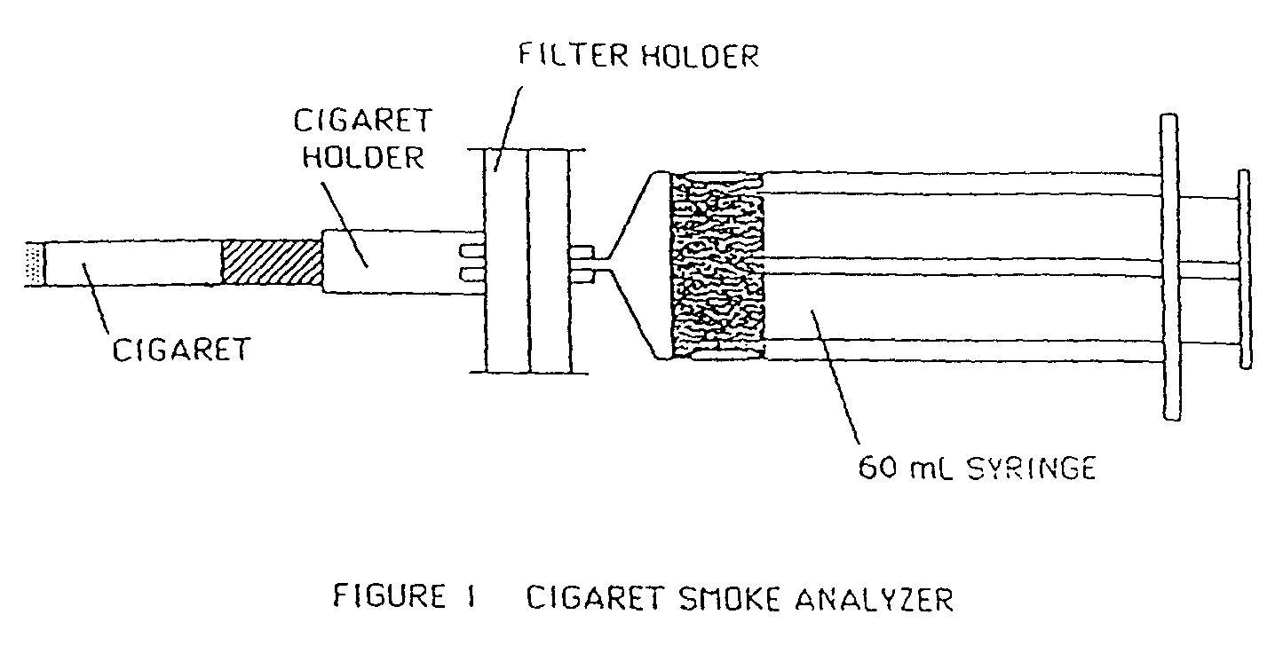

2.2 Cigarette Smoke
Connect the cigarette holder to the filter holder (see Figure 1) containing a 1.2μm filter. Make sure the membrane filter is very securely attached to the syringe each time you attach it (any leaking of air into the syringe will invalidate the readings especially NO_{x}). Light a cigarette making sure that the entire tip is smoldering. Immediately place it in the cigarette holder and use the empty 60 mL syringe to draw a 35 mL puff of two-seconds duration (the intensity of the burn is important and the timing as a result is critical for reproducibility). Between puffs, the filter apparatus should be disconnected from the syringe to expel the filtered smoke into the air. Any visible cloudiness in the filtered smoke indicates that the millipore filter is either perforated or seated incorrectly. Wait one minute and draw a second 35 mL puff. After the second puff, the cigarette and filter holder should be transferred to the first indicator syringe containing 20 mL of reagent. When one minute has elapsed since the second puff, draw a 35 mL, two-second puff through the filter into the indicator syringe. This will necessitate pulling the plunger to the 55 mL mark (watch for the vacuum it can be substantial).

Disconnect the filter holder from the syringe, cap the syringe (parafilm), and shake vigorously. Allow the filtered smoke to remain in the syringe for at least 30 minutes with occasional shaking.
The cigarette should be discarded and the membrane filter removed from its holder, transferred to the correct petri-dish and dried at 50ºC for 30 minutes.
When the colour development in the syringe is complete (at least 30 minutes) expel all gas from the syringe while retaining the exposed indicator in the syringe. Draw 20 mL of unexposed indicator into the syringe. This dilution to a total of 40 mL is necessary to produce a colour intensity which can be read with the spectrophotometer.

Carry out a duplicate determination for which you will use a new filter (1.2μm) and a second syringe containing 20mL of indicator.
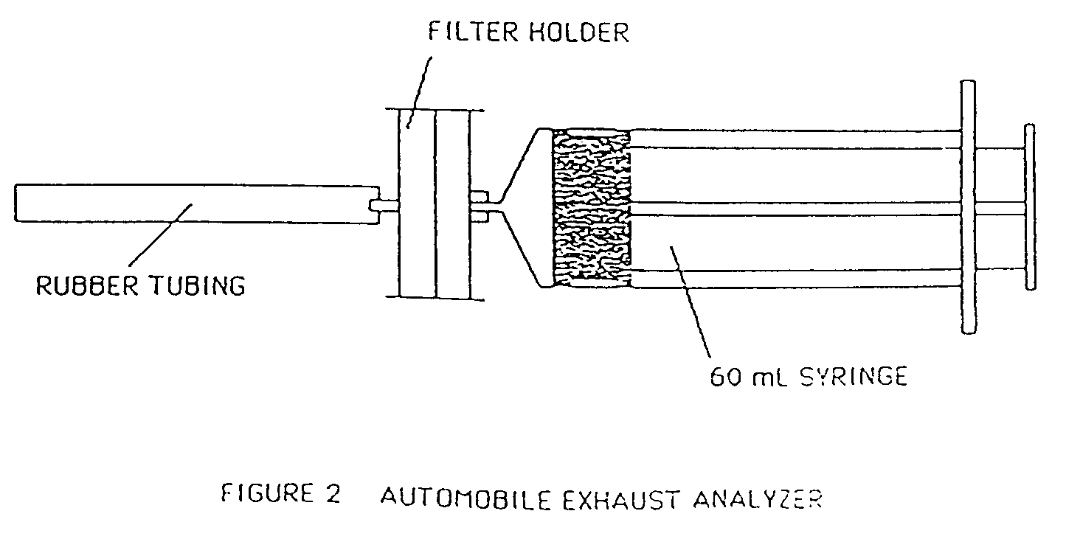
2.3 Engine Exhaust
Replace the cigarette holder on the membrane filter holder with a short (3-4 inch) piece of rubber tubing (see Figure 2). Place a new 0.2μm filter in the holder and connect the holder to an empty syringe. Use the empty syringe to draw sixty 50 mL aliquots of exhaust gas from an idling internal combustion engine through the filter. (The draw rate is not important in this case.) Remove the syringe and transfer the filter holder to a syringe containing 5 mL of indicator reagent. Draw 55 mL of exhaust through the filter into the syringe by pulling the plunger to the 60 mL mark. Disconnect the filter holder from the syringe, cap the syringe, and shake vigorously. Allow the filtered exhaust gas to remain in the syringe with the 5 mL of indicator for at least 30 minutes with occasional shaking.

The membrane filter should be removed from it’s holder, transferred to the correct watch glass and dried at 50ºC for 30 minutes.

Carry out a duplicate determination for which you will use a new filter (0.2μm) and a second syringe containing 5mL of indicator.

2.4 Colorimetric Standards
(These should be prepared during the 30 minute colour development period)
(1) Using a 10 mL syringe, add 0.50 mL of 5.0 μg /mL NO₂⁻ solution to a 25 mL graduated cylinder. Dilute to the 25 mL mark with NOx indicator. Mix and pour 10 - 20 mL into a labelled test tube and stopper it securely. Discard the remaining solution and rinse the graduated cylinder with distilled water.

(2) Repeat the above procedure with 1.00 mL, 2.00 mL, 3.00 mL and 4.00 mL of stock nitrite solution. The concentrations of NO₂⁻ represented by the four standards are 0.10 μg /mL, 0.20 μg /mL, 0.40 μg/mL, 0.60 μg /mL, and 0.80 μg /mL, respectively. All five standard solutions should be kept in stoppered test tubes for 15 minutes or longer to ensure complete colour development.

2.5 Gravimetric Analysis
Reweigh all four membrane filters and determine the number of grams of particulate matter by subtraction. Convert grams of particulate matter to milligrams of particulate matter. Use equation (4) to calculate the number of milligrams of particulate matter per cubic meter of sample.

(4) mg/m³ = mg particles, x (10⁶ mL / m³)
total mL sampled

2.6 Colorimetric Analysis
With the spectrophotometer set to a wavelength of 550 nm, measure the absorbance of the five standards using unexposed NOx indicator as a blank (transfer the solutions into the cuvettes using pasteur pipettes).. Plot a standard curve , absorption versus concentration.
Measure the absorbance of the four exposed indicator samples and using the standard curve determine the concentration of nitrite ion (NO₂⁻) in each exposed indicator solution.

3. CALCULATIONS AND QUESTIONS

In your report you should include the following.
a. Cigarette brand: Filter: (Yes / No)
b. Engine Make: Model: Year:

3.1 Particulates
(i) Mass of filter in grams after sampling
(ii) Mass of filter before sampling
(iii) Grams of particulates
(iv) Milligrams of particulates
(v) Volume (in mL) used for particulate sampling
(vi) Concentration of particulates in mg /m³
(vii) Average mg /m³ for cigarette
(viii) Average mg /m³ for engine

3.2 NOx

Absorbance of Standards
0.10 μg NO₂⁻ /mL ______________
0.20 μg NO₂⁻ /mL ______________ 0.40 μg NO₂⁻ /mL ______________
0.60 μg NO₂⁻ /mL ______________ 0.80 μg NO₂⁻ /mL ______________

From these values plot a standard calibration curve.

Use equation (2) to calculate the number of micrograms of NOx per litre in the 4 samples.

μg NOx/L = mg NOx/m³ = (μg NO₂⁻ /mL) x (Vi/Vg) x (1.39) x (1000 mL/L) ( 2)

where 1.39 is the factor for converting NO₂⁻ to NO₂,
V_{i} is the total volume of indicator used, (40 mL for smoke, 5 mL for exhaust),
V_{g} is the volume of gas sampled, (35 mL for smoke, 55 mL for exhaust).

Calculate the concentration in parts per million using equation (3).

ppm NOx = [(μg NOx /L) /46] [RT/P] (3)

where R is the gas constant (0.082 L atm K⁻¹ mol⁻¹, N.B. this has different units to R=8.314 J mol⁻¹ K⁻¹),
T is the absolute temperature (300 K), P is the pressure (1 atm), and 46 is the molecular weight of NO₂.

Cigarette Engine
1 2 3 4
Absorbance of exposed indicator sample
NO₂⁻ concentration (μg /mL)
Concentration of NOx (mg/m³)
Concentration of NOx (ppm)

Finally, calculate the average concentration of NOx in ppm for the cigarette and for the engine exhaust.

Cigarette Engine

Average [NOx] (mg/m³)
Average [NOx] (ppm)

Reference:
The current guidelines for air quality standards can be found in:
http://www.epa.qld.gov.au/environmental_management/air/air_quality_monitoring/air_pollutants/
ASSIGNMENT 3
MEASUREMENT OF WATER QUALITY - I

AIMS
An introduction to several common analytical procedures used in assessing water quality. The first week will look at pH and the determination of Dissolved Oxygen (DO) using the Winkler method. The Biochemical Oxygen Demand (BOD), Total and Suspended Solids tests will be commenced. No report is due this week. Only one combined report is due after completion of both Assignments 2 and 3.

1. INTRODUCTION

The parameters that are usually measured in natural waters are Temperature, Dissolved Oxygen, Conductance (or Salinity), and pH. Some commercial instruments are available that measure several or all of the above parameters and can carry out these measurements remotely for the purpose data logging. The interaction of the water with sample containers and the degassing that happens in water occurring during sample transport mean that these parameters should be measured in situ if possible.

1.1 Determination of pH
The pH of an aqueous solution may be easily measured with a pH meter by immersing a combination electrode (or two separate electrodes) into a container of the water sample. The reference electrode supplies a constant potential and the pH sensitive electrode (sensitive to H⁺) supplies a variable potential depending on the H⁺ ion concentration. The pH meter is calibrated with standard buffer solutions having known pH values. Calibration is made with buffer solutions of appropriate ionic strength to ensure accurate pH measurements. The pH meter gives a much more precise measurement of pH than indicator paper and is used whenever accurate determinations are needed.

1.2 Total and Suspended Solids
Although some water contaminants may be gases (like dissolved ammonia) or liquids (like oil), the majority of the common contaminants are dissolved or suspended solids. Sea water (although it may not necessarily be polluted) has an overall dissolved salt content of 35,000 ppm. In general, water is considered to be a salt water if it contains over 3,000 ppm dissolved solids, brackish water if it contains 500 - 3,000 ppm dissolved solids, and fresh water if it contains less than 500 ppm.
In the present experiment, no attempt will be made to determine the nature of any individual dissolved or suspended solid in a water sample. The purpose is simply to measure the combined or total concentration of all solids in parts per million.

1.3 Determination of Dissolved Oxygen (DO) in Water
The solubility of oxygen in water is quite low under ordinary atmospheric pressure and temperature conditions. Oxygen makes up 21% of the volume of the atmosphere which means that its partial pressure is 0.21 atmosphere when atmospheric pressure is one atmosphere. At 20 ºC and an oxygen partial pressure of 0.21 atm, the solubility of oxygen in water is only 0.0092 g/L (9.2 mg/L). Like all gases, oxygen’s solubility decreases as the temperature of water increases. This can be seen in Table 1.
Oxygen concentration in water can be measured by means of an oxygen-sensing electrode, spectrophotometrically or titrimetrically.
1.3.1 Dissolved Oxygen Meters
Dissolved oxygen meters or as they are sometimes called DO probes are electroanalytical devices that use a delicate, semi-permeable membrane to control the passage of oxygen to a working electrode. They are normally calibrated against air-saturated fresh water. A correction has to be made for measurements in saline water at the measured temperature (T). Some instruments have this facility built-in, but, where this is absent, correct the saline water value using the equation:

D.O. (corr) = (D.O. of saline water air saturated at T) x meter reading of saline water sample
(D.O. of fresh water air saturated at T)

The dissolved oxygen values of air saturated saline and fresh waters are given in Table 1.
1.3.2 The Winkler Method
The Winkler Method is a titration technique for the determination of dissolved oxygen content. The method involves several oxidation-reduction reactions, the first of which involves the oxidation of manganese (II) ion by dissolved oxygen to form manganese (III) hydroxide. This step 'fixes' the dissolved oxygen so that the solution may be analysed at later date in the laboratory.

4Mn²⁺ + O₂ + 8OH⁻ + 2H₂O → 4Mn(OH)_{3(s)}

In the presence of sulphuric acid, manganese (III) ion oxidizes iodide to iodine followed by the reaction of iodine with iodide to form the yellow- brown triiodide ion.

2Mn(OH)₃ + 3H₂SO₄ + 2I⁻ → 2Mn²⁺ + 3SO₄²⁻ + I₂ + 6H₂O
I₂ + I⁻ → I₃⁻

The iodine is then titrated with thiosulphate forming iodide and tetrathionate.

I₂ + 2S₂O₃²⁻ → 2I⁻ + S₄O₆²⁻

Adding all of the above equations leads to the following overall reaction stoichiometry:

O₂ + 4S₂O₃²⁻ + 2H₂SO₄ → 2S₄O₆²⁻ + 2SO₄²⁻ + 2H₂O

1.4 Biochemical Oxygen Demand (BOD).
It is important in water quality control to have a measure of the potential oxygen uptake that accompanies the bacterial consumption of organic material in a water body. This is the basis of the Biochemical Oxygen Demand (BOD) test. In this test, the water to be analysed is diluted, seeded with some common bacteria if necessary, and incubated for a standard time of 5 days to allow aerobic biodegradation to take place. The measured drop in dissolved oxygen over that period is termed the BOD for the particular sample. The BOD of natural waters can be measured to assess levels of pollution while the BOD in waste waters or effluent is used in the management of these wastes.

In practice, BOD values may range up to 5000 mg/L of oxygen for very polluted streams or raw effluents (Table 2). This is far in excess of the maximum dissolved oxygen capacity of 7-14 mg/L for natural waters. To determine BOD values then, it is normal procedure to carry out tests on samples diluted to varying extents with uncontaminated water, so that one or more of the mixtures will give a measurable dissolved oxygen consumption in the reliable range of 4-6 mg /L.
Table 1. Solubility of Oxygen in Saline Water

% NaCl | 0.0% | 0. 8%. | 1. 6% | 2. 5% | 3. 3%
Temp. ºC | Dissolved Oxygen (mg/L)
0  1  2  3  4  5 | 14.16  13.77  13.40  13.04  12.70  12.37 | 13.8  13.4  13.1  12.7  12.4  12.1 | 13.0  12.6  12.3  12.0  11.7  11.4 | 12.1  11.8  11.5  11.2  11.0  10.7 | 11.3  11.0  10.8  10.5  10.3  10.0
6  7  8  9  10 | 12.06  11.75  11.47  11.19  10.92 | 11.8  11.5  11.2  11.0  10.7 | 11.1  10.9  10.6  10.4  10.1 | 10.5  10.2  10.0  9.8  9.6 | 9.8  9.6  9.4  9.2  9.0
11  12  13  14  15 | 10.67  10.43  10.20  9.97  9.76 | 10.5  10.3  10.1  9.9  9.7 | 9.9  9.7  9.5  9.3  9.1 | 9.4  9.2  9.0  8.8  8.6 | 8.8  8.6  8.5  8.3  8.1
16  17  18  19  20 | 9.56  9.37  9.18  9.01  8.84 | 9.5  9.3  9.1  8.9  8.7 | 9.0  8.8  8.6  8.5  8.3 | 8.5  8.3  8.2  8.0  7.9 | 8.0  7.8  7.7  7.6  7.4
21  22  23  24  25 | 8.68  8.53  8.39  8.25  8.11 | 8.6  8.4  8.3  8.1  8.0 | 8.1  8.0  7.9  7.7  7.6 | 7.7  7.6  7.4  7.3  7.2 | 7.3  7.1  7.0  6.9  6.7
26  27  28  29  30 | 7.99  7.87  7.75  7.64  7.53 | 7.8  7.7  7.5  7.4  7.3 | 7.4  7.3  7.1  7.0  6.9 | 7.0  6.9  6.8  6.6  6.5 | 6.6  6.5  6.4  6.3  6.1
31  32  33  34  35 | 7.42  7.32  7.22  7.13  7.04
36  37  38  39  40 | 6.94  6.86  6.76  6.68  6.59

Note: Use this Table ONLY when it is necessary to calibrate with air saturated water samples containing
known or estimated concentrations of salinity in the ranges listed.

Table 2. Typical BOD Values for some Waters and Waste Waters

Water Body  Unpolluted streams  Heavily polluted streams  Secondary treated sewage effluent  Raw sewage and industrial effluent | BOD (mg/L)  <1  >10  5- 10  300 – 5000

A theoretical Biological Oxygen Demand can be calculated on the basis of the complete chemical oxidation of the organic material. Taking the example of sucrose, 332g of the carbohydrate consumes 384g of oxygen for complete oxidation, a ratio of 1 : 1.16 w/w.
C₁₂H₂₂O₁₁ + 12O₂ → 12CO₂ + 11H₂O + energy
Sucrose
The MW of the hydrocarbon is related to oxygen consumption and even higher specific oxygen uptakes will occur with more highly reduced carbonaceous materials such as starch and fats.

2. EXPERIMENTAL

For this experiment and other water analysis experiments, each pair of students is expected to analyze at least three different water samples. In general these samples will be as follows:
a. Secondary Treated water from the Wastewater Treatment Plant (obtained by the technician)
b. Water from “Sewerage Creek” – Yorkeys Knob (obtained by the technician).
c. A water sample, of the students own choosing, collected prior to coming to the lab class. This should not be taken from sewerage effluent or other hazardous water sources. You will need one 2 litre sample which should be collected in a plastic bottle which is overfilled and then the cap screwed down tightly. Samples should be collected at most the day before the practical.

Each sample should be identified clearly in the report write up.

NOTE: When you are collecting water for analysis you MUST pour a sample of the water from the 1L plastic bottles provided into a clean beaker. YOU NEVER SAMPLE DIRECTLY FROM SAMPLE CONTAINERS.

2.1 Total and Suspended Solids
2.1.1 Suspended Solids
(1) Rinse four glass-fibre filter discs (Whatman GF/C 1.2 μm) with distilled water (3 x 20 mL) using a membrane filter apparatus, all four can be done in one go. N.B. DON’T SCREW DOWN TOO HARD on the filter papers. Carefully separate the filters using a small spatula and transfer to named and weighed petri-dishes. Dry the discs at 105 ºC for 1 hr. Allow to cool for ½ hr in a dessicator containing silica-gel, then weigh each filter disc. Re-place the filter discs in the dessicator until the next practical, (N.B. the petri-dishes will need to be stacked).
(N.B. there must only be dry samples in the dessicator)

2.1.2 Total Solids
(1) Heat each of three labelled empty 200 mL beakers in an oven at 105ºC for 10 minutes. Use tongs to place the dry beaker on a heat resistant mat for cooling, cool them in the desiccator for ½ hr before measuring the weight (the beakers must be heated and cooled) of each with an analytical balance.
You must start this before 9.30 am.

(2) Swirl one of the three bottles of water and then obtain a uniform sample which is exactly 100 mL using a measuring cylinder. Swirling is especially important if the water is turbid and appears to contain some suspended solids.

(3) Pour the 100 mL sample to be analyzed into the first beaker. Use the hot-plate to gently boil this sample. While the first sample is boiling, 100 mL of the second sample should be placed in the second beaker. Begin boiling this second sample with a second hot-plate, but be sure that the beakers do not boil over. After evaporation is complete, use tongs to place the dry beaker with its contents on a heat resistant mat for cooling. It is VITALLY IMPORTANT to remove the heat from under the beaker just before the point of total dryness is reached, there must be a mL or less of liquid left. If the beaker boils dry the collected solid will be ejected from the beaker - CAUTION!! The beaker should then be placed in the over at 105ºC for a few minutes to complete the drying process.
(4) Continue the above procedure until all three water samples have been evaporated and the three beakers have cooled on the heat resistant mats. Cover with a watch glass and leave in the oven until the following week.

2.2 Determination of pH
Use the following steps to analyze the water samples and also some commercial products. The samples to be tested include vinegar, coca-cola, washing powder. (For solid materials, dissolve a spatula-full in 5 mL distilled water.) Here you will use a standard glass combination pH electrode (glass electrode + reference electrode + pH meter).
WARNING -
Handle the combination electrodes very cautiously. They are VERY FRAGILE and cost about $140.00.

  - Determination of Biochemical Oxygen Demand (BOD) in water.

One partner starts this section at the start of the practical and is then assisted by the second partner after they have got 2.1 – 2.2 going.

For this experiment only two different samples will be used. One will be sample (a) and the other sample (c). For each sample you will need 1 x BOD bottle containing undiluted sample water – these simply provide the DO values for each pure water sample.

A number of dilutions are needed. You are required to do each dilution in duplicate. One of the duplicates is required to get the initial DO value of the sample, which will be recorded today, and the other is required to get the final DO value after the week long incubation. Each BOD bottle supplied holds 200mls of solution.
For sample (a) you need to do a; X 40, X 20, X 10, and a X 5 dilution. For a X 40 dilution you pipette accurately 5mL of your sample into the BOD bottles and add 195mls of the BOD dilution water – N.B. IT MUST NOT BE DISTILLED WATER).
The dilution equation can be used to calculate the volume required for dilution: c₁V₁ = c₂V₂.
is rearranged to read c_{initial} / c_{final} = V_{final} / V_{inital}
e.g. x40 dilution 40/1 = 200mL/x ⇒ x = 5mL ie c_{initial} = 1, c_{final} = 1/40
For sample (c) A wider range is required because we don’t know the approximate BOD.
So do: X 100, X 50, X 20, X 10 and a X 5 dilution.
You must have your dilution values checked by a demonstrator before you make up your samples.
Slightly overfill the bottles before capping. NOTE: THEY MUST BE OVERFILLED.
Cap the bottles immediately the dilutions have been carried out. No air bubbles should remain in the bottles.

(2) Do all of the dilutions required including the duplicates at the same time ie. Set up your labelled BOD bottles on the bench, pipette the required amount of sample into each bottle and add the BOD dilution water. Put the lids on the bottles. Put one set of the samples aside for analysis next week.

In the standard 5-day BOD determination, the bottles should be stored in an incubator for 5 days at
20 ^{O}C and analyzed at the end of that time period. As this lab class meets only once per week, the BOD can be estimated by allowing the bottles to stand in the incubator for one week at 20 ºC. The samples will be analyzed for their new DO at the beginning of the next practical (Prac 4).

- Analyse one of the duplicates for DO for sample(a) as outlined in section 2.4 and calculate the DO.

Analyse one of the duplicates for DO for sample(c) as outlined in section 2.4 and calculate the DO.

Analyse a sample of oxygen saturated water as outlined in section 2.4 and calculate the DO – this is
the control.

Analyse the sample provided which has oxygen removed as outlined in section 2.4 and calculate the
DO – this is the blank.
2.4 Determination of Dissolved Oxygen (DO) in Water using the Winkler Method

The following steps should be followed for all dissolved oxygen measurements, ie for all BOD samples.
The extra water samples (other than BOD samples) that you should run Winkler titrations for are:
(i) a control - distilled water sample saturated with oxygen at room temperature.
(ii) a blank - the blank supplied by technician (oxygen free distilled water)
(iii) sample (a) - undiluted
(iv) sample (c) - undiluted

You should run the control first it should be around 8.2mL ie titrate quickly to 7mL and then go dropwise after this. Do the blank next, this should be nearly 0mL and so go dropwise from the start. If either are greatly different from the above values consult your demonstrator BEFORE commencing any other Winklers ie before you add reagents to your BOD dilution samples.

Prepare a set of reagents in small labelled beakers:
(i) Mn(II) solution (ii) iodide solution
Care should be taken to avoid drawing in air bubbles as the following reagents are drawn into the syringe.

(iii) conc. sulphuric acid is kept in the fume cupboard in a measured dispenser. (The dispenser has already been adjusted by the Technician)

You must be wearing gloves, a lab coat and safety glasses before proceeding. Make sure you have all of the equipment required before taking the lids off your bottles and proceeding. ( You can check with your tutor if in doubt ). You may use two syringes to speed up the process but the Mn(II) must go in before the iodide.

(1) Draw 1.0 mL of manganese (II) solution into the syringe by pulling the plunger precisely to the 1.0-mL mark. Do not draw more than 1.0 mL. Place the tip of the syringe beneath the surface (1cm) of the sample and gently push the plunger. Do this to all of the samples being analysed this week including the blank and the control. Shake each sample for 30-60 seconds.

(2) Rinse the syringe with distilled H2O before using the next reagent. Draw 1.0 mL of iodide solution (containing sodium hydroxide and sodium azide) into the syringe. Again, place the tip of the syringe just under the surface of the samples and gently push the plunger. Place the lids on the bottles and shake for 15 sec. Allow the bottles to sit on the bench with the lids on for at least 2min (this must be timed). A dark-coloured precipitate of manganese(III) hydroxide will form.

(3) Take your samples in the tray to the fumecupboard. When you are ready, prime the conc. Sulphuric dispenser, use a beaker for this. CAUTION : this is concentrated acid and will cause significant burns.
Take the lids off the bottles and dispense 1.0mL of conc. Sulphuric into each one. Put the lids back on and mix well. The manganese(III) hydroxide precipitate will disappear as iodide is oxidized to iodine. The colour of the solution will range from pale yellow to brown depending on the amount of iodine formed. Once the sulphuric acid has been added, dissolved oxygen in air bubbles or in rinse water will not affect the titration because the low pH stabilizes the mixture.

(4) A clean 50-mL burette should be set up, rinsed with 0.025 M sodium thiosulphate several times and then filled with the 0.025 M sodium thiosulphate. Air bubbles should be expelled from the burette tip and the initial burette reading recorded. When the burette with sodium thiosulphate is ready, transfer the entire contents of the bottle to a 500-mL Erlenmeyer flask. Add starch indicator and titrate with standard thiosulphate to the point where the blue/black starch-iodine colour has just completely disappeared.
NOTE: This is a fast titration and should be completed within approximately 1 minute and the must swirl your flask throughout the titration. Keep this solution for comparison with the next titration. Record this final burette reading.

You will follow exactly the same procedure for the 7 day incubated samples next week.

Note that the values you obtain in 2.3 for no dilution give DO values for samples (a) and (c).

3. CALCULATIONS AND QUESTIONS

3.1 The pH Meter
For each of the water samples report the pH and also record the temperature. The probe must be very carefully rinsed between samples to avoid contamination resulting in erroneous readings.

• Rationalise the observed pH values for the water samples and the other solids and liquids tested.

3.2 Determination of Dissolved Oxygen using the Winkler Method
The number of milliliters of sodium thiosulphate solution required for the blank (de-oxygenated solution) should be subtracted from the titration value for all water samples tested.

It is apparent from the overall stoichiometry of the titration reaction, that 4 thiosulphate ions are required for every O₂ molecule. Each mole of thiosulphate used represents 8 grams (0.25 mole) of oxygen. Thus, the following equation holds true:

(8 g O₂ /mol S₂O₃²⁻ ) x (L S₂O₃²⁻ ) x [S₂O₃²⁻ (mol/ L)] = g O₂ (1)

Equation (1) can be used to calculate the number of grams of O₂ in the volume of water analyzed (200 mL).

The number of milligrams can be calculated using equation (2).

(8 g O₂ /mol S₂O₃²⁻ ) x (L S₂O₃²⁻) x [S₂O₃²⁻ (mol/ L)] x (1000 mg/g) = mg O₂ (2)

The dissolved oxygen concentration in mg O₂ per liter is determined by dividing mg O₂ by the number of litres analyzed:
DO = mg O₂ /0.200L (3)
Our working equation is then:

DO = {8 x V( S₂O₃²⁻) x [S₂O₃²⁻] x 1000} / 0.200 mg O₂ / L (4)

Report the DO values for the water samples analysed.
• Explain what the DO values indicate about the quality of each water sample.
• What errors are involved in this determination?

ASSIGNMENT 4
MEASUREMENT OF WATER QUALITY - II

AIMS
An introduction to several common analytical procedures used in assessing water quality. This week will finish the BOD and Total and Suspended Solids tests and determine the Hardness and Conductivity of water.

1. INTRODUCTION

In the last assignment background material was introduced on the standard procedures used in determining the Dissolved Oxygen content and the Biological Oxygen Demand which you should revise. This week we will complete the Biological Oxygen Demand and the solids experiments. We will also determine the hardness and conductivities of water which are two other common indicators of water quality.

1.1 Conductivity of Water
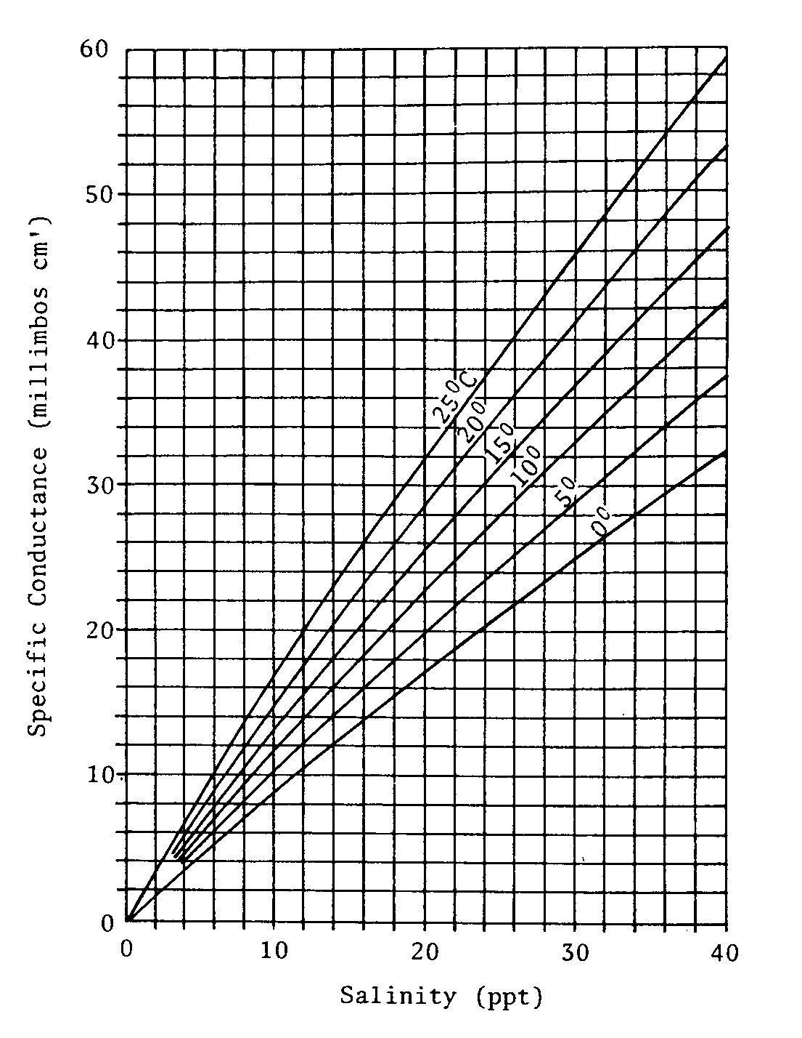
Conductance yields a measure of a water’s capacity to pass an electric current. An aqueous system containing ions will conduct an electric current. In a direct-current field the positive ions migrate toward the negative electrode while the negative ions migrate toward the positive electrode. Most inorganic acids, bases, and salts are good electrolytes. Molecules of organic compounds such as sucrose and ethanol do not dissociate into ions in aqueous solution and therefore produce aqueous solutions which have poor conductivity.

The standard unit of electrical resistance is the ohm. The standard unit of electrical conductance is its inverse, the mho. As expected, 1000 μmho = 1 mmho. Measurements of conductance are usually expressed in micro- or millimho per centimetre, μmho/cm or mmho/cm (the equivalent S.I. units are micro- and milliseimens, μS and mS). The YSI Model63 water quality probe used in this course measures conductance in mS/cm. Some instruments also have a salinity scale expressed in parts per thousand (ppt); this scale may be used for estuarine or seawaters with salinities greater than 2ppt, and is usually not applicable to freshwaters. Values in conductance units may be converted to salinity units (>2ppt) using the Figure below.
1% 2% 3% 4%

Figure. 1. Conversion between specific conductance (mmho/cm) and salinity (ppt, parts per thousand) for diluted seawaters at several temperatures.

Freshly distilled water has a conductance of 0.5 to 2 μmhos, rising to a value of 2 to 4 μmhos after a few weeks of storage. The increase results principally from the absorption of atmospheric carbon dioxide and to a lesser extent ammonia.
Most high quality waters have conductances between 50 and 500 μmhos, with highly mineralized water being in the range of 500 to 1000 μmhos and even higher.

1.2 Hardness of Water
Water containing high concentrations of the soluble dipositive ions (Fe²⁺, Mg²⁺, and primarily Ca²⁺) is known as hard water. In addition to adding taste to water, iron in the form of soluble iron (II) is readily oxidized to iron (III) which forms insoluble Fe³⁺ compounds. It soon forms ugly, hard to remove rust brown stains on plumbing fixtures and clothes. Calcium in hard water is responsible for scale in boilers and household jugs. Upon heating, calcium is precipitated as calcium carbonate on the boiler sides and in the boiler tubes. The scale is a poor conductor of heat and causes a waste of fuel. Excessive scale deposits may result in boiler explosions. In the case of hot water heaters, excessive boiler scale may cause heater failure due to burning out of the heating element.

For many years, the standard procedure for determining water hardness was the soap hardness test. In this procedure, a standard soap solution was added drop wise to a measured quantity of water and then the mixture shaken. The number of drops of soap solution required to produce a significant foaming was used to calculate the water hardness.

Currently, hardness producing ions are titrated with the sequestering (complexing) agent, ethylenediaminetetraacetic acid (EDTA). The accuracy obtainable with this procedure is much more satisfactory than that of the soap hardness test. In this experiment, we will find the total concentration of metal ions which react with EDTA, and we will assume that this equals the concentration of Ca²⁺.

2. EXPERIMENTAL

The same water samples will be used as in practical 2:
a. Secondary Treated water from the Wastewater Treatment Plant (obtained by the technician)
b. Water from “Sewerage Creek” – Yorkeys Knob (obtained by the technician).
c. A water sample, of the students own choosing, taken prior to coming to lab. You will need the
remainder of your sample which has been stored in a freezer over the previous week.

Each sample should be identified in a conspicuous place in the report book.

At this point half the class will commence on 2.1.1 and the other half on 2.2. When the equipment for 2.1.1 becomes free then the second group can commence on 2.1.1.

2.1 Total and Suspended Solids (Completion)

2.1.1 Suspended Solids
(1) Check the weights of your filter discs that were stored in the dessicator for one week, they should agree to within a mg. Before dispensing your water ensure that the water samples are well mixed. Filter 200 mL of a water sample through one of these dried and weighed glass-fibre discs, N.B. DON’T SCREW DOWN TOO HARD. If a sample is particularly dirty it may be necessary to reduce the volume to 100 mL to prevent the filter clogging. Rinse with distilled water. When removing the paper from the holder be careful unscrewing the filter paper holder, you must not rip the paper – use a small spatula and gently lift up the paper. Re-dry the disc at 105 ºC for 1 hr, cool in a dessicator for ½ hr, and reweigh. Carry out this procedure for each of the water samples.
2.1.2 Total Solids
(1) The three beakers should be transferred from the 105 ºC oven to a dessicator. Measure the new beaker weights as soon as the beakers are cool – when you remove the beakers from the dessicator weigh them quickly as the material is very hydroscopic.

2.2. Conductivity of Water
WARNING!
The multiparameter Water Quality Probe which you are about to use being used contains a fragile sensor which is easily damaged - handle with care. You will be using this out in the field and so this experiment aims to give you some practice with using it.

Rinse the probe with sample water. A plastic 100 mL graduated measuring cylinder is then ¾ filled with sample water. The probe is inserted, air bubbles are eliminated from the conductivity cell (gentle tapping) and the conductivity, salinity and temperature are noted. The inlet for the conductivity cell is high on the probe and you must make sure this is immersed, move the probe up and down a few times to ensure good mixing. You will need to rinse the probe carefully with distilled water in between samples.

(1) Record the conductance in mS/cm in your report book.
(2) Record the values of salinity by switching the meter to read out in salinity.
(3) Record the values of temperature by switching the meter to read out in ºC.

Proceed in the same way until all the water samples have been measured.

2.3 Biochemical Oxygen Demand (Completion)
For the two groups of samples which were incubated last week [(a) and (c)] you will now carry out the final DO measurements using Winkler titrations.

The following steps should be followed for all dissolved oxygen measurements, ie for all BOD samples.
The extra water samples (other than BOD samples) that you should run Winkler titrations for are:
(i) a control - distilled water sample saturated with oxygen at room temperature.
(ii) a blank - the blank supplied by technician (oxygen free distilled water)

You should run the control first it should be around 8.2mL ie titrate quickly to 7mL and then go dropwise after this. Do the blank next, this should be nearly 0mL and so go dropwise from the start. If either are greatly different from the above values consult your demonstrator BEFORE commencing any other Winklers ie before you add reagents to your BOD dilution samples.

Prepare a set of reagents in small labelled beakers:
(i) Mn(II) solution (ii) iodide solution

Care should be taken to avoid drawing in air bubbles as the following reagents are drawn into the syringe.

(iii) conc. sulphuric acid is kept in the fume cupboard in a measured dispenser. (This has already been adjusted by the Technician)

You must be wearing gloves, a lab coat and safety glasses before proceeding. Make sure you have all of the equipment required before taking the lids off your bottles and proceeding. ( You can check with your tutor if in doubt )

(1) Draw 1.0 mL of manganese (II) solution into the syringe by pulling the plunger precisely to the 1.0-mL mark. Do not draw more than 1.0 mL. Place the tip of the syringe just beneath the surface of the sample and gently push the plunger. Do this to all of the samples being analysed this week including the blank and the control.

(2) Rinse the syringe with distilled H2O before using the next reagent. Draw 1.0 mL of iodide solution (containing sodium hydroxide and sodium azide) into the syringe. Again, place the tip of the syringe just under the surface of the samples and gently push the plunger. Place the lids on the bottles and shake for 15 sec. Allow the bottles to sit on the bench with the lids on for 2min (this must be timed). A dark-coloured precipitate of manganese(III) hydroxide will form.

(5) Take your samples in the tray to the fumecupboard. When you are ready, prime the conc. Sulphuric dispenser, use a beaker for this. CAUTION : this is concentrated acid and will cause significant burns.
Take the lids off the bottles and dispense 1.0mL of conc. Sulphuric into each one. Put the lids back on and mix well. The manganese(III) hydroxide precipitate will disappear as iodide is oxidized to iodine. The colour of the solution will range from pale yellow to brown depending on the amount of iodine formed. Once the sulphuric acid has been added, dissolved oxygen in air bubbles or in rinse water will not affect the titration because the low pH stabilizes the mixture.

(6) A clean 50-mL burette should be set up, rinsed with 0.025 M sodium thiosulphate several times and then filled with the 0.025 M sodium thiosulphate. Air bubbles should be expelled from the burette tip and the initial burette reading recorded. When the burette with sodium thiosulphate is ready, transfer the entire contents of the bottle to a 500-mL Erlenmeyer flask. Add starch indicator and titrate with standard thiosulphate to the point where the blue/black starch-iodine colour has just completely disappeared. Keep this soln for comparison with the next titration. Record this final burette reading.

2.4 Hardness of Water and Waste Water
There are two EDTA concentrations 0.01M for hard water and 0.001 M for soft water. Carry out a rough titration with the 0.01 M EDTA solution first, if this titration goes when only 1 - 2 mL of titrant is added then you will need to repeat using the lower concentration EDTA solution. Carry out this procedure for samples (a), (b) and (c).

(1) Rinse a 50mL burette with about 10 mL of EDTA solution. Mount it in a burette clamp and fill it to above the 0.0 mark with EDTA solution. Open the tap and carefully release solution into a waste beaker until the bottom of the meniscus stands at exactly 0.0 mL. No bubbles should remain in the burette tip. With a safety bulb and 50 mL pipette transfer 50 mL of the water sample (recently shaken) to be tested into a 250 mL flask. Add 2 mL of the buffer solution (using a syringe or a 10 mL graduated cylinder) and 2-4 drops of EBT indicator to the beaker (pipette the EBT into your flask in the fumecupboard).

(2) Titrate with EDTA from the 50-mL burette and note when the colour changes from wine red to blue. You may need to practice finding the end point several times by adding a little tap water and titrating with EDTA. Save a solution at the end point to use as a colour comparison for other titrations. Do not add more than 1 excess drop of EDTA. If the endpoint is overrun, the results will be meaningless, and the titration should be repeated. The volume of EDTA solution is read to the nearest 0.05 mL and should be recorded directly.
For each 1.0 mL of 0.01 EDTA solution required, the water contains 10 ppm of hardness as CaCO₃.

The water samples you should run hardness titrations for are:
(i) a control - Ca²⁺ solution ( contains 250 μg CaCO₃ /mL ). Use 0.01 M EDTA.
(ii) a blank - oxygen-free distilled water. Use 0.001 M EDTA.
(iii) sample a
(iv) sample b - take only 5mL of this sample, add 45 mL of distilled water and titrate.
(this is a dilution to get the sample on the same scale with the titrant)
(v) sample c

3. CALCULATIONS AND QUESTIONS

3.1 Total and Suspended Solids
For each sample report the values for suspended solids and total solids.

3.1.1 Suspended Solids
The difference between the weight of a filter disc before and after filtration and drying corresponds to the weight of suspended solids in the 200 mL water sample. Use the following formula to determine the ppm of suspended solids for each sample. Record these values and any calculations.

grams of suspended solids x 1,000,000
ppm suspended solids = 200 mL of sample

(Recall: ppm is parts per million by mass, for water 1.0g ≈ 1.0 mL (25 ºC) ⇒ 1ppm = 1g / 1,000,000 mL)

3.1.2 Total Solids
The difference between the weight of a beaker before and after evaporation corresponds to the weight of total solids in the 100 mL water sample. Use the following formula to determine the ppm of total solids for each sample. Record these values and any calculations.

grams of total solids x 1,000,000
ppm total solids = 100 mL of sample

3.2 Biological Oxygen Demand
Calculate the DO values from the Winkler method.
The number of milliliters of sodium thiosulphate solution required for the blank (de-oxygenated solution) should be subtracted from the titration value for all water samples tested.

The working equation is : DO = {8 x V( S₂O₃²⁻) x [S₂O₃²⁻]} / 0.200 mg O₂ / L (1)

You do not have to solve equation (1) as the concentration of thiosulphate has been adjusted so that the relationship is 1mL S₂O₃²⁻ = 1mg O₂ / L – your titres directly give the DO values required.

The BOD in mg O₂ / L is the difference between the initial and final dissolved-oxygen concentrations times the dilution factor:

Biochemical Oxygen Demand = (DO_{initial} -DO_{final}) x (Dilution Factor). (2)

DO drop = DO_{initial} -DO_{final}

At least one of the dilutions for each sample has to have a DO drop of 4 - 6 mg / L to give a satisfactory BOD result. Ignore measurements where DO_{final} < 1 mg/L (insufficient dilution), or DO_{initial} -DO_{final} < 1 mg/L (too much dilution), or DO_{initial} -DO_{final} > 7 mg/L invalid insufficient dilution.
Report the BOD₇ (BOD for 7 days) values of the two different samples and comment on the degree of eutrophication.

3.3 Conductance and Salinity
Report the water sample and the corresponding conductance.

From the conductivities obtained, use Assignment 4 Figure1, to estimate the concentration of sodium chloride in parts per thousand (ppt) that is equivalent to each observed conductivity.

• Compare the NaCl values (ppt) obtained from the conductivity values with those directly obtained from the meter. Are they consistent?

• Indicate which of the samples have significant inorganic solids contents and explain your rationale

3.4 Hardness of Water and Waste Water
• For each sample calculate the total concentration of Ca²⁺ in mol/L as well as the hardness of the water.
• N.B watch the dilution factor for sample b.

3.5 Dissolved Solids

• From the difference between the total solids and the suspended solids calculate the dissolved solids content (ppm) of each water sample.

• Is this consistent with the conductivity / salinity values?

Reference:
(1) The Australian and New Zealand Guidelines for Fresh and Marine Water Quality (2000) – in reserve.

ASSIGNMENT 5
MEASUREMENT OF WATER QUALITY - III

AIMS
An introduction to several common analytical procedures used in assessing water quality. This week the standard 'moly-blue' spectrophotometric method for analysis of phosphate in water will be looked at. An investigation of the phosphate levels in a common detergent will also be carried out.

1. INTRODUCTION

1.1 Analysis of Phosphate in Water
In the present experiment, we will analyze a series of natural water samples for their phosphate content. Detergents are among the greatest contributors to phosphate content in rivers and lakes because phosphate containing compounds are used in detergent formulation as water softeners (builders). Phosphate is not toxic to animals or plants. In fact, it is a plant nutrient which stimulates the growth of aquatic weeds and algae. The use of phosphate fertilizers in agriculture also results in substantial transfer of soluble phosphate to the waterways as runoff. This may cause lakes and rivers to become clogged and overrun with plants due to excessive plant growth which is usually referred to as eutrophication.

The phosphorous which is present in a water sample is classified analytically into 3 main categories:
1) Orthophosphate PO₄³⁻
2) Condensed phosphate eg. Na₄P₂O₇ (pyrophosphate)
3) Organically bound phosphate P(=O)(OR)₃
Operationally the phosphorous may be found in both the dissolved and suspended forms and to estimate this filtration through a membrane filter is carried out with analyses carried out on both the filtered and unfiltered sample.

To convert the various phosphorous species present such as condensed phosphates and organic phosphate to orthophosphate an acid / oxidative digestion process is used:

K₄P₂O₇ + 2H₂SO₄ + H₂O → 2H₃PO₄ + 4K⁺ + 2SO₄²⁻
P(=O)(OR)₃ + S₂O₈²⁻ → H₃PO₄ + S₄²⁻ + organic fragments
H⁺

The principle of the analytical method used to determine total phosphorous involves the conversion of the phosphrous to orthophosphate, followed by the formation of molybdophosphoric acid, which is then reduced to the intensely coloured complex, molybdenum blue. The amount of molybdenum blue present is determined spectrophotometrically - a colorimetric process.

In aqueous solution at neutral pH orthophosphate is present as the H₂PO₄⁻ ion. The acidified ammonium molybdate reagent provides the molybdate species MoO₃. The reaction of the two form a phosphomolybdate complex.
12 MoO₃ + H₂PO₄⁻ → [H₂PMo₁₂O₄₀]⁻

The phosphomolybdate complex formed is then reduced by Sn(II) to form an intensely coloured molybdenum blue mixed oxide complex.
[H₂PMo₁₂O₄₀]⁻ + 9H⁺ + 4Sn²⁺ → [(MoO₂.4MoO₃)₂.H₃PO₄]⁻ + MoO₂ + H₂O + 4Sn⁴⁺
"molybdenum-blue"

This analytical method is extremely sensitive and is reliable down to concentrations below 0.1 mg phosphorus per liter.

1.2 Phosphates in Detergents
The largest source of phosphorous entering the environment is synthetic detergents which contain phosphate compounds to soften water, increase the pH of water, and increase surfactant efficiency. Sodium tripolyphosphate (STPP) is the most widely used currently, and ordinary detergents may contain up to 50% of it by weight. Automatic dishwasher detergents require high levels of STPP because it effectively prevents waterspotting during the drying process.
The use of phosphates in Australian home laundry detergents continues to decline. However, even with limitations on phosphates in detergents, specialty cleaners, such as automatic dishwasher detergents and institutional products, are still allowed to contain high amounts of phosphorus or phosphate compounds. Consequently, some lakes still continue to develop green algae blooms in the summer due to high phosphorus levels in the lake water.
This experiment allows us to see how manufacturers have responded to public pressure and it provides an opportunity to determine if detergent formulas meet Australian standards. The experimental procedure consists of digestion of a detergent sample determining the phosphate content on a neutralised solution spectrophotometrically.

2. EXPERIMENTAL

2.1 Analysis of Phosphate in Water
The spectrophotometers will be employed in the measurement of colour intensity of the molybdenum blue solutions. A wavelength of 650 nanometres will be used in these analyses.

2.1.1 Prepare the following standard phosphate solutions:
(1) 0.025 ppm standard:
(2) 0.25 ppm standard:
(3) 0.50 ppm standard:
(4) 0.75 ppm standard:
(5) 1.00 ppm standard:
(6) 2.00 ppm standard:
The basic procedure is illustrated for the 0.25ppm standard.
0.25 ppm standard: Place 2.00 mL of 5.0 ppm phosphate solution in a 100 mL graduated cylinder and dilute to 40 mL with distilled water. (Save exactly 25 mL in a plastic cup for analysis with the spectrophotometer.)
You will need to carry out a serial dilution to prepare the 0.025 ppm standard. That is you will first prepare a 0.50 ppm standard and then you will dilute this by a factor of 5 to prepare the 0.025ppm standard.

Before preparing the solutions make sure your calculations are checked by a demonstrator.

Blank: Set aside 25 mL of distilled water which will be treated with the colour developing reagents to serve as a blank.

These five standard solutions and the blank should now be treated according to the following "analysis of colour" procedure. After measuring the absorbance of these solutions, make a plot of absorbance
(y-axis) versus concentration (x-axis).

2.1.2 Analysis of Colour developed in the samples:
This procedure is used for the five standard solutions, the blank and for the three water samples which are to be analyzed for phosphate.

The three water samples are :
a. Secondary Treated water from the Wastewater Treatment Plant (obtained by the technician).
(diluted 5 mL made up to 50 mL using distilled water)
b. Water from “Sewerage Creek” – Yorkeys Knob (obtained by the technician).
Note this sample may have to be diluted if there is a lot of pollution in the creek, the technician will
advise you in advance.
c. A water sample, of the students own choosing, taken prior to coming to lab.
Method
For each of the water samples take 25mL and filter this into a clean plastic cup using a membrane filter and syringe – this is to remove particulates containing adsorbed P. Push the sample water through the membrane filter slowly.
(1) Place in a plastic cup 25 mL of the water sample to be analyzed.
Put 1.00 mL of ammonium molybdate solution into the plastic cup using an autopipette and swirl to mix. To the cup add 2 drops of stannous chloride solution and mix by swirling. If phosphate is present, a blue colour will develop to a maximum in 5 minutes.

Note: The time period is somewhat critical. Measurements should be taken anywhere from 10 to 12 minutes after addition of stannous chloride.

(2) While you are waiting for the blue colour to develop, set the wavelength to 650 nm on the spectrophotometer. Use the blank solution to set it to read zero absorbance.

(3) Using 650 nanometres wavelength, measure the absorbance (after 10-12 minutes colour development) of the molybdenum blue sample.

If the sample is one of the six standards, the absorbance value will be used to make a plot of absorbance versus the concentration of the standards ie. a calibration curve.

If the sample is one of the three unknowns you will determine the ppm phosphate by comparing the absorbance of the solution to the standard calibration curve. If your value is > 2 ppm then you will need to dilute the sample.
eg. add 5 mL of sample to a measuring cylinder and make up to 25 mL using distilled water, now apply the "Analysis of colour" procedure, the final ppm of phosphate value will need to be multiplied by 5 (25/5).

  - Sample preparation

This section needs to be commenced at the start of the practical session.

(1) Place about 0.1 gram of detergent in a weighing dish and record the exact weight of detergent in your report book.

(2) Add the sample to a 100 mL beaker (use distilled water to transfer quantitatively) containing a stirrer bar and add 10 mL of the digestion solution cH₂SO₄ / persulphate - CAUTION STRONG ACID.

(4) After the addition cover with a watch glass, and boil gently for about 1.5 hours. Do not boil dry. If you need to move the beaker use the padded gloves. CAUTION: This solution may spit at you. DO NOT REMOVE WATCH GLASS. Add water if it is going dry using a squeeze bottle, pour down the lip of the beaker. Do not place arms over beakers the vapour is highly corrosive.

(5) Allow the solution to cool and the solution to clear. Transfer the entire contents into a 2L volumetric flask, was the beaker with several approx. 10mL portions (aliquots) of distilled water.

(6) After dilution to 2 L in a volumetric flask (with distilled water) take out 25 mL and place in a 200 mL volumetric flask. Add 2 drops of phenolphthalein indicator and then add 1M NaOH dropwise until a faint pink tinge is apparent - at this point the solution will be neutral. Make up to 200 mL using distilled water. The solution is now ready to be analysed by the "Analysis of colour" procedure of Part 2.1.2. Record the result in your report book.

3. CALCULATIONS AND QUESTIONS

3.1 Analysis of phosphate in water

The following data should have been reported:
(i) Sources of water samples.
(ii) Absorbance of standards.
(iii) Absorbance of water samples.
(iv) Concentration of phosphate in water samples.

• Identify those aspects of the procedure which may have introduced some error into the final results.
• In each case indicate whether the error would cause the measured value to be too high or too low.
• Compare with Australian standards.

3.2 Phosphates in Detergents

The following data should have been reported:
(i) Identity of the Detergent Sample
(ii) Exact mass of Sample g

Percentages as either % STPP(Na₅P₃O₁₀), % phosphate, and % phosphorus may be calculated using the general formula:
ppm PO₄³⁻ x W = % X (X = STPP or PO₄³⁻ or P)
(weight of sample g)

where W is the equivalent weight conversion factor (from ppm) which includes the (25mL – 200mL) dilution :
W = 6.208 for STPP (Na₅P₃O₁₀, Sodium TriPolyPhosphate)
W = 1.600 for orthophosphate ion (PO₄³⁻)
W = 0.522 for phosphorus (P).

Calculated Percentages
percent Na₅P₃0₁₀ %
percent PO₄³⁻ %
percent P %

• Identify sources of possible error, and indicate whether these errors would tend to cause high or low results.
• How do your results compare with the phosphorus content of the product as indicated by the manufacturer?
The manufacturer claims a orthophosphate content of 23.6% and a total phosphorus content of 7.7%.
• What are the main sources of error in this procedure. Indicate whether these errors would tend to cause high results or low results?

References:
(1) The Australian and New Zealand Guidelines for Fresh and Marine Water Quality (2000) – in reserve.
.
ASSIGNMENT 6
PREPARATION OF LABORATORY STANDARDS
AND ION EXCHANGE CHROMATOGRAPHY
AIMS
In most analytical procedures there is a requirement to prepare laboratory standards. This practical is concerned with the preparation of standard base and buffer solutions. Experience is also gained in the use of ion exchange chromatography.

1. INTRODUCTION

1.1 Standardisation of acids and bases
Any analytical procedure relies on the carefully calibrated response of the method to known quantities of a primary standard. The primary standards which are used are normally easily weighed, quite stable, easy to use and have purity 99.9% or better. In this practical we will carry out an acid-base titration using standardised NaOH which you will have prepared.

NaOH is not a primary standard as the reagent grade (LR) material contains Na₂CO₃ (from reaction with atmospheric CO₂) and water. As large quantities are used in making up the standard solution it is not appropriate to use expensive Analytical Reagent (AR) grade material. A calibration standard is therefore made using a primary standard material which is then titrated against the secondary standard we wish to use. Here we will use a solution of potassium hydrogen phthalate (KHP, a weak organic acid) as the calibration standard. The NaOH solution is made up at approximately the correct concentration and then titrated against the calibration standard to ascertain the true concentration. At this point it becomes standardised NaOH. Once prepared the standardised NaOH is called the stock solution. This stock solution is usually diluted to obtain a solution of the required concentration. A strongly basic solution such as 0.1 M NaOH must be protected from the atmosphere otherwise it will absorb CO₂ and the resulting weak acid that forms changes the OH⁻ concentration. The basic solution must also be stored in plastic containers (PET) not glass. Glass behaves as an ion exchange medium and reduces the OH⁻ concentration upon storage (boiling 0.01 M NaOH in a glass vessel for 1h reduces the molarity by 10% due to this process!).

To standardise a strong acid such as HCl the primary standard base Na₂CO₃ is used. Primary standards are purchased as commercial products of AR grade and on occasion they must be dried before use - as is the case for potassium hydrogen phthalate. Before using a primary standard for the first time it is wise to check a standard analytical chemistry textbook such as Vogel's Quantitative Inorganic Analysis to determine if any special preparation is needed before using the standard.

The stoichiometric equation for the reaction between NaOH and Potassium Hydrogen Phthalate is:

1 : Potassium Hydrogen Phthalate + 1: NaOH → 1 : Na⁺K⁺ Phthalate²⁻ + 1 H₂O
(HO₂C)C₆H₄CO₂⁻K⁺

You will need this equation to calculate the quantities of the Potassium Hydrogen Phthalate (KHP) required in section 2.1 (3)

1.2 Preparation of buffers
A laboratory buffer solution is a chemical system that is used to reduce the effect of adding small quantities of acid and base to the pH of the solution of interest. Buffers are commonly used in any system that requires the control of biochemical parameters (eg. physiological pH). The preparation of a buffer is, as a result, a standard laboratory procedure. As you will remember from CH1011 a buffer requires the presence of essentially equal quantities of an acid and it's conjugate base which are both of moderately high concentration. As an example of a widely used buffer we will look at the "tris" buffer system. Tris(hydroxymethyl)aminomethane or "tris" is a primary standard weak base that exists in equilibrium with it's conjugate acid with a pKa for the conjugate acid of 8.075 at 25 ºC.

BH⁺ B

The Henderson-Hasselbalch equation allows us to calculate the pH for a buffer solution :

pH = pKa + log {[B] / [BH⁺]}

We could go about preparing a buffer by using this equation to calculate the amounts of acid and base that we would need to mix to obtain a certain pH but a range of interferences are possible:

l. You may have to consider activity coefficients.
- often a large effect as these are concentrated ionic solutions.
2. The temperature might not be correct - pK_{a} is very strongly dependent on temperature.
eg. tris buffer : pH 8.7 at 7ºC, pH 8.08 at 25 ºC, pH 7.7 at 37 ºC
3. You will probably make a calculator error anyway as we have an equation with logs...

A better way to make the buffer is to weigh out the solid "tris hydrochloride" standard and then prepare a solution of known molarity. The pH of this solution is then monitored while the solution is titrated with strong base until the pH required is obtained. This is what you will do in this experiment.

1.3 Ion Exchange Chromatography
You have previously encountered thin-layer chromatography (TLC) as a means of separating organic compounds (CH1012). In TLC the separation of the compounds was based on the interaction (retention) between the compound dissolved in the mobile phase and the silica support (the stationary phase on the surface of the TLC plate). Ion-exchange chromatography relies on retention differences between the solute ions and charged sites on the stationary phase (support). In anion exchange resins positively charged groups on the resin attract solute anions, while cation exchange resins have negatively charged groups in the support which attract cationic solute ions. The resins are amorphous (non-crystalline) solids of polymeric organic material.
The resin we will use is a polystyrene resin which is obtained by copolymerisation of styrene and divinylbenzene; 50W-X2 (100/200 mesh); the X2 indicates the degree of cross-linking between the polymer chains - here 2%. The mesh size indicates the physical size of the resin particles; 100/200 indicates medium sized particles (0.075 < x < 0.150mm) which will give a reasonable time for passage of the mobile phase through the column. A fine mesh means that the mobile phase will travel more slowly but will give a better separation of ions on the column. This is a strongly acidic cation exchange resin which indicates that there are strongly basic sites on the resin - in this case -SO₃⁻ sulphonate groups.
-SO₃⁻ sulphonate groups

Cross-link between polymer chains

Ion Exchange resin 50W-X2

The cross-links create pores in the resin, which control the entry of cations to the basic sites on the polymer.
A selectivity for cations is observed and for this resin it is : Ag⁺ > Rb⁺ > K⁺ > Na⁺ >Li⁺.
Ions such as Li⁺ have a large hydrated radius and therefore do not have as much access to the pores as do the smaller hydrated cations such as Rb⁺. Higher charged ions will bind more strongly eg. Al³⁺ > Zn²⁺ > K⁺.

As the name Ion Exchange Chromatography implies this is an exchange process where the ions on the resin are exchanged for those in the mobile phase. The 50W-X2 resin as it is placed into the column is in the acid form, that is the cations are H⁺. It may then be turned into the sodium form by passing a solution containing a moderate sodium ion concentration through the column - the H⁺ ions will be displaced and will be collected in the eluate (the solution that is collected at the bottom of the column).

When a solution containing more than one ion is placed on the column the ion with the higher relative selectivity will load preferentially onto the column - given equal concentrations of the ions in solution.
If the resin has been exchanged with a high selectivity ion (eg. Na⁺) it will still exchange almost quantitatively with small amounts of a low selectivity ion (eg. Li⁺) if a solution of the latter is passed over the resin as the exchange process is a typical equilibrium phenomenon which is governed by Le Chatelier's principle.

Resin⁻ Na⁺ + Li⁺  Resin⁻ Li⁺ + Na⁺

Ion Chromatography is the method of choice for determining the presence of anions in solution; this uses an instrumental variant of ion exchange chromatography. The solution containing anions to be studied is placed onto an anion exchange resin; the anions are then eluted off using a solution containing a non-detectable anion. The anions as they come off the column are detected quantitatively using a conductivity detector.

In the laboratory the most common use of ion exchange resins is in water purification where "De-ionised Water" means that the water has been passed through a cation exchange resin in the H⁺ form and an anion exchange resin in the OH⁻ form. All foreign ions in the water will exchange with the resins and the displaced ions will form more pure water (H⁺ + OH⁻).

2. EXPERIMENTAL

This is long practical if you don’t work efficiently – try to read up and know what you are to do in advance.

2.1 Preparing Standard Base - Standard NaOH
(1) A 50 wt % aqueous NaOH solution (18.768 M N.B this is based on ana average contaminated sample jar, you won’t necessarily get anything close to this) is prepared by adding 50g of NaOH with stirring to 50 mL of water (measuring cylinder) in a 125 mL conical flask on a heater/stirrer. Make sure the stirrer bar is centered so that it doesn’t kick the very concentrated solution out. The reaction is exothermic and so slow addition of the solid should be carried out (the milky appearance will slowly disappear). Remove the stirrer bar and then use a ice water bath to cool the solution to room temperature. Sodium carbonate is insoluble in this solution and precipitates out. Pour the viscous solution into a labeled 50mL plastic jar.
CAUTION: THE PREPARED SOLUTION IS VERY CAUSTIC.

(2) Boil 600 mL of distilled water for 5 minutes in a conical flask containing anti-bumping granules to expel CO₂. Pour the water (cooled to a just above room temperature) into a 500 mL polyethylene bottle, which should be tightly capped whenever possible. Calculate the volume of aqueous 50 wt% NaOH needed to produce 500 mL of ≈ 0.188 M NaOH (check your value before making up the solution with a demonstrator). Use a graduated cylinder to transfer the very concentrated NaOH to the 500 mL volumetric flask and then add around 400 mL of the distilled water (which has partially cooled). Mix well (invert completely) and allow the solution to cool to room temperature (use an ice bath to speed this up if necessary). Now make up to the mark (the volumetric is only accurate at 25ºC).

- Calculate the weight of a sample of solid potassium hydrogen phthalate (M = 204.223) that is required to react with ≈ 25 mL of 0.188 M NaOH. (See the “Introduction” for the balanced equation).
You will need four samples of around this weight. Weigh out the four samples and record the amount to 3 decimal places. Dissolve each sample in ≈ 25 mL of distilled water in a 125-mL conical flask. Add 3 drops of phenolphthalein indicator to each. Fill the burette with the 0.188 M NaOH you have made up, the burette should have a loosely fitted cap (tissue) to minimize entry of CO₂. Titrate one of the samples rapidly to find the approximate end point.

- Calculate the approximate volume of NaOH required for each of the other three samples (based on the sample masses you used) and titrate them carefully. During each titration, you should periodically tilt and rotate the flask to wash all liquid from the walls into the bulk solution. When very near the end, you should deliver less than 1 drop of NaOH at a time. To do this, carefully suspend a fraction of a drop from the burette tip, touch it to the inside wall of the flask, wash it into the bulk solution by careful tilting, and swirl the solution. The end point is the first appearance of faint pink colour that persists for 15 s. (The colour will slowly fade as CO₂ from the air dissolves in the solution.)

You should obtain at least 2 titres that are consistent within ± 0.05 mL.

2.2 Preparing "tris" Buffer
The following is a standard method to prepare 250 mL of buffer containing 0.100 M tris at a
pH of 7.60.

(1) Weigh out 0.025 mol of tris hydrochloride (M 157.597) and dissolve it in a beaker containing about 200 mL of water.

(2) Place a pH electrode (MUST BE CALIBRATED) in the solution and monitor the pH while stirring.

(3) Add your standardised NaOH solution (≈ 0.188M) to the solution from a burette until the pH is exactly 7.60. You must record the value of this titre.

(4) Transfer the solution to a 250 mL volumetric flask and wash the beaker with small volumes of water a
few times. Add the washings to the volumetric flask.

(5) Dilute to the mark and mix. This buffer solution at the correct pH is now ready to use.

N.B. The reason for using 200 mL of water in the first step is so that the volume will be reasonably
close to the final volume during pH adjustment. Otherwise, the pH will change slightly when the
sample is diluted to its final volume and the ionic strength changes.

(6) Take 50 mL of the buffer and place into a 100 mL beaker. Place a pH electrode in the solution and add 1 mL of NaOH 0.1 M. Record the new pH.

Repeat the same measurement but use 50 mL of distilled water instead of the buffer.

(7) Take 50 mL of the buffer and place into a 100 mL beaker. Place a pH electrode in the solution and add 1 mL of HCl 0.1 M. Record the new pH.

Repeat the same measurement but use 50 mL of distilled water instead of the buffer.

2.3 Ion Exchange Chromatography
This section needs to be commenced at the start of the practical session.

Known quantities of NaCl, Fe(NO₃)₃, and NaOH will be passed through the acid form of the Ion Exchange Resin 50W-X2. The H⁺ which is released from the resin by addition of each cation containing solution will be measured by titration with your “0.0188” M NaOH (which is prepared by dilution of your standardised “0.188 M” NaOH).

(1) You require “0.0188” M NaOH in this experiment. You will need to carry out a dilution of your standard “0.188 M” NaOH solution (this was prepared at step 2 in 2.1 and is in the 500mL volumetric flask) using a 10 mL pipette and a 100 mL volumetric flask to prepare this solution.
(c_{dil} x V_{dil} = c_{conc} x V_{conc})

(2) Fill the chromatography column with water, close it off, and test for leaks. There must be no air bubbles (if it is blocked you will need pressure to get it going). Then drain the water until it remains 2 cm above the tap and close the column again.

(3) Make a slurry (thin paste) of 1.1 g of 50W-X2 cation-exchange resin in 5 mL of water and pour it into the column using a funnel. If the resin cannot be poured all at once, allow some to settle, remove the supernatant liquid with a pipette, and pour in the rest of the resin. Run down the water to the surface of the resin + approx. 1mm.

Wash the column with ≈ 5 mL of water. Use the first few milliliters to wash the glass walls and
allow the water to soak into the resin before continuing the washing. [Unlike most other chromatography supports, the one used in this experiment retains water when allowed to run "dry". Ordinarily you must not let the liquid fall below the top of the solid phase in a column.]

(4) Generate the H⁺-saturated resin by passing ≈ 10 mL of 1 M HCl through the column.
Wash the column with ≈ 15 mL of water. Use the first few milliliters to wash the glass walls and
allow the water to soak into the resin before continuing the washing.
At this point the column is ready to use. At every stage run the column down till the liquid level is just to the top of the resin – it must not run down past this.
(5) Analyse the following three samples one after the other:
(a) a 2.00mL aliquot (graduated pipette) of 0.30 M NaCl - follow the procedures in Step 6.

(b) a 2.00mL aliquot of 0.10 M Fe(NO₃)₃ - follow the procedures in Step 6.

(c) a 10.0mL aliquot of your “0.0188” M NaOH (prepared in Step 1) -follow the procedures in Step 6.

(6) The general procedure for analysis of a sample is as follows:
(a) Place a clean 125-mL flask under the outlet and pipette the sample onto the column.

(b) After the reagent has soaked in, wash it through with 10 mL of H₂O, collecting all the eluate.

(c) Add 3 drops of phenolphthalein indicator to the flask and titrate with “0.0188” M NaOH (Step 1).
N.B. in these titrations if your “0.0188” M NaOH standard has a low concentration you may need
to use more than 50 mL – don’t run pass the end of the marks on your burette, re-fill early!
(d) Place a waster beaker under the column and flush with 5mL of H2O through the column to clean it ready for the next sample.

3. CALCULATIONS AND QUESTIONS

3.1 Preparing Standard Base - Standard NaOH
• Calculate the average molarity ($\overline{x}$), standard deviation (σ).

σ = $\sqrt{\frac{\sum_{i}{{\left(x_{i} − \overline{x}\right)}^{2}}}{n − 1}}$
Your sample titres converted to molarities are the x values, you have carried out n titres and $\overline{x}$ is the average (mean) molarity.

NOTE: you are not to calculate mean volumes, you calculate a concentration from every titre
and then calculate a mean molarity and standard deviation. The equation is c = n/V.

3. 2 Preparing "tris" Buffer
• Calculate the theoretical amount of your “0.188 M” NaOH that needs to be added to 3.940 g of tris
hydrochloride to make 250 mL of 0.100 M tris at a pH of 7.60.
Use the Henderson-Hasselbalch equation given that the pK_{a} of trisH⁺ (= BH⁺) is 8.075 at 25 ºC.

BH⁺ + OH⁻  B⁻ + H₂O

pH = pKa + log {[B] / [BH⁺]}

• Discuss the difference between the calculated and the actual volumes of NaOH that were required to
prepare the pH 7.60 buffer..

• Discuss the results of 2.2 (6) and (7) in terms of the suitability of your buffer to maintain a stable pH.

3. 3 Ion Exchange Chromatography
• For the 2.00-mL aliquots of 0.30 M NaCl and 0.10 M Fe(NO₃)₃ calculate the theoretical volume of
your “0.0188” M NaOH needed for each titration ( N.B. 1 M of cations²⁺ displaces 2M of H⁺) .

• Compare the experimental results you obtained with the theoretical results - do they agree?

• For 2.3.5 (c) explain the result you obtained in the titration.
ASSIGNMENT 7
IDENTIFICATION OF FOOD DYES
AND PRESERVATIVES

AIMS
To quantitatively determine the preservative content in soft drinks and to separate and identify the
colour additives in jellybeans using column chromatography and ultra-violet spectroscopy.

1. INTRODUCTION

There are many chemicals that are in common use in the human environment that affect our quality of life. A variety of chemical substances are added to foods to "improve" their flavour, appearance, nutritive value and keeping qualities. These additives are classed according to their function and usage as preservatives, antioxidants, colours, flavours, sweeteners, emulsifiers, acidulates, aerators, humectants, free-running agents, vitamins and minerals. Two of these classes, preservatives and colours, are looked at in this practical.

1.1 Preservatives
Benzoic acid and its sodium salts are among the most widely used antibacterial additives used in foods. Many berries (e.g. raspberries) contain appreciable amounts (up to 0.05%) of benzoic acid as part of their natural composition.
Benzoic Acid

Use of this additive is permitted by about thirty countries around the world, including Australia, for use in a great variety of foods, particularly soft drinks. Long-term tests with rats have shown that no accumulation in the body occurs. The body excretes benzoic acid as hippuric acid within 15 hrs of eating food containing it.

Sulphur dioxide, SO₂, is unique in being a most effective inhibitor of the deterioration of dried fruits and fruit juices. It is also used as an anti-oxidant and anti-browning agent in wine making. Sulphur dioxide destroys the vitamin, thiamine, and so its use in major sources of this vitamin, such as meat, is not permitted.

1.2 Colour additives
Coloured substances are added to foods to make them appear more attractive. Some colours have a natural origin, such as turmeric, a yellow dye that is extracted from the root of an East Indian herb. However, most food colour additives are synthetic coal-tar dyes, many of which have been found to be carcinogenic. It is interesting to note that the list of permitted red dyes has halved in the last 30 years. Opinions as to which dyes are safe vary from country to country, and even from region to region within a country.

Orange B is a typical example of a synthetic coal-tar dye, which is often used to colour orange skins:
Orange B

The coal-tar designation comes from the presence of aromatic rings. It is in these rings and the diazo
(-N=N-) link that the coal-tar dye structurally resembles many known carcinogens.

Most artificially coloured foods are tinted with a relatively small number of these synthetic (coal-tar derived) dyes. Usually these dyes have undergone initial extensive testing at the Food and Drug Association (FDA) in the USA and from there they have been adopted in other countries after local requirements and testing standards are met. In Australia the Australian Food Standards Codes are generated to correspond to these Food, Drug, and Cosmetic (FD&C) dyes eg. Red 2 = Food Additive Number 123, Blue 1 = Food Additive Number 133 etc. Often these dyes will also have a trade name for example we have been generously supplied standard dyes by Queensland Flavours and Fragrances (Wight Mountain, Q 4520) and their products have names like Red 2 = Amaranth Powder Colour, Blue 1 = Blue Brilliant Powder Colour.

The most commonly used dyes include FD&C Yellow 5, Blue 1, Red 40, Orange B (only allowed in casings of sausage and similar meats), and Citrus Red 2 (only allowed on orange skins). Other allowed FD&C dyes include Yellow 6, Blue 2, and Green 3. Currently, Red 3 and Red 4 are banned in USA, but they were used in some foods such as maraschino cherries until about 15 years ago. At present, manufacturers of materials containing FD&C dyes are not required to list on the label the specific dye or dyes used. They may simply use the term ”artificial colour”, but many products are now indicating the colour which is actually used.

We will identify a FD&C dye or dyes in at least one food product from their absorption maxima by comparing with the information provided in Table 1. Dyes will be separated and isolated for spectrophotometric identification by solvent gradient chromatography by means of simple liquid column chromatography with a disposable liquid chromatography cartridge.

This experiment demonstrates a simple chromatographic separation which is easy to visualize due to the brilliant colours produced by FD&C dyes. The "Sep Pak" cartridge used to separate the dyes is an example of a Solid Phase Extraction (SPE) cartridge. These SPE cartridges are used routinely to separate organic compounds such as pesticides from background matrices, and drugs in blood and urine samples.
Detection and identification of the dyes in the experiment is aided by use of the spectrophotometer which can sense wavelength and colour intensity variations with greater precision than the human eye. The procedure is qualitative in that it allows one to determine the identity of an unknown dye in a commercial product. We will not carry out quantitative analysis in this experiment to save time but it would normally be carried out as you have done previously by making a calibration curve for each dye and then measuring the unknown at the chosen wavelength.

Table 1. Expected Absorption Maxima (nm) of FD&C Dyes
Dye  Yellow 5  Yellow 6  Red 4  Red 2  Red 3  Blue 2  Green 3  Blue 1 | Solvent System  water  water  water  water  water  water  water  water | Absorption Maxima (nm)  422  480  495  520  527  610  625  627
The maxima will vary slightly due to variations in solvent, temperature and spectrophotometer operation.

The chemical structures of the FD & C dyes are given on the following page where you will see their resemblance to Orange B.
FD & C. Food Dyes
Visible Spectra of FD & C. Food Dyes (Shimadzu Minispec)
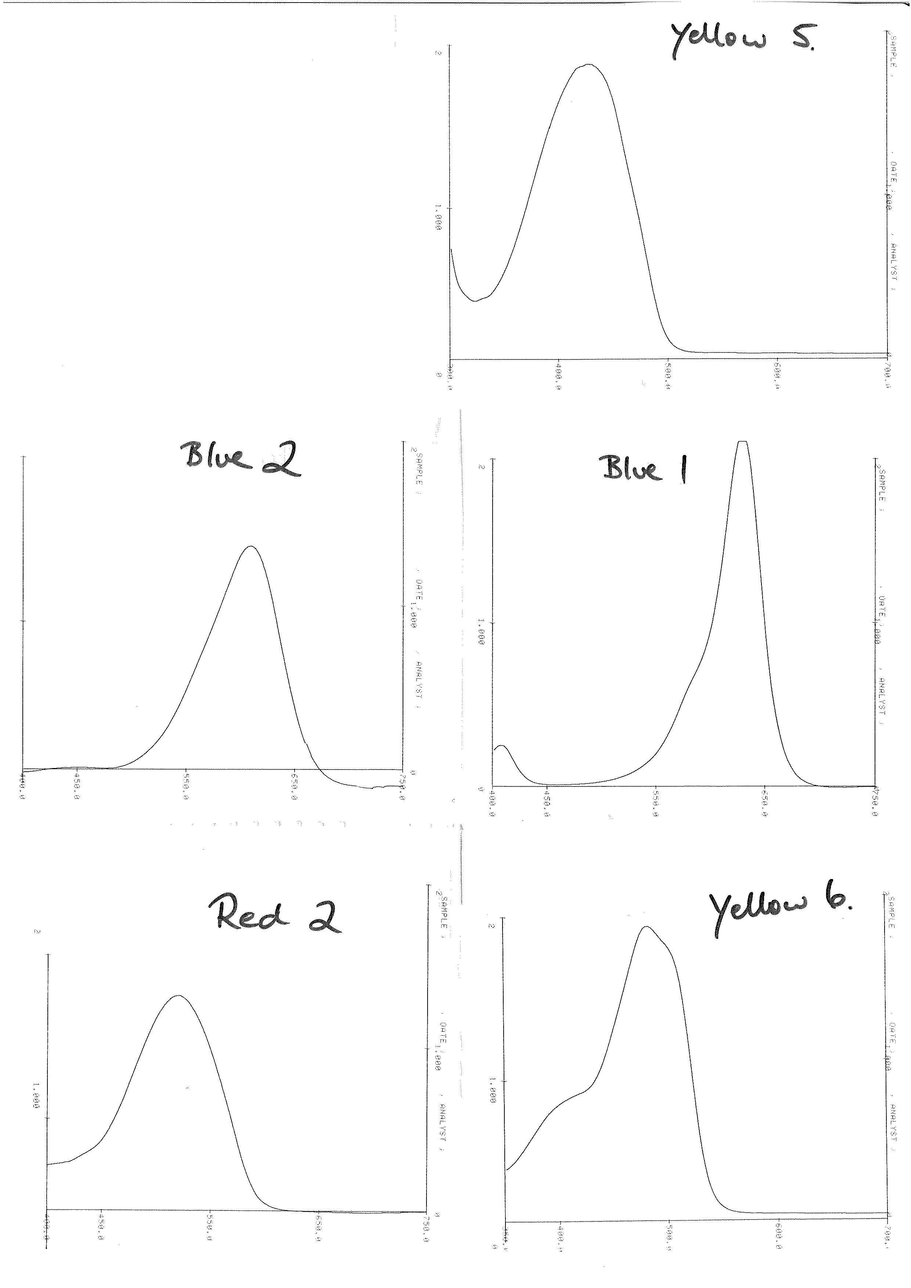
2. EXPERIMENTAL

2.1 Known Food Dyes.
Standard solutions of the dyes Red 2, Blue 1, Yellow 5 and Yellow 6 are prepared by dissolving a drop of the concentrated dye solution in 200 mL of water (N.B as we are only interested in qualitatively identifying the unknown dyes the volume does not need to be measured accurately).

You will be provided with spectra of these 4 known food dyes which have been run on the Shimadzu scanning UV-Visible instrument using distilled water as a blank.

The absorption maxima in Table 1 should be quite close to those found in the spectra. Peak shape is also important in identifying known compounds in unknown mixtures and this is the reason that you have been provided with the spectra.

2.2 Separating Unknown Dyes in Jellybeans.
Separate the dyes in jellybeans using the following procedure:
(1) Set up a series of 10 labelled (1 – 10) test tubes in a test tube rack for isolating the dye or dyes.
You will need mixtures of H₂O and methanol in the following procedure these are readily prepared in
a measuring cylinder and then may be stored in beakers for use.
You will need the following mixtures (H₂O:MeOH): 9mL:1mL, 8:2, 7:3, 6:4, 5:5.

(2) Prepare a ”Sep Pak” chromatography cartridge by passing 5 mL of methanol through it with a syringe. You always use a push action through these cartridges (never pull). Then rinse the ”Sep Pak” with 5 mL of water from a syringe.

(3) Add 15 mL of warm water to 2 jellybeans (either 2 green or 2 purple) in a 50 mL beaker.
Allow to stand for 15 minutes or until they look white. Do not let stand for too long or too much sugar will be extracted with the colours. Remove the jellybeans with forceps. Let the solution cool and then draw 2 - 4 mL of the coloured solution (NOT the particulate matter at the bottom) into a 5 mL syringe. Next attach a Sep Pak cartridge to the syringe and force the coloured mixture through the cartridge slowly (1 drop every second) allowing the liquid to pass into test tube 1. This will trap the dyes on the chromatography support (stationary phase).

(4)
a. Remove the cartridge from the syringe, rinse the syringe with water, and then refill it with 9 mL H₂O
and 1 mL methanol. Replace the cartridge on the syringe and slowly force the H₂O - methanol mixture through it. Run the first 5 mL of this mixture into the second test tube. Run the remaining 5 mL of this mixture into a third test tube. If two or more dyes are present, one of them may have begun separating by this time.
b. Repeat step (a.) using the same H₂O:MeOH mixture allowing 5 mL of the next solution to run into the fourth test tube and the second 5 mL to run into the fifth tube.
c. When the first dye appears to have been completely eluted from the chromatography cartridge, use 10
mL of an 8-mL H₂O / 2-mL methanol mixture to begin eluting the second dye into a new test tube.
Running the first 5 mL of this new 10 mL mixture into a test tube and the second 5 mL into another
clean test tube.
d. Follow this with a 7-mL H₂O / 3-mL methanol mixture
e. Follow this with a 6-mL H₂O / 4-mL methanol mixture
f. Finally use a 5-mL methanol / 5-mL H₂O mixture

(5) Pick the test tubes which appear to have the purest, most concentrated solution of the dyes and run their spectra as outlined in the following procedure in 2.3. If you and/or your tutor are not satisfied with the way the dyes have separated, try repeating the procedure.

2.3 Spectrophotometric measurements
Use the Shimadzu spectrophotometer. The spectra of all solutions may be determined directly by placing several milliliters of each in the sample cuvette and then capping the sample using parafilm. Use distilled water as a reference. Scan from 400 to 800 nm.

2.4 Benzoic acid in Soft Drink
In this experiment you will extract benzoic acid from a common soft drink " Sprite®" into an organic solvent diethyl ether. The partitioning of an organic compound from water, in which it is marginally soluble, into an organic solvent in which the compound is more soluble is commonly used in analytical chemistry to concentrate the analyte of interest.

You will be provided with a calibration curve which relates the intensity of the UV absorption of benzoic acid to 5 known concentrations of benzoic acid.

All manipulations of the diethyl ether are to be carried out in the fumecupboard. CAUTION diethyl ether is VERY FLAMMABLE.
- Place 25 mL of degassed soft drink in a 100 mL separating funnel. Mix in a few drops of 2 M hydrochloric acid.
- Extract the mixture with three portions of diethyl ether, using volumes of 50, 25 and 25 mL. Combine the extracts, and wash twice with 15 mL portions of water.
- Dry the ether extract by swirling with anhydrous sodium sulphate. Decant off, rinsing the residue with 20 mL of ether into a 250 mL Quickfit flask.
- Evaporate the residue to dryness using a rotary evaporator (wait at least 3 minutes after it has gone to
dryness to remove the last traces of the ether). .
(5) Dissolve the residue in a small volume of ethanol and transfer to a 100 mL volumetric flask, make up
to the mark with ethanol (shake well).
IN THE FOLLOWING DO NOT THROW OUT ANY DILUTIONS UNTIL YOU HAVE HAD YOUR RESULTS CHECKED BY THE DEMONSTRATOR.
(6) Take out 10 mL of this sample and make up to 100 mL with ethanol in a second 100 mL volumetric
flask.
(7) Carry out a further 10 fold dilution with ethanol in another 100 mL volumetric.

(8) Record the ultraviolet spectrum of the solution from 190 to 270 nm against an ethanol blank. In dilute ethanol solution benzoic acid has a maximum at 240 nm. You will need to use quartz cells to carry out these measurements as soda glass and borosilicate glass absorb light in the UV region and are therefore not transparent to the incident light. Please handle the quartz cells carefully they cost $200 a pair! Use ethanol in the reference cell.
Check your value with a demonstrator before discarding solutions.

From CH1012 you will recall that aromatic systems absorb UV and this π−π* absorption is used here
as a characteristic absorption of benzoic acid.

3. CALCULATIONS AND QUESTIONS

3.1 Data Analysis: Jelly Beans
Staple in all absorption spectra to your report book.
Be sure to identify each spectrum with respect to the known or unknown dye which it represents.

• For each standard use the absorption curve obtained from the spectrophotometer to estimate the
approximate wavelength at which a maximum absorbance level is reached, and record this as the
”observed” absorption maximum.
• Use Table 1 to identify the ”expected” absorption maximum for each of the knowns and record this
value, report your measured value in the observed column.
Known Dye Expected Absorption Maxima Observed Absorption Maxima

• Using the spectra of the unknown dyes in the commercial product(s) identify each dye present from
its observed absorption maximum after consulting Table1 and your spectra.
Unknown Dye Observed Absorption Sample Identity
• What evidence supports your identification of dyes in the jelly beans?

• Draw the structure of each dye (and name it) that was detected in the jellybeans.

3.2 Data Analysis: Soft Drink

• What concentration of benzoic acid was found in the soft drink?

• What levels of preservatives are allowed by the local food and drug regulations in drinks?
References:
(i) Food standards code : incorporating amendments up to and including Amendment 41 / Australia
New Zealand Food Authority. 1998. Australia New Zealand Food Authority.) – in reserve.

(ii) Approved food standards including recommendations of the session of Council, April 1975.
National Health and Medical Research Council (Australia) – in reserve.

• Is the observed figure for benzoic acid in Sprite® below these levels?

ASSIGNMENT 8
FIELD TRIP
STREAM WATER QUALITY INVESTIGATION

AIMS
A field trip where aquatic sampling protocols are developed and used in conjunction with in situ and laboratory analytical techniques. The quality of the water in an urban creek will be evaluated in terms of requirements for the maintenance of aquatic life and evaluation will be made of natural and man-made factors influencing water quality over the length of the creek.

NOTE : You will encounter some mosquitos, sandflies, mud and either sun or rain. To measure the stream profile people will have to wade up above their knees, everyone should expect to have to cross a creek. Please come equipped appropriately.

1. INTRODUCTION
Most major cities contain a limited number of large waterways such as bays, harbours, and rivers together with a network of small urban streams. During the growth of the cities, many streams have been enclosed or otherwise converted into drains. In addition, these streams have been subject to an increasing pollution load from contaminated urban run-off water, industrial operations, and other activities.

In recent years there has been increasing interest in checking the water quality in urban streams where the streams and adjacent land are being used as parks and natural recreation areas by city dwellers. Polluted streams represent a health risk and also contaminate the larger bays and waterways, reducing their value for fishing, swimming and aquatic sports.

An investigation of stream water quality should include a survey where various physical and chemical characteristics of the stream are measured. These measurements may then be used to assess if the water quality meets certain criteria for human use and for the maintenance of aquatic life. As well, the survey should look for any changes in these characteristics over time or place, so that possible links can be made with influencing factors such as water flow, climate, surrounding land use, and the input of effluents and wastes.

2. EXPERIMENTAL
The main objectives of the field trip are:
(i) To evaluate the quality of the water in an urban creek (Half-Moon Creek) with emphasis on the requirements for the maintenance of aquatic life

(ii) To identify and evaluate natural and man-made factors influencing water quality over the length of the creek.

2.1 Survey Planning
Mapping
Topographical maps of Half-Moon creek and the catchment will be provided. From these maps, major features of land use and any sources of point discharges such as factories and sewage plants can be identified. A series of sampling sites should be selected so that they are connected with these features; in particular where point discharges are known or suspected, sites up- and downstream should be selected in order to assess the effect of these discharges on water quality. The sites should be checked for ease of access and suitability. We will visit three sites which you can discuss later for their suitability.

Timing
Because water flow and water use change with time, a rapid survey should be planned to assess the water quality along a stream over a limited time period. Also, many streams are tidally influenced for many kilometres, and in these cases the survey should be conducted at a fixed point in the tidal cycle. A factor to be taken into account with tidal streams is the "tidal lag" or the time difference in the tidal cycle between the mouth and a place upstream. Because of this lag, it is often more practicable to begin a rapid survey at the stream’s mouth at a particular point in the cycle and then work upstream. Due to the fixed time available to us we will commence in the upstream catchment and work down to the tidal zone.

2.2 Field and Laboratory Tests
Week 1
Fifteen tests are suggested to be included in a typical survey. The list is not exhaustive, but covers parameters which have an important bearing on water quality. The tests are relatively straightforward but would cover more than two laboratory sessions and we will therefore focus on just a subset.

In the field we will measure 5 physico-chemical parameters: temperature, stream flow, pH, conductivity (and salinity) and dissolved oxygen content.
In the laboratory we will determine the total acidity and alkalinity of samples the water.

The three sites that we visit are to be labelled in your notebooks and the spreadsheet:
1) Uni Creek - the branches are labelled A branch (rapids), B branch (pipe), main branch (under bridge)
2) Sewerage Creek
3) Moon River

At least four tests should be carried out at each site in a typical field survey. These tests are:
1. Temperature measurement
2. Dissolved oxygen measurement
3. Conductance and/or salinity measurement
4. pH measurement
In addition, more complex field tests and laboratory analysis of field samples may include measurement of:
5. Acidity - free acidity, total acidity
6. Alkalinity - total alkalinity 7. Phosphorus content
8. Biochemical oxygen demand 9. Chlorophyll-a
10. Suspended solids 11. Oil and grease in sediments
12. Ammonia 13. Available chlorine
14. Streamflow and discharge 15. Turbidity

2.3 Field Measurements
Only in some instances will it be possible to perform a measurement in situ, and many tests require a water sample to be taken. Standard practice is to take a measurement or a water sample from about 15 cm below the surface in mid-stream, although in the deeper stretches of our creek this may not be possible as we would need a boat. Large, floating material should not be included in the sample. The collected sample may either be tested on site or stored for later laboratory analysis.

2.3.1 pH, Conductance (or Salinity) and Dissolved Oxygen
These parameters should be measured in situ.where possible, as a close approximation we will quickly sample and transfer into large open beakers (so that there is no opportunity to drop the multi-probe into the stream!). Some commercial instruments are available that measure all of the above parameters eg. Horiba, YSL. In this instance we will use different YSL probes for several of the measurements.
Your should consult the manual for the instrument for the correct procedure in calibrating and using the sensor and all modes should be calibrated before you leave the laboratory. In this instance we will rely on the technician having calibrated the pH and conductivity probes and will check the calibration on the DO probe before you leave.

a. Calibration of DO probe.
Take particular care of the gas-permeable membrane at the tip of the probe. This should have no punctures. If the probe had been standing in water for some time, you would gently wipe the membrane surface to remove algal or bacterial slimes - in this case it will not be necessary.

Check the Zero calibration : Wash the probe 2 - 3 times with distilled water and place it in the zero standard solution (contains sodium sulphite which removes dissolved oxygen).
Span calibration : Wash the probe 2 - 3 times with distilled water and place it in the span calibration solution (air has been bubbled air through the water for several hours to saturate the solution with O₂).

If a further check on the probe calibration is needed, the dissolved oxygen content can be assayed titrimetrically using the Winkler method and cross comparison made.

Field measurements : you should report your results directly into your report book at each site.
Replicates of each measurement will be carried out for each analysis at each site – a different pair will carry out the replicate measurement.
(1) Determination of Dissolved Oxygen in Water Using the Oxygen Electrode
A sample in a plastic bottle should be taken in the stream where the bottle is overfilled, capped and the measurement made immediately afterwards on shore. The DO salinity correction will be turned off on the instrument initially so that you can practice with manual correction of data, then the correction will be turned on and the conductivity value obtained with the second probe entered directly. CAN SOMEONE PLEASE REMIND THE TECHNICIAN NOT TO TURN ON THE SALINITY CORRECTION.
Transfer 1 litre of the sample water into a plastic beaker without excessive aeration and quickly place the probe into the sample to obtain a DO reading. Calculate the % DO saturation.

(2) Determination of pH.
A sample should be taken in the stream using a plastic sample bottle and the measurement made on shore in the plastic beakers, you can use the same sample as you used for the DO measurement.
Water Quality
pH < 5.5 Caused by acid pollution
pH of 5.5 Pure water in equilibrium with the atmosphere
pH between 5.5 and 7.1 Good quality soft natural water
pH between 7.9 and 8.9 Typical of hard water
pH between 8.1 is 9.1 Seawater

The acceptable range for domestic water is between pH 5.5 and 9.5.

(3) Conductivity or Salinity.
A sample should be taken in the stream and the measurement made on shore, you can use the same
sample as you used for the pH & DO measurements.
For information on the relationship between conductance and salinity consult Assignment 2.

(4) Turbidity, reactive Fe³⁺, reactive P.
These parameters will be measured using the Hachi DR 820 calorimeter, you can use the same
sample as you used for the pH & DO measurements. For each element prepare 2 samples at the same time as there is a reaction time associated with formation of the coloured complex used in these analyses. Make sure that you wash the glass container used in the Hachi thoroughly with distilled water before filling with sample water and then rinse 3 x with small amounts of sample water before filling to the mark.

2.3.2 Physical Measurements

(1) Determination of temperature.
These readings should be taken in the stream at the three different sites from which you took your water samples.

(2) Streamflow.
The velocity of a stream is the rate of water movement past a given point. The flow or discharge of the stream is the total amount of water transported past a given point in unit time, and is usually expressed in cubic metres per second.

An approximate value for the discharge of a stream may be calculated by the velocity-area method. In this method, the discharge is given by the product of the cross-sectional area of the stream and the average water velocity. The area is determined by measuring the cross-sectional profile of the stream channel, and a rough estimate of the velocity is taken as 0.8 times the mid-stream surface velocity (ie. a single velocity measurement is used).

The point velocity of water will vary from bank to bank and from surface to bottom. A more accurate way of applying the velocity-area method involves integration of the velocity over the flow section. Referring to
Fig. 1. , the cross section is divided into several segments. The average velocity of each segment is taken as roughly the measured velocity at 6 /10th the depth of water in the middle of the segment. The discharge of each segment can then be determined, and the sum of these discharges taken as the flow of the stream.
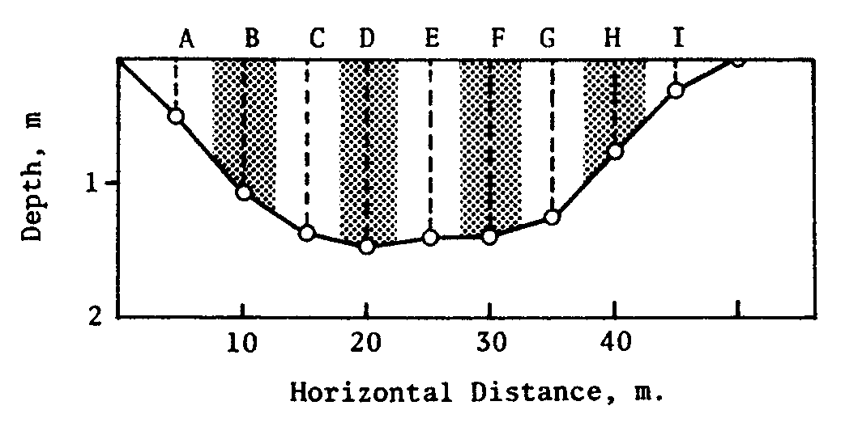

Fig. 1. Profile of a stream obtained by depth measurements at several points. Flow measurements at 0.6 depth are taken at each point. Segments (shaded and unshaded) can then be constructed in order to estimate the discharge of the stream.
(i) Stretch a measuring tape between the banks of the stream. At every 1- 2m, whichever is more appropriate for the width of the stream, estimate the depth of the water using either a surveying staff or a graduated line. At each point, use a flowmeter (set of AVERAGING) to measure the water velocity in metres per second at 0.6 depth above the bed of the stream. The measurements must be made with the propeller at 90º to the tape measure and pointing into the flow of the water.

(ii) Draw up a cross-sectional profile of the stream on squared paper. Connect the points showing the
depth of the stream bed with straight lines. Divide the cross section into segments as shown in Fig. 1.

(iii) Estimate the area of each segment in square metres by counting squares in the diagram and multiplying by the appropriate conversion factor (1 square = xx m²). Multiply this figure by the velocity (at 0.6 depth) to obtain the discharge of each segment in m³ / s.
(ie. discharge of segment = no of squares x area of square x velocity)
Total the discharges of the segments to obtain the flow of the stream in cubic metres per second, estimate the error.
For a pipe you will calculate the surface area using S.A. = πr²

2.3.3 Sample Collection and Storage
At each site 2 samples (125 mL) in plastic containers will be collected and stored in the Esky for later analysis in the laboratory.

Table 1. Summarises some procedures for sampling and storage. In general, a sample is used to rinse and fill a pre-cleaned and labelled container, which is then sealed and cooled to about 4ºC in an Esky. Glass and plastic containers may be used with the type of container selected depending on the analysis to be performed.

Table 1. Recommendations for Sampling and Preservation of Samples

Measurement  Temperature  Salinity  pH  Dissolved Oxygen  BOD  Turbidity  Residues  Phosphorus  Ammonia  Available chlorine  Chlorophyll -a  Oil and Grease  Acidity  Alkalinity | Vol. Req. (mL)  1000  100  25  25  1000  100  250  50  400  1000  350  1000  100  100 | Preservative method  Det. in situ  Det. in situ  Cool, 4 ºC  Det. in situ  Cool, 4 ºC  Det. in situ  Cool, 4 ºC  Det. in situ  Cool, 4 ºC  Cool, 4 ºC  Cool, 4 ºC  Cool, 4 ºC  Cool, 4 ºC  Cool, 4 ºC  Cool, 4 ºC add H₂SO₄  Cool, 4 ºC  Cool, 4 ºC | Maximum holding time  -  -  24 h  -  6 h  -  6 h  -  7 d  7 d  7 d  24 h  5 h  6 h  24 h  6 h  6 h

2.5 Laboratory Measurements
Week 2 – To be completed while you are waiting around during the toxicology practical.
Back in the laboratory each pair will carry out analyses on 3 of the samples that you have collected - one from each of the sites. For each sample you will determine the total acidity and alkalinity.

2.5.1 Total Acidity
Total acidity is the total acid content of water that can be titrated to pH 8.3 using NaOH.
The acidity is a result of carbonic acid (H₂CO₃) and other weak acids in the water.

Pipette 20 mL of sample water into a 125 mL conical flask, add 2 drops of phenolphthalein indicator and a stirrer bar. Titrate using NaOH 0.00100 M until there is a colour change from until it appears faint pink-purple. From this calculate the mmol OH⁻ / l litre of water which is necessary to bring the water to the equivalence point.
The normal units for acidity in natural waters are meq/L where 1 meq = 1 mmol OH⁻ these are the meq required to neutralise the acidity in the water.

2.5.2 Alkalinity
The total basic content of water that can be titrated to pH 4.5 using HCl is referred to as alkalinity.
The alkalinity is a result of carbonate and bicarbonate from carbonate minerals & atmospheric CO₂ and OH⁻ in the water.
Alkalinity ≈ [OH⁻] + 2[CO₃²⁻] + [HCO₃⁻]

Pipette 20 mL of sample water into a 125 mL conical flask, add 2 drops of methyl orange indicator and a stirrer bar. Titrate using 0.00100 M HCl until there is a colour change from yellow to apricot.
If your sample has a high salinity (determined in the field > 10ppt, eg. Moon River) indicating a marine influence you will need to dilute the water by a factor of 10 before carrying out the titration.
From this calculate the mmol H⁺ / 1 litre of water which is necessary to bring the water to the equivalence point. The normal units for alkalinity in natural waters are meq/L where 1 meq = 1 mmol H⁺ these are the meq required to neutralise the alkalinity in the water.

POST-PRACTICAL: You will be enter your results from you notebook into a spreadsheet after the class (this will be sent out and can also be collected from the LearnJCU web site in the Practicals Directory) and send them to your demonstrator who will then collate them. The collated spreadsheet will then be sent out to the class (and put on the LearnJCU CH2041 web site in the Practicals Directory) as a complete set of data.

3. CALCULATIONS AND QUESTIONS

3.1 DO Measurements
In Assignment 2 we covered the use of the Winkler technique to measure dissolved oxygen concentrations. Here we have made use of an O₂ selective electrode technique. Note the YSI-55 provides only salinity corrected values whereas you have to correct the values for salinity provided by the YSI-63 as detailed below.

Remember you will be taking measurements in a stream with tidal influences and so the dissolved oxygen content measured below is going to have to be corrected using the equation:

DO (corr) = (DO of saline water air-saturated at T) x DO meter reading of saline water sample
(DO of fresh water air-saturated at T)

A table of DO values in saline water is given in Assignment 2. Give the raw and corrected values in your report.

3.2 Total acidity and basicity
• Discuss the significance of the measured total acidity and alkalinity in terms of the buffer capacity of
the water.
• What is the difference between the total acidity and the pH of the water?

3.2 The report

The following items should be included in the report:
1. Introduction: The nature of the study area, the water quality parameters studied and the aims of the study

2. Experimental procedures. These should be identified and very briefly outlined. Known procedures should be referenced.

3. Results. This section should summarize numerical results and include observations. The results should be presented in tables and/or graphs if applicable. Sufficient text should be included so as to identify the results. Notes should be made on the precision of the results as well as on any significant errors associated with the methods used. Calculate means and standard deviations where there are more than 3 values collected in the same sampling location.

4. Discussion. This should cover the significance of your findings in relation to water quality and the use made of the stream. The discussion may include:
(a) a sketch map of the stream showing the sampling sites and adjacent major developments
(b) graphs showing the variation in the water quality parameters along the length of the stream
(c) comparisons made with recommended water quality criteria
(d) any relationships between the parameters
(e) identification of some factors that influence water quality
(f) estimates of the diluting capacity of the stream (from the calculated stream flow at Site 1).
This section may include general comments on the standard of water quality, and guidelines for future investigations and water management.

5. References. References to personal communications and published material should be indicated in the text. These references should be collected at the end of the report in the order in which they appeared in the text.
References:

(i) Natural Resources of the Barron River Catchment 2. Water Quality, Land Use & Land
Management Interactions. A.L. Cogle, (2000) Queensland Government. – in reserve.

ASSIGNMENT 9
TOXICOLOGICAL CHEMISTRY

AIMS
An introduction to toxicological chemistry and toxicological testing. The practical will introduce the principles involved in a toxicological bioassay and will involve a simple, small-scale static bioassay

1. INTRODUCTION

Toxicology is the science of poisons or toxicants as they are called in toxicology. A toxicant is a chemical substance that is harmful to living organisms through its effects on tissues, organs or the biological processes of the organism being studied. A variety of toxic substances are discharged into the environment where they may exert harmful effects on organisms. Environmental toxicology is broadly concerned with the effects of air and water pollutants, residues in food and biota and industrial hygiene.

Toxic substances have two important aspects to their action.
(i) The physiological impact of the substance on organisms
(ii) The concentration in the environment, or dose administered to the organism, which causes that effect.

This concept includes the basic principle that harmful effects are related to dose or concentration and below a certain minimum there will be no harmful effects.

These principles are illustrated by the hypothetical data plotted in Fig. 1. This indicates the lethal response of a uniform population of an organism when subject to increasing doses or environmental concentrations, over a set period. Below a concentration of 1 no mortalities are observed, but between concentrations of 1 to 2.5 the most susceptible individuals in the population succumb. Most of the population is affected by concentrations between 2.5 and 5, but some individuals are very resistant and concentrations above 5 are needed to cause mortality. So in any uniform population there will be a Gaussian (normal) distribution in terms of susceptibility to a toxic agent. It is expected that each agent will have a dose response curve characteristic of that substance.
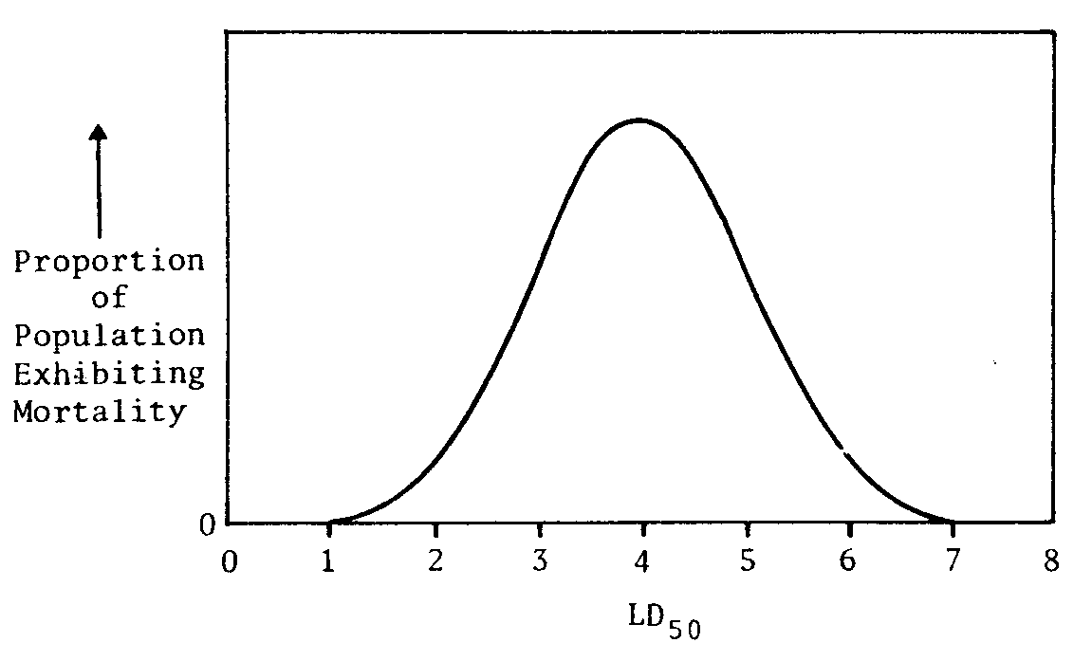
50% 34%
σ = Standard deviation of
distribution = 10 mg /L
70 80 90 100 110 120 130
LC₅₀ mg / L
LC₁₆ LC₈₄

Figure 1 Hypothetical lethal response curve of an animal population exposed to a toxicant.
This represents a normal response with the mean of 100 mg /L and the standard deviation 10 mg / L.

Further examination of Fig. 1 shows how we can obtain a numerical measure of toxicity from the data. The Concentration or Dose which causes mortality to 50% of the organisms, LC₅₀ and LD₅₀ respectively, represents toxicity to the ”average” organism and occurs at the middle of the distribution. An estimate can be made of the standard deviation by taking the maximum lethal dose - minimum lethal dose and dividing by six (this is because in any normal distribution more than 99% of the data lie within 3 standard deviations each side of the mean).
Using the well known properties of the normal distribution the various toxicant concentrations can be interpolated from the graph, for example from the above figure :

LC_{I} σ [toxicant] (mg /L)
LC₀ 3 70
LC₂ 2 80
LC₁₆ 1 90
LC₅₀ 0 100
LC₈₄ -1 110
LC₉₈ -2 120
LC₁₀₀ -3 130

Toxicity to 84% (LC₈₄) or toxicity to 16% (LC₁₆) of the organisms can then be determined from the dosage 1 standard deviation from the LC₅₀ value.

It is important to note that within the same species a variety of factors may influence the measured toxicity. These include such characteristics as age, sex, size, general physical condition and environmental conditions.

The LD₅₀ is not an acceptable experiment to be carried out on animals (eg. lab mice, rats) under the Australian code of practice for the care and use of animals for scientific purposes (NHMRC 1997). Under the Code the definition of an animal is “any live non-human vertebrate, that is, fish, amphibians, reptiles, birds and mammals, and encompassing domestic animals, purpose-bred animals, livestock and wildlife”.

In the past though LD₅₀ experiments were widely used and the LD₅₀ values obtained are routinely listed on the Material Data Sheets for chemicals. Table 1 indicates the range of toxicities exhibited by a variety of substances towards mammals. This can be used to classify the toxicity of a substance according to a scale such as that illustrated in Table .2.

Table 1. Approximate LD₅₀ of a Number of Chemical Agents for a Variety of Mammals

Agent  ethyl alcohol  sodium chloride  morphine sulphate  DDT  nicotine  tetrodotoxin (puffer fish)  ”dioxin” (TCDD) † | LD₅₀ (mg/kg body weight)  10,000  4,000  900  100  1  0.10  0.001

Table 2. General Classification of the Toxicity of Substances

Classification  Extremely toxic  highly toxic  moderately toxic  slightly toxic  practically non-toxic  relatively harmless | LC₅₀ or LD₅₀ (mg/kg body weight or concentration)  <1  1 - 50  50 – 500  500 – 5, 000  5,000 – 15,000  >15,000

Aquatic toxicology tests, or bioassays, are conducted to evaluate the toxicity of specific materials or effluents, to determine permissible effluent discharge rates, to establish the relative sensitivity of various aquatic organisms, and to identify effects of physical and chemical variables such as temperature and pH on toxicity.

Two sorts of bioassay may be identified.
(i) The chronic, sub-lethal test, which examines responses in essential life processes such as growth, reproduction and changes in blood composition – these tests may be carried out on animals.
(ii) The acute lethality test, where the measured response is death – these tests may not be carried out on animals.

Chronic tests are sometimes long-term while acute tests may take only a few days. With all tests the test organisms should be as uniform in all characteristics as possible and the environmental conditions should be constant during the test period. For higher organisms such as mammals live animal testing has been largely replaced by tissue culture experiments where the bioassays are applied to cell cultures.

Simple static aquatic bioassays can be carried out in aquaria containing simple test organisms such as crustaceans by using different concentrations of the toxicants. This procedure suffers from the disadvantages of (i) a gradual loss of toxicant through absorption by the organisms, and other mechanisms, as well as (ii) additional toxic effects due to the wastes produced by the test organisms.
More accurate and consistent results are obtained using "flow-through" aquaria. In this method the liquid in the aquaria is continually replaced by a controlled in-flow of fresh water and toxicant in the correct concentration. Flow-through aquatic bioassays require complex equipment and also chemical monitoring to check the toxicant concentration, therefore the following experiment uses the static procedure.

The choice of test organism is of critical importance. Organisms selected should be important from an ecological, commercial and recreational viewpoint in the area where the test results apply. For practical reasons, they should be easily obtainable in large numbers. But it is important to remember that the conditions of the laboratory bioassay may differ from that in the natural environment. For example the organism may have a restricted area for movement in which factors such as dissolved oxygen, temperature, salinity, pH and so on may differ from the test conditions. In addition the size, age, sex and physical condition of the test organisms may not be representative of the natural population. Thus there is a need for caution in applying the results of bioassays to natural populations. There is a great need for toxicology data on aquatic organisms as these are often used as bio-indicators of water quality. In this study we will use a very common and abundant organism – the brine shrimp (Artemia franciscana ).

The chosen toxicant for this study is a heavy metal Cr(VI) present in the compound potassium chromate.
2. EXPERIMENTAL

2.1 Static Bioassay of Chromium(VI) toxicity
The bioassay covers about 2 days. It requires monitoring on frequent occasions and so adequate plans should be made ahead.

Cr(VI) is carcinogenic chemical – gloves must be worn at all times and spillages immediately wiped up.

Normally a preliminary assay is conducted to determine the order of magnitude of Cr(VI) concentration that is toxic to the brine shrimp. This has been carried out for you and a reasonable range of concentrations will span 20 mg- 5000 mg Cr(VI) / L (ie. 20 – 6400 ppm).

The dilution water is seawater that the brine shrimp have been bred in. The brine shrimp have hatched the day before the test and are acclimatized to this seawater.

A detailed assay should span a range of Cr(VI) concentrations from that causing zero mortality to that causing complete mortality. Concentrations following a logarithmic series are most appropriate and may be taken from the following lists: Group A Control, 20 64 112 1120 3600 4500
Group B Control 3600 4300 5000 5700 6400
The class will be divided into 2 groups. Group A will span the lower concentration range 20 – 4500 ppm, Group B will span the higher concentration range 3600 – 6400 ppm.

(1) Collect 7 small plastic Petri dishes and write on the bottom with permanent marker the concentration of chromate. A zero chromate Petri dish will serve as a control.

(2) Using a 25mL measuring cylinder pour 15 mL of sea water into each of the labelled Petri dishes and mark in several places around the perimeter where the meniscus is. Also place a small pen mark (must be above the meniscus) on the lip of the Petri dish so that when you rotate the dish under the microscope you can tell when you have completed a 360 degree rotation. Remove the 15 mL of sea water.

(3) Using a clean plastic disposable pipette suck up approximately 10 brine shrimp (must be more than 10, several small drops) and gently dispense into a Petri dish (keep the drops apart). Repeat until all the Petri dishes are loaded with shrimp and around 10mL of seawater.

(4) Using the low powered dissecting microscopes and the disposable plastic pipette add or take out brine shrimp until you have exactly 10. Then add 10mL of seawater. You should also have the sea water approximately 5mL below the mark on the Petri dishes. Observe the brine shrimp for a few minutes, and replace any that show obvious signs of damage through handling.

(5) Choose the chromate stock solution appropriate 20 – 200ppm (Stock 5 000ppm ), 360 – 500ppm (Stock 50 000ppm), 3600 – 6400ppm (Stock 100 000ppm), and then calculate the quantity (μL) you will need to add to the 15mL of seawater in each Petri dish to prepare the desired concentrations.
Use: c₁V₁ = c₂V₂ in this case you can assume that your final volume V₂ is 15mL as you are adding a much smaller quantity V₁ from the micropipette (1mL or less).
V₁ = volume to add, C₁ = concentration of stock, C₂ = concentration in series, V₂ = 15mL
(6) After doing your calculations choose the appropriate stock chromate solution use a micropipette
(10-100μL or 100-1000μL ) to dispense the chromate into each Petri dish. Practice with water using the micropipettes first and then ask your demonstrator to check your technique before using the chromate stock solutions.

A Reminder on Using micropipettes.
A set of two micropipettes is available to you in a set of shared equipment. The caps of the micropipettes indicate the volume ranges over which they can be used: 10-100µL, and 100-1000 µL .
Set the desired volume by holding the micropipette body in one hand and turning the adjustment knob until the correct volume shows on the digital indicator. Like all machines there is some 'play' in the volume adjustment knob. To overcome this problem it is recommended that you always approach the desired volume by dialing downward (at least one-third revolution) from a larger volume setting – that is you will always finish a setting with a clockwise motion.
Attach a new disposable tip to the shaft of the pipette. Press on firmly with a slight twisting motion to ensure a good seal. Depress the plunger to the FIRST POSITIVE STOP. This part of the stroke is the calibrated volume displayed on the digital dial.
Holding the micropipette vertically, immerse the disposable tip into the sample liquid to a depth of about 1.5 mm (do not exceed 3mm). Release the pushbutton slowly, allowing the solution to gently rise in the pipette tip.
To DISPENSE THE SAMPLE, place the tip end against the side wall of the receiving vessel and depress the plunger slowly to the FIRST STOP. Wait about 1 second for the solution to drain. Keeping the tip in the solution take your finger off the plunger this loads the tip with the mixture. Now push the plunger of the pipette to the first stop again (releases the mixture and cleans out the tip) and take the tip out of the solution. Whilst you are holding the pipette just above the surface of solution depress the plunger to the SECOND STOP, expelling any residual liquid in the tip
Withdraw the micropipette from the vessel and then let the plunger return to the UP POSITION.
Remove the tip before placing the micropipette on the bench or in it’s holder.
A fresh tip should be fitted for each sample to prevent carryover between samples.

(7) Make up to the mark on the Petri dish with sea water and start timing.
Run the assay for 48 hours (two days). Do not feed the brine shrimp over this time. Record the brine shrimp mortalities at known time intervals. A convenient set of intervals is:
15, 30 minutes,
1, 1.5, 2, 2.5, 3, 4 and 6 hours,
1, 2 days.
After 24 hours have elapsed there should be no deaths in the control. Ideally, there should be a chromate concentration at and above which there is 100% mortality at a given time and another below which there is zero mortality.

(8) Remove the brine shrimp as soon as they die using the transfer pipette and put them into the marked beaker covered with Gladwrap. Even if this is between the chosen observation times. Brine shrimp should be considered dead when under proper magnification there is clearly no movement in the modified legs. Count the number dead (not alive) at each time interval. Make consistent %mortality figures from the start of the experiment.

(9) Measure the following parameters for on the seawater :
(i) pH (ii) salinity Using the YSI probe

DEMONSTRATOR: You will be e-mailed a spreadsheet and asked to enter your results which you will then e-mail back with your data entered for collation. They will then be sent out to the class as a complete set.

3. CALCULATIONS AND QUESTIONS

3.1 Analysis of Data
Several methods are used to analyse bioassay data. One method is illustrated below with a set of mortality data for groups of 10 shrimp exposed to five Cu(II) concentrations for 4 days (see Table 3).
The number of animals in each test group is shown against the chromate concentration for each observation time. This is converted to a percentage mortality versus Cu(II) concentration and this is plotted in Figure 2.

Table 3. Shrimp Mortality Data

[Cu²⁺] | Number of test animals surviving after:
mg/L | 30min, | 1, | 2, | 4, | 14, | 24hr, | 2,
10 | 9 | 7 | 4 | 2 | 0 | 0 | 0
5.6 | 10 | 9 | 7 | 5 | 2 | 1 | 1
3.2 | 10 | 10 | 9 | 7 | 5 | 4 | 3
1.8 | 10 | 10 | 10 | 9 | 8 | 7 | 6
1.0 | 10 | 10 | 10 | 10 | 10 | 10 | 9

Figure 2 illustrates the plot for the 14-hr observation for chromate as a toxicant to shrimp and shows that the data may be fitted to a sigmoid curve. This type of sigmoid dose response curve is expected of natural populations. Most shrimp behave close to the ”average”, and succumb to a narrow range of toxicant concentration, However, a few shrimp display particular sensitivity or resistance to the toxicant.

In practice, it is easier to fit a straight line to experimental data. Figure 2 shows that a straight line can be fitted to the points closest to the 50% median, ignoring the points for 0 and 100% mortality. From this line can be read off the 14-hr LC₅₀ of 3.2 mg/L of Cu.
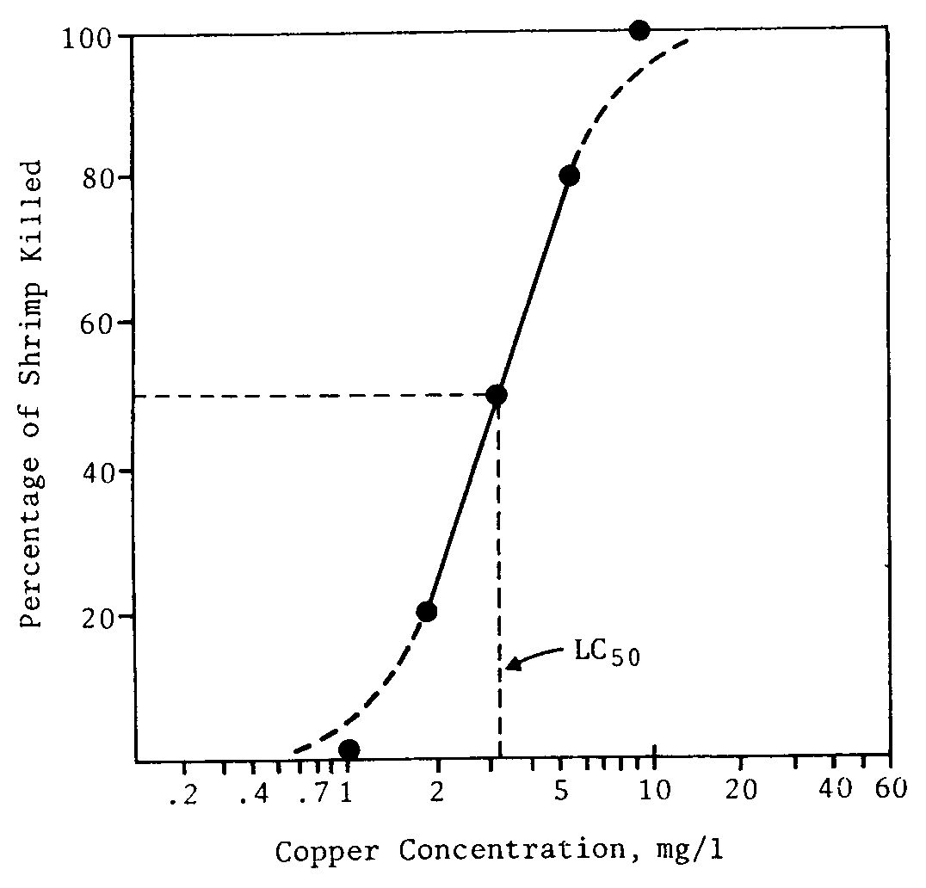
In the example shown deaths are still occurring at 96 hours. Longer experiments with a narrower range of concentrations may be used to indicate a concentration at which acute lethality ceases, a ”threshold lethal concentration”.

Figure 2. Plot of mortality versus toxicant concentration at 14 hours.

Note the logarithmic scale for the concentration. The dashed curve would fit ideal figures.
The solid line is better fitted to data for a limited number of animals which behave similarly to the average organism. From the solid line is obtained a 14-hr LC₅₀ of 3.2 mg/L of copper.

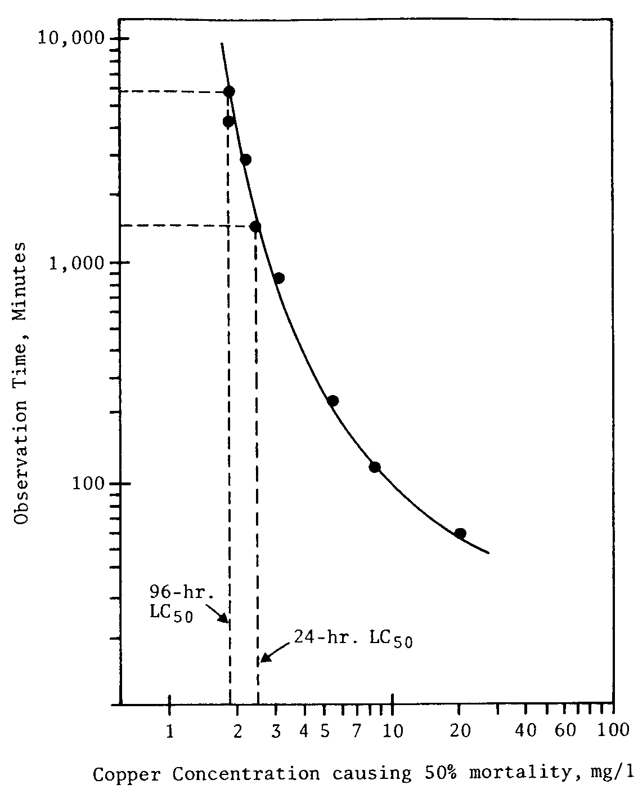

Figure 3. Plot of LC₅₀ versus observation time.

This is easiest to see in a plot such as that shown in Figure 3. To make a such as plot LC₅₀ values are calculated for each observation time. These values are then plotted against time as the experiment progresses, to obtain a "toxicity curve" as shown in Fig. 3. From this curve can be read off the 24- and 96-hr LC₅₀ which in this case are 2.5 mg/L and 1.8 mg/L of chromate, respectively.

POST-PRACTICAL.
As soon as you have completed your experiment then you should enter the data into the spreadsheet that has been sent to you (or download it from the LearnJCU web site, Practicals directory). This then should be sent back to the demonstrator that day. The class results will then be collated and sent back to you (and placed on the LearnJCU web site in the Practicals directory).
For your analysis you make use of all the class data (ie you don’t calculate means) when you make the log/linear graphs.

First you calculate %mortalities and make sure all the times are in minutes. Next you look for the first time where you have over 50% mortalities for 3 different concentrations. You then plot each time interval after this, each plot will be a log/linear graph (%mortality vs concentration). Plot the data from every group at a particular time interval onto the same graph. The line of best fit is the middle of a group of points and so at each concentration there will be scatter about the line of best fit, leave out extreme outliers.
Off each log/linear graph you calculate an LC₅₀ and these you then place onto the log/log graph (LC₅₀ vs time).

You should analyse your data as above making tables and plots such as Table 3, Figures 2 and 3. A plot shown in Figure 3 (log / log paper) should be drawn as the bioassay proceeds. To do this you will need to draw plots such as Figure 2 (log / linear graph paper) at each time interval.

• What is the LC₅₀ at 24 hours and 48 hours for the test organisms under the conditions used?

• What are the government regulations for typical Cr(VI) concentrations in aquatic areas?

• What are the toxicity characteristics of Cr(VI), consult and MSDS for information.

• How do these regulations compare with the LC₅₀ data obtained from our experiment?

• Can you estimate a threshold lethal concentration for chromate from your bioassay data?

• Suggest how dissolved organic matter may influence the toxicity of dissolved chromate.

• Suggest how improvements could be made to this experiment.

References :
(1) National Pollutant Inventory database http://www.npi.gov.au/about/list_of_subst.html
(2) The Australian and New Zealand Guidelines for Fresh and Marine Water Quality (2000) – in reserve..
or on-line http://www.deh.gov.au/water/quality/nwqms/
(3) Standard Methods for the Examination of Water and Wastewater 17th ^{e} (1995) – in reserve.
(4) Vermont SIRI searchable MSDS site : http://hazard.com/msds/
Australian alternative site : http://www.msds.com.au/

ASSIGNMENT 10
FIELD TRIP
WATER QUALITY LABORATORY

AIMS
To observe the type of procedures that are used in a NATA accredited analytical laboratory. In particular to become familiar with the types of chemical techniques used in analyzing water and environmental samples.

NOTE : This practical is compulsory, 20 marks are given for attendance and a reasonable write up of the
methods demonstrated in the laboratory. This is not a full written report, rather a “field
report” which is your notes written in sufficient detail to explain what was observed. The content
covered in this practical will be examined in your theory examinations.
You will need enclosed footwear.
1. INTRODUCTION

Throughout Australia there are a large number of analytical chemical laboratories that routinely analyse samples using quantitative analytical techniques. The techniques that are used in each laboratory vary depending on the type of matrix and the analtyes that the analyst in charge of the laboratory is presented with. There are two main types of chemical laboratory in Australia, those that are concerned with analyzing samples from the mineral industry and those that are concerned with analyzing environmental samples (typically water, soil etc). Both types of laboratory operate on a commercial basis and must ensure both high throughput of samples and quality in their analyses. To this end most large laboratories undergo an accreditation process with a national body called NATA (National Association of Testing Authorities). This is Australia's Government-endorsed provider of accreditation for laboratories and similar testing facilities. NATA services the largest association of accredited laboratories in the world and is independently evaluated on a regular basis by its international counterparts to ensure that its operations remain in-line with international practices. NATA acts as the national authority for accreditation of laboratories conducting tests, calibrations and measurements in a wide spectrum of technical fields and is the national body for accreditation of producers of certified reference materials.
NATA accreditation of a laboratory:
• provides an internationally recognised means of evaluating the competence of organisations to
perform specific tests, calibrations, measurements and inspections;
• allows these facilities to determine whether they are performing their work correctly and to
appropriate standards;
• helps testing and inspection facilities maintain their competence through regular surveillance visits;
• provides formal recognition of competent testing and inspection services and thus enhances their
marketing;
• assists manufacturing organisations to ensure the quality of in-house testing of their products;
• enables customers to identify and select reliable testing, calibration, measurement and inspection services.
Our focus in this practical is on looking at the typical techniques used in an environmental laboratory. There are two such laboratories in Cairns, Cairns Water (a subsidiary of Cairns City Council) and SGE. Our visit to the Cairns Water Laboratory will take advantage of the fact that this laboratory is both NATA accredited for Chemistry and Microbiology, we will look at both sections. The examinable content will focus on the Chemical analysis section. In the Chemical analyses carried out a large amount of instrumentation is used. You should read through your lecture notes on topics such as Atomic Absorption/Emission spectroscopy, Flow Injection, BOD, Visible spectroscopy. These techniques are routinely used in the laboratory and you will see how they are performed and the procedures the analyses go through before they are presented to the customer.

2. EXPERIMENTAL
The main objectives of the trip to the are:
1. to observe the analyses used to monitor the quality of the water in the Cairns domestic supply.
2. to see how a modern NATA accredited analytical laboratory functions.

3. REPORT

There will be no report write up for this Assignment. You are expected to make notes throughout the trip and the material covered will be examined in the Test 2.

ASSIGNMENT 11
DETERMINATION OF ACID LEVELS
IN ACID SULPHATE SOILS

AIMS
To introduce some of the standard tests, POCAS and ANC, used in determining the degree of acidification in acid sulphate soils and acid mine wastes.

1. INTRODUCTION

1.1 Acid Sulphate Soils
In coastal North Queensland acid sulphate soils are a big problem. Their management needs to be considered during the planning stage – before land is cleared, drained or construction works begin. Acid sulfate soils impact on:
(a) engineering and landscaping works – including the type of concrete and steel required, the design of roads, buildings, embankment and drainage systems. Sulphuric acid is very corrosive.
(b) agricultural practices – including suitability of crops, liming practices, fertilizer requirements and drainage systems. High soil or water acidity will reduce crop yields.
(c) environmental quality – including soil quality, surface and groundwater quality, and aquatic habitats. High acidity in waterways will result in 'fish kills'.

Tropical soils are frequently acidic as the base cations (Ca²⁺, Mg²⁺, Na⁺, K⁺) are readily leached out by the heavy rainfall. Acid sulphate soils are those that contain elevated levels of the iron sulfides (FeS and FeS₂) but principally iron pyrite (FeS₂). The sediments in the coastal regions in the mangrove swamps are those most prone to the formation of acid sulphate soils as they are maintained in a reducing environment naturally. When drained the soils becomes oxic and the exposure of the iron sulphides to oxygen, for example by drainage and excavation of these soils, can readily generate sulphuric acid. This may result in rapid and intense acidification of soils, surface water and ground water. Acidic leachate can also release aluminium (toxic), iron and other metals from the soil which then impacts in a secondary manner on the environment.

Acid sulphate soils which have been oxidised and are generating sulphuric acid are called ‘actual acid sulphate soils’ and have a soil pH of 4.5 or less.
Soils which contain pyritic material that has not been oxidised are referred to as ‘potential acid sulphate soils’ and these generally have a soil pH that is neutral or slightly alkaline.

Field indicators for actual acid sulphate soils include:
- water of pH < 4.5 in adjacent streams, drains, ground water or ponding on the surface.
- unusually clear or milky blue-green drain water within or flowing from the area (aluminium released by the acid sulphate soils acts as a flocculating agent)
- extensive iron stains on any drain or pond surfaces, or iron-stained water and ochre deposits
- soil pH < 4
- any jarositic horizons or iron oxide mottling in auger holes or recently dug surfaces; (for EA students) jarosite is a pale yellow mineral deposit, KFe₃(SO₄)₂(OH)₆, which can precipitate as pore fillings and coatings on fissures. jarosite is not always found in actual acid sulphate soils
- corrosion of concrete and / or steel structures
- dominance of reeds, rushes and other swamp-tolerant vegetation
– including estuarine occurrences of Melaleuca ericafolia. (For BT students)

Field indicators for potential acid sulphate conditions include:
- typically waterlogged, unripe muds (soft, buttery texture) or estuarine silty sands
- soils mid to dark grey to dark greenish-grey in colour
- positive peroxide test
- offensive odour, predominantly due to ‘rotten egg gas’ (H₂S).

The criteria for determining whether soils are acid sulphate soils are based on the chemical tests called the ‘acid trail’ and ‘sulphur trail’. If either criteria is exceeded, the soil is an acid sulfate soil.
These criteria are also related to soil texture. The clay content of soil can influence the amount of sulphuric
acid generated after soil disturbance. Clay soils can have a natural pH buffering capacity and the levels
of oxidisable sulphur in the soil which require management action will vary with clay content. In commercial environmental assessments particle size analyses and elemental analyses are used to ensure suitable criteria are applied for the specific soils. These analyses use elaborate instrumental facilities. In this case we will look at a well studied soil (To be advised). Criteria for determining whether soils are acid sulfate soils are provided in the following table.

Table 1. Criteria for determining the presence of an acid sulphate soil.
Criteria
Soil Texture | Sulphur trail % oxidisable sulphur  (oven dry basis) | Acid trail mol H⁺ / tonne  (oven dry basis)
Sands to  loamy sands  Sandy loams  To light clays  Medium to  Heavy clays  and silty clays | 0.03  0.06  0.1 | 18  36  62

If either the sulphur trail or acid trail value is exceeded for a given soil type then the soil is an acid sulphate soil.

1.2 Chemical Analysis of Acid Sulphate Soils and Acid Mine Wastes
Acid sulphate soils and acid mine wastes have in common an acidity which is generated as a result of the exposure of mineral pyrite material to the oxidative environment.

Methods for analysing acid sulphate soil samples to assess acid generation potential include:

1.2.1 Total Oxidisable Sulphur (TOS) method
The TOS method is used to evaluate the potential environmental risk from acid produced by the
oxidation of sulfides – predominantly pyrite or iron disulfide (FeS₂).
TOS is estimated as total sulphur minus extractable sulphur (with 4M HCl) and is reported as the weight of oxidisable sulphur expressed as a percentage of the total dry weight of the soil.
The TOS method can be used to provide a screening estimate of the sulphur trail.

1.2.2 Peroxide Oxidation – Combined Acidity and Sulfate (POCAS) method
The POCAS method aims to provide a standard approach for determining the potential acidification
of acid sulfate soils. It measures two indicators of potential acidity.
i) Sulphur trail
- a measure of oxidisable sulphur and is expressed as a percentage of the dry weight of the soil. This requires sulphate analyses, which are best, performed with ICP-AES (covered in SC 3880.03)
- Runs into problems with jarosite where it often overestimates the potential acid generation.
ii) Acid trail
- A measure of the total sulphidic acidity and is typically expressed in mol H⁺ ions per tonne of dry soil.
- Runs into problems if large shells are present where it underestimates potential acid generation.

The POCAS procedure is comprised of three distinct parts:
Step 1. Extraction with 1M KCl to determine soluble and adsorbed sulphur (S _{KCl} %) and the Total Actual Acidity (TAA).
Step 2. Oxidation of the soil with hydrogen peroxide to produce maximum acidity from any reduced sulphidic material, determining the sulphate content (S _{P} %) of the digested solution, and titration of
the Total Potential Acidity (TPA) of the solution
Step 3. Calculating the differences between steps 2 and 1 gives:
(1) the sulphur trail, used to predict the potential acid risk from un-oxidised sulphur compounds
- Peroxide Oxidisable Sulphur
S _{POS} % = S _{P} % - S _{KCl} %
(2) the acid trail, used to predict the Total Sulphidic Acidity
TSA = TPA - TAA

We will carry out a slightly modified version of the acid trail to fit into one laboratory session.

Methods used for acid sulphate soils and acid mine wastes for establishing the acidity include :

1.2.3 Acid Neutralising Capacity (ANC) method
The Acid Neutralising Capacity is a measure of the buffering capacity or inherent neutralising ability of the material (often due to the presence of carbonate minerals) being studied. This is determined by the addition of a known amount of standardised hydrochloric acid (HCl) to an accurately weighed sample, allowing the sample time to react (with heating), then back-titrating the mixture with standardised sodium hydroxide (NaOH) to determine the amount of HCl consumed by reaction with the sample. The HCl will digest carbonates, gypsum (CaSO₄.2H₂O) and the so-called acid volatile sulphides (iron monosulphides) evolving the smelly and poisonous H₂S, for this reason this digest is carried out in the fume cupboard. For any potential acid forming material (PAF) the ability of the material to buffer acid is indicated by the ANC analysis.
Note: This is the best example you have in your practical experiments in this course of a back-titration.

1.2.4 Net Acid Generation (NAG) method
The NAG method (sometimes called NAGP = Net Acid Generation Potential) involves the addition of a solution of hydrogen peroxide to a prepared sample of material to oxidise reactive sulphide, then measurement of the pH of the reaction solution and titration with NaOH of any net acidity produced by the acid generation and neutralisation reactions occurring in the sample.

Many variations of the normal 'static' NAG test procedure are appropriate for laboratory and field use to provide the level of detail required for a particular site or situation. This can range from a detailed waste rock classification program to routine operational monitoring (or simply identifying potentially acid forming (PAF) and non-acid forming (NAF) material types. Once calibrated, the NAG test is a very effective procedure for operational monitoring and is currently used at a number of mine sites for control of acid mine wastes. We will look at the normal 'static' NAG analysis in this experiment.
The NAGP test is very similar to the Total Potential Acidity (peroxide digest and NaOH titration) test which is part of the 'acid trail' in the POCAS method. We will only carry out the slightly harder POCAS test.

Table 2 "Fizz Ratings" and associated acid quantities for titrations to be used in the ANC determination.
REACTION FIZZ [HCl] (M) HCl (mL) [NaOH] (M)
RATING MOLARITY VOLUME MOLARITY
No reaction 0 0.5 4 0.1
Slight reaction 1 0.5 8 0.1
Moderate reaction 2 0.5 20 0.5
Strong reaction 3 0.5 40 0.5
Very strong reaction 4 1.0 40 0.5
Extreme reaction 5 1.0 60 0.5

Sampling. The sampling frequency (no. of soil or waste samples taken per site) is determined by the size of the site.
(1) Less than five hectares. At least 8 - 10 sampling locations. For soils samples are collected at each change in soil horizon or every 0.5m to a total depth of 1m below the proposed development depth or 2m below the surface (whichever is greater).
(2) More than five hectares. At least two sampling locations per hectare and every change in soil horizon (as above).

You will be provided with samples from the East Trinity acid sulphate soil site (Nat. West).
Samples (a) have been collected from a 5 - 15 cm horizon, samples (b) from a 15 - 25 cm horizon.

East Trinity is a paired site where there are regions of undisturbed potential acid sulphate soils (mangrove swamp) and disturbed actual sulphate soils (reclaimed land).
You are not told if the samples you are given are from the undisturbed or disturbed region and it is the function of the practical to work out if your sample is an actual acid sulphate soil or a potential acid sulphate soil

2. EXPERIMENTAL
2.1 Sample Preparation

POCAS is best run on fine ground, homogeneous samples (< 0.5 mm) of soil which have been oven dried.

NAGP and ANC tests are typically used on mine sites and can be carried out on samples of drill core (both diamond and percussion), bulk rock samples and blast hole cuttings. Large particle sized materials should initially be crushed to nominal 4 mm then a sub-sample taken by riffle splitting. The sub-sample should then be pulverised to approximate1y 200 Mesh (<75μm). Tailings and process residues can be tested in the 'as received' state or they can be pulverised prior to testing.

The sample preparation procedures we will not be involved with in this experiment as it is time-consuming and involves standard earth science processing methods using a rock mill.
You will be provided with a sample of oven dried acid sulphate soil which has been passed through the ball mill. For all your tests you will use this oven-dried (85 ºC), pulverised material.
In all the pH measurements you will use the FET semiconductor pH electrodes as these are more robust for working with soil suspensions.
Partner A Commences here

2.2 Determining the Acid Neutralising Capacity (ANC)
(1) To determine the amount and concentration of acid to be used in the analysis, the sample is given a "Fizz Rating". This is achieved placing a small amount of pulverised sample (approximately 0.5 g) on a watch glass. One or two drops of 1:3 HCl (approximately 8% HCl) is then added to the sample. The presence of CaCO₃ is indicated by a bubbling or audible "fizz" (effervescence). A fizz rating is then given to the scale of reaction obtained as indicated in Table 2.

(2) Accurately weigh around 2.0 grams of air -dried pulverised sample into a clean, dry 250 mL beaker. Carefully pipette the required volume of HCl (as indicated in Table 2 based on the fizz rating) into the beaker and add approximately 20 mL of distilled water.
CAUTION : 0.5M acid is concentrated and will cause burns. We are adding water to acid which is normally an incorrect procedure but here it is being done because of the requirement for reaction with the ASS sample.

(3) Prepare a blank by pipetting the same volume and concentration of HCl into a clean beaker containing no sample and add approximately 20 mL of distilled water.

(4) Place the beakers (covered by a watchglass) in a water bath (or hot plate) and heat to 80 to 90 ⁰C, s swirling the beaker occasionally for 1 hour or until reaction is complete.
Note: reaction is complete when no gas evolution is evident and the particles settle evenly over the bottom of the flask. DO NOT LET THE BEAKERS EVAPORATE TO DRYNESS.

(5) Allow the beaker to cool to room temperature. Then add distilled water to give a total volume of approximately 100 mL and measure the pH of the mixture.
(i) If the pH is in the range 0.8 to 1.5, then proceed with the Step 6
(ii) If the pH is higher than 1.5 then additional acid needs to be added to the sample so that the total amount added is equivalent to the next highest fizz rating.
(iii) If the pH of the mixture is less than pH 0.8, then too much acid may have been added, except when the test is being run at a fizz rating of 5. In such cases it is recommended to repeat the test using the next lowest fizz rating.
(6) Vacuum filter the sample, add distilled water to give a total volume of approximately 125 mL.
Vacuum filter the blank, add distilled water to give a total volume of 125 mL.

(7) (i) Titrate against standardised Sodium Hydroxide (NaOH) solution (using the molarity of NaOH listed in Table 2) with constant stirring (stirrer bar) using a pH electrode (support in a clamp) to monitor the titration.
N.B. Be VERY CAREFUL with these titrations as it is EASY to overshoot the endpoint. ESPECIALLY THE BLANK - YOU ONLY GET ONE CHANCE.
(ii) Interrupt the titration near pH 5 and add 2 drops of 30% H₂O₂ to oxidise any dissolved Fe²⁺ ion.
(iv) Continue the titration to pH 7.0 and record the volume of NaOH added.
(v) Titrate the ¹blank" using NaOH us indicated in Table 2.

(N.B. In the standard analytical procedure you would run duplicates on every fifth sample.)

2.3 Determining Total Sulphidic Acidity (TSA) 'acid trail' in the POCAS Method

Partner B Commences here doing 2.3 : start by carrying out the peroxide digest 2.3.3.

2.3.1 Determining Total Actual Acidity (TAA) - Part A KCl extraction
(1) Accurately weigh approximately 2.5 g of pulverised sample into a 125 mL conical flask
containing a magnetic stirring bar.

(2) Make a 1:20 suspension by adding 50 mL of 1M KCl using a measuring cylinder.

(3) Extract the solution by stirring for 1 hour (do not heat) and then vacuum filter the resultant suspension to obtain a clear solution.

(4) Prepare a blank by taking a clean 125 mL conical flask with a stirrer bar and adding 50 mL of 1M
KCl, stir for 1hour then vacuum filter.

2.3.2 Determining Total Actual Acidity (TAA) - Part B NaOH titration
(1) Pipette 25 mL of the solution into a 250 mL beaker containing a stirrer bar and
measure the pH (pH_{KCl}).

(2) If pH_{KCl} is greater than 5.5, then TAA is zero

(3) If pH_{KCl} is less than 5.5, then titrate the 25 mL aliquot with standardised 0.05 M NaOH to
pH 5.5 with stirring. Record the molarity and titre of alkali used to reach pH 5.5

(4) Titrate the blank sample using the same molarity NaOH.

2.3.3 Determining Total Potential Acidity (TPA) - Part A Peroxide digest (oxidation)
(1) Accurately weigh approximately 2.5 g of pulverised sample into a 500 mL beaker
containing a magnetic stirring bar. Record the total weight of beaker plus sample + stirrer bar.

(2) Make a homogeneous 1:5 suspension by adding 12.5mL 2M KCl with a measuring cylinder. A 1:5 ratio is initially selected to enhance peroxide oxidation but the final ratio is 1:20 as in the TAA titration.

(3) Completely oxidise the sample by adding 10 mL aliquots of AR grade hydrogen peroxide (30%, measuring cylinder) to the suspension with stirring – maximum 30 mL. This operation needs to be carried out in the fume cupboard.
CAUTION : 30% peroxide will cause burns.
Care needs to be taken to avoid samples bubbling / frothing-over when the initial aliquot of peroxide is added. If the reaction is too vigorous, add more distilled water to the sample. You must stand with a distilled water wash bottle ready to use as you add aliquots.
If necessary, gently heat (max. 55-60ºC) the sample between additions of peroxide aliquots until oxidation is complete (that is the effervescing has ceased) this may take up to an hour. Record the total volume of H₂O₂ aliquots used for calculating the blank corrections.
NOTE: at this point you must start (7) as well as continuing on with steps (4) – (6).
You add an aliquot to the blank just after you have added an aliquot to the sample.
(4) Add 12.5 mL of 2M KCl and if the total volume is < 50 mL add sufficient distilled water to make up the volume to approximately 50 mL.

(5) Remove the excess peroxide by heating between 85 and 95 ºC until bubbling has stopped and the solution has cleared.
N.B. You must not stop this process early - it must go to completion otherwise you will get false titres.
If the total volume exceeds 50 mL then reduce it to 50 mL by boiling carefully.

(6) Weigh the flask plus contents and add distilled water until it coincides with the original weight + 50.0 g (50 mL of 1M KCl at 25 ºC). Vacuum filters the suspension to obtain a clear solution.

- Prepare a blank by a adding 12.5 mL of 2M KCl to a 125 mL flask containing a stirring bar. Add the total volume of peroxide added at step (3). Add a further 12.5 mL of 2M KCl. Remove the peroxide by heating with stirring between 85 - 95 ºC until bubbling stops (CAUTION the reaction will be quite vigorous this time). N.B. You must not stop this process early - it must go to completion otherwise you will get false titres.
Add distilled water to make up to a 50 mL volume.

2.3.4 Determining Total Potential Acidity (TPA) - Part B NaOH titration.
(1) Pipette 25 mL of the peroxide digest solution into a 250 mL beaker containing a stirrer bar
and measure the pH (pH_{KCl}).

(2) If pH_{KCl} is greater than 5.5, then TPA is zero.

(3) If pH_{KCl} is less than 5.5, then titrate the 25 mL aliquot to pH 5.5 with stirring using standardised
0.05 M NaOH.
Record the molarity and titre of alkali used to reach pH 5.5.

(4) Double oxidation step - immediately add a 2.5 mL aliquot of 30% peroxide with stirring and note the pH. If the pH drops below 5.5, titrate with stirring back to pH 5.5 with the same molarity NaOH as you used above. Record the total titre of alkali used to reach pH 5.5.

(5) Titrate 25mL of the blank sample using the same molarity NaOH as used in steps (3) and (4).

(N.B. In a normal analytical run duplicates of selected samples would be included within each batch.)

2.4 Squeeze Test Analysis.
The physical properties of an acid sulphate soil may be used to support the chemical analyses of the sample. A convenient technique is to simply squeeze the soil sample between your fingers. If a soil is a typical unripe mangrove mud then it will very easily pass through the fingers.

Take a sample of the soil sufficient to fit comfortably into the palm of your hand. Remove any large fragments of organic matter, gravel or shells. Moisten the soil with water, a little bit at a time. Knead the soil until the ball of soil formed just fails to stick to the fingers. If necessary, add more soil or water to attain this condition, known as the “sticky point Continue kneading for 1 to 2 minutes until there is no apparent change in the soil ball. The soil ball, now called a bolus is ready for texture analysis.
The properties of the bolus and a ribbon formed from it help characterize the soil texture. We will not go into a full texture analysis (which is done in EA2007). Instead we will used the Index of Squishability.

The ability to pass through the fingers is given an index :
"The Index of Squishability" 1 2 3
doesn't pass thru passes thru runs thru readily
Fully ripened Unripened mud
In conjunction with a description of the soil the index may be used to assess the degree of conversion of the soil from a potential to an actual acid sulphate soil.

• Use this information to assist with your decision on the type of acid sulphate soil that you have been given.

2.5 Soil pH.
Soil pH is normally measured using either deionised water 1:5 soil: water pH(1:5 water) or using a 0.01M CaCl₂ solution pH(1:5 CaCl₂). The ionic composition of the liquid phase affects the measured pH value by its influence on the equilibrium between exchangeable and soil solution H⁺ and on the electrochemical response of the pH electrode. It is normal to use 0.01M CaCl₂ solution, as its ionic composition is similar to that of many natural soils. As a rough guide the pH in CaCl₂ is usually 0.8 pH units lower than in water but can be as much as 2.0 pH units lower on grey sands and so you must quote the solution you use for measuring the soil pH.

Add 5g of soil and 25mL of 0.01M CaCl₂ to a plastic cup and stir using a magnetic stirrer for 30 minutes.
Vacuum filter the solution and place the filtrate in a new plastic cup and measure the pH using a calibrated pH meter. You will carry out this pH(1:5 CaCl₂) measurement on the two soils provided in the buckets.

• Use this information to assist with your decision on the type of acid sulphate soil that you have been given.

3. CALCULATIONS AND QUESTIONS

3.1 Determination of Acid Neutralising Capacity (ANC)

Calculation of ANC ANC = $\frac{\left(V_{1}\text{ x }[\text{HCl}]\right)− \left(V_{2}\text{ x }[\text{NaOH}] x B\right)}{\text{wt}} x K$ (1)

Where:
V₁ = volume of HCl added in mL from table 2
V₂ = volume of NaOH from titration in mL
[HCl] = concentration of HCl from table 2
[NaOH] = concenration of NaOH from table 2
B = ( [HCl] x Vol. of HCl in blank) / ( [NaOH] x Vol. of NaOH titrated in blank)
wt = sample weight (2.0xx grams)
K = conversion factor K = 49.0 (to calculate in kg H₂SO₄ / t)
K = 5.0 (to calculate %CaCO₃ equivalent)
K = 0.50 (to calculate in mol H⁺ / t equivalent)

• What is the function of the B term in the above equation?

As a further check on whether the correct amount of acid has been added to the sample, the following is recommended. At the end of the titration, check whether the ANC result for the sample is within the following limits in Table 3.

Table 3. Recommended ANC Ranges (% CaCO₃ equivalent) for Each Fizz Rating

Fizz rating | 0 | 1 | 2 | 3 | 4 | 5
Lower limit for ANC | - | 5 | 30 | 100 | 200 | 500
Upper limit for ANC | 10 | 40 | 150 | 300 | 700 | -

If the ANC result for a sample is within the specified range for the fizz rating at which the test was conducted then it is likely that the correct amount of acid has been added. If the result is outside of the range, then it is recommended that the analysis be repeated at a different fizz rating (which would take a further 1.5 - 2.5 h!).
• Does your soil sample have any significant buffering capacity from the ANC result?

3.2 Total Sulphidic Acidity (TSA) Test Procedure

Calculation of TSA TSA = TPA - TAA mol H⁺ / t (2)

Where:

TAA = $\frac{V_{1} x \left(T_{1}− T_{2}\right) x M_{1} x \text{1000}}{V_{2} x W_{1}}$ mol H⁺ / t (3)

TPA = $\frac{V_{5} x \left(T_{3}− T_{4}\right) x \left(M_{2} \text{or} M_{3}\right) x \text{1000}}{V_{6} x W_{2}}$ mol H⁺ / t (4)
Where:
V₁ = volume of KCl 50 mL
V₂ = volume of KCl 25 mL
V₅ = volume of KCl 50 mL
V₆ = volume of KCl 25 mL
T₁ = titre volume (NaOH) in mL
T₂ = blank titre volume (NaOH) in mL
T₃ = total titre volume (NaOH) in mL
T₄ = blank titre volume (NaOH) in mL
W₁ = sample weight in grams
W₂ = sample weight in grams
M₁ = molarity of NaOH
M₂ = molarity of NaOH 0.05 M

Calculate TAA, TPA and TSA for your soil sample.

• Estimate if your soil is an Actual Acid Sulphate Soil or Potential Acid Sulphate soil using the information in Table 1.

• Suggest an appropriate management strategy for such a soil type.

Reference:
“Acid sulfate soils manual” (1998) – in reserve.
ASSIGNMENT 12
FIELD TRIP
WATER TREATMENT

AIMS
To observe the type of procedures that are used in treating and monitoring water at a public water utility and become familiar with the types of physical and chemical processes and monitoring that are used in controlling water quality. To observe the operation of a modern Biological Nutrient Removal (BNR) sewerage plant and become familiar with the processes involved with controlling effluent water quality.
NOTE : This practical is compulsory, 20 marks are given for attendance and a reasonable write up of the
methods demonstrated in the laboratory. This is not a full written report, rather a “field
report” which is your notes written in sufficient detail to explain what was observe, in particular
you should prepare a flow chart of the operation of each facility you visit.
You will need enclosed footwear.
1. INTRODUCTION

In most urban situations people rely on good quality water to be provided by the local municipal water supply. The evolution of a variety of processes for treating raw water has resulted in a perception in the developed parts of the world that we can turn on any tap and out will come, clear, safe and often palatable drinking water. With the large scale water scare in Sydney in 1998 there are now some reservations about this and for those of you that have taken a bath in Adelaide you will know that the technology does not always manage to fulfill the "clear" requirement. Nevertheless, Australia for a dry continent supplies remarkably good, safe water for human consumption. This is in stark contrast to the dryer under-developed nations of the world where up to 20 million people die each year from waterborne diseases due to poor or non-existent water purification procedures.

Primary Aeration 2º Settling and Hardness Disinfection
Settling Coagulation Removal

Al or Fe salt added Phosphate
to ppt colloids.
Raw Consumer
Water

Water
Molecules
Suspended
Air Ca²⁺ pptd. as Cl₂ or O₃ Particles
the phosphate

Figure 1. The typical stages of purification of drinking water.

1. Raw water is either classified as ground water or surface water.
Ground water comes from deep underground aquifers with wells generally 100's of metres deep. This source of water may or may not be replenished on the human timescale. Mexico City, for instance, is due to run out of water from their main aquifer in the next century. In Australia bore-water is seldom used as a municipal water supply as it tends to be very hard. The advantage of ground water is that it is a very clean source of water as the ground has effectively filtered out impurities.
Surface water is drawn from lakes and rivers and this is the principle source of raw water in Australia. Lakes with controlled catchments provide much lower levels of contaminants than rivers where pollutants from agricultural, industrial and recreational use and sewage outfall must all be removed. Surface water has higher levels of suspended and organic materials than ground water but is constantly being renewed and so there are large quantities available.

2. Primary settling is carried out in large holding basins where coarse particulate matter settles out. The pH is adjusted with lime if the raw water pH is below 6.5.

3. Aeration is used to remove dissolved odoriferous gases such as H₂S and also to oxidise some of the organic material present in the water.
4. Secondary settling and Coagulation is necessary to remove the colloidal material present. Either Fe₂(SO₄)₃ or Al₂(SO₄)₃ ("alum") are used to capture the colloidal material onto the gelatinous hydroxides Fe(OH)₃ and Al(OH)₃ that form when these compounds are added to water.

5. Hardness removal. Calcium Ca²⁺ and magnesium Mg²⁺ are the two ions usually responsible for water hardness. The Ca²⁺ ion may be removed by addition of soluble phosphate so that the insoluble phosphate Ca₃(PO₄)₂ forms. Alternatively, Na₂CO₃ may be added to precipitate CaCO₃. When sufficient OH⁻ is added Mg (OH)₂ precipitates.

6. Disinfection is necessary as bacteria and viruses are still found in the water at this stage. A variety of techniques are used including:
(a) Addition of Cl₂ - HOCl, hypochlorous acid is the active ingredient. Chlorination also results in the formation of several toxic halocarbons if organic material is present in the water. This method of water purification is being phased out.
(b) Addition of O₃ - ozone has a short lifetime and a 10 minute treatment is sufficient to clean up water, it is relatively expensive to generate ozone on site.
(c) ClO₂ - chlorine dioxide gas is a radical species with a short lifetime that does not chlorinate organic compounds. NaClO₂, sodium chlorite is treated with Cl₂ on site to generate the unstable gas.
(d) Ultraviolet light - short wavelength radiation produces free radicals in solution such as OH., when these radicals are generated in solution they remove dissolved organic matter. Short wavelength of light also has a germicidal action, breaking down DNA, and this requires only 10s of contact time.
(e) Membrane filtration is beginning to be used where nanometre pore membranes are used to filter out essentially all material except for water.
Methods b) - e) do not provide any residual protection from bacterial infection once the water has left the treatment plant and so often low level chlorination is used after these steps to provide this level of protection. As no organic material is present this final light chlorination step produces no toxic products.

Once finished the water must be tested to verify that the contaminants of interest have been removed. Metals such as iron are a nuisance in water imparting colour and an unpleasant "metal" flavour; others such as lead, cadmium and mercury are toxic and their levels must be checked. As analytical equipment now routinely tests to the ppb levels it has proven necessary to set levels which the water supplier must meet. For these heavy metals the level set is around 2μg/L. Nitrates from agriculture often contaminate the raw water and the level of NO₃⁻ is monitored as it also is a water toxic. Each country sets the maximum acceptable concentration levels permitted and those given in the Table 1 are quite representative.

2. EXPERIMENTAL
The main objectives of the trip to the are:
1. to find out about the water treatment methods currently in use in the Douglas Shire.
2. to observe the analyses used to monitor the quality of the water in the Douglas Shire Facilities.

3. REPORT

There will be no report write up for this Assignment. The material covered will be examined in the Test 2.
You should make a flow chart of the operation of each water treatment facility detailing changes in water quality and what tests are used to ensure the required water quality.

Table 1. Typical Drinking Water Standards

Substance | MAC (ppm) | Substance | MAC (ppm)
Inorganics
Aluminium | 0.2 | Arsenic | 0.05
Cadmium | 0.005 | Chloride | 250
Copper | 1.0 | Cyanide | 0.2
Fluoride | 1.5 | Iron | 0.3
Lead | 0.01 | Manganese | 0.05
Mercury | 0.001 | Nitrate | 45
Selenium | 0.01 | Silver | 0.05
Sodium | lowest practical | Sulphate | 500
Uranium | 0.02 | Zinc | 5.0
Organics
Aldrin / Dieldrin | 0.0007 | DDT | 0.03
Lindane | 0.004 | Parathion | 0.035
Phenols | 0.002 | Trihalomethanes | 0.35

| RIP OUT SECTION
|
|
| These notes are intended as a work book for this part of the course.
|
| Please make comments on any part of the course here as you go along and then at the
| end of the course make sure you rip out this section and return it to the Chemistry
| Department box. This will enable the course to be improved with time and at the
| same time ensures that THIS IS NOT A RE-SALEABLE ITEM.
|
|
|
|
|
|
|
|
|
|
|
|
|
|
|
|
|
|
|
|
|
|
|
|
|
|
|
|
|
|
|
|
|
|
|
|
|
|
|
|

Failure to clean-up will result in a loss of marks!
at an atmospheric pressure of 760mm Hg
(N.B.conductance is an intensive property - it does not depend on the amount of substance present)
Should one of your four unknown samples produce a very dark blue colour which cannot be read with the spectrophotometer, dilute the original water sample 100 fold. This is accomplished by placing 1.0 mL of the water sample in a 100 mL graduated cylinder and then adding enough distilled water to bring the volume up to 100 mL. Now 25 mL of this diluted sample may be analysed according to directions for colour developed in sample, previously given. Remember that the concentration which you ultimately obtain from this sample will have to be multiplied by 100 because of the 100 fold dilution.
This is the minimum recommended volume for one determination.
From: Loomis, T.A. (1974, Essentials of Toxicity, 2nd Edn., Lea & Febiger, Philadelphia, p. 18 - 19) † 2,3,7,8-tetrachlorodibenzo-p-dioxin
5 is used for high ANC material ( > 400kg H2SO4/t ) eg. limestone
MAC = Maximum Acceptable Concentration

