CH1012 Tutorial 9 Answers

- Predict and name the organic product from each of the following reactions.
Which mechanism is occurring:

(i)

electrophilic addition, Markovnikov direction of addition. Formation of a halo-substituted cycloalkane.
1-iodo-1-methylcylcohexane

(ii)

electrophilic aromatic substitution reaction 2,4,6-tribromoaniline
aniline is a highly activated with the NH₂ group a ortho,para directing group, multiple substitution results.

- Carboxylic acids are much stronger acids than alcohols. Using simple examples and chemical equations explain why this is the case.
In the following examples the carboxylic acid (acetic acid pKa 4.76) dissociates readily to form the conjugate base as the anion is resonance stabilised. In the case of the alcohol (ethanol pKa 16.00) there is no resonance stability for the anion and so the equilibrium lies heavily to the LHS.

- The reaction of 2-methyl-2-bromoheptane with sodium hydroxide proceeds by an
S_{N}1 nucleophilic substitution mechanism.
• Provide a detailed reaction mechanism and identify (name) the
stereochemistry of the reactants and products.
• How would you alter the reaction conditions to bring about the
Formation of the R optical isomer would be favoured in an aprotic solvent such as acetone.

4. Describe in detail the mechanism for the following reactions :
(i) the bromination of nitrobenzene in the presence of ferric bromide.

5. Give 2 examples of heterocyclic aromatic compounds and show how these obey the (4n +2) π
electron rule.
The special stability of aromatic compounds results from the delocalisation of the pi electrons around the planar ring system. When the number of electrons able to form a pi system is (4n +2) then a stable aromatic system is formed. Resonance stabilisation is not obtained with other electron counts.

1. 2. 3.

1. Pyridine 5 x sp² carbons 5 electrons, 1 x N sp² 1 electron out of plane, therefore 6 pi electrons.
2. Pyrrole 4 x sp² carbons 4 electrons, 1 x N sp² 2 electrons out of plane, total 6 pi electrons.
3. Furan 4 x sp² carbons 4 electrons, 1 x O sp² 2 electrons out of plane, total 6 pi electrons.
6. The nitration of phenol is a typical reaction of aromatic compounds with electrophilic reagents.

PhOH + NO₂⊕ → ortho-NO₂PhOH + para-NO₂PhOH (Ph = C₆H₅)

Explain why substitution occurs at the ortho and para positions rather than the meta position.

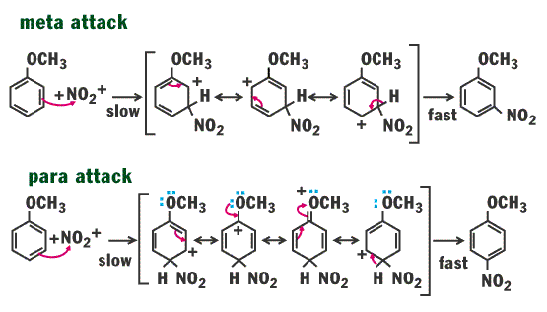
OH
OH
OH
OH
OH
OH
:OH
+OH
OH
OH
OH

