CH1012 Tutorial 6 Answers

Be
Be
+
Be₂⁺
A
O
A
O
M
O
σ
1
s
σ
∗
1
s
σ
2
s
1
s
1
s
2
s
2
s
σ
2s*
1.

The bond order = 1/2 (4 - 3) = 1/2

The molecule will be paramagnetic as there
Is one unpaired electron.

2. Using Band Theory describe how a p-type semiconductor differs from an n-type semiconductor.
Semiconductors are solids which have a small gap between the valence (filled) and conduction (empty) bands. This band gap may be crossed by themally excited electrons.
A p-type semiconductor is one where further positive charges have been added to the solid, this is done by adding dopant atoms which have one fewer valence electrons than the atoms in the bulk solid. This creates a new empty band at the top of valence band which is called an acceptor band. The acceptor band accepts electrons from the valence band creating holes in the valence band. These holes are effectively mobile as electrons can move into them from other regions of the solid. These mobile "hole" charge carriers are responsible for the increased conductivity in p-doped semiconductors.
An example of a p-type semiconductor is silicon doped with gallium.
A n-type semiconductor is one where further negative charges have been added to the solid, this is done by adding dopant atoms which have one more valence electrons than the atoms in the bulk solid. This creates a new empty band at the bottom of conduction band which is called an donor band. The donor band moves electrons readily into the conduction band enhancing conductivity.
An example of a n-type semiconductor is silicon doped with phosphorus.

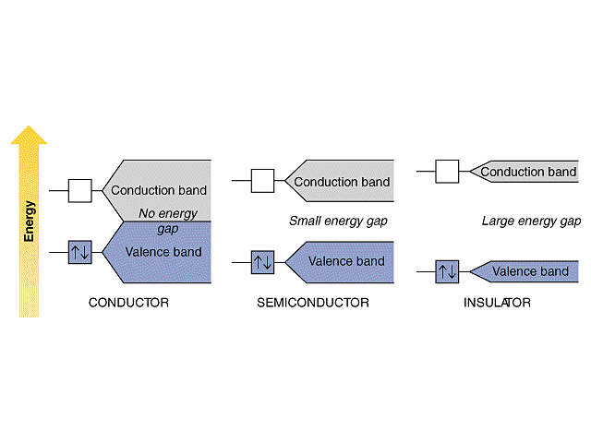

3. Provide IUPAC names for the following molecules:

3-methylbutanal 6-methyl-2,5-heptanedione

4. Draw skeletal structures for the following molecules:

4-iodo-4-ethyl-2-methylhexane benzyl bromide

5. Provide IUPAC names for the following molecules:
.

(S)-6-bromo-1-heptanol Z-1-bromo-2-fluoro-1-cyclopentene

6. Draw skeletal structures for the following compounds:

(a) 2-chloro-3,3-dimethylheptanoic acid (b) 3-bromo-3-ethyl-1-pentene

