CH1012 Tutorial 6 Answers

1. Define the term principal quantum number.
Which 2 quantum numbers define a 2s orbital?

A quantum number is a number which specifies an orbital (a solution of the Schrodinger equation)
The principal quantum number n is an integer that defines the size (shell) of an orbital.
n = 1 ...
n = 2, l = 0 defines a 2s orbital

2. Inside a bottle of Coke® the partial pressure of CO₂ is 3.5 atm at 25ºC. K_{H}(CO₂, 25ºC) = 3.3 x
10⁻² mol L⁻¹ atm⁻¹ in water.
• Calculate the solubility of carbon dioxide in Coke® under these conditions assuming that the
Coke® is a dilute solution that behaves like H₂O.
• Why does the CO₂ bubble out of the Coke® when it is opened? (N.B. you will need
some calculations here)

[CO₂] = K_{H} x p(CO₂) = 3.3 x 10⁻² mol L⁻¹ atm⁻¹ x 3.5 atm = 0.1155 mol L⁻¹

If the bottle is opened then the partial pressure of CO₂ drops to the ambient level (0.036% / 100) x 1atm = 3.6x10⁻⁴atm. p_{i} = X_{i} p_{total}

[CO₂] = K_{H} x p(CO₂) = 3.3 x 10⁻² mol L⁻¹ atm⁻¹ x 3.6x10⁻⁴atm = 1.19 x 10⁻⁵ mol L⁻¹

The difference in the solubilities between when it is capped and when it is uncapped is released as a pulse of carbon dioxide gas which rapidly bubbles out of the solution
(0.1155 - 1.19 x 10⁻⁵ = 0.11549 mol L⁻¹ released).

3. Draw molecular orbital diagrams for N₂ and O₂.
Calculate the bond orders and predict the stability of each of these diatomic molecules using
these MO schemes.

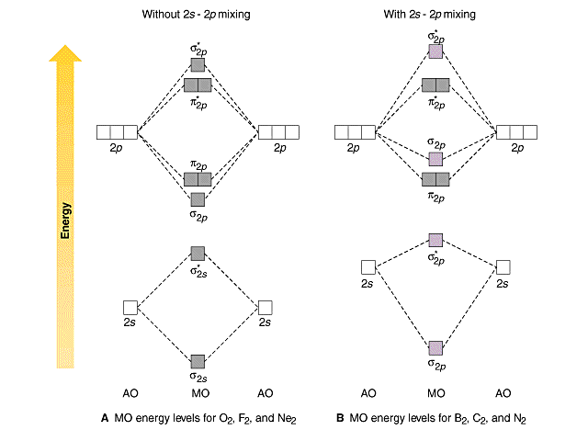
E
NE
RGY
σ_{2s}
σ∗_{2s}
Without s-p mixing
With s-p mixing

O₂ N₂

O₂ N₂
The bond orders: O₂ = 1/2(8 - 4) = 2 N₂ = 1/2(8 - 2) = 3 .
Both would be expected to be stable as the bond order is greater than 0.
Oxygen would be expected to have 2 unpaired electrons and therefore would be paramagnetic.

4. What is Hund’s Rule?
• Illustrate how this influences the magnetic properties of one of the above molecules.

Hund’s Rule says that when atomic or molecular orbitals of equal energy are populated with electrons then the electrons enter spins parallel and un-paired until all the equivalent orbitals have been singly occupied after which spin-pairing occurs with spins anti-parallel.
In oxygen the π*_{2p} orbitals illustrate this process which leaves the molecule with 2 unpaired electrons making the molecule paramagnetic (instead of diamagnetic which would have occurred if the π*_{2p} electrons spin paired immediately)

5. Draw skeletal structures and provide IUPAC names for the following compounds:

CH₃CH₂CH(C₂H₅)CH₂CH(CH₃)CH₂COOH
5-ethyl-3-methylheptanoic acid
CH₃CH₂CHCl(CHO)
2-chlorobutanal

6. Draw a 3-D molecular structure for 4-chloro-2-cyclohexenone.

7. Determine if there are any chiral centres in the following molecules and assign R or S absolute configurations to the chiral centres you find.

Chiral centres
S S

