CH1012 Tutorial 5 Answers

1. The vapour pressure of n-butane is 3.41 x 10⁵ Pa at 30ºC and 8.95 x 10⁵ Pa at 70ºC.
Calculate ΔH_{vap} (n-butane) in this temperature range.

$$ℓn\left(\frac{P2}{P1}\right) = \frac{{\text{-H}}_{\text{vap}}}{\text{R }}\left(\frac{1}{T2}−\frac{1}{T1}\right)$$

$$\left[−\text{R x }ℓn\left(\frac{P2}{P1}\right)\right]\text{ x}{\left(\frac{1}{T_{2}}−\frac{1}{T_{1}}\right)}^{−1}= {ΔH}_{\text{vap}}$$

$$\left[−8\text{.}\text{314}\text{ x }ℓn\left(\frac{8\text{.}\text{95}}{3\text{.}\text{41}}\right)\right]\text{ x}{\left(\frac{1}{\text{343}}−\frac{1}{3\text{03}}\right)}^{−1}= {ΔH}_{\text{vap}}$$

-8.0225 x -2598.225 = ΔH_{vap}
20844.316 J = ΔH_{vap}
ΔH_{vap} = 20.8 kJ / mol

2. Describe the main features of the Hall-Heroult process for the production of aluminium
metal from alumina.

Cathode: Al₂O₃ + 6e → 2Al + 3O²⁻
Anode: C + 2O²⁻ → CO₂ + 4e
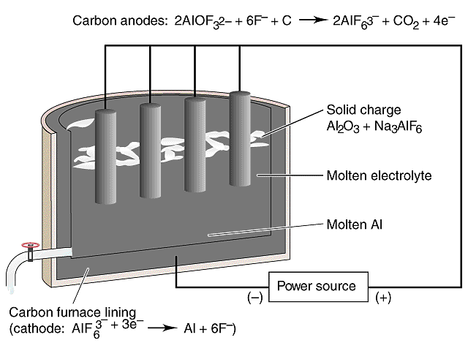
Overall: 2Al₂O₃ + 3C → 4Al + 3CO₂
The electrolyte is cryolite ( Na₃AlF₆) and alumina.
At 1000ºC this is molten.

The cells operate at 4.7 volts but have huge
Currents > 100kA
The carbon anode is consumed

3. Explain the characteristics of interstitial alloys and heterogenous alloys using
examples to illustrate your answer.

Interstitial alloy - one atom type is much smaller (typically main group) and fits in the interstices of the bulk structure. eg. Fe / C where the C content in the steel varies from <0.2% mild steel to > 1% in
carbon steel.

Heterogeneous alloys - components not dispersed uniformly. eg. Pearlite Steel,
phase 1 pure iron, phase 2 cementite Fe₃C
3Fe + C → Fe₃C ΔH +ve at >1000 ºC most of C is present as Fe₃C

4. What are the physical properties of an azeotropic mixture?

An azeotropic mixture is a constant boiling mixture of two liquids where the composition of the vapour phase and liquid phase are the same x₁:x₂ vapour = x₁:x₂ liquid. The azeotropic mixture is arrived at by removal of the volatile components during distillation and is either a minimum or maximum on a temperature vs composition diagram.

5. The van der Waal's equation accounts for the behaviour of a real gas. What are the van der Waal's forces and how do they relate to this equation?
The van der Waal’s Forces are the weak intermolecular forces between molecules (atoms). They include forces such as (i) hydrogen bonding, (ii) dipole-dipole, (iii) dispersion forces (instaneous dipoles).
They relate to the van der Waals equation in that the pressure in a real gas is lower than that of an ideal gas due to the intermolecular forces, therefore the extra term (na² /V²) is added to the pressure to correct for the effect of these forces.

6. Which quantum numbers define the energy of a 3dz² orbital?
What is the value of the azimuthal quantum number for this orbital?

3dz² The energy is defined by the principal quantum number n and the azimuthal quantum
number l.
The values for 3dz² are n = 3, l = 2

