CH1010 Tutorial 8 Answers

- Why is oxidative phosphorylation important in the catabolism of glucose? Provide a detailed energetic breakdown.
Glucose contains bond energy stored in the multiple C-O-H and C-C bonds.
In glycolysis 2 molecules of ATP
are produced but this contains only a
fraction of the available energy in a
molecule of glucose. Part of the energy
is stored in the 2NADH, the rest is in
pyruvate.
The pyruvate is then oxidised releasing
another 1NADH (x2 = 2NADH) and
forming acetyl-CoA.
In the citric acid cycle acetyl-CoA is oxidised to CO₂. The energy released is transferred in the oxidation/reduction
reactions to the electron/H carriers 3NAD⁺
and 1FAD (x2 = 6NADH, 2FADH₂)
and 1GTP is formed
(x2 = 2ATP equivalents) .
The net result is that from the glycolysis and the TCA cycle = 10NADH and 2FADH₂ are formed.
In oxidative phosphorylation the electron carriers are oxidised and the electrons passed into an electron transport chain that is used to create a proton gradient across the mitrochondrial membrane.
ATPsynthase then uses the proton gradient to synthesize ATP.
Each NADH = 3ATP (glycolysis cytosol 1 NADH = 2ATP) Each FADH₂ = 2ATP
Thus 1 molecule of glucose generates 32ATP from electron transport as opposed to the 4ATP generated directly from glycolysis plus the TCA cycle.

2. What is chemiosmotic theory and why is it important in oxidative phosphorylation?
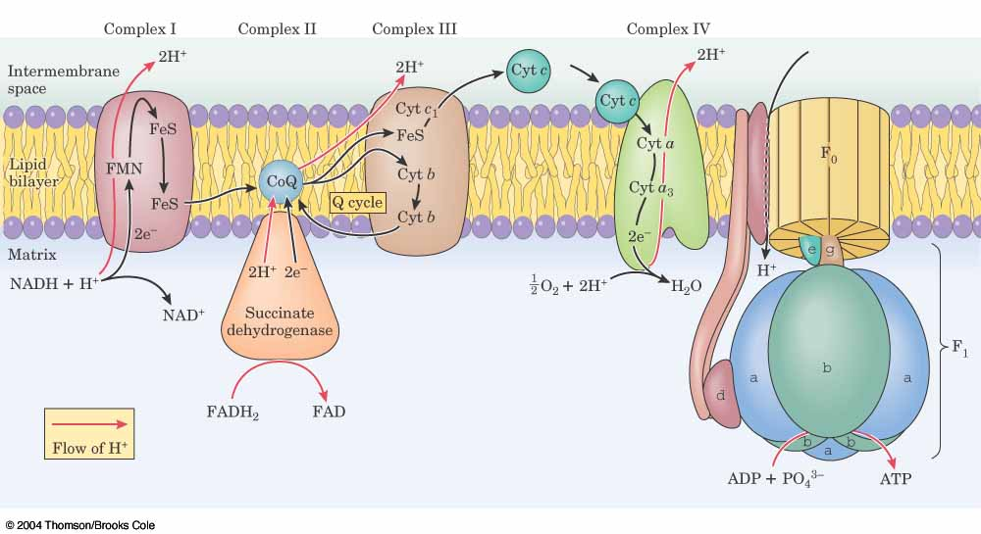
Chemiosmotic theory was proposed by Peter Mitchell in 1961 to explain the
synthesis of ATP in the mitrochondrion. The theory states that a proton
gradient is built up across the mitochondrial membrane as a result of the
electron transport chain operating as a proton pump (high [H⁺] intermembrane,
low [H⁺] matrix). The [H⁺] gradient stores chemical potential energy which is used
in the proton translocating F_{O}F₁ ATP synthase. This transmembrane protein has a
F_{O} stalk which functions as a proton channel. As the protons travel down the
channel the rotor and stator of the F₁ knob of the complex change conformations
and rotate. The rotations create different sites in F₁ {open (release ATP,
bind ADP + Pi), loose, tight (ATP formed)}which create ATP from ADP +
phosphate and release ATP into the matrix. The majority of the energy is used in
releasing the ATP from the binding site in the F₁ component. 3H⁺ are used to synthesise 1 ATP.
3. What are the five main steps in fatty acid synthesis? What is the function of each step?
Fatty acid synthase is the multi enzyme complex that carries out fatty acid synthesis it possesses a coenzyme called acyl carrier protein ACP that has a phosphopantheine prosthetic group. The phosphopantheine swinging arm carries the intermediates from one enzyme site to the next site (7 enzymes in E. choli).
Priming – primes acetyl-CoA onto FA synthase – this happens only at the start of synthesis
1. Loading – formation of malonyl-CoA and loading on ACP
2. Condensation – condensation of fragments on ACP (1st time acetyl grp) → 2C+chain + CO₂
3. Reduction – ketone reduced to alcohol, reduces bond order
4. Dehydration – removes water, forms double bond
5. Reduction – reduces double bond to give a saturated chain which is C₂ longer than the initial chain.
Loop back to 1.
Once palmitic acid has formed a thioesterase cleaves the palmitic acid off ACP and the cycle is ready
to begin again.

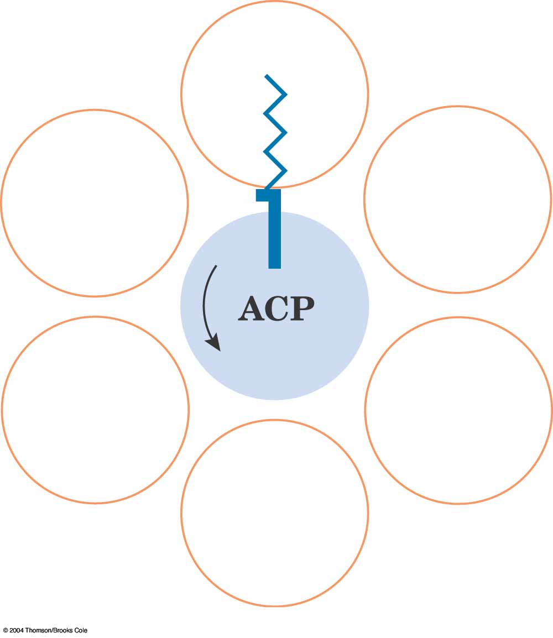

4. What are the various functions of chlorophylls during photosynthesis?
The main function of chlorophyll molecules is in the light reactions of photosynthesis to gather energy of incident photons and pass them into membrane systems that are able to manufacture NADPH and ATP. The molecules NADPH and ATP are used to drive the formation of carbohydrates in the dark reactions.
The light reactions of photosynthesis occurs in photosynthetic units called photosystems that are built into the thylakoid membrane of the thylakoid disks in chloroplasts. There are two photosystems (PS-I, PS-II), each photosystem has two groups of chlorophylls (Chl) and accessory pigments. The first group are antennae light harvesting Chl (LH) which function to gather light energy and pass it (optically) towards the second group which are called reaction centre Chl (RC). Several hundred LH Chl pass energy towards 2 special reaction centre Chl. In photosystem I the RC Chl is P-700, in PS-II the RC Chl is P-680.
Absorption of sufficient energy (from the antennae Chl) and a photon by P-680 (<680nm) causes charge separation at P-680 and production of an electron which is fed to the electron transport chain, at the same time water is oxidised (to provide the electron) and O₂ released.
The electron-transport chain follows the Z-scheme passing the electron from carrier to carrier until it arrives at PS-I Chl P-700 where it is excited to a high energy state (photon <700nm), the reduction potential is now sufficient to reduce NADP to NADPH. This is one of the functions of the Chl to produce sufficient energy to reduce NADPH. As the Z-scheme operates a proton gradient is built up across the thylakoid membrane, this is used to drive the synthesis of ATP, this is the second place that the energy gathered by the Chl is used.

P680 : chlorophyll absorbs < 680nm
P700 : chlorophyll absorbs < 700nm
Electron transport
chain

