CH1010 Tutorial 6 Answers

1. Draw the structure of andosterone. Identify the rings (A –D). Identify any chiral centers in the molecule using asterisk(s). FIX aldosterone.

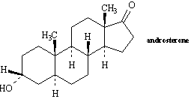

7 chiral centres

2. Match each of the following terms to a structure from the list below. There is only one correct structure for each term, and structures may be used more than once. Place the letter of the structure in the blank to the left of the corresponding term.

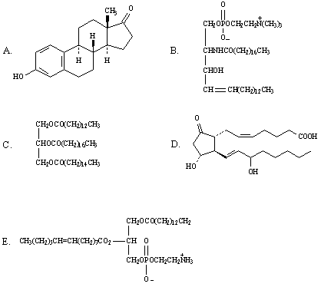

__________ a phosphoglyceride

ANS:
E

2. __________ a triglyceride

ANS:
C
3. __________ a sphingolipid

ANS:
B

6. __________ a steroid

ANS:
A

3. Draw the structure of a triacyglycerol oil. Indicating the triol and fatty acid components.

glyceryl trioleate

- Sketch the general structure of a cellular membrane indicating where the lipid and protein components are to be found. What is the function of lipids in cellular membranes.

Lipids compose around 40 – 60% of the mass of membranes. The main lipids present are glycerophospholipids, such as lecithin (and the steroid cholesterol in animal membranes).
The glycerophospholipids are amphipathic molecules, they have a polar end and a non-polar end. When the glycerophospholipids molecules are placed into an aqueous medium the self-assemble into a lipid bi-layer. This is the basic structure of the membrane, the polar heads on the outside and the non-polar tails on the inside. The lipids then function to create a structure that is impermeable to water and semi-permeable to small molecules such as O₂, CO₂ etc that have low polarity. The structure is more or less fluid depending on the double bond content of the fatty acids in the glycerophospholipids and the cholesterol content (the planar molecule is quite rigid). The outside layer contains bulkier phospolipids than the inside of the membrane due to the curved nature of the membrane. Lipid transport is possible laterally but not in a flip-flop motion from layer to layer.

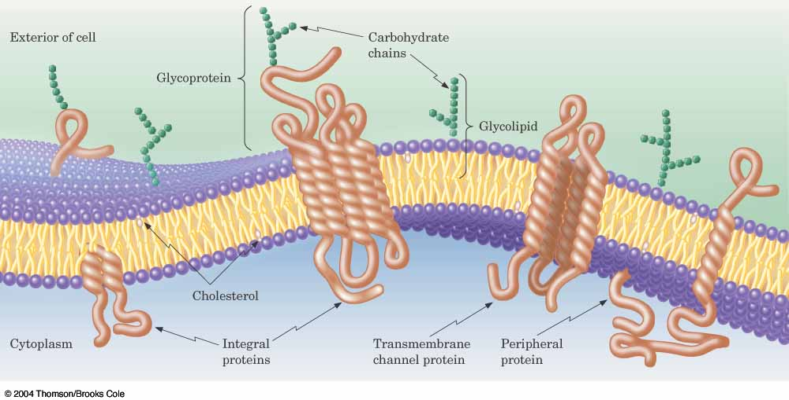
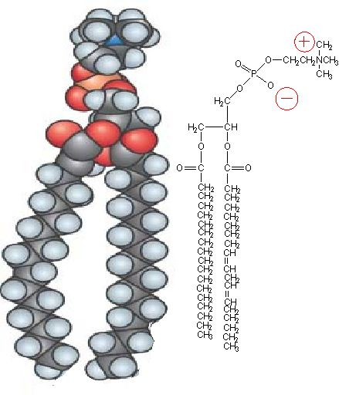

- What is passive transport across a plasma membrane.

There are two types of passive transport across the membrane, both require no expenditure of energy by the organism for transport to occur.
1) Simple diffusion through the membrane occurs for non-polar molecules such as O₂ and CO₂.
These molecules diffuse down a concentration gradient from high concentration to low concentration.
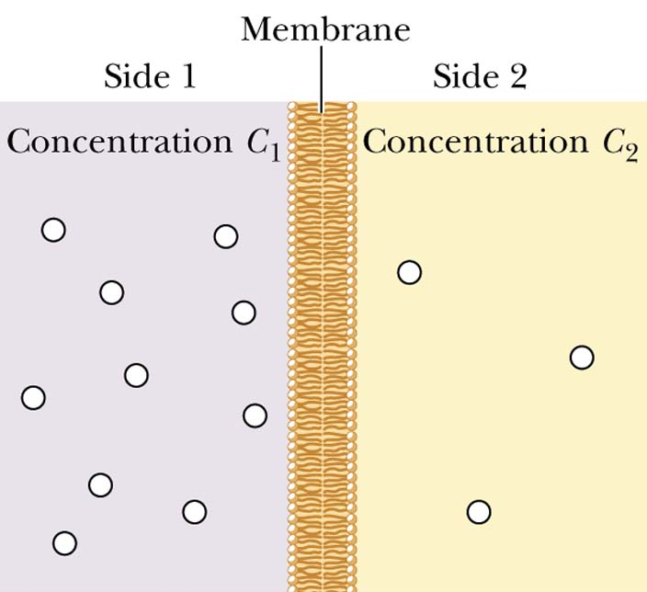
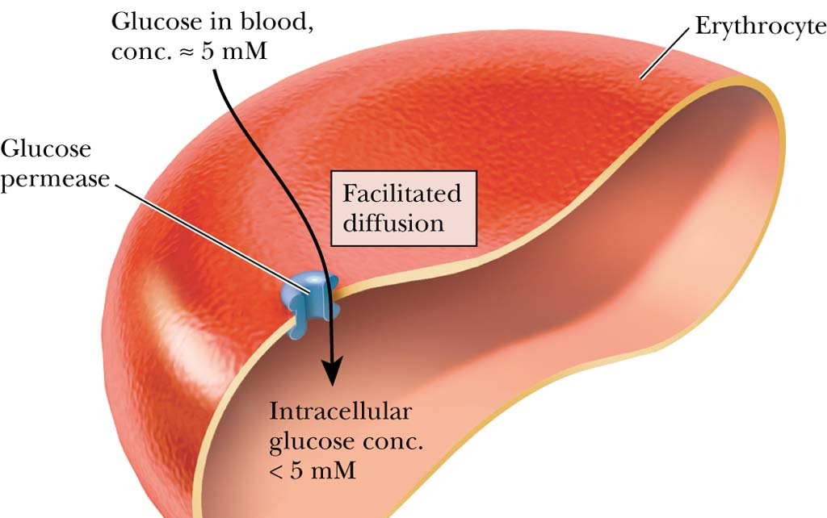
2) Gap junctions are transmembrane protein channels which present a pore through which small polar molecules such as sugars, amino acids and certain ions can pass. The gap junctions are controlled and can open and close their pores on demand. Nevertheless the transport through the pore is by diffusion from a high concentration to a low concentration. Glucose for instance travels into erythrocyte cells (RBC) - in the blood glucose is 5mM while inside the RBC it is <5mM. The carrier protein called glucose permease allows facilitated diffusion of glucose through the membrane.

