CH1010 Tutorial 6

Name: / 04

1. Draw the structure of andosterone. Identify the rings (A –D). Identify any chiral centers in the molecule using asterisk(s)s.

2. Match each of the following terms to a structure from the list below. There is only one correct structure for each term, and structures may be used more than once. Place the letter of the structure in the blank to the left of the corresponding term.

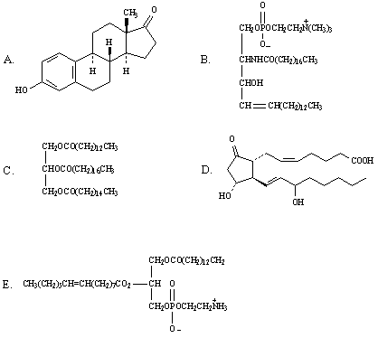

__________ is a phosphoglyceride
__________ is a triglyceride
__________ is a sphingolipid
__________ is a steroid

3. Draw the structure of a triacyglycerol oil, indicating the triol and fatty acid components.

- Sketch the general structure of a cellular membrane indicating where the lipid and protein
components are to be found.
• What function do lipids have in cellular membranes.

- What is passive transport across a plasma membrane.

