CH1010 Tutorial 5 Answers

- Name each of the following and classify it as a purine or pyrimidine base.

1. cytosine, pyrimidine 2. adenine, purine
3. guanine, purine 4. thymine, pyrimidine

2. Draw a Haworth structure of the sugar deoxyribose as the 2’-deoxyribofuranose form.
• Number the carbon system and indicate where the anomeric carbon is, the position the
base and phosphate will attach in the related nucleotide.
• Why it is called a furanose structure?

C1 is the anomeric carbon. The base attaches at the anomeric carbon by a condensation reaction. The phosphate attaches either at 5’ or 3’. The structure is drawn in the hemiacetal form - furanose indicates a 5-membered ring structure.

3. Draw structures of two monodentate ligands and two bidentate ligands.

Monodentate: C≡O, Cl⁻
Bidentate:

4. What is a coordination compound and what does the term coordination geometry mean?
• Provide a biological example illustrating the coordination geometry.
A coordination compound is one where there are one or more covalent bonds from ligands to a central metal (ligands are neutral molecules or anions). The compound exists as a metal complex that behaves as a discrete unit in solution. Most coordination compounds involve Transition Metals, but some may also form from Main Group Metals such as magnesium. The coordination geometry is the geometry of the ligand atoms which are directly bound to the metal. The normal geometry in transition metal coordination compounds is octahedral, that is obtained with 6 atoms from the ligands bonded to the central metal centre.
The heme centre in myoglobin and hemoglobin provides and example of an octahedral coordination geometry.

5. What is a holoenzyme? Provide an example to illustrate your answer.

A holoenzyme is the combination of a cofactor and a apoenzyme that functions as an active enzyme. The apoenzyme is the globular protein component which contains an active site cleft. The cofactor is a metal or organic molecule which binds to the apoenzyme and activates it catalytically.
An example is: pyruvate kinase apoenzyme, Mg²⁺ cofactor provides the holoenzyme complex: Mg²⁺/pyruvate kinase. This enzyme catalyses step 9 in glycolysis where phosphenol is converted into pyruvate and ADP to ATP.
{ Kinase means an ATP-dependent enzyme that transfers a phosphate from ATP to a substrate (here operating in the reverse sense). }
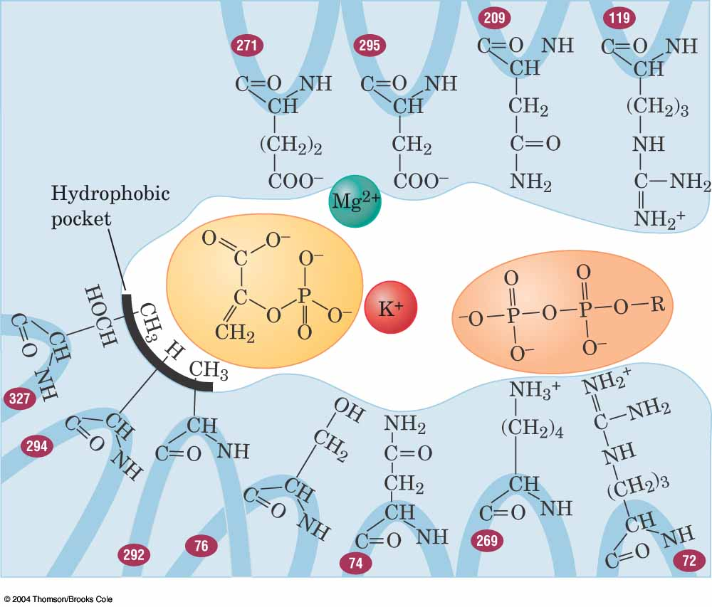

- Draw a structure of Vitamin B₃ (niacin) and indicate the biochemical function for this molecule.

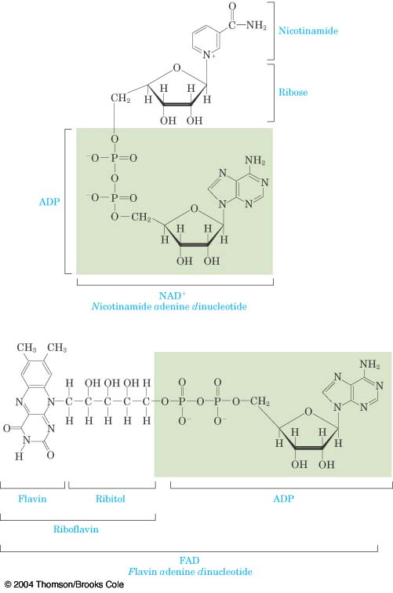
Niacin (nicotinic acid) is a small organic molecule that is used
in the biosynthesis of the cofactor NAD⁺.
NAD⁺ is an electron and H⁺ carrier.

