CH1010 Tutorial 5

Name:

- Draw a line-angle structure of the following nucleoside : 2’-deoxyadenosine
and the following nucleotide : thymidine-5’-monophosphate

2. Explain what denaturing a protein involves and list 3 different methods of denaturing a protein.

3. Draw structures of two monodentate anionic ligands and a bidentate neutral ligand.

4. Using the Co(EDTA)⁻ complex as an example explain the following terms.
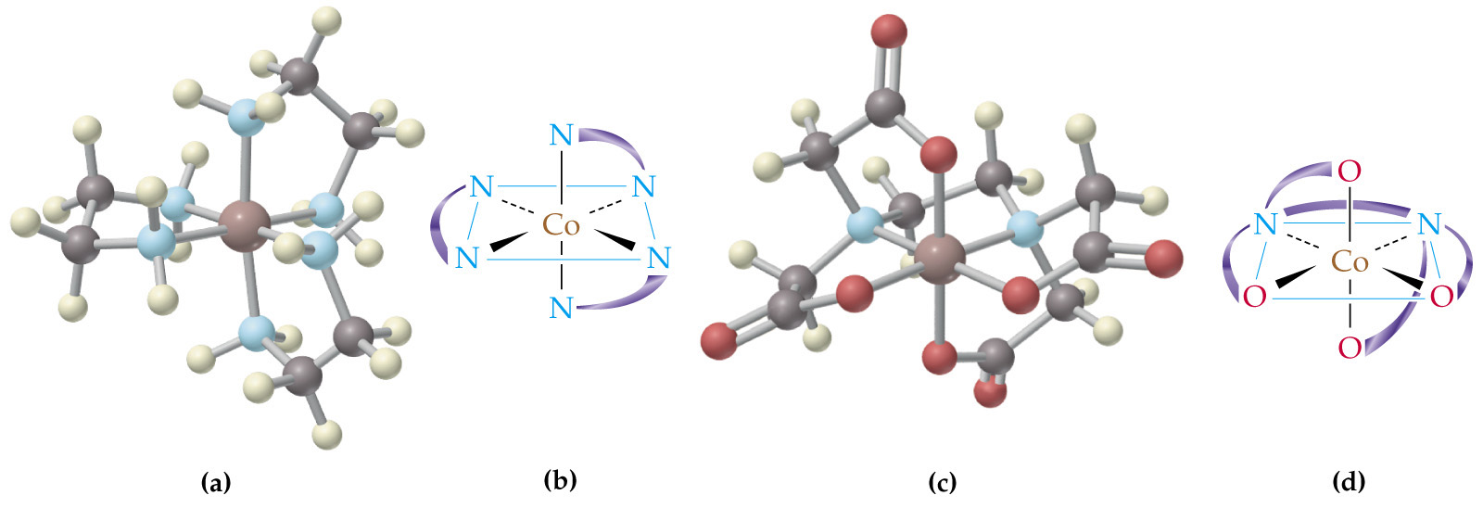
• Coordination geometry
• Chelate ring
• Polydentate ligand

.

5. What is a proenzyme? Provide an example to illustrate your answer.

- Draw a structure of Vitamin A and indicate the biochemical function for this molecule.

