CH1010 Tutorial 4

Name:

1. Place asterisks at all the chirality centers (stereocentres) in the molecule below.

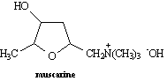

• What class of compound would you expect this molecule, which is a toxin found in
certain mushrooms (Inocybe geophylla), to belong to?

2.

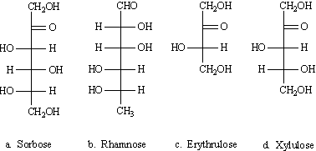

Identify each of these sugars according to carbon chain (triose, tetrose …) and functional group (aldose, ketose).

3. Draw a Fischer projection of D-galactose and a Haworth projection of α-D-galactopyranose.

4. Draw a section of primary structure of a peptide using the following sequence:
Ala-Gly-Asp-Cys-Lys-Asp
To do this you will need to provide a line-angle structure and indicate the peptide bonds.

5. Explain the molecular basis for how size exclusion chromatography (SCE) is able to separate proteins.

6. Valine is described as an essential amino acid. What does this mean?

7. Porcine dynorphin is a neuropeptide having 17 amino acid residues. Its structure is:
Tyr-Gly-Gly-Phe-Leu-Arg-Arg-Ile-Arg-Pro-Lys-Leu-Lys-Trp-Asp-Asn-Gln
What fragments would result if dynorphin were cleaved by trypsin?

