CH1010 Tutorial 3 Answers

- Provide IUPAC names for the following compounds:
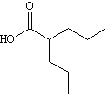

ANS: 2-propylpentanoic acid

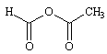
ANS: acetic formic anhydride
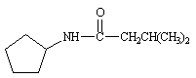
ANS: N-cyclopentyl-3-methylbutanamide

- Draw line-angle structures corresponding to the following IUPAC names:
• 2-phenyl-2-propanol

ANS:
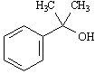

• 2,2-dimethyl-1,3-cyclopentanedione

ANS: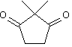

2,4-hexanediamine
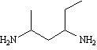
ANS:

3. Classify each of the following nitrogen atoms in the following compounds as primary,
secondary, tertiary, or quaternary.

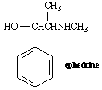

ANS:
The nitrogen atom in ephedrine is secondary.

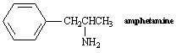

ANS:
The nitrogen atom in amphetamine is primary.

4. Cyclohexene and 2-hexyne both have the molecular formula C₆H₁₀. How would you use infrared spectroscopy to distinguish between the two compounds?

ANS:
To use IR spectroscopy to distinguish between isomers, find a strong IR absorption present in one isomer that is absent in the other isomer.

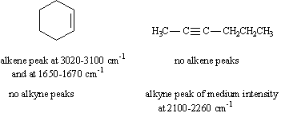

5. Circle any conjugated portions in the molecules below.
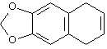
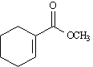

ANS:
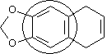
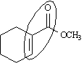

6. An impure organic solid was purified using two standard laboratory techniques.
• Name two techniques that could be used for this purification and explain how they
would separate the impurity from the pure material.

The purified solid was analysed by combustion analysis and found to contain 40.0% carbon and
6.71% hydrogen. The electron impact mass spectrum provided a molecular ion at m/z 90.
• Determine the empirical and molecular formulae for this compound.
• Draw a line-angle structure for a possible molecule that obeys this molecular formula,
and indicate how this could be verified using infrared spectroscopy.
1) Thin layer chromatography: the sample would be dissolved, placed on the bottom of a preparative TLC plate and the plate developed using an appropriate solvent combination. The impurity would separate as a distinct band from the pure compound which would then be identified under UV light, scrapped off the plate and then removed from the silica support using a polar solvent.
2)Crystallisation, if the compound was sufficiently pure then the trace impurity would be removed by slowly crystallising the pure compound while leaving the impurity in solution. This relies on slightly different solubilities of the impurity and pure compound and is best done by slow cooling. The pure crystals would be washed with a solvent in which it had low solubility to remove the last trace of the impurity.

C40.0 H6.71 O 53.29 (difference is oxygen)
Ratios 40.0/12.01 6.71/1.008 53.29/16.00
3.3306 6.6567 3.3306
1 2 1
Empirical formula: C₁H₂O₁
Weight of empirical formula: 12+2+16 = 30

Molecular formula: = C₃H₆O₃ weight = 90 = [M⁺] from mass spectrum

These molecules have a carbonyl that could be used for verifying the identity of the compound.
- The compound is a carboxylic acid and so a C=O stretch would be expected at around 1700 cm⁻¹, the hydroxyl group would have a band at around 3400 cm⁻¹. Comparison would be made with a standard spectrum for this compound and the fingerprint region used for final confirmation.

