CH1010 Tutorial 3

Name: / 04

- Provide IUPAC names for the following compounds:
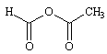
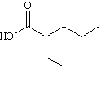

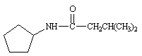

- Draw line-angle structures corresponding to the following IUPAC names:
• 2-phenyl-2-propanol

• 2,2-dimethyl-1,3-cyclopentanedione

• 2,4-hexanediamine

3. Classify each of the following nitrogen atoms in the following compounds as primary,
secondary, tertiary, or quaternary.
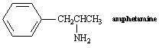
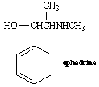

4. Cyclohexene and 2-hexyne both have the molecular formula C₆H₁₀. How would you use infrared spectroscopy to distinguish between the two compounds?

5. Circle any conjugated portions in the molecules below.
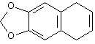
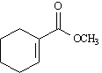

6. An impure organic solid was purified using two standard laboratory techniques.
• Name two techniques that could be used for this purification and explain how they
would separate the impurity from the pure material.

The purified solid was analysed by combustion analysis and found to contain 40.0% carbon and
6.71% hydrogen. The electron impact mass spectrum provided a molecular ion at m/z 90.
• Determine the empirical and molecular formulae for this compound.
• Draw a line-angle structure for a possible molecule that obeys this molecular formula,
and indicate how this could be verified using infrared spectroscopy.

