CH1010 Tutorial 2

Name: / 04

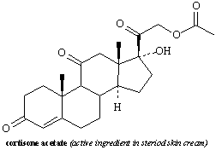
1. Identify the functional groups in the following molecule:

2. Convert the following structure into a line-angle drawing.
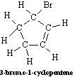

3. Provide IUPAC names for the compounds below:

(CH₃)₂CHCH₂CH(CH₂CH₃)CH₂C(CH₃)₃

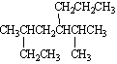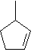

4. Draw line-angle structures corresponding to the following IUPAC names:

3,6-dimethyl-1,4-cyclohexadiene

2-chlorophenol

6. The hydrobromination of 2-methylbut-2-ene gives a mixture of products as illustrated.
• Predict the major product and provide a detailed mechanism using mechanistic arrows.

