CH1010 Tutorial 10 Answers

- Describe the following terms: gene, intron, exon, satellite, transcription factor.
gene: a section of DNA that codes for the synthesis of a protein (or tRNA, or mRNA).
structural gene: transcribed into mRNA
regulatory gene: controls transcription
intron: a non-coding section of DNA (and mRNA)
exon: a coding section of DNA (and mRNA)
satellite: a non-coding section where a short nucleotide sequence repeats hundreds of times.
transcription factor: binding proteins with various binding motifs: zipper, zinc finger
that bind to DNA in the nucleosome making the DNA less dense and more accessible for transcription. RNA polymerases attach to the promoter regions of DNA via transcription factors, near the TATA box region of the promoter.
Certain transcription factors help regulate the rate of synthesis of mRNA (in the case of RNA Pol II) activators enhancing the rate by binding at enhancer sites, repressors lower the rate by binding at silencer sites.

- Why is post-transcriptional modification of mRNA required?
Transcription makes a copy of the DNA code in mRNA in the nucleus of the cell. This is not the working copy ‘mature mRNA’ that is required in translation which occurs in the cytoplasm. A combination of an endonuclease and a polymerase functions to cap the ends of mRNA at the 3’ end creating the polyA (polyAdenylate) tail. The 5’ end is capped by a methylated guanine by a transferase enzyme. These capping reactions make the RNA stable to attack by cellular exonucleases (enzymes which catalyse the release of nucleotides from one end of a polynucleotide chain).
Spliceosomes function to splice the introns out of the mRNA which is then able to leave the nucleus. The spliceomsomes are large (nearly as big as ribosomes) and are unable to leave the nucleus, the introns spliced out range from 65 – 10000 bp and removal is often a limiting step.
The mature mRNA is often only a fraction of the size of the as transcribed mRNA (recall in humans only 3% of the genome codes for proteins).

3. Match each of the following terms to a structure from the list below. There is only one correct structure for each term and structures may be used more than once. Place the letter of the structure in the blank to the left of the corresponding term.

A. GAUCGUAAA B. AUGGCUGAG
C. translation D. transcription
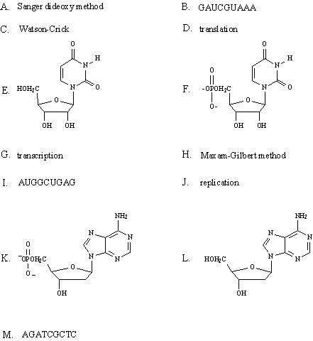
G. CGTCCATTA H. AGATCGCTC

I.
J.

K. replication

_____ a pyrimidine nucleotide

ANS:
E

__________ RNA base sequence with guanine at the 3' end.

ANS:
B

__________ DNA base sequence with cytosine at the 3' end.

ANS:
H

__________ uridine

ANS:
E

_____a purine nucleoside

ANS:
J - 2’-deoxyadenosine

__________ RNA base sequence complementary to the DNA base sequence which codes for
Leu-Ala-Phe: CTAGCATTT

ANS:
A

18. __________ 2'-deoxyadenosine 5'-phosphate

ANS:
I

19. __________ process by which mRNA directs protein synthesis

ANS:
C

4. Describe the function of a ribosome in protein synthesis.

A ribosome is a sub-cellular unit that forms for translation and then disassembles after translation in the cytoplasm. They are formed from rRNA and proteins in two sub-units, in the case of eukaryote cells a 40S and 60S ribosome form a full 80S ribosome complex. The ribosome has a special tRNA^{met} which is an initiator tRNA which pairs with the AUG start codon on mRNA.
There are two binding sites in the 80S ribosome: A site, P site.
During the 3 steps in elongation the ribosome moves along the mRNA 1 triplet codon at a time, called
translocation.
P site where the peptide chain resides at the start.
A site where aminoacyl-tRNA binds with the correct anticodon to the mRNA codon.
1) tRNA binds to A site.
2) AA from tRNA is joined to the existing peptide chain from the P site.
3) next the existing peptide chain moves from the P site and is bound to the AA from the tRNA.
3) Translocation, the ribosome moves 1 codon, the peptide is translocated from A to P site, the empty tRNA is released.
After the STOP codon is read from the sequence then termination occurs and a releasing factor binds the A site, cleaves the polypeptide chain, releases tRNA and then the entire complex dissociates.
Often several ribosomes operate on the same mRNA strand to increase the speed of translation which is quite slow at around 18AA /s per ribosome.

5. What is a chaperone and why is a chaperone necessary?
A chaperone is a protein which binds to a nascent (newly created) protein to enable the correct folding of the nascent protein. Many proteins are globular proteins with very complicated tertiary shapes that result from the correct folding of the protein. Molecular chaperones bind to (or encapsulate) medium to large proteins and inhibit the formation of incorrect folds in the protein – assisted self-assembly.
Small proteins do not need chaperones and fold correctly without assistance.

