CH1010 Tutorial 10

Name: / 04

1. Describe the following terms: gene, intron, exon, satellite, transcription factor.

2. Why is post-transcriptional modification of mRNA required?

3. Match each of the following terms to a structure from the list below. There is only one correct structure for each term and structures may be used more than once. Place the letter of the structure in the blank to the left of the corresponding term.

A. GAUCGUAAA B. AUGGCUGAG
C. translation D. transcription
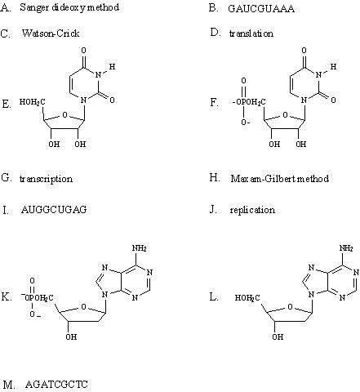
G. CGTCCATTA H. AGATCGCTC

I.
J.

K. replication

_____ a pyrimidine nucleotide
__________ RNA base sequence with guanine at the 3' end
__________ DNA base sequence with cytosine at the 3' end
__________ uridine
_____a purine nucleoside
__________ RNA base sequence complementary to the DNA base sequence which codes for
Leu-Ala-Phe: CTAGCATTT
__________ 2'-deoxyadenosine 5'-phosphate
__________ process by which mRNA directs protein synthesis

4. Describe the function of a ribosome in protein synthesis.

5. What is a chaperone and why is a chaperone necessary?

