CH1010 Tutorial 8 Answers

- Provide a detailed reaction scheme for oxidative phosphorylation.
• Where are Complexes I - IV found in oxidative phosphorylation and what is their function?

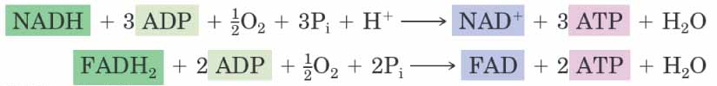
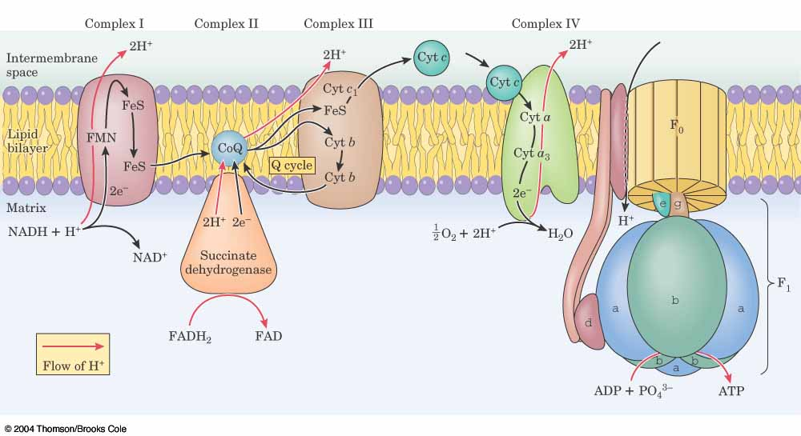
The protein complexes are integral membrane proteins with quaternary structure that are found studded into the inner membrane of the mitochondrion. The function of the complexes is to oxidise substrates produced in the TCA cycle and glycolysis (NADH, FADH₂).
42
subunits
4
subunits
2
subunits
2
subunits
Complex I oxidizes NADH to NAD⁺
Complex II oxidizes FADH₂ to FAD
Complex III oxidizes CoQH₂, transfers e⁻ to cytochrome c (Cyt c) (and releases energy)
Complex IV, cytochrome oxidase, Cyt c is oxidized and electrons are transferred to O₂
Overall result: 4H⁺ + O₂ + 4e⁻ → 2H₂O + energy

2. How does ATP synthase create ATP?

ATP synthase creates ATP by phosphorylation of ADP. ATP synthase is an enzyme complex which catalyses this process. The energy used to drive this is provided by the proton gradient across in the inner membrane. As protons are moved through a channel in ATP synthase the electrochemical potential energy of the proton gradient is converted into the chemical bond energy of the new phosphoric anhydride bond in ATP, this is achieved through conformational changes in the protein complex.
ATP Synthase may be regarded as a rotating molecular motor, a flow of protons turns the motor.
The cγε subunits form a rotor, the abδ subunits a stator.
The F₁ portion αβγδε subunits (knob) is where ATP synthesis occurs.
The F₀ portion abc (stalk) contains a proton channel it spins the rotor and stator each time an H⁺ ion passes through the channel.

3. Using fatty acid biosynthesis as example explain how a typical anabolic cycle works.
Fatty acid synthase is the multi enzyme complex that carries out fatty acid synthesis it possesses a coenzyme called acyl carrier protein ACP that has a phosphopantheine prosthetic group.
The phosphopantheine swinging arm carries the intermediates from one enzyme site to the next site (7 enzymes in E. choli).
Priming – primes acetyl-CoA onto FA synthase – this happens only at the start of synthesis
5 Steps are repeated.
1. Loading – formation of malonyl-CoA and loading on ACP
2. Condensation – condensation of fragments on ACP (1st time acetyl grp) → 2C+chain + CO₂
3. Reduction – ketone reduced to alcohol, reduces bond order
4. Dehydration – removes water, forms double bond
5. Reduction – reduces double bond to give a saturated chain which is C₂ longer than the initial chain.
Loop back to 1.
Once palmitic acid has formed a thioesterase cleaves the palmitic acid off ACP and the cycle is ready to begin again.

As a typical anabolic reaction this takes as a simple carbon building block, here acetyl-CoA (obtained from oxidative carboxylation of pyruvate which has originated from glycolysis). Rather than build in large units these small units are added successively until the target fatty acid is synthesized. The process occurs in a fixed spot, here the Acyl carrier protein found in the cytosol (aqueous portion of cell outside organelles). Energy is consumed in large quantities in the form of ATP and NADH.
8 acetyl-CoA + 14 NADPH + 7 ATP → palmitate + 14 NADP+ + 8 CoA + 7 ADP + 7 Pi
4. What is the Z-scheme of photosynthesis and where does it occur?
The Z-scheme is the electron transfer process that occurs in the light reactions of photosynthesis.

The light reactions of photosynthesis occurs in photosynthetic units called photosystems that are built into the thylakoid membrane of the thylakoid disks in chloroplasts. There are two photosystems (PS-I, PS-II), each photosystem has two groups of chlorophylls (Chl) and accessory pigments. The first group are antennae light harvesting Chl (LH) which function to gather light energy and pass it (optically) towards the second group which are called reaction centre Chl (RC). Several hundred LH Chl pass energy towards 2 special reaction centre Chl. In photosystem I the RC Chl is P-700, in PS-II the RC Chl is P-680.
Absorption of sufficient energy (from the antennae Chl) and a photon by P-680 (<680nm) causes charge separation at P-680 and production of an electron which is fed to the electron transport chain, at the same time water is oxidised (to provide the electron) and O₂ released.
The electron-transport chain follows the Z-scheme passing the electron from carrier to carrier until it arrives at PS-I Chl P-700 where it is excited to a high energy state (photon <700nm), the reduction potential is now sufficient to reduce NADP to NADPH. This is one of the functions of the Chl to produce sufficient energy to reduce NADPH. As the Z-scheme operates a proton gradient is built up across the thylakoid membrane, this is used to drive the synthesis of ATP, this is the second place that the energy gathered by the Chl is used.

P680 : chlorophyll absorbs < 680nm
P700 : chlorophyll absorbs < 700nm
Electron transport
chain

