CH1010 Tutorial 6 Answers

1. Draw the structure of Cortisol. Identify the rings (A –D). Identify any chiral centers in the molecule using asterisk(s)s.

2. Steroids are widely used as performance enhancing drugs. Using an example explain what a steroid is and why they are useful as performance enhancing substances.

Steroids are organic compounds found in lipid extracts of plant and animal tissue. The lipid fraction is that component that dissolves in non-polar organic solvents (eg. ether). Steroids are derivatives of perhydrocyclopentaphenanthrene and contain 3 fused 6 rings (A-C) and a fused 5 ring (D). They originate from the common precursor steroid cholesterol. Most steroids function in the human body as hormones, chemical messengers which provide biochemical control over certain bodily functions (water retention, sexual characteristics, ..). The anabolic steroids mimic the steroid testosterone which has as an effect on protein (muscle) body mass.

3. Draw the structure of a tristearin, indicating the triol and fatty acid components. Indicate the
ester linkages.

- Sketch the general structure of a cellular membrane indicating where the lipid and protein
components are to be found.
• What function do proteins have in cellular membranes.

Lipids compose around 40 – 60% of the mass of membranes. The main lipids present are glycerophospholipids, such as lecithin (and the steroid cholesterol in animal membranes).
The glycerophospholipids are amphipathic molecules, they have a polar end and a non-polar end. When the glycerophospholipids molecules are placed into an aqueous medium the self-assemble into a lipid bi-layer. This is the basic structure of the membrane, the polar heads on the outside and the non-polar tails on the inside. The lipids then function to create a structure that is impermeable to water and semi-permeable to small molecules such as O₂, CO₂ etc that have low polarity. The structure is more or less fluid depending on the double bond content of the fatty acids in the glycerophospholipids and the cholesterol content (the planar molecule is quite rigid). The outside layer contains bulkier phospolipids than the inside of the membrane due to the curved nature of the membrane. Lipid transport is possible laterally but not in a flip-flop motion from layer to layer.

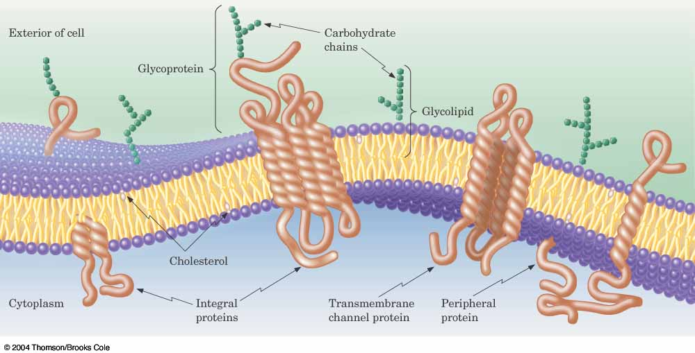
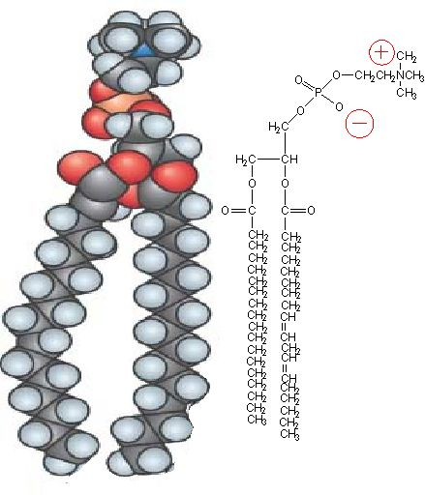

Peripheral membrane proteins may function as enzymes where the enzymatic reaction occurs on the membrane surface. Receptor proteins on the membrane surface bind specifically to biologically important substances that are involved in the transmission of extracellular signals into the cell where biochemical responses are triggered.

Integral (trans-membrane) proteins are typically either transport proteins or multi-subunit enzymes. The transport proteins move substances into and out of the cell in response to metabolic demand either through passive (gated ion channel) or active (lactose permease) control.

- What is active transport across a plasma membrane, provide an example to support your
answer.

Active transport involves the expenditure of energy (usually in terms of ATP) to move a substance into or out of a cell through the cell membrane against a concentration gradient. The proton pump is an example where a proton gradient across the membrane is created by actively pumping hydrogen ions through the membrane. Proton pumping is involved in oxidative phosphorylation where the transmembrane protein complexes I, II, IV pump hydrogen ions from the matrix to the intermembrane space in the mitochondria. This creates a proton gradient that is used to drive the synthesis of ATP.

