CH1010 Tutorial 5 Answers

- Draw a line-angle structure of the following nucleoside : 2’-deoxyadenosine
and the following nucleotide : thymidine-5’-monophosphate

2. Explain what denaturing a protein involves and list 3 different methods of denaturing a protein.

Any alteration of the native structure of a protein which causes a loss of biological activity is called denaturation. Denaturation does not imply a modification of the primary structure of the protein but rather a disruption of the secondary and tertiary structures.
Denaturing agents include:
- Heat: can disrupt hydrogen bonding in globular proteins unfolding polypeptide chains with the result that coagulation & precipitation occur.
- Detergents such as sodium dodecylsulfate (SDS) disrupt hydrogen bonding. Commonly used in gel electrophoresis to ensure the protein is unstructured and charged – SDS-PAGE.
- Reducing agents such as 2-mercaptoethanol HOCH₂CH₂SH cleaves disulfide bonds
- reduces -S-S- to –SH groups removing major structural elements.
- Heavy metal ions: transition metal ions such as Ag⁺, Pb²⁺, Hg²⁺, and Cd²⁺ form water-insoluble salts with -SH groups; Hg²⁺ for example forms -S-Hg-S-
- Alcohols: 70% ethanol denatures proteins, used to sterilize skin before injections.
- Chaotropic agents are denaturing salts which bind strongly to proteins destabilization of hydrophobic interactions in proteins reducing hydration . Anions are more successful than cations. Br⁻ < I⁻ < ClO₄⁻ < SCN⁻ < Cl₃CCOO⁻ (chaotropic series).
- Urea and guanidine hydrochloride, are effective at high concentration, i.e. 4 M to 8 M. They disrupt hydrogen bonding and reduce the hydrophobic interactions in the protein.
- Acids or bases which cleave salt bridges. Moderate concentrations of certain acids, e.g. trichloroacetic acid, usually lead to complete denaturation and precipitation and can therefore be used to stop enzymatic reactions.

3. Draw structures of two monodentate anionic ligands and a bidentate neutral ligand.

Monodentate: Br⁻, Cl⁻

Bidentate: ethylene diammine

4. Using the Co(EDTA)⁻ complex as an example explain the following terms.
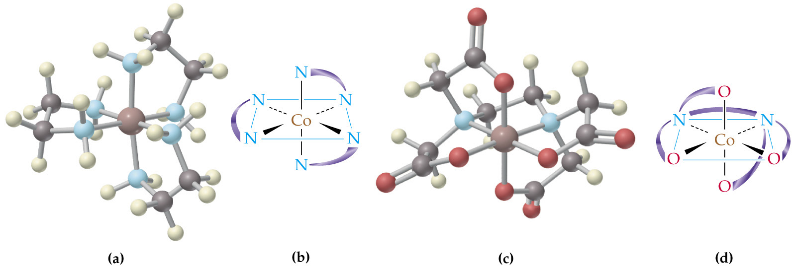
• Coordination geometry
• Chelate ring
• Polydentate ligand

The coordination geometry in the molecule shown is 6, octahedral.
Chelate ring is the ring formed from a ligand with 2 donor
atoms bonded to the metal and is typically either 5-6 atoms
in size including the metal. Here there are 5 chelate rings in
the molecule.
Polydentate ligand means that the ligand binds to a metal
through more than 2 donor atoms. In this case the EDTA
ligand is a 6 donor atom polydentate ligand.

5. What is a proenzyme? Provide an example to illustrate your answer.

Proenzyme inactive precursors of enzymes that require some change (such as the hydrolysis of a fragment) to become active. Proenzymes typically contain extra-long polypeptide chains that block activity, are activated by either acidic or enzymatic hydrolysis to remove the inhibiting portion.
eg Pepsin is secreted as the proenzyme pepsinogen by the zymogenic (chief) cells of the gastric glands in the stomach and is activated by acidic pH (HCl) (and a positive feedback process where any pepsin formed catalyses the formation of more pepsin) where a short peptide fragment is cleaved off and the active site exposed. Pepsin functions best in a pH of 1.5-2.0 in order to break bonds between amino acids in proteins, producing short-chain polypeptides and is referred to as a proteolytic enzyme.

- Draw a structure of Vitamin A and indicate the biochemical function for this molecule.

Vitamin A and its metabolites retinal and retinoic acid are important in maintaining vision (retinal) and in gene transcription (retinoic acid). Retinal is is bound to a protein opsin in the rod cells of the retina to form rhodopsin the light sensitive pigment which initiates an optic nerve response in vision. Retinoic acid is an intracellular messenger which effects the transcription of many genes.

