CH1010 Tutorial 4 Answers

1. Place asterisks at all the chirality centers (stereocentres) in the molecule below.

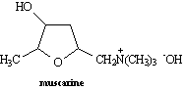

ANS:
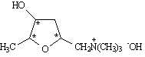

• What class of compound would you expect this molecule, which is a toxin found in
certain mushrooms (Inocybe geophylla), to belong to?

Alkaloid – it is an amine which is obtained by extraction from fungi.

2.

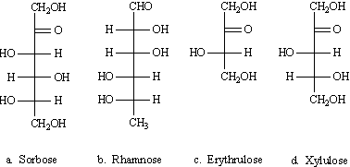

Identify each of these sugars according to carbon chain (triose, tetrose …) and functional group (aldose, ketose).

a. ketohexose b. aldohexose c. ketotetrose d. ketopentose

3. Draw a Fischer projection of D-galactose and a Haworth projection of α-D-galactopyranose.

4. Draw a section of primary structure of a peptide using the following sequence:
Ala-Gly-Asp-Cys-Lys
To do this you will need to provide a line-angle structure and indicate the peptide bonds.

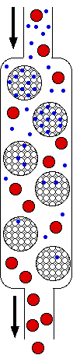
5. Explain the molecular basis for how size exclusion chromatography (SCE) is able to separate proteins.

Exclusion chromatography separates molecules such as proteins on the basis of size. A column is filled with semi-solid beads of a polymeric gel (typically Sepharose) that will admit small proteins (blue) into their interior but not large ones (shown in red). When a mixture of proteins dissolved in a solvent (typically a buffer) is applied to the top of the column, the smaller proteins are distributed through a larger volume of solvent than is available to the large molecules. This is a result of the small proteins being delayed as they bump their way out of the pores. Consequently, the large proteins move more rapidly through the column, and in this way the mixture can be separated (fractionated) into its components. The porosity of the gel can be adjusted to exclude all proteins above a certain size.

6. Valine is described as an essential amino acid. What does this mean?

ANS:
Humans are able to synthesize only 10 of the 20 amino acids necessary for protein synthesis. The remaining 10 are called essential amino acids since they must be obtained from dietary sources. Failure to include an adequate dietary supply of these essential amino acids can lead to severe deficiency diseases.

6. Porcine dynorphin is a neuropeptide having 17 amino acid residues. Its structure is:
Tyr-Gly-Gly-Phe-Leu-Arg-Arg-Ile-Arg-Pro-Lys-Leu-Lys-Trp-Asp-Asn-Gln
What fragments would result if dynorphin were cleaved by trypsin?

ANS:
Trypsin catalyzes the hydrolysis of peptides as the carboxyl side of arginine and lysine. Consequently, the fragments resulting from trypsin hydrolysis of dynorphin are:

Tyr-Gly-Gly-Phe-Leu-Arg
Arg
Ile-Arg
Pro-Lys
Leu-Lys
Trp-Asp-Asn-Gln

