CH1010 Tutorial 3 Answers

- Provide IUPAC names for the following compounds:

OHCCH₂CH₂CH₂CHO pentanedial
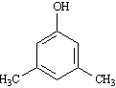
ANS:

3,5-dimethylphenol

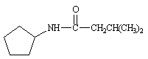

ANS:
N-cyclopentyl-3-methylbutanamide

- Draw line-angle structures corresponding to the following IUPAC names:
• N-ethyl-N-methylcyclohexylamine

• 2,2-dimethyl-propanoic acid

3. Classify each of the following nitrogen atoms in the following compounds as primary,
secondary, tertiary, or quaternary.

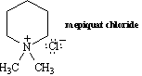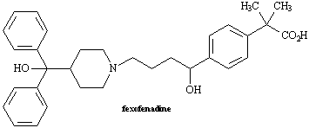
quaternary tertiary

4. At what approximate positions might this compound show infrared absorptions?

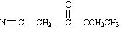

ANS:
This compound should show a medium absorption at 2210-2260 cm⁻¹ for the nitrile, a strong absorption at about 1735 cm⁻¹ for the ester carbonyl. There would also be a strong absorption at about 1100 cm ⁻¹ for the C-O bond of the ester in the fingerprint region.

5. Circle any conjugated portions in the molecules below.
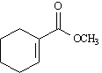

ANS:
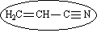 ANS: not conjugated

6. An impure organic liquid was obtained from the wood of the sandalwood tree Santalum austrocaledonian using standard laboratory techniques.
• How could purification of the liquid be carried out?
A minor component of the organic liquid was obtained in a pure form and gave the following
microanalytical results:
C: 46.59 % H: 8.80 % N: 13.58 %
Infrared spectroscopy of a sample of the liquid gave several strong bands at 3390, 2900 and 1705 cm⁻¹. In a mass spectrum of the compound a molecular ion was obtained at m/z 103.

• Determine the empirical and molecular formulae for this compound.
• Draw a line-angle structure for a possible molecule that obeys this molecular formula, and indicate how this could be verified using infrared spectroscopy.

The compound would be purified by fractional distillation and the purity verified by boiling point, TLC or further microanalysis.
.

NH₂CH₂CH₂CH₂COOH 4-aminobutanoic acid
Working:
100% - (46.59 + 8.80 + 13.58) = 31.03% = %O
46.59/12.01 = 3.879 8.80/1.008 = 8.73 31.03/16.00 = 1.939 13.58/14.01 = 0.969
/0.969 4 9 2 1
C4 H9 O2 N1
m/z 4*12 + 9*1 + 2*16 + 14 = 103
empirical + molecular formulae C₄H₉O₂N
IR Bands: NH 3390, OH(COOH) 2900, CO(COOH) 1705, CH 2900

