CH1010 Tutorial 10 Answers

1. Describe the following terms: genome, chromatin, oligonucleotide, transcription factor.
genome = the set of instructions required to construct a replica of itself.

chromatin = DNA is wound around a core of histone proteins to make nuceleosomes which
are then wound like “beads on a string” into chromatin fibres.

oligonucleotide = small number of nucleotides

transcription factor: binding proteins with various binding motifs: zipper, zinc finger
that bind to DNA in the nucleosome making the DNA less dense and more accessible for transcription. RNA polymerases attach to the promoter regions of DNA via transcription factors, near the TATA box region of the promoter.
Certain transcription factors help regulate the rate of synthesis of mRNA (in the case of RNA Pol II) activators enhancing the rate by binding at enhancer sites, repressors lower the rate by binding at silencer sites.

2. Describe structure and function of a gene.
A gene is a section of DNA that codes for the synthesis of a protein (or tRNA, or mRNA).
The structure of the gene is: regulatory gene: controls transcription (typically contains the TATA box) followed by the structural gene which is transcribed into mRNA. The structural gene contains
intron: a non-coding section of DNA (and mRNA)
exon: a coding section of DNA (and mRNA)
satellite: a non-coding section where a short nucleotide sequence repeats hundreds of times.

3. What is a polysome and why is a polysome necessary?
A polysome is a polyribosome. That is there are a large number of ribosomes constructed along the same mRNA molecule.
- The advantage to this is that the speed of any single ribosome is quite slow reading around 18 amino acids / second at full speed. By placing ribosomes every 100 nucleotides parallel processing achieves a much higher rate of protein synthesis.

4. Amino acids need to be activated before they can be used in protein synthesis.
Explain how amino acids are activated and how there is a high level of quality control in this step of charging the amino acid.

Amino acids are activated by the enzymes aaRS (amino acyl t-RNA Synthases), there are 20 each is specific for an amino acid.
The aaRA enzyme bonds the activated amino acid to the 3’ terminal -OH group of the tRNA by an ester bond at the opposite end of the tRNA molecule is a codon recognition site the codon recognition site is a sequence of three bases called an anticodon loop.

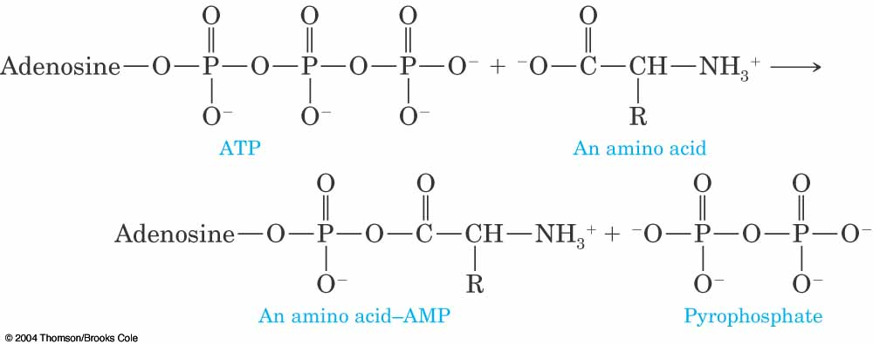

1) amino acid: the aminoacyl-AMP is bound to the AARS and binding of the correct AA is verified by an editing site on the AARS. This only lets the correct AA bind to the aaRS.
2) tRNA: there are specific binding sites (identity elements) on tRNAs that are recognized by aaRS – the aaRS gets the correct tRNA.

5. Describe the process of post-translational modification in protein synthesis. Provide examples of each type of modification.

Translation is the process of translating the mRNA code into a polypeptide chain.
Newly synthesized polypeptides are often modified before they reach their final form. This is called post-translational modification.
- specific bonds in precursor polypeptides are cleaved eg. preproinsulin → proinsulin → insulin
105-residue polypeptide called preproinsulin
cleavage from preproinsulin of a 24-residue N-terminal "signal sequence" yields proinsulin, an 81-residue polypeptide
Proinsulin then undergoes folding, disulfide bond formation, and cleavage to give the two polypeptide chains of the active hormone, insulin
- leader sequences (such as the N-terminal Met) are removed by specific proteases (Met-aminopeptidase).
- factors such as heme groups may be attached – eg. cytochromes
- disulfide bonds may be formed - proinsulin → insulin
- AAs may be modified eg. proline →hydroxyproline – collagen contain a large proportion of
hydroxyprolines
- addition of carbohydrates (covalent modification) - Mucus glycoproteins (mucins)

