CH1010 Tutorial 3

Name:

- Provide IUPAC names for the following compounds:

OHCCH₂CH₂CH₂CHO

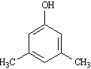
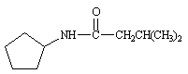

- Draw line-angle structures corresponding to the following IUPAC names:
• N-ethyl-N-methylcyclohexylamine

• 2,2-dimethyl-propanoic acid

3. Classify each of the following nitrogen atoms in the following compounds as primary,
secondary, tertiary, or quaternary.

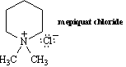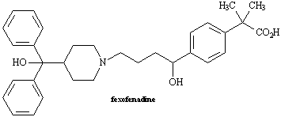

4. At what approximate positions might this compound show infrared absorptions?

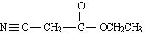

5. Circle any conjugated portions in the molecules below.
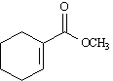

6. An impure organic liquid was obtained from the wood of the sandalwood tree Santalum austrocaledonian using standard laboratory techniques.
• How could purification of the liquid be carried out?

A minor component of the organic liquid was obtained in a pure form and gave the following
microanalytical results:
C: 46.59 % H: 8.80 % N: 13.58 %
Infrared spectroscopy of a sample of the liquid gave several strong bands at 3390, 2900 and 1705 cm⁻¹. In a mass spectrum of the compound a molecular ion was obtained at m/z 103.

• Determine the empirical and molecular formulae for this compound.
• Draw a line-angle structure for a molecule that obeys the molecular formula you have determined showing how you came up with this structure.

