CH1010 Tutorial 2

Name: / 05

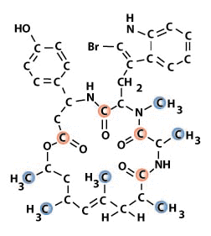
1. Identify the functional groups in the following molecule.
The molecule is Jasplakinolide obtained from a bright orange
rubbery sponge (Jaspis Johnstoni).

2. Convert the following structure into a line-angle drawing.
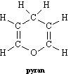

3. Provide IUPAC names for the compounds below:

4. Draw line-angle structures corresponding to the following IUPAC names:

2,3-dimethylhexanoic acid

3-phenylpropanal

6. The hydrochlorination of 1-propene gives a mixture of products as illustrated.
• Predict the major product and provide a detailed mechanism using mechanistic arrows.

