CH1010 Practice Examination - Answers 2004

Question 1

(a) Ionic compounds are found in many biological systems.
• Define an ionic bond and provide an example of an ionic compound
• What is an oxidising agent? Illustrate your answer using an oxidising agent from
the citric acid cycle – provide a half-reaction.
Ionic bond – an electrostatic force of attraction between a cation and an anion in an ionic solid.
sodium chloride is an example – NaCl(s).

An oxidising agent is one that is reduced in a reaction.
NAD⁺ + H⁺ + 2e⁻ → NADH - step 3 TCA cycle.

(b) Physiological pH is between 7.35 and 7.45.
• Why is the pH maintained over such a small range?
• What is a pH buffer – illustrate your answer using an example.
(4 marks)
The pH is maintained over such a small range as the proteins that operate in the blood plasma are very sensitive to pH. Optimum performance of enzymes and carriers such as hemoglobin occurs when they are at their optimum charge state which is dictated by the pH of the solution the protein is in.
A pH buffer is a two component system which resists change in pH when small amounts of acid or base are added. The 2 components are approximately equimolar amounts of a weak acid and the salt of the weak acid.
An example would be the acetate buffer CH₃COOH + H₂O  CH₃COO⁻ + H₃O⁺
which has a pH of 4.75.

(c) A colourless oil gave the following microanalytical results:
C: 54.55 % H: 9.09 %
Infrared spectroscopy of the sample gave strong bands at 3200 and 1721 cm⁻¹. In a mass spectrum of the compound a molecular ion was obtained at m/z 88.
• Provide a molecular formula and using the infrared information suggest a possible
structure for this compound. Explain clearly how you arrived at the structure.
• How would you purify a mixture containing this oil and petrol?
(6 marks)
C: 54.55% H: 9.09% O: 36.36% (= 100 – 54.55 - 9.09)
4.546 9.09 2.273
2 4 1
Empirical formula: C₂H₄O₁ M = 44
Molecular formula: C₄H₈O₂ as m/z = 88
Infrared: v(C=O) aldehyde 1721, v(C-O)
CH₃CH₂OCH₂CH(=O) C₄H₈O₂ M/Z = 88

The compound would be purified by fractional distillation and the boiling point checked, the purity could be further verified by TLC and then repeated microanalyses or IR spectroscopy.

Question 2

(a) In structurally classifying proteins there are four levels of structural complexity
– 1º, 2º, 3º and 4º structure.
• Using a short stretch of peptide chain (4 amino acids) indicate the primary (1º)
structure. In your answer you must indicate the peptide bonds and name the amino
acids. You must choose amino acids on the following basis :
acidic side chain, basic side chain, neutral side chain, polar side chain.
• When the peptide chain you have drawn is placed into water at a pH of 3.0 what will
be the overall charge on your peptide?
• What is quaternary structure (4º) in protein chemistry, illustrate your answer using
an example and explain how the quaternary structure relates to the function of the
protein.

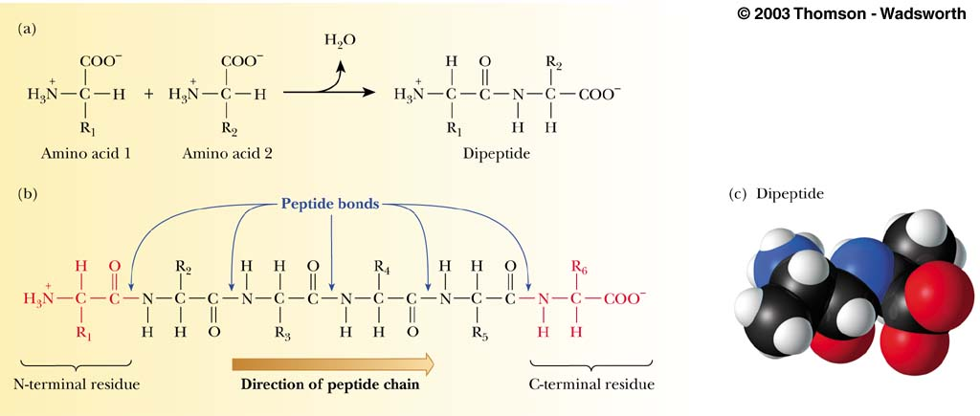

R₁ = H, R₂ = CH₂SH, R₃ = CH₂COOH, R₄ = -(CH₂)₄NH_{2,} R₅ = CH₃.

Gly, Cys, Asp, Lys, Ala
Neutral Polar Acidic Basic Neutral
The primary structure is the amino acid sequence of the protein from the N-terminal end to the C-terminal end.

At pH 3.0 the COO- of the amino acids will be protonated (C-terminal, Asp) ⇒ 2 x NH₃+
so the peptide will be cationic.

Quaternary structure is the overall structure of a multi-peptide protein. It arises due to non-covalent groupings of sub-units.
eg. Hemoglobin has an α₂β₂ quaternary structure where α and β are subunits.
The protein is a carrier protein and is able to carry 4 oxygen molecules (or CO2) from the lungs to the tissues requiring oxygen. It has 1 heme centre in each of the 4 subunits which means it can carry 4 oxygens per molecule rather than 1 which is more efficient.

- Most enzymes are globular proteins which function to speed up biochemical reactions.
• Provide an example of an enzymatic system labelling the various components:
substrate, enzyme, product, cofactor
• Indicate the effect that varying the following parameters has on the rate of reaction:
pH, T, [substrate], [enzyme]
• What is a proenzyme? Provide an example to illustrate your answer.
(4 marks)
Pyruvate kinase (PK) is a phosphate group transfer enzyme which requires ADP and phosphoenolpyruvate as substrate(s), these are the chemical reactants.
Mg²⁺ and K⁺ are cofactors. Cofactors are the non-protein part of an enzyme, here they are ions which are required for the enzyme to become active. The ions bind in the vicinity of the active site. The holoenzyme is the active enzyme which comprises the apoenzyme (PK) and cofactors. PK transfers a phosphate from phosphoenonlpyruvate to ADP to form ATP and pyruvate which are the products.
Varying the rate of reaction:
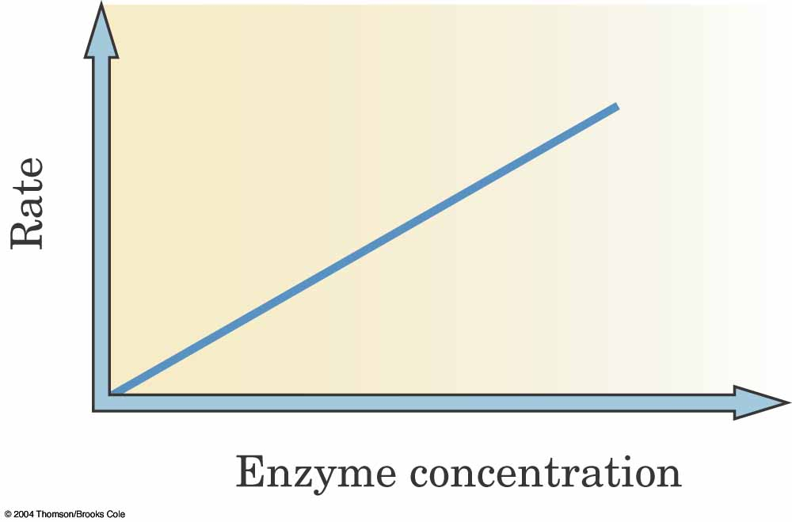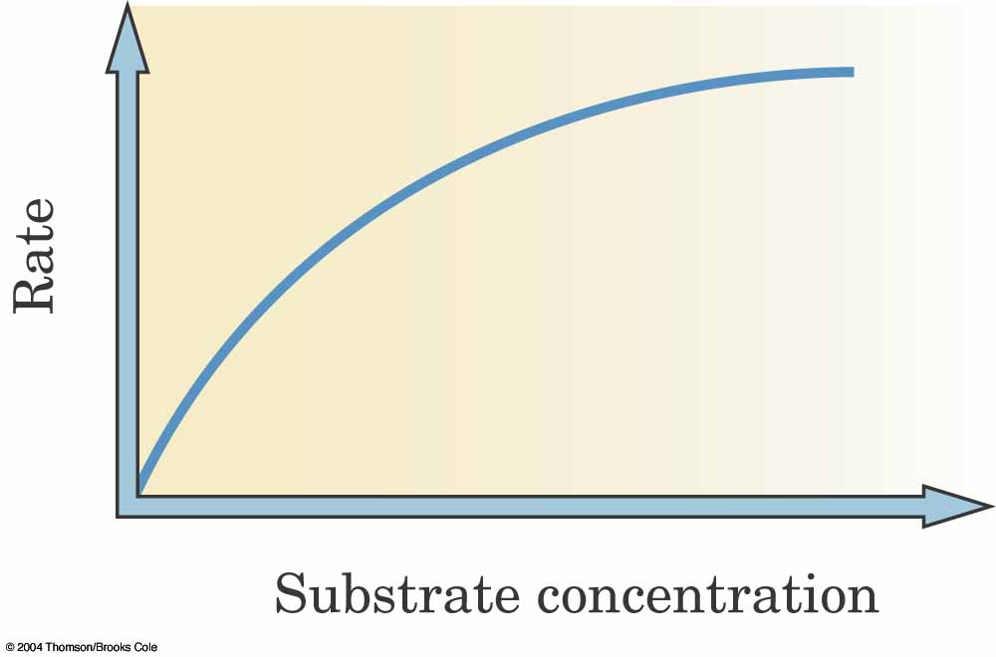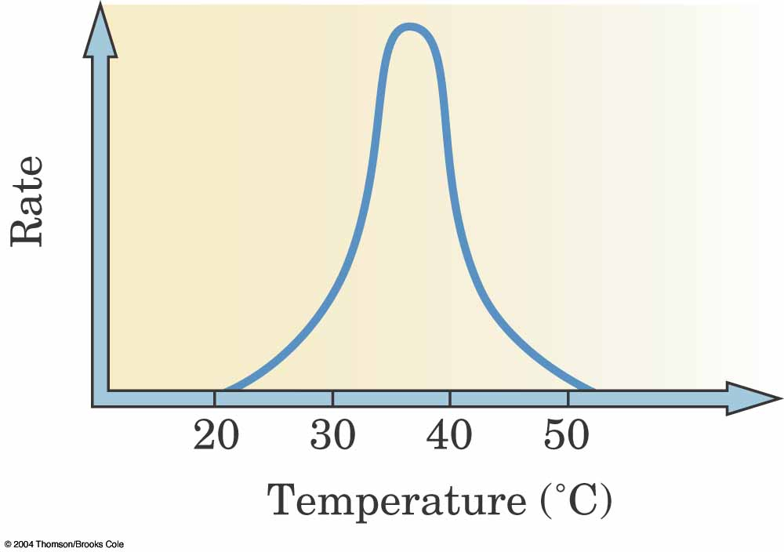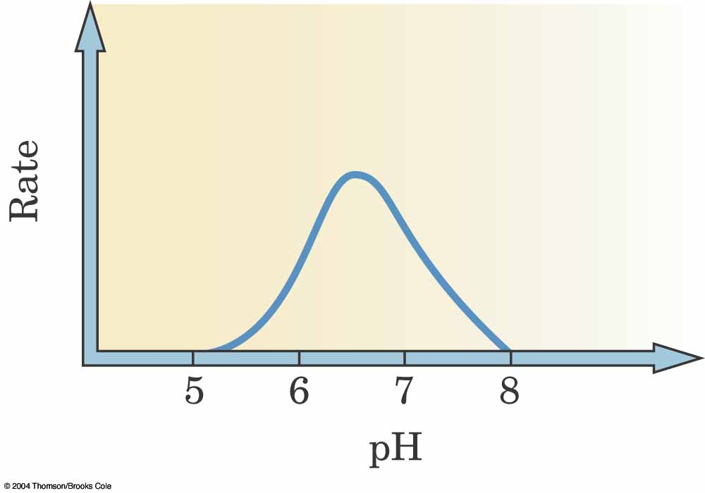
A proenzyme is one that requires a section of the peptide chain be removed to form the active enzyme. An example is trypsinogen a proenzyme which forms trypsin (a digestive enzyme) on activation.
(c) Vitamins, microminerals, macrominerals and macronutrients are all components of the diet.
• How do vitamins differ from microminerals? Provide an example of each class of
nutrient and indicate a function for the vitamin and a function for the micromineral.
• What property makes the B-group vitamins fundamentally different from the
D-group vitamins?

Vitamins are organic compounds required in small quantities in the diet whereas microminerals are inorganic metals required in the diet.
Vitamins: Vitamin C ascorbic acid.
Microminerals: Fe, Cu, Zn, I, F

The B-group vitamins such as niacin (B₃) are water soluble whereas the D-group vitamins such as D3 are lipid soluble.

Question 3
Timing: you should complete this question in 15 minutes.

(a) Membranes provide vital physical barriers for cells. The most fundamental characteristic of a cellular membrane is the lipid bilayer structure.
• Sketch a small section of membrane schematically indicating the lipid bilayer.
• Draw a structure of a glycophospholipid that would be found in the lipid bilayer.
• The lipid bilayer is amphipathic – what does this mean?
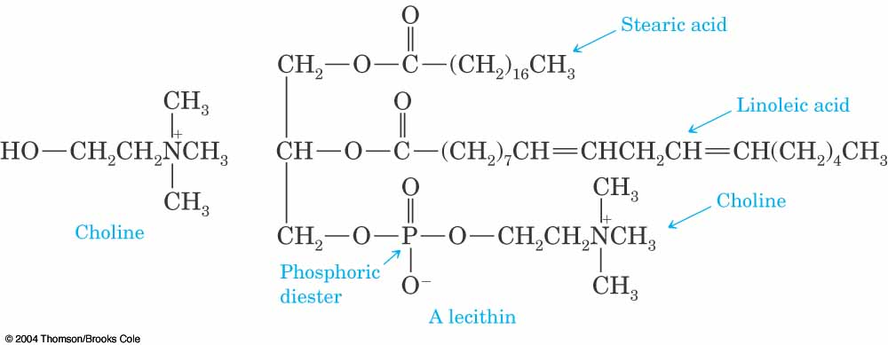

Amphipathic means that it has both hydrophobic and hydrophilic characteristics. The outside surface contains the polar head groups and is water liking whereas the inner surface is composed of the bulky fatty acid tails and is water hating.

(b) Metalloenzymes may be regarded as macromolecular coordination compounds. To aid in
the understanding of metalloenzymes simpler molecules such as [Mo(NH₃)₃Cl(en)]⁺ are
studied. [ N.B. en = NH₂CH₂CH₂NH₂ ]
• What is the coordination geometry and coordination number in
[Mo(NH₃)₃Cl(en)]⁺?
• What type of ligand is en?
• Provide an example of a metalloenzyme and it’s function.

The coordination geometry is octahedral and the coordination number is 6.

The ligand is bidentate – it can coordinate through the 2 nitrogen atoms.

The [4Fe-4S] clusters in Complex I are an example of a metalloenzymes and this protein functions to accept electrons from NADH in the electron transport chain.
Another metalloenzymes is carbonic anhydrase which contains Zn and functions to produce carbonic acid from CO₂.

(c) Photosystems I and II are involved in the Z-scheme of photosynthesis?
• Briefly detail the main characteristics of the Z-scheme.
• What are the main functions of the Z-scheme?

The Z-scheme is a grouping of photosynthetic complexes and a complex associated electron transfer cytochrome complex on the thylakoid membrane on the inside of the thylakoid disks in the chloroplasts of plants. The Z-scheme transfers energy from photons into the energy of NADPH and ATP – the so called light reactions.
A photosystem (photosynthetic unit) is an outside grouping of antennae chlorophyll (several hundred) and accessory pigments (such as carotenoids) called a light harvesting complex which funnels energy (as light) to a reaction centre which contains special chlorophylls (photosystem II PS-II contains P700, PS-I contains P680) and integral membrane proteins. The photosystems structure are located on the thylakoid membrane inside the thylakoid disks of chloroplasts.
The function of the photosystems is to generate a proton gradient across the thylakoid membrane (low stroma, high intrathylakoid space) and to reduce NADP to NADPH in the light reactions of photosynthesis.
In the Z-scheme PS-II passes a photoelectron to a group of electron carriers and onto PS-I which then absorbs a further photon and the electron is then able to reduce NADP.
In the course of the reaction O₂ is produced by the oxidation of water as a useful by-product.
The proton gradient is required for ATP Synthase to function and generate ATP.
The ATP and NADPH that are produced by the Z-scheme are used in the synthesis of carbohydrates such as sucrose in the dark reactions of photosynthesis.
The proton gradient is created as a result of the operation of the PS-II and plastoquinone in the electron-transport chain called the Z-scheme of photosynthesis.
Question 4
Timing: you should complete this question in 15 minutes.

(a) Glycolysis and β-oxidation are major catabolic pathways.
• Briefly describe glycolysis and β-oxidation indicating the starting materials,
products and energy yield per carbon.
• In what ways do glycolysis and β-oxidation differ from each other and in which
ways are they similar.

Glycolysis is the 9 step process which transforms glucose into pyruvate and generates energy carriers
Reactants: glucose / ADP / NAD / P_{i} → Products: pyruvate / NADH / ATP

β-oxidation is a series of 4 steps that cleaves carbons from a fatty acid chain 2C at a time. Following the 4th step the acetylCoA is fed into the TCA cycle and NADH and FADH₂ into the oxidative phosphorylation.
Reactants: fatty acid / CoA / ATP / FAD / NAD⁺ → Products: acetylCo / ADP / NADH / FADH₂
Both processes feed into the TCA cycle and oxidative phosphorylation. Glycolysis first has to have the pyruvate converted into acetylCo.
The energy yields are different: the energy yield is 6ATP per C in glucose overall and 8ATP per C in stearic acid overall in β-oxidation.

(b) The acyl carrier protein (ACP) is an intrinsic part of the synthesis of fatty acids.
• Describe the various steps in the synthesis of fatty acids using ACP.
• What is anabolism?

Fatty acid synthase is the multi enzyme complex that carries out fatty acid synthesis it possesses a coenzyme called acyl carrier protein ACP. The acyl carrier protein is a holoenzyme containing a phosphopantheine prosthetic swinging arm. In E. choli fatty acid synthesase there are 7 enzymes which are involved in catalysing the 5 major steps in fatty acid synthesis. The flexible phosphopantheine swinging arm of ACP carries the intermediates from one enzyme site to the next site. The growing fatty acid chain is carried then by ACP and grows until C16 at which point it is cleaved from the ACP.
Step 1 Loading (places the FA chain or starter chain on ACP)
Step 2 MalonylCoA (synthesis and loading onto ACP
Step 3 Condensation Step 4 Reduction Step 5 Dehydration Step 6 Reduction

Anabolism is the biosynthesis of complex molecules using simple precursor molecules and energy provided by energy carrier molecules such as ATP – complex pathways are involved in anabolism.

(c) The electron transport chain operates in oxidative phosphorylation.
• What is the electron transport chain?
• Sketch the general structure of ATPsynthase. How does this complex play a part in
oxidative phosphorylation?

The electron transport chain is a series of enzyme complexs and associated coenzymes that are bound
into the inner-membrane of the mitochondrion. There are 4 complexes. NADH passes an electron to Complex I, FADH2 passes electrons to Complex II. Complexes I and II pass electrons to Coenzyme Q which then passes electrons to Complex III. Complex III passes electrons to cyctochrome C which moves them along the surface of the membrane to Complex IV which passes the electrons to oxygen which is reduced to water.
- ATP Synthase may be regarded as a rotating molecular motor, a flow of protons turns the motor. As it turns the mechanical energy is converted to bond energy as ADP/Pi is turned into ATP and then ejected from the ATP synthase.
- The cγε subunits form a rotor, the abδ subunits is a stator.
The F₁ portion αβγδε subunits (knob) is where ATP synthesis occurs.
- The F₀ portion αβχ (stalk) contains a proton channel it spins the rotor and stator each time an H⁺ passes thru.

Question 5
Timing: you should complete this question in 15 minutes.

(a) DNA and RNA carry the information required to make proteins.
• How does DNA differ from RNA?
• What are introns and exons?
• What role does the regulatory gene play in protein synthesis?

DNA has a deoxyribose sugar while RNA has a ribose sugar.
DNA uses the base Thymine while RNA uses the base Uracil.
DNA is a double stranded structure, RNA is a single stranded structure.
DNA is a high molecular weight polymer (10kb), rRNA is high molecular weight, mRNA moderate molecular weight (<1kb), and tRNA low molecular weight (70-100b).
(Fix lecture 13 Slide 15 base pairs in RNA to bases.)

Exons are sections of a structural gene that will be expressed either as proteins or RNA.
Introns are spacer sections in a structural gene that will not be expressed.

The regulatory gene contains promotors which are used for recognition of the start of the structural gene (sections such as the TATA box). It also contains silencers which slow down or stop transcription and enhancers which speed up transcription. This transcription level regulation is the main control on the speed of protein synthesis.

(b) Replication is the process that ensures that genetic information is passed with high accuracy from one cell generation to the next.
• Provide an overview of the major steps in DNA replication
• What are Okazaki fragments and why are they required?
ORUPSL

1) Opening up the superstructure: during replication, the very condensed superstructure of chromosomes is opened by a signal transduction mechanism.
(One step in this mechanism involves acetylation of key lysine residues, acetylation removes a positive charge and thus weakens the DNA-histone interactions.)

2) Relaxation of higher DNA structures: DNA gyrases (topoisomerase) relax the supercoiling in DNA by introducing either single strand or double strand breaks in the DNA
3) Unwinding of the DNA double helix: Helicases attach themselves to 1 strand of DNA and cause the separation of the double helix. Unwinding can occur at the ends or in the middle.
(The helicases catalyze the hydrolysis of ATP as the DNA strand moves through; the energy of hydrolysis promotes the movement of the helicase.)
4) Formation / complexation of Primers: Primases form primers which are short RNA oligonucleotides synthesized from ribonucleoside triphosphates (4 – 15 nucleotides) for the lagging strand synthesis.
(These are then complexed with DNA polymerase and placed in the lagging strand synthesis. The ribonucleosides are needed as the primer must provide a free 3’-OH for the growing chain to attach to)
5) DNA polymerase Synthesis: DNA polymerase aligns the incoming complementary nucleotides to the template, allowing hydrogen bonding to form and joins the nucleotide backbone. After completion DNA polymerases proof-read the completed chain checking & repairing base-pair errors.
6) Ligation: The short Okazaki fragments are joined together by DNA ligase. RNA primers get replaced with DNA.

In the lagging strand synthesis the complexation of a short stretch of nucleotides primers (RNA) occurs once every second at the replication fork (catalysed by primase). Another 200 nucleotides are added the Okazaki fragment – in the 5’ → 3’ direction using the other core of the DNA polymerase. This is running in the opposite direction to the leading strand synthesis, away from the replication fork and occurs as the DNA polymerase only works in the 5’ → 3’ direction. Once this core reaches the previous primer section the core releases from the template and returns to the new primer to begin the synthesis of another Okazaki fragment. This is semi-discontinuous synthesis.

(c) Translation and Transcription are 2 major steps in protein synthesis.
• Detail briefly the major steps in DNA transcription?
• What is a ribosome and what is it’s function?
• Quality control is important in protein synthesis, explain where quality control is
implemented in translation.

Transcription involves 3 major steps:
1) initiation where the Pol II complex (Pol-II + transcription factors) interacts with the promotor region of the DNA gene through the transcription factors and forms an open complex. Helicases unzip the DNA.
2) Elongation: the Pol II catalyses the zipping up of the complementary nucleotides (from the 4 ribonucleotide triphosphates) in the 5’ → 3’ direction.
3) Termination: a concensus sequence is detected (AAUAAA) which stops Pol II, which dissociates.
There is also a pre-initiation stage prior to step 1 where the RNA Pol-II enzyme and transcription factors organise to form the initiation complex.
A ribosome is a complex multiprotein structure formed from 2 bodies the large body (60S) and the small body (40S) to make the complete 80S ribosome complex. It contains two sites P site and A site where protein synthesis occurs and is initially loaded with tRNA^{met} and mRNA. The function of the ribosome is to read the mRNA code, take in the appropriate activated aminoacyl-tRNA molecules and synthesis a peptide chain from them. The function then is protein synthesis.

The quality control in translation is mostly implemented in two steps.
1) selectivity of the aminoacylRNAsynthetase (AARS) for the correct amino acid (size, shape selectivity) and for the correct anticodon on tRNA (also shape).
2) the termination step in translation only occurs when one of the correct STOP codons (such as UAA) is read – this prevents the release of the protein if the reading frame is moved by a mutation.

