
Department of Chemistry
Cairns Edition

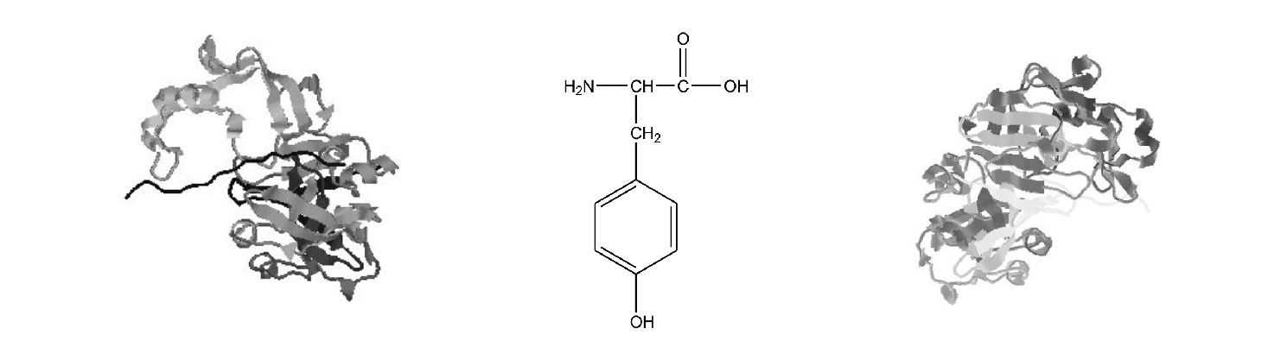

CH1010
LABORATORY NOTES
2005

Name:

Partner:

DEPARTMENT OF CHEMISTRY

CH1010 PRACTICAL COURSE

Table of Contents

Assignment Subject

General Introduction
Notes on Biological Chemistry Assignments
Techniques of Organic Chemistry

1 Laboratory Safety
2 Acid-base Properties of Organic Compounds
3 Structure in Organic Molecules
4 Chromatography: Amino Acids and Plant Pigments
5 Isolation of Caffeine from Coffee Beans
6 Recrystallisation of Natural Products

7 Micropipettes and Spectrometers
8 Casein and α-Amylase
9 Gel Electrophoresis and Vitamin C Analysis

GENERAL INTRODUCTION

1. INTRODUCTION

This course involves aspects of organic, inorganic and physical chemistry. Some of it is qualitative, other parts are quantitative. As far as is possible the laboratory work is organised to correspond with the lectures but a perfect match is not possible.

2. WORK INVOLVED

a. Before you come into the laboratory, check the LearnJCU timetable to find out which assignment you will be doing then read over, understand and prepare for that assignment. Sort out any queries before the lab class by the use of textbooks and tutorial staff. Where possible, complete equations in the "REPORTS" book.

b. You should arrive on time for the session. Once in the laboratory, before beginning your lab work, you should collect last week's report. Often there will be a tutor-led discussion before the practical work begins.

c. When you have finished the lab work you should clean up your work space and return any borrowed apparatus to the preparative laboratory. Glassware and other apparatus are to be cleaned and replaced (ready for use by the next student) in your allocated bin. Usually there will be a tutor-led discussion on treatment of results. If you have finished early you should begin (and often complete) your calculations and begin to write up your report. The class finishes at 5pm. All experimental work must be completed by 4.45pm, anyone leaving early will be marked absent unless all of the lab work is completed AND a completed report is presented to your tutor.

d. After the practical session you should complete your report and hand in your report book.

e. If you are absent for a medical reason you should present a medical certificate to your tutor in the next lab session and ensure that it is noted on your record. Absence for any other valid reason should be explained in writing or preferably by a certificate from the University student councillor and must be recorded with your tutor.
If you miss 3 or more practicals without a valid reason you will have failed the practical component and will have to repeat the course.

3. REPORTS

A "REPORTS" book must be obtained from the Medicine, Health and Molecular Sciences Faculty office and used to write up your reports.
Reports will be handed in at the end of the practical session.

Make sure that your name, day and demonstrator are clearly recorded on the front of your "REPORTS" book.

4. ASSESSMENT

The details are the same for each assignment as shown below.

Assignment | Lab* | Report | Total
1 | 5 | 15 | 20
2 | 5 | 15 | 20
3 | 5 | 15 | 20
4 | 5 | 15 | 20
5 | 5 | 15 | 20
6 | 5 | 15 | 20
7 | 5 | 15 | 20
8 | 5 | 15 | 20
9 | 5 | 15 | 20

* Failure to clean-up will result in a loss of marks!

5. ITEMS NEEDED

1. One copy of the "CH1010 REPORTS" book.
2. One copy of "CH1010 CHEMISTRY LABORATORY NOTES" (this book!).
3. A breakage deposit must be paid to the cashier and the receipt number entered on your card by the third week of the second semester. Deductions will be made from refunds for breakages and special equipment damaged and a small amount for laboratory coat cleaning.
4. A laboratory gown (provided), safety glasses (provided) and protective footwear (ordinary shoes but not thongs) must be worn at all times in the laboratory.

6. SAFETY

SAFETY MANUAL.

As part of the practical component of this course you are required to read the Safety Manual that accompanies this course. THIS IS COMPUSLORY and a record is kept electronically that indicates that you have downloaded the Safety Manual for reading.

To access the Safety Manual the WEB address is :
http://cnsfse01.jcu.edu.au/Schools/Chemistry/SafetyManual/manual.htm
At the prompt enter your student login name and password and then download the Safety Manual for reading.
Alternatively the manual may be addressed from the CH1010 LearnJCU web site under Course Documents.

6.1 Accidents

Accidents do happen in chemical laboratories, usually through thoughtlessness. You are therefore requested, for your own sake and that of your neighbours, to read the Safety Manual and to THINK before you act. Remember to heat organic solvents on a water bath or hot plate - NOT OVER A BUNSEN BURNER.

6.2 Fire

Many organic solvents are highly flammable and require cautious handling. If a fire starts, turn out all adjacent burners and remove everything that may ignite. Water should not be used on fires involving organic chemicals. Smother fires by covering with any suitable object (e.g. bunsen mat) to exclude air. Fire extinguishers are available in all laboratories and should be used for larger fires.

6.3 Handling chemicals

Many chemicals are TOXIC and should be handled with caution. Chemicals spilt on the skin should be washed off immediately with plenty of water followed by soap and warm water. Gloves are provided for some experiments. Care should be taken not to leave chemicals where others may come into contact with them. Any liquid running down the side of a container should be wiped off with a piece of paper towel.

All experiments involving the use or generation of irritating or corrosive substances e.g. Br₂, HNO₃ etc., should be carried out in a fume cupboard.

In many cases bottles are provided for waste chemicals and must be used for this purpose.

6.4 Pregnant Women

Many chemicals are teratogenic and should not be handled by pregnant women. If any student is pregnant then they should inform their laboratory supervisor and they will be directed to perform only those practical experiments for which it is safe for them to undertake.

7. DATA RECORDING

Measurements and observations should normally be recorded in your "REPORTS" book or separate notebook. Whenever it is possible and appropriate, data should be plotted as it is obtained.
TECHNIQUES OF ORGANIC CHEMISTRY

Two of the experiments in the organic section are natural products experiments. In general natural product chemistry aims to obtain a chemical of interest (often pharmacological) in pure form from a natural material.
The normal procedure is to extract the compound of interest from the natural material in the solution phase,
generally this requires a previous maceration step.

Raw natural material Extraction Product + Impurity
⬇ "Purification"
Pure Product

Apart from the desired product, however, the extraction mixture may also contain inorganic and organic impurities. "Purification" involves the separation of the pure product from this extraction mixture.

EXTRACTION PROCEDURES:

Normally an extraction involves an initial partition into polar water soluble components and non-polar lipid soluble components. To do this the natural product mixture is mixed with an equal volume of water. The usual isolation procedure involves the addition of a quantity of low boiling solvent such as diethyl ether (b.p.35ºC) [which is normally referred to as simply "ether"] or petroleum ether (b.p ~30-40⁰C) and the organic material separated from the water soluble components using a separatory funnel (see diagram).

A consideration of the expression "like dissolves like" is used to decide which layer the product is likely to be found in. This means that a non-polar organic product will transfer almost exclusively into the non-polar organic solvent while the polar inorganic salts will be confirmed to the polar water (aqueous) layer. Both diethyl ether (ρ 0.71 g.cm-³) and petroleum ether (ρ 0.66 g.cm⁻³) are less dense than water so when these solvents are used, the organic layer will be above the aqueous layer. Occasionally chloroform (ρ 1.48 g.cm⁻³, b.p. 62⁰C) or dichloromethane
(ρ 1.33 g.cm-³, b.p. 41⁰C) are used as the extraction solvent, in which case the organic layer will be below the aqueous layer.

The organic layer is separated from the aqueous layer by running the lower layer out of the bottom of the funnel. If the organic layer is on top of the aqueous layer, a little of the organic layer is run out with the aqueous, the tap closed and the organic layer tipped into a dry flask through the top of the funnel. This limits the amount of water that is put into the flask with the organic layer. Small quantities will remain suspended in it however, and they can to be removed by use of an anhydrous inorganic salt such as sodium sulphate, calcium chloride or magnesium sulphate. The wet organic solvent will often appear cloudy but will become clear (meaning "see through" not colourless) when dry. Most organic compounds boil at a higher temperature than the extraction solvents, so the solvent can be removed by distillation on a steam bath. (Note that a bunsen is not used for the distillation. This is because both ether and petroleum ether have very low flash points and are highly flammable). The organic product, if a liquid, is then distilled and its boiling point determined as described above.

If the organic product is a solid it will remain in the distillation flask after the solvent is removed and will most likely crystallise on cooling. It can then be recrystallised from a suitable solvent.

RECRYSTALLISATION

The resulting solid or semisolid product from an extraction must then be purified. Recrystallisation is a very effective method of purifying organic solids. This process may be divided into a number of distinct steps:

1. The solid to be recrystallised is dissolved in a minimum volume of a suitable solvent (e.g. water, ethanol, etc.) at or near its boiling point, then a slight excess (~10 %) of hot solvent is added.

2. A fluted filter paper and a short stemmed funnel are preheated by pouring a few mLs of pure boiling solvent through them. Before they are allowed to cool, the boiling solution containing the compound to be recrystallised is poured rapidly through them. The filtrate is them returned to the heat to ensure complete solution at the boiling point. The filtration removes insoluble contaminants like dust etc. as well as organic impurities which are not soluble in the chosen solvent. It is important to do the preheating process properly otherwise large quantities of the product will crystallise out on the filter paper.

3. The funnel is then removed, the flask covered and allowed to cool to room temperature (or cooler if instructed). The pure organic compound should crystallise in the flask as it cools. The best crystals, and hence the purest material, are obtained if the solution is allowed to cool slowly without disturbance.

4. When crystallisation is complete, the pure crystals are separated from the mother liquor (Recrystallisation solvent containing impurities) by vacuum filtration, using a small amount of the mother liquor or a spatula to assist in the transfer of the crystal to the filter. The crystals should be gently pressed down onto the filter paper so that a rapid flow of air passes through them.

5. The crystals should be washed with a few mL of chilled pure recrystallisation solvent to remove all traces of mother liquor adsorbed on the surface of the crystals, and sucked dry.

Experimental Procedure
The following instructions give details for recrystallisation of a solid from (a) water, and (b) from a flammable solvent such as ethanol.

(a) Recrystallisation of a compound from water
Heat some water to boiling point in a large conical flask* over a bunsen or hotplate. Place the compound in another dry conical flask. Add some boiling water to the solid together with several boiling chips (crushed tile) or sticks,# and try to dissolve the solid with heating. Add small amounts of hot water to the crystals until they just dissolve, then add about a 10% excess.

Allow the solution to boil very gently while you prepare a fluted filter paper. Place the filter paper in a glass funnel and preheat both paper and funnel by pouring boiling water through them. While still hot, quickly pour the solution containing your compound through the filter and collect the filtrate in a clean vessel.
Briefly return the filtered solution to the heat to redissolve any solid material that may have prematurely crystallised, then cover the vessel and allow it to cool slowly without disturbance.

* Conical flasks NOT beakers should be used for recrystallisations because; (a) it is easier to rinse the inner walls of a conical flask, (b) when heated, the solvent will reflux on the inside of the flask with minimal evaporation and (c) the narrow neck of the conical flask makes it easier to handle than a beaker, especially when hot.

# Boiling chips or sticks provide sharp points on which bubbles can easily form. In their absence, large bubbles form over the entire bottom of the flask and cause the mixture to "bump".
Filtration and Collection of Crystals
(See apparatus in diagram) When the solution is quite cool and crystallisation is complete the crystals must be collected by vacuum (suction) filtration. Select a suitably sized Hirsch or Buchner funnel and place it in your side arm test tube or filter flask. You will notice that these funnels have perforated ceramic bases with large holes in them. Unlike a sintered glass disk, these funnels must be used in conjunction with a suitably sized filter paper. The filter paper is placed on the funnel and moistened with a little of the recrystallisation solvent (water in this case) and the vacuum applied. With a moistened finger, ensure that the paper is flat and that all the holes are covered. Swirl the crystals in the mother liquor, and pour the mixture quickly and carefully into the funnel. In some cases the volume of solvent may be too great for the side arm test tube and it will be necessary to drain it half way through the filtration. Do not discard the filtrate until you are sure you have a reasonable yield of crystals (consult your demonstrator if unsure). Crystals left in the flask may be helped out with a spatula or with a little of the mother liquor. Gently press the crystals down on the filter paper and carefully wash them with a mL or two of cold recrystallisation solvent (iced water). Use the vacuum to suck them dry, covering the top of the funnel with a larger filter paper to keep dust out. When the crystals seem fairly dry, transfer them to a larger filter paper. The filter paper should be folded to prevent loss while still allowing the crystals to dry. Place them in your cupboard and record their melting point once they are completely dry (usually the next day).

(b) Recrystallisation of a sample from ethanol

NO BUNSENS SHOULD BE USED NEAR ETHANOL.
You will do all recrystallisations from organic solvents over a steam bath or on a hotplate in a fume cupboard.

Warm some ethanol in a conical flask to near boiling on a steam bath or hot plate. Place the compound to be recrystallised in another dry conical flask and warm it in the same way. If you are using a hot plate, be careful not to over-heat the compound before adding the solvent. Add a boiling chip or stick then hot ethanol, a little at a time, until the compound completely dissolves. Add a ≈ 10% excess of hot ethanol and keep the solution gently boiling. Quickly warm a fluted filter paper and funnel by pouring some boiling ethanol through it. Filter the solution into a clean dry vessel by quickly pouring it through the filter paper and funnel. Warm the filtrate briefly to redissolve any material which may have crystallised during filtration and then cover it and set it aside to cool slowly without disturbance.

Filter the crystals using vacuum filtration as described above and leave them to dry in air, before recording their melting point.

DETERMINATION OF PURITY

Since, in most areas of chemistry it is vital that we work with pure substances, various ways of characterising compounds and determining their purity have been developed.

Two important properties used for this purpose are the boiling point or range of a liquid and the melting point or range of a solid. If a compound is pure and crystalline, and if it doesn't decompose on heating, it will have a sharp (range 2º) and characteristic melting point. As with a boiling point, the melting point of a pure solid can be used to help identify it, if used in conjunction with other measurements. In addition, if one has an idea of the identity of a recrystallised compound, and an authentic sample of the proposed compound is available, unambiguous structural proof can be obtained by recording a "mixed melting point". This is done by making a 1:1 mixture of the unknown and the authentic sample (by grinding them together on a watch glass) and recording the melting point of the resulting mixture. All three melting points (unknown, authentic and mixed) will only be the same if the two compounds are identical. The technique relies on the fact that impurities lower or depress the melting point of a compound. If the compounds are identical and have a melting range of e.g. l49-l51ºC, we report "m.p. and mixed m.p. 149 - l5l ºC, unaffected by admixture with authentic sample." It should be noted that solvent can also be considered to be an impurity, hence a compound must be COMPLETELY DRY before its melting point is recorded.

Experimental Procedure for the Determination of a Melting Point:
Seal one end of a melting point capillary by rotating the end in a bunsen flame (NB: Before you light the bunsen, ensure there are no organic solvents in the vicinity) until a small bead of molten glass closes off the end. Allow the capillary to cool. Now take a small sample of the solid to be tested (or 1:1 mixture for a mixed m.p.) and crush it on a watch glass, using a spatula. Scrape a small quantity of the powder into the open end of the sealed melting point capillary and, while holding the bottom of the tube, tap it on the bench until the compound falls down into the end that is sealed. Alternatively the capillary may be dropped down a length of glass tubing several times. If the powder inside the melting point tube is clearly visible, you have added enough. Do not add more than is necessary. Place the tube in the electrically heated m.p. apparatus and heat slowly. Record the temperature range over which the solid melts, i.e. the temperature range from when you see the first crystal melt to when the whole sample is molten. A temperature range of more than 3⁰ C suggests that the sample is not pure.

It is vital that the sample is heated slowly, so that the melting point tube and the thermometer are as close to the same temperature as possible. The melting point should always be recorded with rising temperature (sample going from solid to liquid), rather than with falling temperature (sample going from liquid to solid) because in the latter case, supercooling of the liquefied test substance can lead to large errors.

Other Purity Criteria:
In modern organic laboratories a range of techniques are used to confirm structural assignments and purifies of organic compounds. These include refractive index, elemental analysis (which gives the % C, H, O, N etc), mass spectrometer, infrared and ultraviolet spectroscopy and NMR spectrometry. In this course we will concentrate on the more simple techniques of boiling point and melting point determination, and examine some basic aspects of the interpretation of infrared and ultraviolet spectra.

ASSIGNMENT 1
LABORATORY SAFETY

AIMS

Safety is an important issue when experimental work is carried out in a laboratory situation. This practical is concerned with identifying and minimizing the risks in common laboratory procedures, becoming familiar with Material Safety Data Sheets and working out what to do in the event of a dangerous situation or an accident in a laboratory.

1. INTRODUCTION

Chemicals are found in nearly all laboratory situations. Each chemical has associated with it some degree of risk (eg. corrosive, carcinogenic, flammable). The information on the risk associated with the use of a chemical may be found in the Material Safety Data Sheet (MSDS) for that chemical. These MSDS sheets accompany every chemical that enters a laboratory. Each laboratory is required to have, near the doorway to the laboratory, a folder that contains the MSDS sheets for all the chemicals in the laboratory.

Workplace Health and Safety is managed at the University by the Workplace Health & Safety Officer. The Workplace Health & Safety Act requires that all members of an organisation maintain safe work practices. In the event of an accident the laboratory supervisor will report to the Workplace Health & Safety Representative who then reports back to the Workplace Health & Safety Officer. In the laboratory each student must act in a safe manner and if they are doing something that is hazardous then they are required to notify others in their vicinity that they are carrying out a hazardous operation. This is a requirement of the Act and is generally applicable to all laboratory environments.

Prevention of accidents is the key to maintaining a safe laboratory. In each operation carried out in a practical experiment the various hazards associated with the chemicals being manipulated need to be assessed. The level of risk is then determined in a Risk Assessment procedure and if any area of the procedure has a high risk then measures are taken to lower the risk. All practical experiments in the Chemistry courses in Cairns have had Risk Assessments carried out and they fit within the Safety Guidelines laid down within the WH & S Act.

A SAFETY VIDEO will be shown illustrating how to work safely in a laboratory.

2. EXPERIMENTAL

You will do this experiment In Pairs
2.1 Material Safety Data Sheets

You will be given a set of reagents with their accompanying MSDS sheets. A hypothetical accident situation is presented to you in your report book and you are asked to suggest how to deal with the accident situation on the basis of the information from the MSDS sheets.

2.2 Obtaining Safety Information

This section you will complete after the practical. You will need to go to the library and familiarise yourself with how to obtain MSDS information from the WEB and how to find safety information from the literature.
2.3 Laboratory Awareness

You will be instructed on how to work safely in the laboratory by anticipating standard hazards. A familiarisation trip around the lab will cover the location and use of equipment such as spill kits, fire extinguishers and eye wash stations.

References

Vermont SIRI searchable MSDS site : http://hazard.com/msds/
Australian alternative site : http://www.msds.com.au/
Chemwatch: http://max.chemwatch.net/cg2/

SAFETY MANUAL.

As part of the practical component of this course you are required to read the Safety Manual that accompanies this course. THIS IS COMPUSLORY and a record is kept electronically that indicates that you have downloaded the Safety Manual for reading.

To access the Safety Manual the WEB address is :
LearnJCU/CH1010/Documents/PracticalDocuments /CH1010 Safety Booklet
or
http://cnsfse01.jcu.edu.au/Schools/Chemistry/SafetyManual/manual.htm
At the prompt enter student login name and password then download the Safety Manual for reading.
ASSIGNMENT 2

ACID-BASE PROPERTIES
OF ORGANIC COMPOUNDS

AIMS
To develop a knowledge of the acid-base characteristics of some common biological materials through the use of a pH meter. To study the acid-base properties of an amino acid by titration with the strong base NaOH. From the titration curve the pK_{a}s for the carboxyl and amide groups will be obtained and the isoelectric point pI for the amino acid will be determined.

1. INTRODUCTION
1.1 Acid-base chemistry
In Biology it is important to be familiar with the acidic or basic characteristics of compounds which have ionisable protons (acids) or are able to accept protons (bases). The classes of organic compounds where acid- base properties are particularly important include: carboxylic acids (including fatty acids), amines (including alkaloids), amino acids and nucleic acids.
1.2 The pH of a Solution

The pH scale is a measure of the relative acidity (or alkalinity) of a solution with respect to water. On this scale a value 7.0 is neutral (H₂O), below 7.0 is acidic, and above 7.0 is basic. The formal expression for pH is:

pH = -log₁₀[H⁺]

where [H⁺] is the concentration of free hydrogen ions present within the solution, as expressed in mol/dm³.

Sample calculation:
Evaluate the pH for a 0.1 mol/dm³ and 0.05 mol/dm³ solution of hydrochloric acid (HCl).
Answer:
Hydrochloric acid is a strong acid so it dissociates fully in water, i.e.
HCl + H₂O → H₃O⁺ + Cl⁻
where H₃O⁺ represents the free hydrogen as it exists in water. Because the acid fully dissociates the concentration of free hydrogen ions present in the system will be the same as the initial concentration of the acid. So:

(i) 0.1 mol/dm³ HCl solution (ii) 0.05 mol/dm³ HCl solution

[H₃O⁺] = 0.1 mol/dm³ [H₃O⁺] = 0.05 mol/dm³
pH = -log(0.1) pH = -log(0.05)
= 1.0 = 1.3

Note that the lower the acid concentration the higher the pH of the solution.

It is possible to change the pH of a given solution simply by adding an appropriate acid or base. Consider a solution with a pH = 1 ([H₃O⁺] = 0.1 mol/dm³) and then make the solution more basic by adding OH⁻ ions. These ions will react with the acid to produce water:
HCl + OH⁻ → H₂O + Cl⁻
this decreases the concentration of the acid and hence the concentration of hydrogen ions in the solution.
We are going to look at the acid-base properties of representative compounds from the classes of organic compounds mentioned above and look at some common materials around you and then in the next section focus attention on the amino acids.

1.3 Amino acids.
Amino acids in solution exist as zwitterions (ie. has both a positive and a negative charge).

This is an amphoteric compound because it behaves as both an acid and a base in the Bronsted definition of
acid and bases. As an acid, it can donate an H⁺ and becomes the conjugate base:

Acid Base Conj. base Conj. acid

As a base, it can accept an H⁺ ion and becomes the conjugate acid:

Base Acid Conj. acid Conj. base

To study the acid-base properties of an amino acid, one can perform a simple titration. We start our titration with the amino acid being in its acidic cationic form at a low pH:

(I)

As we add a base, OH⁻, to the solution, the pH will rise. We record the pH of the solution by using a pH meter after each addition of the base. To obtain the titration curve, we plot the millilitres of NaOH added against the pH of the solution (Fig. 1).
Figure 1
The titration curve of an amino acid without an
ionisable side-chain.
Note that there are two flat portions (called legs) on the titration curve where the pH does not increase appreciably with the addition of NaOH. The midpoint of the first leg, (1), is when half of the original acidic amino acid (I) has been titrated and it becomes a zwitterion (II).

(II)

The point of inflection (2), occurs when the amino acid is entirely in the neutral zwitterion form (II).

At the midpoint of the second leg, (3), half of the amino acid is in the zwitterion form and half is in the basic anionic form (III).

(III)

From the pH at the midpoint of the first leg we obtain the pK_{a} value of the carboxylic acid group, since this is the group that is titrated with NaOH at this stage - the structure going from (I) to (II).
The pK_{a} is the acid dissociation constant of a group, the lower the value the stronger the acid.
The pH of the midpoint of the second leg, (3), is equal to the pK_{a} of the –NH₂, since this is the functional group that donates its H⁺ (from –NH₃⁺) at this stage of the titration. The pH at the inflection point, (2), is equal to the isoelectric point pI. At the isoelectric point of a compound, the positive and negative charges balance each other. This occurs at the inflection point when all the amino acids are in the zwitterion form.

You will obtain a titration curve of an amino acid with a neutral side chain such as glycine, alanine, phenylalanine, leucine, or valine. With a pH meter you will read the pH directly from the instrument after each addition of the base. From the titration curve obtained, you will determine the pK_{a} values and the isoelectric point pI.
2.
EXPERIMENTAL

You will do this experiment In Pairs

2.1 pH Measurements

2.1.1 pH meter calibration
Insert the clean electrode (washed with distilled water) of the pH meter into a standard buffer solution with known pH. Calibrate the pH meter to read the pH of the buffer. Remove the electrode from the buffer, wash it with distilled water, and dry it lightly with a tissue.
Ensure that the pH meter is washed thoroughly, with distilled water, between calibrations.
1. Turn the Operation Switch to on.
2. Immerse the electrodes in pH = 7.0 buffer.
3. Use the Calibration Control to set the meter reading to set 7.0.
4. Rinse the electrode.
5. Immerse the electrodes in the pH = 4.0 buffer.
6. The meter should read 4.0. If it does not, use the Calibration Control to set 4.0.
The pH electrode is now calibrated and ready to use. Every half-hour you should check in the pH 7.0 buffer that the electrode has not drifted or if you suspect there is a problem with the readings always check the calibration.
WARNING -
Handle the combination electrodes carefully, they contain a glass membrane and it is easy to break them if you bash the bottom of the electrode onto something hard like a stirrer bar. They are FRAGILE and cost about $140.00 (from your breakage deposit!).

2.1.2 pH of solutions
Using the calibrated pH meter measure the pH of the solutions located in the fumecupboard. Do not remove these solutions from this location. Enter the results directly into your report book for the following materials: tap water, red wine, red wine vinegar, soap solution (sodium stearate), diethylamine solution (found in barley, this is very smelly and a strong eye irritant! – wash the probe many times after use and leave your gloves in the fumecupboard if you get any of this solution on them).
Ensure that the pH meter is washed thoroughly, with distilled water, between measurements (rinsing with water 3x is normal).

In your report book write down the pH of each solution and indicate the dominant species you would expect to find in solution ie. the conjugate acid or conjugate base. For the soap you may need to do a bit of homework.

2.2 Amino acid titration
(a). Pipette 20 mL of the 0.10 M amino acid solution you are provided with (leucine or phenylalanine) and that has been acidified with HCl to a pH of 1.5 into a 150-mL beaker containing a stirrer bar.
Add 30mL of distilled water (measuring cylinder), support the pH electrode in the beaker using a clamp and the retort stand. Fill a burette with 0.25 M NaOH solution, position it so that it will add directly into the beaker. DO NOT ALLOW THE ELECTRODE TO TOUCH THE BEAKER, BURETTE OR THE STIRRER BAR. Titrate with 0.25M sodium hydroxide while agitating the mixture with the magnetic stirrer. Add the NaOH solution from the burette dropwise at 1 drop/1.5 seconds into the beaker until a pH of 3.0 is achieved, watch the pH metre as this is happening and record values of the titre at every 0.2 pH units. After pH 3.0 slow the drop rate down to 1 drop/3 seconds and keep recording values until a pH of 8.2 is reached. The re-adjust the drop rate back to 1 drop/1.5 seconds and continue until a pH of 12.0 Record the titre and pH in your Report book table as you go. Turn off your pH meter, wash the electrode with distilled water, wipe it dry, and store it in its container.

(b). Draw your titration curve. The scale of “mL of NaOH added” on the Table 2.2 will need to be worked out as you go depending on which amino acid you have been assigned. The Phenylalanine inflection point is around 9 – 10 mL while the Leucine inflection point is around 13 – 14 mL.

From the graph, determine your pK_{a} values and the isoelectric point pI of your amino acid. Record these on your Report book. If the curve looks incorrect repeat step (a) after discussion with your demonstrator as to what might have gone wrong.

3. CALCULATIONS AND QUESTIONS

Complete the following questions in your report book.

1. Why is the pH of tap water not 7.0?

2. In titrating the acidic form of an amino acid with NaOH solution, at which point in the titration curve does it become a zwitterion?

3. If in a solution of alanine, the number of negatively charged carboxylate groups, -COO⁻, is 1 x 10²⁰ at the isoelectric point, what is the number of positively charged amino groups, NH₃⁺?

4. Write the structure of your amino acid at pH (a) 4.0 (b) 12.

ASSIGNMENT 3
STRUCTURE IN
ORGANIC MOLECULES

AIMS
A computer modelling practical which teaches the basic concepts of building simple organic molecules and understanding complex biological molecules using computer graphics.

1. INTRODUCTION
A convenient description of organic chemistry is the chemistry of carbon compounds (other than simple ionic salts such as sodium carbonate). There are many features of organic compounds that make them important in the biological context. Most relate to the structural characteristics of organic compounds which allow for a great diversity in structure and reactivity. Important features of organic compounds are:
(a) Carbon forms 4 strong bonds, either to itself or to other elements. The most common elements found in organic compounds, other than carbon, are hydrogen, oxygen and nitrogen.
(b) Organic molecules are three dimensional and occupy space. The covalent bonds which carbon makes to adjacent atoms are at discrete angles to each other. Depending on the type of organic compound, the angle may be 180º 120º, or 109.5º. These angles correspond to compounds which have triple bonds (1), double bonds (2) and single bonds (3), respectively.
(1) (2) (3)

(c) Organic compounds can have a limitless variety in composition, shape and structure.

A structural formula is a two dimensional representation of a molecule and shows the sequence in which the atoms are connected and the bond type. For example, the molecular formula C4H10 can be represented by two different structures: butane (4) and 2-methylpropane (5)
(4) Butane (5) 2-methylpropane
Compounds with the same molecular formula but with different structural formula (atom connectivity) are referred to as isomers.
The three dimensional character of molecules is expressed by its stereochemistry. When looking at the stereochemistry of a molecule, we examine the spatial relationships between atoms on one carbon and the atoms on an adjacent carbon. Since rotation can occur around carbon-carbon single bonds in open chain molecules, the atoms on adjacent carbons can assume different spatial relationships with respect to each other. The different arrangements that atoms can assume as a result of rotation about a single bond are referred to as conformations. A specific conformation is called a conformer.
In cyclic organic molecules rigidity is imposed by the formation of the cyclic system. In rings which do not contain double bonds such as cyclohexane there are two commonly observed conformations, the chair conformation and the boat conformation. In the chair conformation (6) the shape of the carbon framework resembles a lazy-boy recliner type of chair. In the boat conformation (7) the shape of the carbon framework resembles a self-folding paper boat.
(6) Chair (7) Boat
The groups attached to these cyclic ring structures adopt fixed orientations with respect to the carbon framework. If we place a centre of rotation in the middle of the ring as shown it is referred to as an axis of rotation. Groups that come off the ring and run parallel to the axis of rotation are referred to as axial groups (8). Looking at the perimeter of the cyclohexane ring the remaining hydrogens lie roughly on a ring perpendicular to the axis of rotation, the equator of a sphere – hence these are referred to as equatorial hydrogens (9).

(8) Axial bonds (9) Equatorial bonds
Biochemistry involves the study of many very large organic molecules involved in biological systems as well as small ones. In this practical we will look at drawing small biological molecules containing a variety of functional groups which you will identify from Table 1.
We will also be looking at structural elements in larger molecules such as nucleic acids and proteins.
DNA is a linear polymer that is made up of nucleotide units. The nucleotide unit consists of a base, a deoxyribose sugar, and a phosphate. There are four types of bases: adenine (A), thymine (T), guanine (G), and cytosine (C). Two are called purines (Adenine and Guanine) and two pyrimidines (Cytosine and Thymine). These four bases pair up with specific bases of the opposite type. Adenine (A) always pairs with Thymine (T) and Guanine (G) always pairs with Cytosine (C). This means that the DNA strand is complementary, with opposites matching. Each base is connected to a sugar via a ß glycosyl linkage. The nucleotides are connected via the O3' and O5' atoms forming phosphodiester linkages.
Proteins are large polymers of amino acids. The bond between one amino acid and the next is referred to as a peptide bond which is the name given to amide bonds which occur in peptides and proteins. The amino acids in proteins are all α-amino acids which means that the side chain comes off the amino acid at the alpha carbon, that is the carbon adjacent to the carbonyl group of the amino acid.

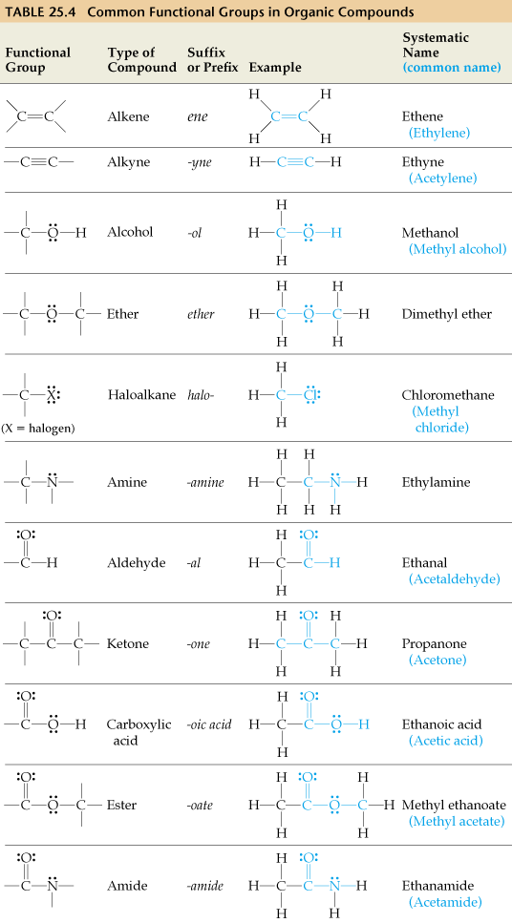
Table 1. Common Functional Groups in Organic compounds.

2. EXPERIMENTAL

2.1 Small molecule building – Single functional groups.
You will use the computer software Chem3-D (CambridgeSoft.com) to create small biological molecules.
The following is a list of small biological molecules which you should be familiar with.
You should provide a condensed formula, line-angle formula and 3-D molecular structure of each molecule in your report book.
Methane CH₄ – produced by ruminants.
Ethene C₂H₄ – growth regulator in plants.
Ethanol C₂H₅OH – produced in fermentation by yeast.
Trimethylamine C₃H₉N – fish-odour molecule.
Formaldehyde CH₂O – defence chemical of ants.
Acetone C₃H₆O – formed in certain catabolic pathways.
Acetic acid C₂H₄O₂ – acid-forming bacteria in anaerobic conditions.
Methyl butanoate C₅H₁₀O₂ – apple smell.
2.2 Multiple functional groups.
Open the structure of taxol from the .c3d file list. Taxol is a natural product obtained from
the bark of the pacific yew, Taxus brevifolia, a chemotheraputic drug used in breast cancers.
• Draw a line-angle structure of taxol in your report book and then identify each functional
group present in the molecule by circling it and then provide the name of each functional
group identified.
2.3 DNA Bases
DNA has four bases adenine, thymine, cytosine and guanine.
Load the bases adenine and thymine from the .c3d file list and then draw the line-angle structure of each into your report book.
• Classify each of the bases as purine or pyrimidines.
• In each base identify the amines as primary (1C attached), secondary (2C attached) or
tertiary (3C attached).
2.4 ATP
ATP is a nucleotide involved in cellular energy transport. It is composed of the adenosine
monophosphate nucleotide found in DNA but with a further two phosphates added, hence the
name Adenosine 5’-TriPhosphate.
Load the structure of ATP from the .c3d file list and then draw the line-angle structure into your
report book.
• Number the sugar ring starting from the anomeric carbon (C 1’).
• Circle the triphosphate section.
2.5 Amino acids
Draw the 3D structure of the following amino acids. Glycine, Cystine.
• In each amino acid identify the functional groups and name them.
• Place a * by the chiral carbon in each amino acid.
Macromolecules
Macromolecular structures such as proteins and DNA can be read with Chem-3D but this program is better suited to small molecules. There are many protein/DNA/RNA structure viewers. These are not designed for creating structures but rather reading structures that have been determined from crystals of proteins or DNA (using crystallography). The program you will use is called RasTop (based on Rasmol) which is one of the most commonly used freeware viewers.
2.6 Protein structure
Open RasTop.
You are provided with a file which contains the structure of part of a protein, called 1hho.pdb.
Load this file and display the ribbon structure for the protein.
• What is the most common secondary structural element of this protein?
• What type of general tertiary structure does this protein have - globular or fibrous?
• Does the protein have quaternary structure?
• Are there any prosthetic groups present in the protein – if so indicate the non-amino
residue label.
2.7 DNA structure
You are provided with fragment of DNA, an oligimer called DNA.pdb.
• What is the name for the secondary structure of this oligimer?
• Indicate the base coding sequence for the DNA duplex.
ASSIGNMENT 4
CHROMATOGRAPHY : AMINO ACIDS
AND PLANT PIGMENTS

AIMS
This experiment is designed to introduce two common chromatographic methods of separation of organic
compounds. In the first experiment pigments from plant leaves will be separated by thin-layer
chromatography and then compared using visible spectroscopy. In the second part of the practical amino acids and a sweetener aspartame (dipeptide) will be separated by paper chromatography. The aim of the paper chromatography experiment will be to identify the hydrolysis products of aspartame (a sweetener) and from this analyse the state of aspartame in Diet Coke®.

- INTRODUCTION

1.1 Isolation and Identification of plant pigments
A commonly used technique in biochemistry is chromatography. Chromatography is the name given to the analytical techniques that separate mixtures into their component parts based on passing the compounds of interest in solution (mobile phase) over a stationary phase. It was invented at the beginning of the twentieth century to answer the question "Why are leaves green?”. To answer this question the green pigment molecules in the leaves had to be separated from the other molecules in the leaf. In this part of the practical we will extract the coloured pigments from leaves into acetone (the solvent used in nail varnish) and will chromatograph these leaf extracts using silica thin layer chromatography (TLC). Extracts of carrots will also be on the chromatogram. By separating the pigments we will be able to see how many of the pigments in the leaves are identical to the pigments in carrots.

In order to analyse the coloured pigments, we will remove them from the chromatogram and measure the wavelengths of the light that the pigments absorb by using a spectrophotometer. Each pigment absorbs different wavelengths of light (colours) to different extents and so each pigment has a unique spectroscopic pattern that allows us to identify it. These coloured pigments are used in photosynthesis, the process of using light energy to make saccharides.

A list of some common plant pigments, in order of increasing polarity is shown below. Chlorophylls are green whereas carotenoids are yellow. The less polar molecules (more hydrophobic, at the top of the list) are likely to travel further up the chromatogram because the solvent used is non-polar (oil like). The absorption spectra of some of these pigments is shown in Figure 1.
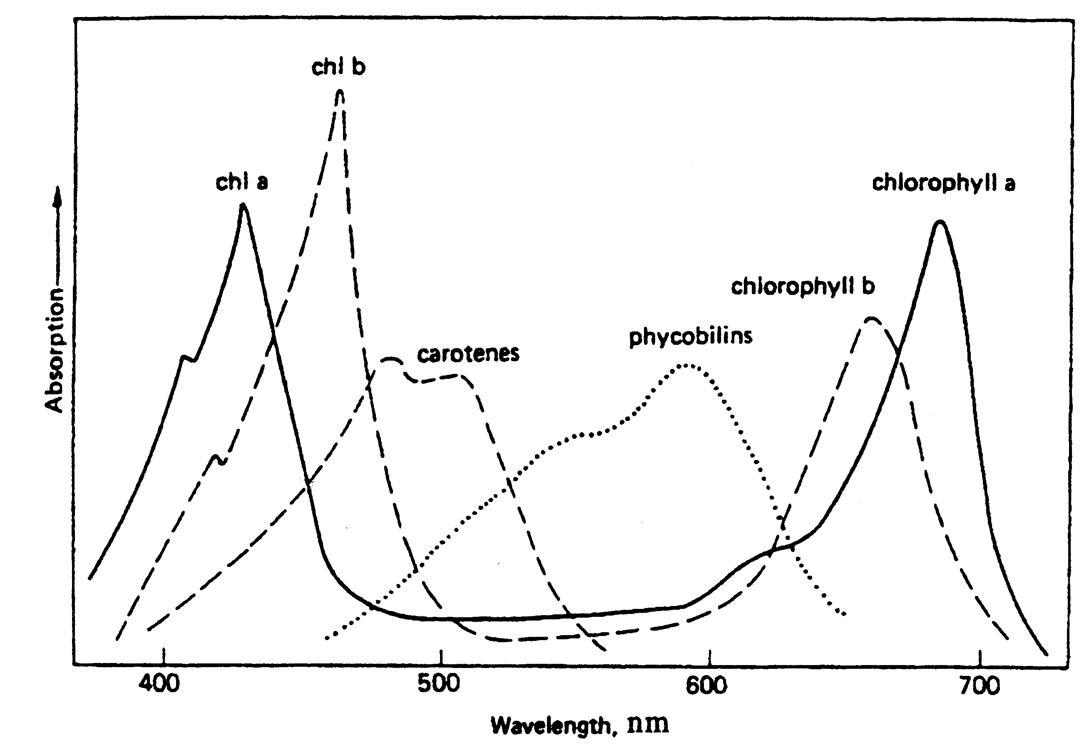
Pigment Colour
β-carotene yellow
chlorophyll a blue-green chlorophyll b apple-green (Granny Smith)
lutein + zeaxanthin yellow
violaxanthin yellow
neoxanthin yellow

Figure 1. The absorption spectra of
four plant pigments
Thin layer chromatography (TLC) is a method of separating the components of a mixture. In TLC, the stationary phase is a thin layer of adsorbent silica particles attached to a solid plate (foil or plastic or glass). A small amount of sample is applied (spotted) near the bottom of the plate and the plate is placed in the mobile phase (solvent mixture). This solvent is drawn up by capillary action. Separation occurs as each component, being different in chemical and physical composition, interacts with the stationary and mobile phases to a different degree creating the individual bands on the plate. The retention factor, R_{f} value, is used to characterize and compare components of various samples.

R_{f} value = distance from origin to component spot
distance from origin to solvent front

The pigments in vegetables, flowers and leaves can be separated and identified by using thin-layer chromatography. Green pigments, known as chlorophylls, serve as the main photoreceptor molecules of plants. Carotenoids, yellow pigments, aid the plant in the photosynthesis process. In addition, xanthrophylls are contained in the chloroplasts which can be isolated and identified using chromatographic techniques.

10 pigments found in concentrated chlorophyll
6 Pigments found in concentrated carotenoid

Pigment | Visible Color | Rf |  | Pigment | Visible Color | Rf
Carotene | Yellow | 0.98 |  | Alpha Carotene | Yellow-orange | 0.97
Xanthophyll | Yellow | 0.86 |  | Beta Carotene | Yellow-orange | 0.94
Xanthophyll | Red | 0.8 |  | Lycopene | Yellow-orange | 0.81
Phaeophytin a | Dark grey | 0.67 |  | Leutein | Yellow-brown | 0.75
Phaeophytin b | Light grey | 0.6 |  | Violaxathin | Yellow-brown | 0.66
Xanthophyll | Yellow | 0.5 |  | Neoxathin | Yellow-brown | 0.28
Chlorophyll a1 | Light blue-green | 0.48
Chlorophyll a | Dark blue-green | 0.46
Chlorophyll b1 | Light yellow-green | 0.30
Chlorophyll b | Dark yellow-green | 0.25
Xanthophyll | yellow | 0.15

We will make use of the retention indices (R_{f} values) to carry out a partial identification of the pigments present in the leaves. You will use a Chlorophyll a extract as a check on the accuracy of the retention indices.
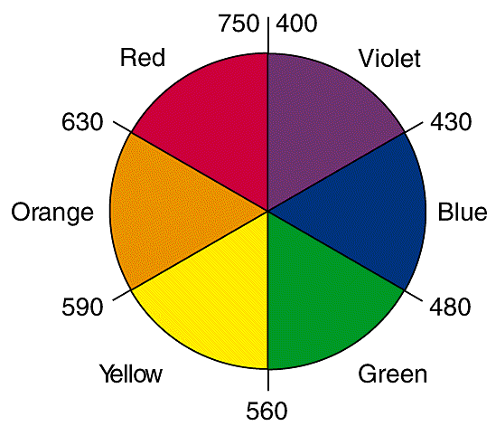
The colour that we see in plant leaves is not the colour that is absorbed it is primarily the complimentary colours that remain unabsorbed on the colour wheel. In the practical you will be provided with spectra that provide the actual wavelengths absorbed by the coloured pigments.

1.2 Separation of Amino acids.
Amino acids are the building blocks of peptides and proteins. They possess two functional groups - the carboxylic acid group gives the acidic character, and the amino group provides the basic character.
The common structure of all amino acids is

The R represents the side chain that is different for each of the amino acids that are commonly found in proteins. However, all 20 amino acids have a free carboxylic acid group and a free amino (primary amine) group, except proline which has a cyclic side chain and a secondary amino group.
Proline
We use the properties provided by these groups to characterize the amino acids. The common carboxylic acid and amino groups provide the acid-base nature of the amino acids. The different side chains, and the solubilities provided by these side chains, can be utilized to identify the different amino acids by their rate of migration in paper chromatography.

In this experiment, we use paper chromatography to identify aspartame, an artificial sweetener, and its hydrolysis products from a common soft drink.
Aspartame
Aspartame is the methyl ester of the dipeptide aspartylphenylalanine. Upon hydrolysis with HCl it yields aspartic acid, phenylalanine, and methyl alcohol. When this artificial sweetener was approved by the Food and Drug Administration in the USA, opponents of aspartame claimed that it is a health hazard, because aspartame would be hydrolysed and would yield poisonous methyl alcohol in soft drinks that are stored over long periods of time. The Food and Drug Administration ruled, however, that aspartame is sufficiently stable and fit for human consumption. Only a warning must be put on the labels of foods containing aspartame. This warning is for patients suffering from phenylketonurea who cannot tolerate phenylalanine.

To run a paper chromatography, we use Whatman No. 1 chromatography paper (note this is not the same as filter paper). We apply the sample (aspartame or amino acids) as a spot to a strip of chromatography paper. The paper is dipped into a mixture of solvents. The solvent moves up the paper by capillary action and carries the sample with it. Each amino acid may have a different migration rate depending on the solubility of the side chain in the solvent. Amino acids with similar side chains are expected to move with similar, though not identical, rates; those that have quite different side chains are expected to migrate with different velocities. Depending on the solvent system used, almost all amino acids and dipeptides can be separated from each other by paper chromatography.

We actually do not measure the rate of migration of an amino acid or a dipeptide, but rather, how far a particular amino acid travels on the paper relative to the migration of the solvent. This ratio is called the R_{f} value. In order to calculate the R_{f} values, one must be able to visualize the position of the amino acid or dipeptide. This is done by spraying the chromatography paper with a ninhydrin solution that reacts with the amino group of the amino acid. A purple colour is produced when the paper is heated. (The proline not having a primary amine gives a yellow colour with ninhydrin.) For example, if the purple spot of an amino acid appears on the paper 4.5 cm away from the origin and the solvent front migrates 9. 0 cm (Fig. 2), the R_{f} value for the amino acid is calculated

distance travelled by the amino acid 4.5 cm
R_{f} = = = 0.50
distance travelled by the solvent front 9.0 cm

In the present experiment you will determine the R_{f} values of three amino acids: phenylalanine, aspartic acid, and leucine. You will also measure the R_{f} value of aspartame.

Figure 2. Paper chromatogram.

Solvent
front

9.0cm
●
Amino Acid
4.5cmmm
444
x
Origin

The aspartame you will analyse is actually a commercial sweetener, Equal by the NutraSweet Co., that contains silicon dioxide, glucose, cellulose, and calcium phosphate in addition to the aspartame. None of these other ingredients of Equal will give a purple or any other coloured spot with ninhydrin. Other generic aspartame sweeteners may contain other non-sweetening ingredients. Occasionally, some sweeteners may contain a small amount of leucine which can be detected by the ninhydrin test. You will also hydrolyse aspartame using HCl as a catalyst to see if the hydrolysis products will prove that the sweetener is truly aspartame. Finally, you will analyze a commercial soft drink supplied by your demonstrator. The analysis of the soft drink can tell you if the aspartame was hydrolysed at all during the processing and storing of the soft drink.

2. EXPERIMENTAL

To be done in pairs.
Start 2.2 first and proceed as far as (e) before commencing 2.1 as there is a 40 minute wait in 2.2.

2.1 Separation and analysis of plant pigments

1. Collect a sample of Cardwellia sublimis (Northern Silky Oak) leaves from the front of the lab. These leaves have been collected from a tree on Campus. Don't use stems or thick veins because they are hard to grind. Also place a small quantity of chlorophyll A extract in a microtube.

2. Cut up the leaves and grind them up in acetone (3 mL) using a mortar and pestle in the fumecupboard.

3. Transfer the liquid from the ground leaf mixture into a microtube using a transfer pipette and let any residual solids settle out for 5 minutes, wash the mortar and pestle with acetone and pass on to another student.

4. Use a pencil to draw a line lightly (the application line) 1 cm from the bottom of a TLC plate (see Fig 3). Place two evenly marked short pencil lines where you will place your spots.

5. On the TLC plate place a spot of your leaf extract at position 1 (take out the liquid from the microtube using a tapered capillary tube), the dimension of the spot should not exceed 2mm. Let this dry and then place another spot in the same position. Continue until you have around 4 spots on the one place (the colour should be nice and dark), then spot the chlorophyll A standard (2 drops) on the second position. Use the thin ends of the capillary tubes and use a different capillary tube for each solution. Be careful not to scrape the white silica powder off the backing plate. Check with a demonstrator that you have applied enough extract to the plate.

6. Place the TLC plate into a beaker with a small amount of the chromatography solvent (75% hexane : 25% acetone) in the bottom and cover with aluminium foil.

7. Once the TLC plates have run (solvent reached nearly the top of the plate) remove the plate, let it dry and sketch pencil marks around each of the bands. Transfer a sketch of your TLC plate into your report book.

Figure 3. A chromatography plate
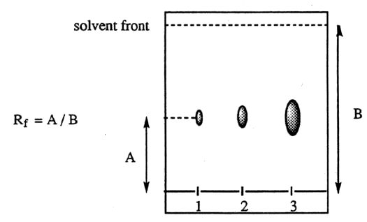
X
Y
R_{f} = X / Y
A

B

Prior to today's practical a leaf extract from the Cardwellia sublimis was run on a Speedy column using a silica stationary phase and the major individual bands collected (Bands A and B) and placed into microtubes with acetone. The contents were mixed to elute the pigments into the acetone. Each solution was then transferred to a glass cuvette and placed in a spectrophotometer. A wavelength scan was carried out and a printout of the scan obtained.

In your report book write down the names of the leaves you have chosen to use.
Observe the scans for each of the bands in the leaf samples you have chosen.
Write down the λ_{max}, the peak absorption(s), for each of the two pigments (A, B) found in Cardwellia sublimis and based on the spectra in Figure 1 identify the pigments present in the leaf – to do this you will use both λ_{max} and the overall agreement in peak position and peak shape.
2.2 Separation of amino acids and analysis of a sweetner
1. Weigh out about 10 mg of the sweetener Equal® (2 tablets) and dissolve in 1 mL of 3 M HCl in a
100 mL beaker, place a couple of bumping granules in the beaker. Heat it with a hot plate to
boiling and boil for 30 seconds, but make sure that the liquid does not completely evaporate.
Cool the beaker and label it "Hydrolyzed Aspartame' with a marker pen.

2. Label five microfuge tubes, respectively, for aspartic acid, phenylalanine, leucine, aspartame, and
Diet Coke®. Place around 0.5-mL of each sample in a microfuge tube.

3. From now on use plastic gloves throughout in order not to contaminate the paper chromatogram.
Take a strip of Whatman no. 1 chromatographic paper, 15 x 8 cm. With a pencil, lightly draw a line
parallel to the 8 cm edge about 1 cm from the edge. Mark the positions of 6 spots, placed equally,
where you will spot your samples (Fig. 4)

Figure 4 Spotting a paper chromatography plate
6
5
4
3
2
1

4. Spotting.
For each sample, use a separate capillary tube. Apply a drop of sample to the paper until it spreads to a spot of 1 mm diameter. Dry the spots (use a hot plate for drying, hold about 1cm above the hot plate using the glass rod). Do the spotting in the following order:
(1) phenylalanine one drop
(2) aspartic acid one drop
(3) leucine one drop
(4) aspartame (in Equal®) one drop
(5) hydrolyzed aspartame three drops
(6) Diet Coca Cola® ten drops

When you do multiple drops, (5) and (6), allow the paper to dry after each drop before applying the next drop. Do not allow the spots to spread to larger than 2 mm in diameter.

Carry out the following manipulations in a fumecupboard.
5. Pour about 15 mL of-solvent mixture (butanol : acetic acid : water) into a large (1 L) beaker. Place a glass rod over the 1L beaker. Using clear tape, affix the chromatographic paper to the rod so that when you lower the rod over the beaker (wrap the tape once around the rod, then onto the paper), the paper will dip into the solvent but the pencil marks and the spots will be above the solvent surface. You will need 2 people to carry out this operation.
Cover the glass rod with paper attached and the beaker with aluminum foil. Place the beaker on a hot plate. Turn the setting to no. 1 (out of 10) and heat the beaker to about 35°C (ie check with a thermometer from time to time). Allow the solvent front to advance at least 6 cm (about 40-50 min.), but do not allow it to get closer than 1 cm from the edge.

6. When the solvent front has advanced at least 6 cm, remove the rod and the paper from the beaker. You must not allow the solvent front to advance up to or beyond the edge of the paper. Mark immediately with a pencil the position of the solvent front. Under a hood, dry the paper with the aid of a heat lamp or hair dryer. Using polyethylene gloves, spray the dry paper with ninhydrin solution.
CAUTION: Be careful not to spray ninhydrin on your hand and not to touch the sprayed areas with bare hands. If the ninhydrin spray touches your skin (which contains amino acids) your fingers will be discoloured for a few days.
Place the sprayed paper on a watch glass in a marked foil dish and place into a drying oven at 105-110°C for 2-3 minutes.

7. Remove the dish and paper from the oven. CAUTION: It will be hot use oven gloves to handle the
foil container – remember not to touch the ninhydrin treated paper.
Mark the centre of the spots immediately with a pencil and calculate the R_{f} values of each spot. If you wait any length of time (minutes) the spots will fade and you will not be able to see them.
Record your observations on the Report Sheet in the table provided.

Identify the amino acids found in the hydrolysate of the sweetener Equal®.

How many spots were stained with ninhydrin (i) in Equal® and (ii) in Diet Coke® samples?

3. CALCULATIONS AND QUESTIONS

Complete the following questions in your report book.

3.1 Plant pigment separation
1. Was your separation completely successful - ie. were the pigments fully resolved?
2. What is the dominant pigment in the leaf.
3. What is the colour mix of the dominant pigment in the leaf.
Colour chart
R – O – Y – G – B – V
red orange yellow green blue violet
670 610 575 530 460 410nm peak maximum

4. What were the other pigments that you tentatively identified in the leaf?

3.2 Amino acid separation

1. If an amino acid moved 1.5 cm on the chromatogram and the solvent front reached 6.5 cm,
what is the R_{f} value of the amino acid?

2. All amino acids, except proline, give a purple colour when stained with ninhydrin, proline turns yellow. Can you give a reason why this amino acid stains differently?

3. Why must you use a pencil and not ink to mark the origin of your spots on the paper?

4. Do you have any evidence that the aspartame was hydrolysed during the processing
and storage of the Diet Coke® sample? Explain.

5. The difference between aspartic acid and phenylalanine is twofold. Aspartic acid has a polar, acidic side chain, while phenylalanine has a non-polar side chain. The molecular weight of aspartic acid is smaller than the molecular weight of phenylalanine. Based on the R_{f} values you obtained for these two amino acids in the solvent employed, which property influenced the rate of migration?

ASSIGNMENT 5
ISOLATION OF CAFFEINE
FROM COFFEE BEANS

AIMS

This experiment demonstrates how the technique of extraction can be used to preferentially remove a single natural product, caffeine from a complex mixture. Thin layer chromatography will be used to confirm the identify of the extracted compound.

1. INTRODUCTION

The process of extraction works by partitioning the components of a mixture between water and an immiscible organic solvent. The more polar components are more soluble in water and thus remain in the aqueous phase, while the less polar compounds are extracted into the organic phase. Extraction is routinely used as the first stage in the purification of products of preparative reactions. Natural product chemists also use the process to obtain compounds from marine and terrestrial plants and animals. The vast majority of known therapeutic substances were first discovered in this way. The extraction of caffeine from coffee beans will be used to demonstrate the power of the technique.

Caffeine occurs naturally in coffee beans, tea leaves, cocoa seeds and cola nuts, and is included in a number of carbonated drinks. In the concentrations found in tea or coffee, it is a mild stimulant, a diuretic and is mildly addictive. In pure form it is toxic. It is a basic, nitrogen containing compound; its structure closely resembles those of the purine bases adenine and guanine, found in RNA and DNA.

Apart from caffeine, ground coffee beans contain a myriad of other natural products including the tannins, which are acidic. However, caffeine is the only major component that is appreciably soluble in organic solvents like dichloromethane (DCM). The rest are highly water soluble. Shaking a coffee solution (hot water extract) with a mixture of aqueous base and DCM will thus result in the extraction of the caffeine into the DCM, while the other coffee components will remain in the aqueous layer.
2.
EXPERIMENTAL You will do this experiment In Pairs

Part A: Extraction
Extract caffeine from coffee beans as follows:

1. Weigh out around 10g (weight measured accurately) of ground coffee into a 250 mL conical flask, add a stirrer bar (gently). Note the coffee sample name in your report book. Place 100mL of distilled water in with the coffee and heat to boiling on a hot plate for 2 minutes. Remove the beaker from the heat using gloves, let the coffee solution cool slightly off boiling and then filter off the coffee grounds and wash them with 5mL of distilled water. Place the coffee solution into a 250 mL conical flask. Carefully add 40 mL of 5M sodium hydroxide solution and swirl until it is thoroughly mixed. Avoid skin contact with this caustic solution.
All subsequent operations will be carried out in a fumecupboard.

2. Transfer the solution to a separatory funnel that is suspended in a metal ring. Add 20 mL of DCM (avoid contact with skin and breathing the vapour), place the stopper on the separatory funnel, remove it from the stand, and with one hand firmly holding the stopper on, invert the funnel. Immediately open the tap to release any pressure that may have built up. Do not point the funnel at anyone at any stage. Close the tap and with the funnel still inverted, shake the mixture for 1 -2 mins, occasionally releasing the pressure by opening the tap. Return the funnel to the metal ring, remove the stopper, and allow the layers to separate.

Separatory Funnel

3. DCM is more dense than water (ρ 1.33 g.cm⁻³) so the bottom layer will be the organic layer. Run the lower layer into a clean 250 mL conical flask. Try to avoid running any of the aqueous layer into the flask. It is best to leave a little organic layer in the funnel.

4. Add another 20 mL of DCM to the funnel and repeat the process. Run the second organic extract (layer) into the first. Discard the aqueous layer from the top of the funnel, so that you don't get any in the tap, and rinse the funnel with a little distilled water. Pour the combined organic extract into the funnel (check that the tap is closed!!) and wash (shake) it with 50 mL of distilled water. Allow the layers to separate and run the organic layer into a dry 250 mL conical flask. Once again avoid running any of the aqueous layer out with the organic layer.

5. There will still be traces of water remaining in the DCM. They can be removed with an inorganic salt that absorbs water. Put about a teaspoon of anhydrous sodium sulphate (or magnesium sulphate) in the DCM solution and swirl it for about 2 minutes. If it is completely dry, the solution above the drying agent should appear completely clear (ie not cloudy). You may need to add more drying agent. Check with your tutor if unsure. Once dry, filter the solution through a funnel containing a fluted filter paper, into a dry flask.

6. Combine your DCM solution with another pair of student's, place in a large pre-weighed round bottomed flask (500mL) containing a few boiling chips, and distil off all the DCM in a distillation set-up similar to that shown below. Make sure you lag the top part of the flask and the head of the distillation apparatus using cotton wool and aluminium foil. Use the thermometer to record the boiling point of DCM. Pour the distillate in the "Recovered DCM" vessel so that it can be re-used.

7. Caffeine will be the main constituent of the material remaining in the flask. Write a description of the residue in your report book. When you are confident that the flask is completely dry inside and out, weigh it and calculate the mass of caffeine you obtained. Record the calculation in your report book. Calculate the mass % caffeine in the ground coffee beans you used in your report book. Scrape the material out of the flask and into a vial. Submit your sample with you report book, labelling the vial with both students' names, group, day and compound name (caffeine).

Part B: TLC analysis
Thin layer chromatography can be used to confirm the identity of the compound extracted from instant coffee. Before attempting this part of the experiment, read the "TLC analysis" section in Assignment 6.

- Perform this part of the experiment individually. Dissolve two rice grain sized portions of your caffeine in approx. 1 mL of DCM. Take a TLC plate and mark it with 3 marks. Place 3 spots on the plate of varying concentration.
- Take a few grains of the pure caffeine sample and make up a solution in DCM. On a new TLC plate make 3 marks and place 3 spots of increasing concentration on the plate.

- Assemble the TLC tank (beaker, filter paper and Petri dish). Run (develop) your TLC plates, using acetone as the eluant. View your TLC plate under UV light and circle the spots with a pencil. Note which are the best concentrations for your sample of caffeine and for the pure sample.
- Prepare a third TLC plate with only 2 marks on it. On the left hand mark place the correct number of drops of your solution and on the right hand mark the correct number of drops of the pure solution. Now develop this plate as before and note down the R_{f} of the compound.

- Sketch your plate in your report book. Does the TLC analysis confirm that the compound you extracted is caffeine? Comment on the purity of the material you isolated.

3. QUESTIONS

1. Why is the coffee solution basified (rather than acidified) before it is extracted with DCM?

2. Describe a procedure other than TLC analysis, that could be used to confirm the identity of your product.
ASSIGNMENT 6
RECRYSTALLISATION
OF NATURAL PRODUCTS

AIMS
This experiment demonstrates how an impure organic solid, contaminated with soluble and insoluble impurities, can be purified by recrystallisation. The solid's melting point and thin layer chromatographic properties will be used as criteria of purity and means of identification.

1. INTRODUCTION

Recrystallisation:
Recrystallisation has been used in research laboratories and in industry for many years as a routine and very effective method to purify organic solids. The crystallisation of sucrose from raw cane juice is a related process. To perform a recrystallisation, a solvent is chosen which will dissolve the compound well at the solvent's boiling point, but poorly at room temperature. For this experiment, water will be used as the solvent. The compound is dissolved in a minimum volume of the solvent, at the solvent's boiling point, and the solution is allowed to cool. The solid will then crystallise out. If the experiment is performed properly, the new crystals will be highly pure. The crystallisation process starts with the formation of one or more "seed" crystals. They then begin to grow, molecules of the solid adding layer upon layer, thus forming a highly ordered lattice. Most impurities will not fit in the lattice and are left in solution. This will only work well if the solution cools slowly and is not disturbed.

Melting Point:
In most areas of chemistry and biochemistry, it is vital that we work with pure substances. Various ways of characterising compounds and determining their purity have been developed. One important property used is the melting point (or melting range) of a solid. If a compound is pure and crystalline, and doesn't decompose on heating, it will have a sharp (range ≤ 2°C) and characteristic melting point. The melting point of a pure solid can thus be used to help identify it, by comparison with tables of known melting points. It can also be used as a measure of purity, since impurities always depress the melting point. It should be noted that solvent can also be considered to be an impurity, hence a compound must be completely dry before its melting point is recorded.

Thin Layer Chromatography:
Chromatography is used widely in the purification and analysis of mixtures. It takes many forms, but always consists of a mobile phase passing over a stationary phase. When a mixture is introduced to the mobile phase, its components exchange between the mobile phase and the stationary phase. The components that prefer to be in the mobile phase will move more quickly than those that prefer to be on the stationary phase. As a result, the various components of the mixture separate. In thin layer chromatography, the stationary phase is usually silica gel (hydrated silicon dioxide) bonded to an inert sheet, and the mobile phase is a liquid which passes up the plate, driven by capillary action. The mixture to be analysed is adsorbed onto the dry silica sheet, which is then placed vertically in a shallow pool of solvent (or eluant). The solvent automatically rises up the plate. Less polar compounds (that prefer to be in the solvent rather than on the silica) move rapidly up the plate. Polar compounds (that prefer to stick to the silica rather than be in the solvent) move slowly up the plate. As each compound has unique polarity properties (as a result of the functional groups it possesses and their arrangement), each one will move up the plate at a different rate to others in the mixture. When the solvent is finally removed, the various compounds remain on the plate and can be visualised, either by UV light if they have a chromophore, or with a stain. The plates used have a fluorescent indicator which helps with the UV detection.

2. EXPERIMENTAL You will do this experiment In Pairs

You will be asked to purify an organic solid that is contaminated with traces of organic impurities and insoluble material. Your tutor will assign you one of a series of unknown compounds which are all organic acids that are extracted from plants. There are three parts in the experiment you will only complete in a timely manner if one student completes part B while the other student is completing part C, part A should be done jointly.

Part A: Recrystallisation
Recrystallise the compound as follows:
The basic procedure is the same for each sample but for unknown 4 you will need to use an ethanol : water (E:W) mixture (20mL ethanol: 80 mL water) rather than straight distilled water for dissolving the compound.

1. Dissolve the compound in a minimum volume of distilled water (or E:W mixture) at or near its boiling point. To do this place the solid in a 100 mL conical flask* and add a little hot distilled water (or hot E:W mixture). Add some boiling chips (crushed tile) or boiling sticks.# Bring to boil on a hotplate in the fumecupboard. If the compound does not dissolve within a 1-2 mins, add a little more water (or E:W mixture) and bring back to boil. Keep repeating this process until the compound just dissolves. Then add a slight excess (~10%) of hot water (or E:W mixture). Keep the solution gently boiling until you are ready to filter it. With the E:W mixture you may need to add nearly 100 mL so make up 200 mL at the start. Note for compound 1 you MUST NOT use more than 50 mL of hot water otherwise it will never crystallise.

2. To remove the insoluble impurities you will need to do a hot filtration. You will need a clean 100 mL conical flask, a short stemmed funnel, a watch glass and a fluted filter paper (ask your tutor how to flute a filter paper). Place the funnel and filter paper on the conical flask and pour a few mLs of boiling distilled water through the funnel. Cover the funnel with a watch glass and keep the whole apparatus hot with the hot plate. Quickly but carefully pour the boiling solution containing the compound to be recrystallised through the funnel. Remove the funnel and return the filtrate to the heat to redissolve any compound that may have prematurely crystallised. If the funnel is preheated properly, very little of the product will crystallise on the filter paper.

3. Cover the flask with a watch glass and allow it to cool to room temperature.
The pure organic compound should crystallise in the flask as it cools.
The best crystals, and hence the purest material, are obtained if the solution is allowed to cool slowly without disturbance. If crystallisation does not occur, consult your tutor.

* Conical flasks NOT beakers should be used for recrystallisations because; (a) it is easier to rinse the inner walls of a conical flask, (b) when heated, the solvent will reflux on the inside of the flask with minimal evaporation and (c) the narrow neck of the conical flask makes it easier to handle than a beaker, especially when hot.

# Boiling chips or sticks provide sharp points or edges on which bubbles can easily form. In their
absence, large bubbles form over the entire bottom of the flask and cause the mixture to "bump".

4. When crystallisation is complete, separate the pure crystals from the mother liquor (re-crystallisation solvent containing impurities) by vacuum filtration. You will need a filter flask, a Buchner funnel, a rubber cone, a rubber hose and a filter paper. The filter paper should fit inside the Buchner funnel such that it covers all the holes but does not touch the sides. Assemble the filtration apparatus and connect it to a gentle vacuum. Wet the filter paper with a few mL of distilled water and check that it is sitting flat and covering all the holes.

Gently swirl the flask containing your crystals and mother liquor, and pour the mixture quickly and carefully into the funnel. If any crystals remain in the conical flask, rinse it with a little cold distilled water and pour the water and crystals into the funnel. A spatula may also help get the crystals out. Gently press the crystals down onto the filter paper so that a rapid flow of air passes through them. Do not discard the filtrate until you are sure you have a reasonable (> 0.1 g) yield of crystals.
5. Wash the crystals with a little cold distilled water to remove all traces of mother liquor, and suck them dry. Transfer them onto a large filter paper, spread into a thin film.
Place the filter paper with your compound in a petri dish. Place the sample in an oven at 60ºC to dry fully. [N.B. The cover must left off the petri dish.]. Report the dry mass in grams in your report book. Hand your sample in with your report book, labelled with your name, day and the compound name.

Part B: TLC Analysis
Use thin layer chromatography (TLC) to test the effectiveness of your recrystallisation. This can be done by running TLCs of the compound before and after recrystallisation, as follows:

1. You will need a beaker, a piece of filter paper, a Petri dish, a pencil, a TLC spotter and a TLC plate. Place the filter paper around the inner wall of the beaker, pour some of the TLC solvent provided (6% acetone in ethyl acetate) in the bottom of the beaker (to a depth of about 3 mm) and place the Petri dish over the top. The filter paper must be touching the solvent. The purpose of the filter paper is to help saturate the air inside the beaker with the TLC solvent.

2. Take four rice grain sized portions of the impure compound and dissolve it in approx. 1 mL of ethanol in a vial. Note that the dark grey, insoluble material will not dissolve – this is some decomposition product.

3. With your pencil (not pen!!!), mark a line across the plate, about 5 mm from, and parallel with, its bottom edge. Mark 3 points (1, 2 & 3) on the line, equally spaced, with the outer ones at least 5 mm from the side of the plate.

4. Dip your spotter in the ethanol solution, being careful not to block it with the insoluble material, and touch it on each of your marks on the TLC plate so that spots of about 2mm diameter are produced. Allow the spots to dry. For the spot marked "1", repeat the process, for "2" repeat it three times, and for "3" repeat it five times.

5. When the spots are completely dry, carefully place the plate vertically in the TLC tank, with the markings at the bottom. The solvent level must be below the level of the line. Cover the beaker with the Petri dish and allow the solvent to flow up the plate. When it is approx. 5 mm from the top of the plate, remove the plate and quickly mark the point the solvent reached. This is known as the "solvent front." Do not allow the solvent front to reach the top of the plate.

6. Allow the plate to dry and view it under a UV lamp. Avoid looking directly at the light. Sketch your plate in your report book. Determine the R_{f} value for each component of the mixture. This is the distance the spot moves up the plate divided by the distance between the bottom line and the solvent front (see the following diagram).

Example of developed TLC plate showing formula used in R_{f} calculation.
N.B. Your plate may show more spots than this.

- Repeat the above process with your recrystallised product. This can be done while the crystals are still a little damp. Make an ethanol solution of your crystals, and place three spots of different concentration on a new TLC plate, develop as before.
- In addition prepare a further plate with 2 spots marked. Use the first plate you ran to determine how much of the impure sample you should place on the first spot (ie did 1 spot, 2 spots or 3 spots give the best result) and use the 2nd plate to determine how much of the pure sample to add to the second spot? - ask you tutor for assistance. Remember to use a clean spotter for each new mixture. Develop and view the plate as before. Sketch it in your report book.

On the basis of your TLC results, comment on the effectiveness of your recrystallisation.

Part C: Melting Point
As it takes more than 20 minutes for all traces of solvent to be removed then you have been provided with purified samples of the unknowns for the melting point determinations.
Identify your unknown by recording its melting range and comparing it with the list of literature melting points shown below. Write your answer in your report book, along with the structure of the compound and its dry mass in grams.

Record the melting point as follows:

- Take a small sample of the solid to be tested and crush it on a watch glass, using a spatula. Scrape a small quantity of the powder into the open end of the sealed melting point capillary and, while holding the bottom of the tube, tap it on the bench until the compound falls down into the end that is sealed. Alternatively the capillary may be dropped down a length of glass tubing several times. If the powder inside the melting point tube is clearly visible, you have added enough. Do not add more than is necessary.
- Place the tube in the electrically heated m.p. apparatus and heat slowly. Record the temperature range over which the solid melts, i.e. the temperature range from when you see the first crystal melt to when the whole sample is molten. A temperature range of more than 3º suggests that the sample is not pure.

3. QUESTIONS

Consult your text to help you answer these questions. One word answers are not adequate.

1. If your impure compound was a liquid, how would you purify it?

2. As an alternative to recrystallisation, describe a chromatographic method that could be used to purify your compound.
Appendix A. Natural product carboxylic acids.

Benzoic acid – obtained from gum benzoin (benzoin tree) 120 – 122ºC.
Salicylic acid - A naturally occurring β-hydroxy acid found in willow bark. 158 – 161ºC.
Cinnamic acid – obtained from cinnamon oil (cinnamon tree) 133 – 134ºC.
Oxalic acid – extracted from the leaves of the plant oxalis or rhubarb. 104 – 106ºC.

ASSIGNMENT 7
MICROPIPETTES AND SPECTROMETERS

AIMS
A micropipette is a standard tool in biochemistry. This practical develops the correct techniques for the use of a micropipette and how to carry out a gravimetric calibration. An absorption spectrum of haemoglobin is obtained in the second part of the practical to illustrate the use of visible spectroscopy in compound identification.

1. INTRODUCTION
1.1 Haemoglobin
Haemoglobin is the major protein in red blood cells and is the molecule that transports oxygen and carbon dioxide around our bodies. It is red when an iron atom in the haemoglobin molecule is complexed with oxygen. It is blue when the iron is complexed with carbon dioxide. (This is why the blood in our veins looks blue). In this practical you are going to discover the wavelength at which oxygenated haemoglobin absorbs the most light.

1.2 Spectrophotometers
The colour of an object is the component wavelength of white light that is not absorbed, that is, which is reflected or transmitted through the object. Molecules absorb different wavelengths (different colours of light, Figure 1) to different extents. Haemoglobin absorbs light in the green part of the light spectrum, so the emerging light (everything that is not green) looks red. A spectrophotometer measures absorbance of light at a particular wavelength. The lower the absorption by a molecule the lower the reading is on the spectrophotometer (N.B. a lower concentration will also reduce an absorption). The absorbance reading on the spectrometer does not require units.

Ultraviolet Violet Blue Green Yellow Orange Red Infrared

400 nm 500 nm 600 nm 700 nm

Short wavelength Long wavelength

Figure 1.
Part of the electromagnetic spectrum, showing how the wavelength of visible light relates to the colour.

1.3 Pipettes
Pasteur pipettes are also called teat pipettes and are used for transferring liquid when the volume of liquid does not need to be measured. As with other pipettes, if you turn them upside-down some of the liquid in the pipette enters the rubber teat. This is a bad idea as it will cross contaminate the next sample transferred. Please do not hold your pipettes upside-down. The glass pipettes are dispensable and go in the sharps bin after use. The plastic ones may or may-not be recycled depending on what you use in them.
Never transfer hot liquids with Pasteur pipettes as they will squirt out unexpectedly, usually over you or a partner next to you.
Advantages: quick and easy to use, very cheap. Disadvantages: non quantitative, sometimes the teat slips off.
Analytical glass pipettes are use for transferring large quantities of liquids (5mL – 50mL) and use a bulb filler. You will get practice with using this type of pipette in later practicals.
Advantages: handles large volumes, accurate. Disadvantages: quite slow to use, has to be cleaned carefully.

Micropipettes allow you to pipette microlitres (µL) of liquid (although some go up to 5mL these days). Micropipettes always have a disposable tip placed on the end before they are used.
Never use a micropipette without first placing a plastic tip on the end of the pipette.

Different sized micropipettes are used to pipette different volumes. Micropipettes which can pipette up to 1 ml (1000 µl) use blue tips, whereas pipettes which pipette 200 µl or less use yellow tips. The dials determine the volume that will be pipetted. You should never use a pipette to pipette a volume larger than its maximum volume (usually printed on the pipette), or you will break it. Micropipettes cost about $300 each. It is better to use a pipette at the maximum end of its range, rather than the minimum, for example if you are pipetting 200 µl, it is better to use a 50-200 µl pipette than a 200 - 1000 µl pipette, this reduces the error in the measurement.
Advantages: handles small volumes, easy to use, accurate. Disadvantages: expensive, can be broken.

1.4 Principle for the calibration of micropipettes
The volume delivered by the micropipette is determined by weighing the amount delivered and dividing this by the density of water at the temperature of measurement. This is called gravimetric calibration. You will carry out a calibration as this is a standard operation that must be performed periodically on all micropipettes.

2. EXPERIMENTAL

All sections will be carried out in pairs. You must dispose of all gloves, pipette tips etc in the Biohazard bags as you are working with bovine hemoglobin in this practical.

2.1 Experimental Procedure for micropipette use and calibration
2.1.1 Using micropipettes.
Most micropipettes are "two-stop" pipettes. This means that when you gently press the end of the pipette it will travel a certain distance and then stop. If you press harder the end will travel further.
A set of two micropipettes is available to you in the set of shared equipment. The caps of the micropipettes indicate the volume ranges over which they can be used: 10-100, and 100-1000 µL.
Set the desired volume at about half full volume (50 µL on the 10-100 µL micropipette) by holding the micropipette body in one hand and turning the adjustment knob until the correct volume shows on the digital indicator. Like all machines there is some 'play' in the volume adjustment knob. To overcome this problem it is recommended that you always approach the desired volume by dialing downward (at least one-third revolution) from a larger volume setting – that is you will always finish a setting with a clockwise motion.
Attach a new disposable tip to the shaft of the pipette. Press on firmly with a slight twisting motion to ensure a good seal. Depress the plunger to the FIRST POSITIVE STOP. This part of the stroke is the calibrated volume displayed on the digital dial.
Holding the micropipette vertically, immerse the disposable tip into the sample liquid to a depth of about 1.5 mm (do not exceed 3mm), use a microtube with some distilled water in it. Release the pushbutton slowly, allowing the solution to gently rise in the pipette tip.
To DISPENSE THE SAMPLE, place the tip end against the side wall of the receiving vessel (microtube) and depress the plunger slowly to the FIRST STOP. Wait about 1 second for the solution to drain. Then depress the plunger to the SECOND STOP, expelling any residual liquid in the tip.
Withdraw the micropipette from the solution and then let the plunger return to the UP POSITION.
Remove the tip before placing the micropipette on the bench or in it’s holder.
A fresh tip should be fitted for each sample to prevent carryover between samples.
2.1.2 Hints for improving micropipette accuracy.
1. Some solutions (such as serum, protein-containing solutions, or organic solvents) leave a film in the pipette tip. This can be a problem in that some of your sample is left behind in the pipette tip. This is overcome by refilling the pipette tip a second time before the sample is delivered to the receiving vessel.
2. Solutions with densities that are very different from water do not pipette well because they are drawn up in the tip too slow or too fast. The only way to compensate for this is to calibrate the micropipettes using the solution with a different density.
3. Cold solutions cause the plastic pipette tip to shrink somewhat and you need to calibrate for this effect as well using ice water if you are pipetting at 0ºC for instance.
4. If an air bubble is noted within the tip during intake, dispense the sample back into the original vessel,
check the immersion depth, and pipette more slowly. If an air bubble appears a second time, discard
the tip and use a new one.

2.2 Quantitative Transfer
Use a Pasteur pipette to transfer between 450μL of Solution A (blank buffer) into a microtube.
Now find a micropipette and set it to 50 µL. Depress the end of the pipette to the first stop and insert the pipette tip into Solution B (haemoglobin solution). Slowly take your thumb off the end of the pipette (this loads the micropipette with 50μL of Solution B). Take the pipette tip out of Solution B and carefully wipe the sides of the pipette tip with a tissue so that all drops of liquid on the outside of the tip are removed (don’t wipe the very end). Do not turn the pipette upside-down. Now place the pipette tip into the microtube containing Solution A just beneath the surface. Push the end of the pipette down to the first stop (this releases the 50μL of Solution B into Solution A). Keeping the tip in Solution A, take your thumb off the end of the pipette (this pulls 50 μL of mixture into the tip). Now push the end of the pipette to the first stop again and take it out of Solution A (releases the mixture which cleans out the tip). Whilst you are holding the pipette just above the surface of Solution B depress the end of the pipette all the way to the second stop, if a droplet is still at the end then touch this on the wall of the microtube (this gets rid of the last trace of material). Then remove the pipette, discard the tip, and place the pipette on the bench.
You have just carried out a quantitative transfer and prepared a diluted sample (1/10) of haemoglobin.
N.B. you never put a micropipette with tip attached down on the bench.

1. How can you tell the difference between the different sized pipettes?
2. How many different sized pipettes could you use to pipette 100 µL?
3. What is the maximum volume that you should pipette with a yellow micropipette?
4. What is the purpose of the second stop of a two-stop pipette?

2.3 Calibration of micropipettes.
The volume delivered by the micropipette is determined by weighing the amount delivered and multiplying this by a correction factor (density of water – temperature and air pressure corrected). Set the micropipette to 500 μL, draw room temperature distilled water up into the tip and deliver it into a small weighed glass vessel. Record the new weight. Repeat this 4 times. Calculate the volume actually delivered and tabulate the results. Be sure to note the temperature of the water.
Determine the average volume delivered and calculate the standard deviation for both solutions.
1. Calculate the mean weight ($\overline{W}$) $\overline{W}= \frac{1}{n}\sum_{i=1}^{n}{W_{i}}$
where W_{i} is the weight of the ith measurement.
i is the counter of the number of the measurement i = 1 – 10.
N is the total number of measurements (10).
2. Find the correct Z-factor (T, P corrected density μL/mg) Z from Appendix A.
3. Calculate the average volume delivered ($\overline{V}$) $\overline{V}= \overline{W}x Z$

4. Evaluate the standard deviation SD_{v} $\text{SD}=\sqrt{\sum_{i=1}^{n}{\frac{{\left(W_{i}−\overline{W}\right)}^{2}}{n−1}}}$

$$\text{SD}={\text{SD}}_{w} \text{xZ}$$
eg. to evaluate the standard deviation 4. using a 1 μL calibration as an example. T =21.5ºC.
10 weighings 0.968, 0.960, 0.984, 0.942, 0.969, 0.966, 0.955, 0.972, 0.958, 0.967 mean weight 0.964.
working equation $\text{SD}{}^{2}=\frac{1}{n−1}\sum_{i=1}^{n}{{\left(W_{i}−\overline{W}\right)}^{2}}$ $\text{SD}{}^{2}=\frac{1}{9}\left[{\left(0\text{.}\text{968}−0\text{.}\text{964}\right)}^{2}+{\left(0\text{.}\text{960}−0\text{.}\text{964}\right)}^{2}+{\left(0\text{.}\text{984}−0\text{.}\text{964}\right)}^{2}+{\left(0\text{.}\text{942}−0\text{.}\text{964}\right)}^{2}+\text{.}\text{.}\text{.}\right]$

$$\text{SD}{}^{2}=0\text{.}\text{000121}$$

$\text{SD}=0\text{.}\text{011}$
$\text{SD}=0\text{.}\text{011} \text{xZ}$
= 0.011 x 1.0032
= 0.011 μL
This type of calibration is appropriate for relatively large volumes like 500μL. When working with smaller volumes such as 1- 2μL you must consider evaporative losses from the weighing vessel. This is done by half filling a weighing vessel with water, weighing it and leaving it open as you dummy dispense into another vessel. The evaporative losses are usually of the order 0.01 – 0.03 μL.
5. What is the difference between accuracy and precision in a measurement? Use you result for the
calibration to illustrate your answer.

2.4 Spectrometer.
Take three 3 ml plastic cuvettes. Label the grooved sides of the cuvettes 1, 2 and 3.
Prepare the cuvettes as follows:
Cuvette 1: 3 mL Solution A (blank buffer solution)
Cuvette 2: 3 mL Solution B (haemoglobin solution)
Cuvette 3: 2700 µL of Solution A and 300 µL Solution B

The contents of cuvette 3 will have to be mixed. To do this, stretch some parafilm (in both directions)
over the end of the cuvette and turn it upside down a couple of times. Never use your finger instead of
parafilm (though you should use your finger as well as parafilm).
Note: the haemoglobin must be kept in ice until used.

Set the wavelength of the spectrophotometer to 400 nm. Use Cuvette 1 as a blank and zero the instrument.
Place cuvette 2 and then 3 in the spectrometer beam and measure the absorbance.
Take the cuvette (2 or 3) that you decide is most suitable and measure the absorbance at 365,
375, 385, 395, 400, 405, 410, 420, 430, and 450 nm.
Remember to zero the machine using Cuvette 1 at each wavelength.
Enter your absorption versus wavelength results in the table in your report book.
Plot a graph of the absorption spectrum of haemoglobin in your report book.

Find a spectrophotometer that has a UV (deuterium) lamp as well as a tungsten lamp. Set the
wavelength to 280 nm and blank the spectrophotometer on air. Now measure the absorbance
of Cuvette 1. Find a quartz cuvette (do not drop) containing solution B. Measure the absorbance
of solution B in this cuvette.

QUESTIONS.
1. How much more concentrated is solution B in Cuvette 2 than in Cuvette 3?
Hint: the dilution equation is c₁V₁ = c₂V₂ (assume your starting concentration is 1mol/L)

2. If you put A into a cuvette ran a spectrum, cleaned the cuvette and then placed B in the same cuvette
and ran a spectrum you would have carried out the spectroscopic measurement in the ideal manner.
Instead you have placed solution B into a different cuvette from solution A.
What assumptions have you made by doing this, which you wouldn't have to make if you used the same cuvette for both solutions?

3. What is the absorption of Cuvette 2 and Cuvette 3 at 400 nm?

4. You are now going to determine the absorbance of haemoglobin at several different
wavelengths. It is preferable not to use absorbance measurements greater than 0.9.
Which cuvette would be better to use? Why?

5. What is the wavelength at which haemoglobin absorbs the most?

6. What were the absorbance readings of solution B in polystyrene Cuvette 1 and in the quartz
cuvette at 280 nm? Why do you think the absorbance readings are so different?
Write down the chemical formula for quartz and the line-angle structure for styrene.

Appendix A. Z Factor at various temperatures.

Temperature  ºC | Z  μL /mg | Temperature  ºC | Z  μL /mg
0 | 1.000243 | 18 | 1.0025
1 | 1.000183 | 19 | 1.0027
2 | 1.000143 | 20 | 1.0029
3 | 1.000122 | 21 | 1.0031
4 | 1.000112 | 22 | 1.0033
5 | 1.000121 | 23 | 1.0035
6 | 1.000141 | 24 | 1.0038
7 | 1.000181 | 25 | 1.004
8 | 1.00023 | 26 | 1.0043
9 | 1.0003 | 27 | 1.0045
10 | 1.00038 | 28 | 1.0048
15 | 1.002 | 29 | 1.0051
16 | 1.0021 | 30 | 1.0054
17 | 1.0023

ASSIGNMENT 8

CASEIN AND
α-AMYLASE

AIMS
The isolation of casein a common milk protein is the function of the first part of the practical. A set of standard chemical tests to identify proteins are then carried out on the isolated casein and the solubility characteristics of the casein are investigated . The next part of the practical looks at the globular protein
α-amylase and which factors control the activity of this enzyme on the hydrolysis of starch.

1. INTRODUCTION

1.1 Protein Solubility
Proteins contain positively charged, negatively charged and neutral regions. The more acidic a solution the more protons are present and the more positively charged a protein becomes. If a protein is in an alkaline solution it is negatively charged. As acid is added the protein becomes progressively less negatively charged until eventually it has no charge at all. The pH at which this occurs is called the isoelectric point, or pI for the protein. Proteins are usually least soluble at their pI values. When more acid is added the protein becomes positively charged and becomes more soluble again.

1.2 Casein
Casein is the most important protein in milk. It functions as a storage protein, fulfilling nutritional requirements. Casein can be isolated from milk by acidification to bring it to its isoelectric point. At the isoelectric point, the number of positive charges on a protein equals the number of negative charges. Proteins are least soluble in water at their isoelectric points because they tend to aggregate by electrostatic interaction. The positive end of one protein molecule attracts the negative end of another protein molecule, and the aggregates precipitate out of solution.
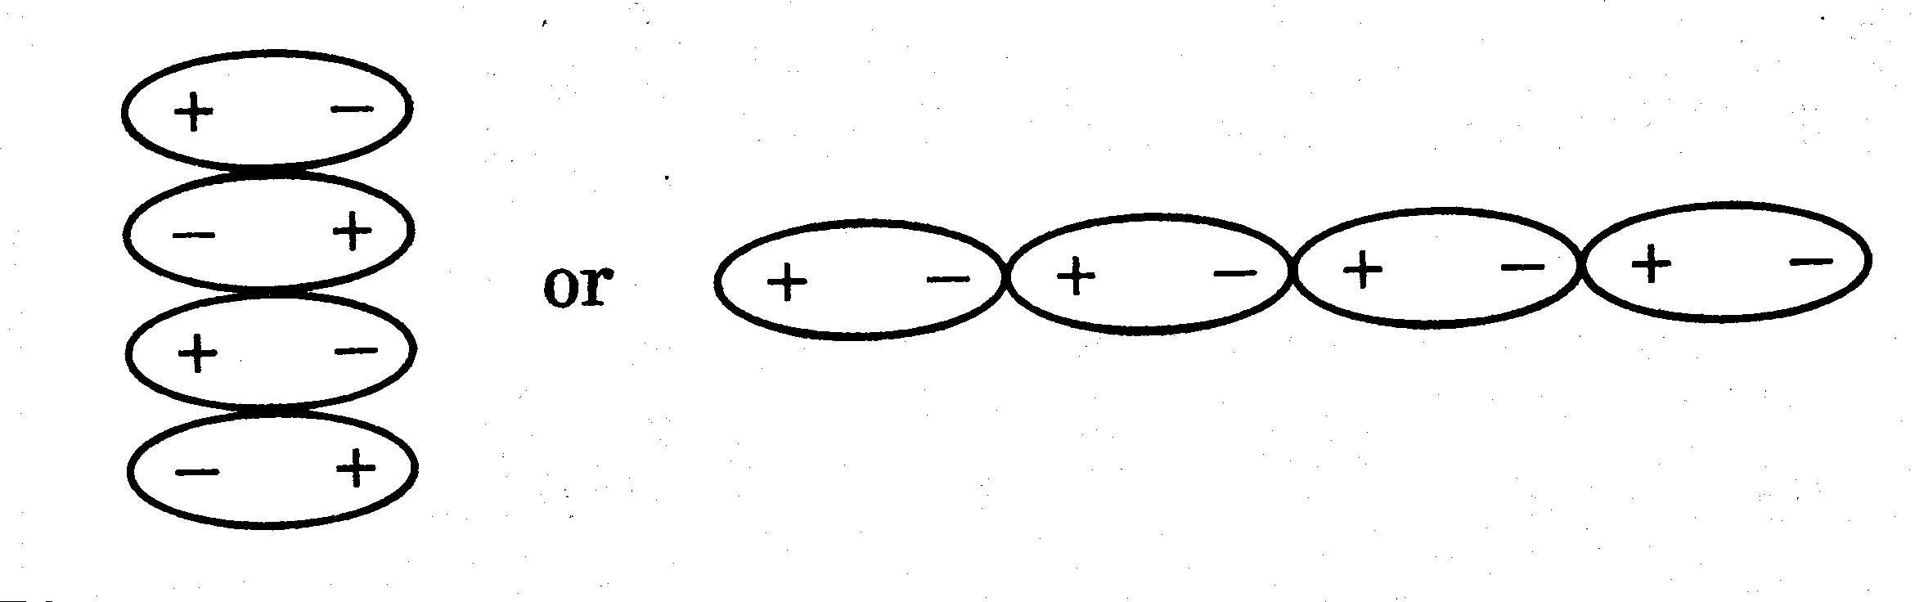

On the other hand, if a protein molecule has a net positive charge (at low pH or acidic condition) or a net negative charge (at high pH or basic condition), its solubility in water is increased.

In the first part of this experiment, you are going to isolate casein from milk which has a pH of about 7. Casein will be separated as an insoluble precipitate by acidification of the milk to its isoelectric point (pH = 4.7). The fat that precipitates out along with casein can be removed by dissolving it in alcohol.
In the second part of this experiment, you are going to prove that the precipitated milk product is a protein. The identification will be achieved by performing a few important chemical tests.

1.3 The biuret test. This is one of the most general tests for proteins. When a protein reacts with copper(II) sulfate, a positive test is the formation of a copper complex which has a violet colour.

This test works for any protein or compound that contains two or more of the following groups:

1.4 The ninhydrin test. Amino acids with a free -NH₂ group and proteins containing free amino groups react with ninhydrin to give a purple-blue complex.

1.5 Heavy metal ions test. Heavy metal ions precipitate proteins from solution. The ions that are most commonly used for protein precipitation are Zn²⁺, Fe³⁺, Cu²⁺, Sb³⁺, Ag⁺, Cd²⁺, and Pb²⁺. Among these metal ions, Hg²⁺, +, Cd²⁺, and Pb²⁺ are known for their notorious toxicity to humans. They can cause serious damage to proteins (especially enzymes) by denaturing them. This can result in death. The precipitation occurs because proteins become cross-linked by heavy metals as shown on below.

People who swallow Hg²⁺ or Pb²⁺ ions are often treated with an antidote of a food rich in proteins, which can combine with mercury or lead ions in the victim's stomach and, hopefully, prevent absorption! Milk and raw egg white are used most often. The insoluble complexes are then immediately removed from the stomach by an emetic.
1.6 The enzyme - amylase
- Amylase is an enzyme (globular protein) that hydrolyses starch into glucose. Starch is a mixture of two large polysaccharides amylose and amylopectin, both composed of D-glucose monomers. Starch combines with iodine to form a black colour (formation of a starch-iodine complex) but small sugars do not. Iodine can therefore be used to detect whether -amylase has hydrolysed starch into glucose or not. By using this detection method (assay), you will investigate the effect of temperature and pH on the enzymatic activity of -amylase.

2. EXPERIMENTAL
You will do this experiment In Pairs. One partner in the pair should commence 2.4 after 1 hour into the practical at the latest.

2.1 Isolation of Casein

All manipulations in 2.1 are to be carried out in the fumecupboard.

1. To a 250-mL conical flask, add 50.00 g of milk (this must be weighed accurately but it does not need to be exactly 50g) and heat the flask in a water bath (a 600 mL beaker containing about 200 mL of tap water; see Fig. 1). Stir the solution constantly with a stirring rod. When the bath temperature has reached about 40ºC, remove the flask from the water bath, and add about 10 drops of glacial acetic acid while stirring. Observe the formation of a precipitate.
N.B. glacial acetic acid is very smelly if you get it on your gloves leave them in the fumecupboard.
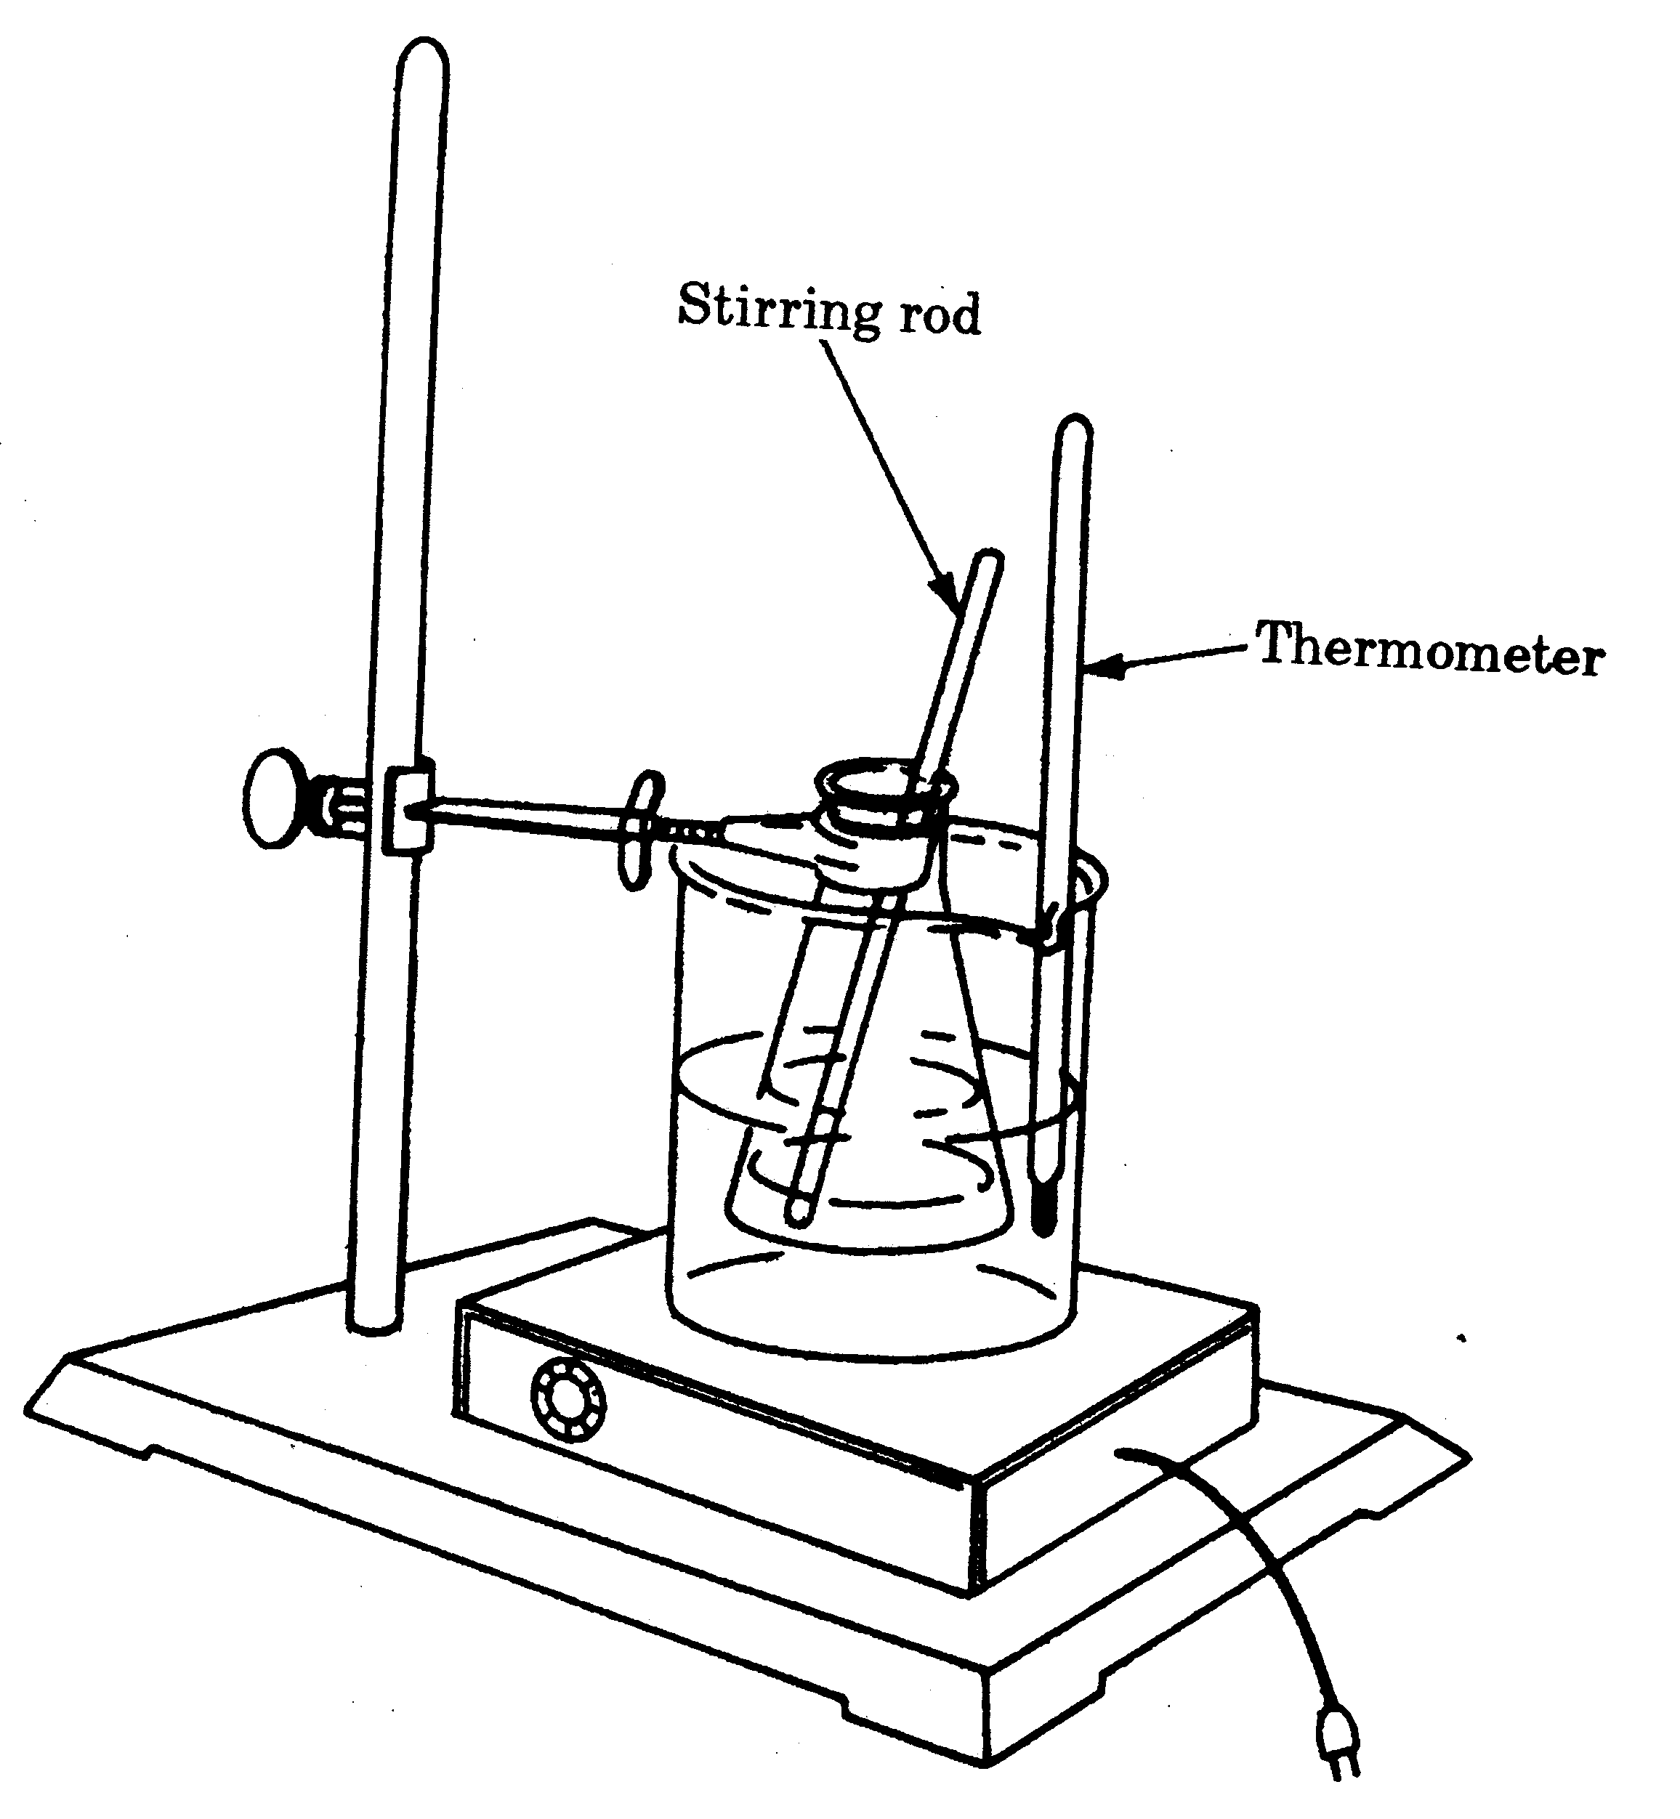
Figure 1.
Precipitation of casein.

2. Filter the mixture into a 100-mL beaker by pouring it through a cheese cloth which is fastened with a rubber band over the mouth of the beaker (Fig. 2). Remove most of the water from the precipitate by squeezing the cloth gently. Discard the filtrate in the beaker. Using a spatula, scrape the precipitate from the cheese cloth into an empty 250 mL conical flask.
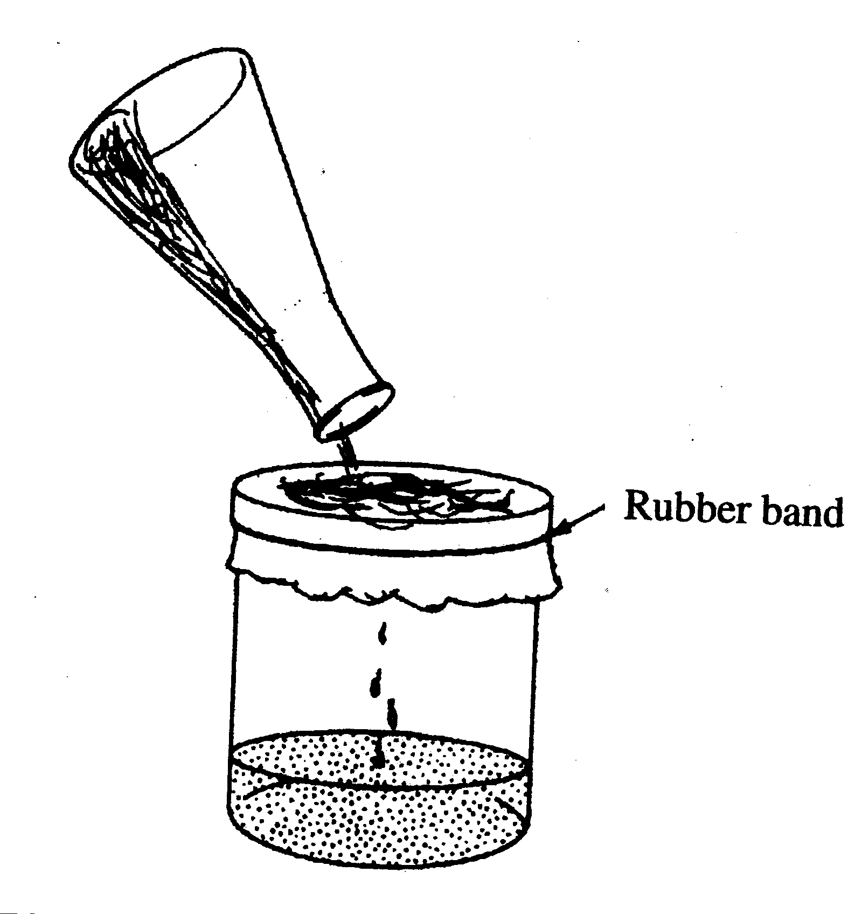
Figure 2.
Filtration of casein.

3. Add 25 mL of ethanol to the flask. After stirring the mixture for 5 minutes with a stirring rod, allow the solid to settle. Carefully decant (pour off) the liquid that contains fats into a beaker. Discard the liquid.

4. To the residue, add 25 mL of a 1:1 mixture of diethyl ether-ethanol. After stirring the resulting mixture for 5 minutes, collect the solid by vacuum filtration. Then add 15 mL of diethyl ether to the flask and wash this through the filter pad.
CAUTION: diethyl ether is highly flammable. Make sure there are no sources of ignition nearby.

5. Spread the casein on a paper towel and let it dry. Weigh the dried casein and calculate the percentage of casein in the milk. Record it on your Report Book.
% casein = weight of solid casein x 100
50.0g milk

2.2 Chemical Analysis of Proteins

1. The biuret test. Place 15 drops of each of the following solutions in five clean, labelled test tubes.

- 2% glycine
- 2% gelatin
- casein prepared in Part 2.1 (one-quarter of a full spatula) + 15 drops of distilled water
- 1% tyrosine
To each of the test tubes, add 5 drops of 10% NaOH solution and 2 drops of a dilute CuSO₄ solution while swirling. The development of a purplish-violet colour is evidence of the presence of proteins. Record your results in your Report Book.

2. The ninhydrin test. Place 15 drops of each of the following solutions in five, clean, labelled test tubes.

- 2% glycine
- 2% gelatin
- 2% albumin
- casein prepared Part 2.1 (one-quarter of a full spatula) + 15 drops of distilled water
- 1% tyrosine

To each of the test tubes, add 5 drops of ninhydrin reagent and heat the test tubes in a boiling water bath for about 5 min. Record your results in your Report Book.

3. Heavy metal ions test. Place 2 mL of milk in each of three clean, labelled test tubes. Add a few drops of each of the following metal ions to the corresponding test tubes as indicated below:

a. Pb²⁺ + as Pb(NO₃)₂ in test tube no. 1
b. Ag⁺ as AgNO₃ in test tube no. 2
c. K⁺ as KNO₃ in test tube no. 3
Record your results in your Report Book.

2.3 Protein Solubility
You are now going to investigate the solubility of casein. This protein has a pI value of about 4.7. You will be able to tell when the pH is close to the isoelectric points (4.7) by using the indicator bromocresol green, which changes colour gradually from blue to yellow between the pH values of 5.4 and 4.0.
Prepare a casein solution by taking a spatula tip of casein (prepared in 2.1) and adding it to 5mL of water in a test tube. Shake vigorously for 2-3 minutes. Let it settle and suck the clear supernatant off using a transfer pipette into a second test tube.

1. Take one test tube and pipette 2 ml of casein solution into it. Add 2 drops of
bromocresol green.

2. Slowly add drops of 0.1 M HCl to the casein solution, mixing the solution by shaking, until the solution is yellow.

3. Now add 2 ml of 2 M HCl to the casein solution in the test tube.

Other than a colour change, what did you observe at the isoelectric point of the casein. Enter this in your report book.

2.4 Activity of the enzyme amylase

Control Experiments
In the following experiments it takes 20 minutes for the colour to develop and so you should commence these experiments relatively early in the practical.
- Set out seven drops of starch solution using a micropipette on a glass slide placed on a white piece of paper – the drop size is 8 μL.
- To the first drop of starch add a small drop of iodine solution using a micropipette tip attached to a Pasteur pipette bulb. This is a control experiment with no enzyme indicating the colour reaction between starch and iodine.
- To each of the other starch drops add a 8 μL drop of -amylase solution using a micropipette and mix well with a toothpick. Do this fairly quickly and note the time.
- Thirty seconds after you added the -amylase add a drop of iodine to the first starch/amylase drop.
- At thirty second intervals add a drop of iodine to the other starch/amylase drops. By doing this you are finding out how long it takes for the enzyme to break down the starch.

You are now going to use the starch test for -amylase activity to investigate the effect of pH and temperature on the enzyme -amylase.

- Place about 0.5 ml of -amylase into each of three microtubes. The tubes are labelled: 1: heat-treated, 2: alkali-treated; 3: acid-treated.

- Place one microtube (heat-treated) in a boiling water bath for three minutes.

- Add one drop of 0.2 M NaOH to the second microtube (alkali-treated) and mix.

- Add one drop of 0.1 M HCl to the third microtube (acid-treated) and mix.

You now need three labelled slides: one slide is for the heat-treated -amylase, one is for the alkali-treated - amylase and the other is for the acid treated -amylase.

- Set out seven 8 μL drops of starch solution onto each of the three glass slides.
- To the first drop of starch on each slide add a drop of iodine solution (using the tip/bulb arrangement).
- Take one slide and add a 8 μL drop of the heat-treated -amylase to each of the six drops and mix well with a toothpick. Do this fairly quickly.

- Thirty seconds after you added the -amylase add a drop of iodine to the first starch/amylase drop and at thirty second intervals add a drop of iodine to the other starch/amylase drops.
Write down your observations in the Report Book.

- After you have finished observing the reaction, repeat steps 12 and 13 with the alkali-treated -amylase and then the acid-treated -amylase.

3.1 CALCULATIONS AND QUESTIONS

Complete the reactions and discussions required in your report book.

1. According to the equation of the ninhydrin reaction given in the introduction to this experiment, one of the products is CO₂. Where does the CO₂ come from?

2. In the isolation of casein following the acidification, you removed the precipitate by filtering through a cheese cloth and squeezing the cloth. If you did not squeeze out all the liquids, would your yield of casein be different? Explain.

3. Does gelatin contain amino acids? Explain.

4. Why is milk or raw egg used as an antidote in cases of heavy metal ion poisoning?

5. According to your results, how many grams of casein are in a glass of milk (175 g)?

6. Other than a colour change, what did you observe at the isoelectric point of the casein?

7. What happened to the casein when you added a large quantity of acid?

8. Casein has an isoelectric point at pH 4.7. What kind of charges will be on the casein in its native environment, that is, in milk at neutral pH?

9. How do you separate the fat from the protein in the casein precipitate?

10. Why does curd form when milk sours?

11. What reaction does -amylase catalyse?

12. What was the effect of temperature on the enzyme -amylase?

13. What was the effect of pH on the enzyme -amylase?

ASSIGNMENT 9
GEL ELECTROPHORESIS
AND VITAMIN C ANALYSIS

AIMS
An introduction to the practical aspects of gel electrophoresis using a set of standard food dyes. The identity of an unknown dye is determined by comparison with the standards. In the second part of the practical a quantitative analysis will be carried out to determine the amount of vitamin C present in a commercial soft-drink.

1. INTRODUCTION

1.1 Gel electrophoresis.

Gel electrophoresis is a technique that has been developed (1973) to separate DNA fragments, taking advantage of the inherent chemistry of the DNA molecule. DNA is negatively charged due to the phosphate groups embedded in the side rails of the helix. When DNA is placed in an electric field, the DNA fragments will migrate toward the positive pole (anode) as they are being repelled from the negative pole (cathode). The sorting of DNA by fragment size in gel electrophoresis makes use of an agarose gel.
Agarose is the polysaccharide ingredient in agar, and is derived from a seaweed. Purified agarose is in powdered form, and is insoluble in water (or buffer) at room temperature. But it dissolves in boiling water. When it starts to cool, it undergoes what is known as polymerization. Rather than staying dissolved in the water or coming out of solution, the sugar polymers cross-link with each other, causing the solution to "gel" into a semi-solid matrix. The polymeric structure of the gel forms a 3-dimensional lattice structure with small pores randomly placed throughout the gel. It is through these pores that DNA molecules or in this practical dye molecules will migrate. Smaller molecules will migrate faster, as there is less friction to the molecule as it moves toward the positive pole. Larger molecules will lag behind as they will not pass through the pores as readily.
The more agarose is dissolved in the boiling water, the firmer the gel will be. Gels are generally mixed at 0.8-1.0% agarose. This concentration will separate a wide range of DNA fragment sizes, ranging from around 500 base pairs (bp) to around 20,000 bp (or 20 kilobases, kb). Separation simply means being able to differentiate between 2 or more fragments of different sizes. If less agarose is used (e.g., 0.5%), DNA fragments less than around 2 kb will all be equally separated by the agarose matrix and will migrate equal distances in equal time - providing no separation. Larger fragments (>20 kb), however, will be able to separate better in this matrix than in a 1.0% gel, where they would be blocked from moving by all the agarose around. Conversely, if more agarose is used (e.g., 2.0%), better separation of very small fragments will be seen, even very small fragments will be separated by this high level of agarose which creates a very complex path for the molecules to get through. However, at this high concentration, anything larger than 3-4 kb will not separate because there is just too much agarose for those fragments to move through efficiently. As agarose polymerizes, it takes on a bluish coloring. This is often used as an indicator that the gel is ready to use. The higher the agarose percentage, the bluer the gel.

Figure 1. Agarose structural unit.

The solvent used to dissolve the agarose is also important. Rather than just use water, ionic buffered solutions are used which allow the DNA (or in this case dye molecules) to run smoothly through the gel. The buffer solutions optimize the pH and ion concentration of the gel and will also bathe the gel as it is subjected to the electric current which actually moves the charged molecules through the gel.

The two commonly used buffers in electrophoresis are TBE and TAE. We will use TBE which is widely used for moderately large DNA fragments. The "T" stands for Tris, a pH buffer which helps maintain a consistent pH of the solution. The "E" stands for EDTA (ethylene diamine tetra-acetic acid), EDTA chelates divalent cations like magnesium. This is important because most nucleases require divalent cations for activity. Any stray nucleases will degrade DNA and this is not what you want if you are running a DNA gel. The "B" or "A" stand for Boric acid or Acetic acid, which provide the proper ionic concentrations for the buffer.
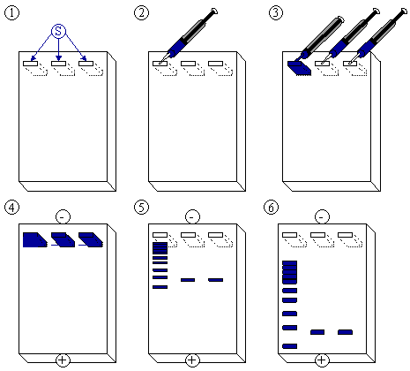

A row of holes called sample wells is placed along one side of the gel, and it is into these that the dye (or DNA) sample will be loaded. The agarose gel is placed in an electrophoresis chamber and covered with a buffer solution containing the ions that help pass the current through the gel. Just prior to loading the dye sample, the dye is loaded with glycerol. The glycerol increases the density of the sample, and helps it sink to the bottom of the well, otherwise it would simply diffuse through the buffer. In DNA analysis tracking dyes are used as visible markers to keep a track of the separation as DNA is colourless. In this practical we are running a set of dyes to illustrate the principal of gel electrophoresis and will use one tracking dye as a reference point.
Following the electrophoresis DNA must be stained for visualisation. The gel is soaked in a stain that will diffuse throughout the gel and become concentrated in areas where it is binding to DNA fragments. The excess stain is then soaked out of the gel, and the fragments will become visible. The staining compound, ethydium bromide, is a potent carcinogen because it reacts with DNA and precludes DNA analysis for first year practicals.
Agarose gel electrophoresis in general can resolve molecules based on charge, size and shape. The migration of DNA molecules in agarose gels is roughly proportional to the inverse of the log of their molecular weight (corresponding to the size of the fragments) as the shape is similar and all have the same charge/weight ratio.
In a modified form called SDS-PAGE, gel electrophoresis is also widely used in separating mixtures of proteins. A different gel is used, polyacrylamide and the proteins must be charged using SDS detergent, otherwise the experimental procedures are quite similar.

1.2 Ascorbic acid

Ascorbic acid is commonly known as Vitamin C. It was one of the first vitamins discovered and played a role in establishing the relationship between a disease and its prevention by proper diet. The disease called scurvy results from a deficiency in ascorbic acid. In this disease, which was common amongst sailors in the 16th and 17th centuries, the skin develops spots and falls off. Ascorbic acid functions as a powerful reducing agent (antioxidant) and helps maintain the iron in the enzyme prolyl hydroxylase in the reduced form. Prolyl hydroxylase is essential for the synthesis of normal collagen, which is why severe skin problems are the result of deficiency in ascorbic acid. Vitamin C cannot be synthesized in the human body and must be obtained from the diet ( e.g. citrus fruits, broccoli, sweet pepper, tomatoes) or by taking synthetic vitamin C ( e.g. vitamin C tablets, “high-C” drinks, and other vitamin C-fortified commercial food). The minimum recommended adult daily intake (ADI) of vitamin C to prevent scurvy is 60mg. There is no reliable medical data to suggest that mega-doses of vitamin C (10000mg+ ADI) can help prevent the common cold or alleviate symptoms.
In this experiment, the amount of vitamin C is determined quantitatively by titrating the test solution (a soft-drink containing vitamin C) with a water soluble form of iodine : I₃⁻. This is called an iodometric titration.
Vitamin C is oxidized by I₂ (as I₃⁻) according to the following chemical reaction.

As vitamin C is oxidized by iodine, I₂, becomes reduced to I⁻. When the end point is reached (no vitamin C is left), the excess of I₂ will react with a starch indicator to form a starch-iodine complex which is a blackish-blue colour.

I₂ + starch → iodine – starch complex (blackish-blue colour)

It is worthwhile to know that although vitamin C is very stable when dry, it is readily oxidized by air (oxygen) when in solution. Therefore a solution of vitamin C should not be exposed to air for long periods. The amount of vitamin C can be calculated by using the following conversion factor:
1mL of I₂ (0.01 M) = 1.76 mg vitamin C.
This simple relationship will be used in the practical to establish how much vitamin C is in a soft-drink.

2. EXPERIMENTAL
You will do this experiment In Pairs.
There are 2 gel rigs used for running the gels in the Biolab electrophoresis chambe and a set of demo rigs that used to practice building and loading gels.

2.1 Agarose Gel Separation of Dyes

2.1.1 Preparation of TBE Working Solution.
The buffer used in this particular gel experiment is a mixture of Tris buffer, Boric acid and EDTA. The stock TBE solution is too concentrated to use but is appropriate for storage. You must dilute this before using it and so the first thing you will do is prepare a TBE working solution.
You will need to use a glass pipette and pipette filler for this operation. Your instructor will go over the operation of this equipment and the potential hazards.
1. Pipette 20 mL of TBE Stock Solution into a 100 mL volumetric flask and make it up to 100 mL with distilled water.

2.1.2 Pouring the Gel
You will be assigned a particular percentage agarose gel to build (range 0.5 – 2.0%) and so you must first calculate the mass of agarose required. This is a mass percent calculation and you will have 40g of solution.
%agarose = X g x 100 you must calculate X g
80 g
eg. 4% = 3.2 g of agarose.
Make sure that you have everything organised before you begin the pouring of the gel.
1. To a 200 mL beaker add X g of agarose gel and 80 mL of TBE Working Solution.
It is best to sprinkle the agarose into room-temperature buffer, swirl, and let sit at least 1 minute before heating. This hydrates the agarose and reduces foaming.
2. Heat the mixture until boiling. Take the beaker off the hot plate using heatproof gloves.
Let stand until it is at 65ºC (hot but not burning to touch at the bottom of the beaker).
3. Have the demo gel rig ready so you can pour the hot solution straight in.
Ensure that the comb is in place.
4. Pour the agarose solution into the gel deck. Pour until the gel comes close to the top of the gel deck,
but do not overfill. The gel will appear thicker than it actually is – observe the level carefully and be
sure to pour in enough agarose. The gel will be around 5mm thick.
5. Wait for 20-30 minutes for the agarose gel to solidify.

2.1.3 Loading buffer
A loading buffer is used for sample preparation. Glycerol increases the density of the TBE buffer, which allows the sample to sink into the well and not spread into adjacent wells.
You are provided with a loading buffer which contains 3 mL of glycerol to 7 mL of TBE Working
Solution.
1. Using a 10-100 μL micropipette, extract 20 μL of each of the 4 standard food dyes (Remember:
suck in your sample using the 1st stop, to eject press to 1st stop and then use the 2nd stop) and
pipette each dye into a microtube, do the same with your assigned mixture.
(Remember to change pipette tips).

2. Your tracking dye, bromophenol blue, should now be added. Add 20 μL of bromophenol blue from
the container provided to each of the microtubes containing the food dyes.

3. Extract 110 μL of the loading buffer and pipette into each of the 5 microtubes (You should now
have a total of 150 μL in each microtube).

2.1.4 Loading the samples in the demo rig
- Cover the gel in the gel rig that you have prepared with approx 1 mm of distilled water. Wait a few minutes before removing the comb. The buffer will soften the gel slightly, allowing the comb to be removed without breaking the wells. Rock the comb back and forth slightly and then pull the comb straight up. Remove the comb carefully to avoid tearing the gel.
- Adjust the micropipette to 14 μL.
- Mix the solution in the dye microtube by pushing the button up and down a couple of times slowly (to the first stop).
- Extract the required quantity (14 μL) from the microtube into the micropipette. Wipe the tip carefully with a Kimwipe®.
- Place the micropipette tip carefully at the top of a well and at a slight angle and very slowly release the sample into the well, only go to the first stop releasing around 7 μL.
- Repeat loading as many lanes as you feel necessary to give you enough practice – both partners should attempt this.

2.1.4 Loading the samples in the Biorad rig
1. Cover the gel in the gel rig (prepared the same day by the technician) with approx 1 mm of TBE Working Buffer. The buffer solution should not be too deep as it reduces the electric field the dye molecules experience and the resolution deteriorates. Wait a few minutes before removing the comb. The buffer will soften the gel slightly, allowing the comb to be removed without breaking the wells. Pull the comb straight up. Remove the comb carefully to avoid tearing the gel.
2. Record on your data sheet in the Report Book the lanes where you will load the dye samples.
3. Adjust the micropipette to 14 μL.
4. Mix the solution in the dye microtube by pushing the button up and down a couple of times slowly (to the first stop).
5. Extract the required quantity (14 μL) from the microtube into the micropipette. Wipe the tip carefully with a Kimwipe®.
6. Place the micropipette tip carefully in the well and very slowly release the sample into the well (to the first stop).
- Repeat the process for each dye sample until all your lanes are loaded. Avoid bumping the rig.

2.1.5 Running the samples
- Once the samples have been loaded, do not move the gel rig and keep agitation of the gel to a minimum. Close the lid on the gel chamber and connect the electrophoresis unit to the power supply (red to red, black to black). Plug the power supply into an outlet.
- Turn the power on and set the voltage to 100V and the timer to 10min.
- Press the RUN button
- Once the electrophoresis has finished turn off the power supply, disconnect the electrical leads from the gel rig and remove the top of electrophoresis chamber.

2.1.6 Analysing the gel
At the end of the run, you will need to measure the tracking dye front for each lane. Ideally the tracking dye front should be even across all the lanes, but this is often not the case as the side lanes move slower than the centre lanes. The reason for this is that the degree of heat dissipation is lower at the centre and the gel in region becomes less viscous allowing the dyes (DNA, protein) to move faster. As a result a smiley effect can often be seen across the tracking dye front. To compare positions then relative mobility is used.

Relative mobility is the ratio of the distance moved by the band (away from the starting wells) divided by the distance moved by the tracking dye.

- Carefully remove the casting tray with the gel. Place the gel in a large foil pie dish.
- Draw a diagram of your gel in your report book showing the banding pattern of the dyes.
- Calculate the relative mobility of each dye.
- Compare the known dyes with the unknown dye sample to determine which 2 dyes were present in your unknown.

2.2 Vitamin C analysis
- Using a 50 mL measuring cylinder transfer 100.00 mL of the fruit drink into a 250 mL conical flask. Then add 20 mL of distilled water, 5 drops of 3M HCl (as a catalyst) and 10 drops of 2% starch solution to the flask.
- Clamp a 50 mL buret onto the buret stand. Rinse the buret twice with 5 mL portions of iodine solution. This is a stain so try to avoid spilling it and use gloves. Let the rinses run through the tip of the buret and discard them. Fill the buret slightly above the zero mark with a standardized iodine solution (the concentration will be given, note it in your Report Book). Make sure there are no air bubbles in the stopcock by fully turning the stopcock several times. Record the molarity of the standardized iodine solution (the concentration will be given) in your Report Book. Record the initial reading on the buret to the nearest 0.02 mL .
- Place the flask that contains the vitamin C sample under the buret and add the iodine solution dropwise while swirling until the indicator just changes colour to dark blue. This colour should persist for at least 20 seconds. Record the final buret reading. Ask your demonstrator for an approximate end point. Note the titration must be done moderately quickly.
- Calculate the total volume of iodine solution required for the titration. The weight of the vitamin C in the sample and percent (w/v) of vitamin C in the drink.

3 CALCULATIONS AND QUESTIONS

3.1 Gel Dyes
- Which dyes are present in the unknown sample?
- What would happen if did you not fill the buffer up to the level before starting running the gel?
- Assuming that all the dye molecules have the same charge which of the dyes has the higher molecular weight?
3.2 Vitamin C analysis

- What volume of fruit drink would satisfy your minimum daily vitamin C requirement.

| RIP OUT SECTION
|
|
| These notes are intended as a work book for this part of the course.
|
| Please make comments on any part of the course here as you go along and then at the
| end of the course make sure you rip out this section and return it to the Chemistry
| Department box. This will enable the course to be improved with time and at the
| same time ensures that THIS IS NOT A RE-SALEABLE ITEM.
|
|
|
|
|
|
|
|
|
|
|
|
|
|
|
|
|
|
|
|
|
|
|
|
|
|
|
|
|
|
|
|
|
|
|
|
|

It is vital that the sample is heated slowly, so that the melting point tube and the thermometer are as close to the same temperature as possible. The melting point should always be recorded with rising temperature (sample going from solid to liquid), rather than with falling temperature (sample going from liquid to solid) because in the latter case, supercooling of the liquefied test substance can lead to large errors in the observed melting point.

